022/06/25- Chalk Dust: We’re back! After taking the Dec. holidays and the month of January off, the Thursday Crew of diggers is back in action. What a beautiful day although it was more of a March weather day than a February weather day! Eight volunteers met Jen (SRD) at the Strip Mine Trailhead and walked a little over a half mile on Chalk Dust to an area where a bridge and then a gabion had previously been built. The goal was to add another layer of rocks to the gabion area and then also wall a couple of areas above the gabion where erosion is doing its thing. Needless to say, there was a lot of rock hauling and lifting. We were able to complete most of the work but will need to return next week to finish off the project.

Volunteers: Bill Perkins, Eric Messerschmidt, Eric Russell, John Braly, Jim Houle, Laura Leon, Roland Stumpf and Andy Ruddie.

Pictures: Laura Leon

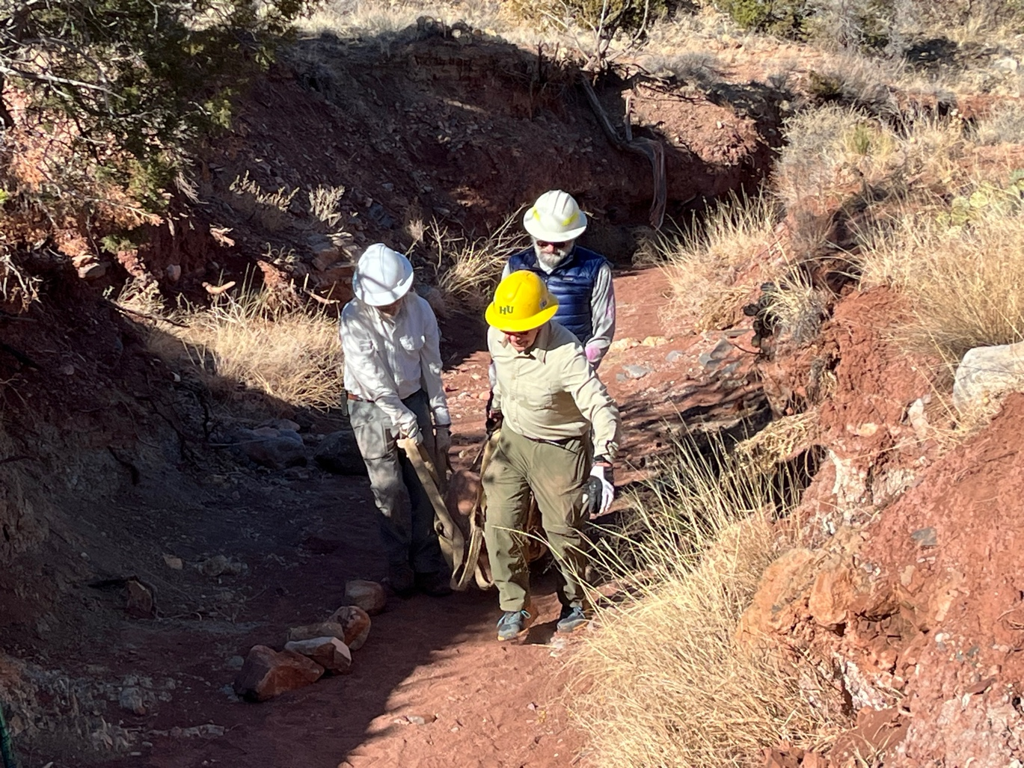

Bill, John and Jim doing the hauling thing.
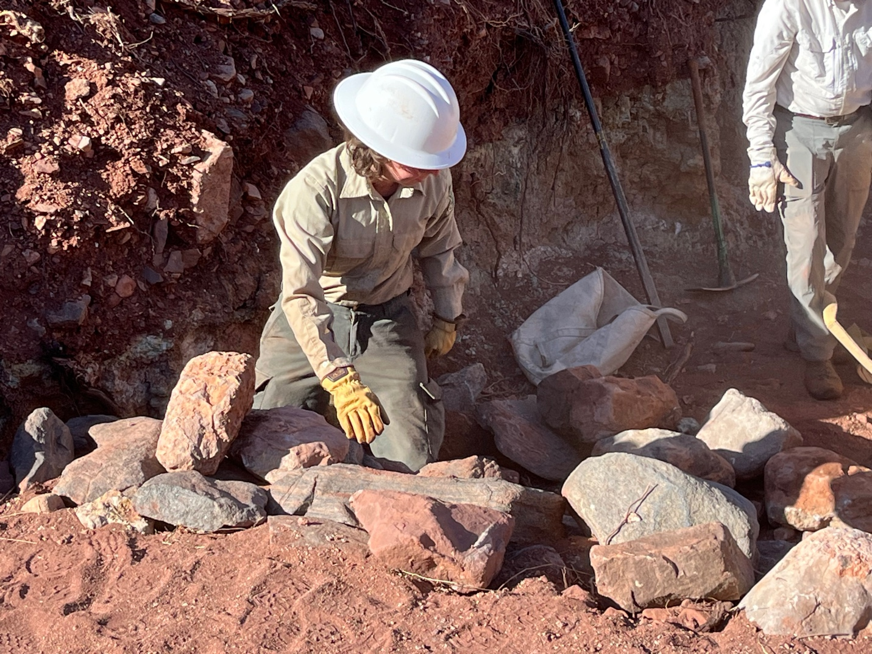

Jen sets stones. They have a vision….

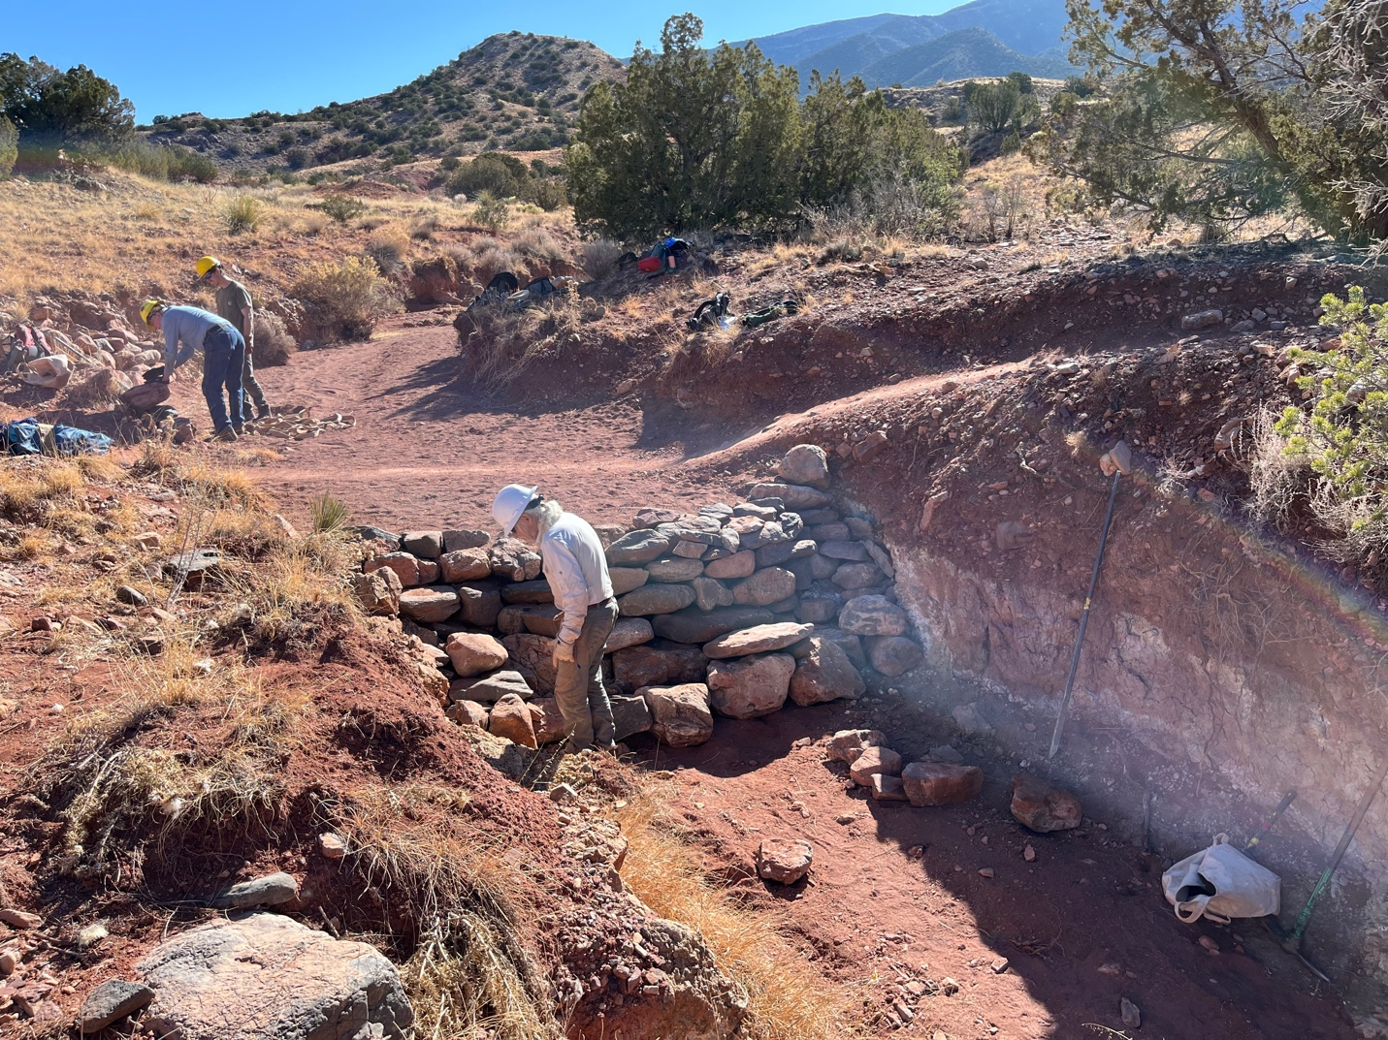

Things are starting to take shape. Wall was added where Bill is standing. Wall was created where the Erics are working and also across the arroyo from the Erics.
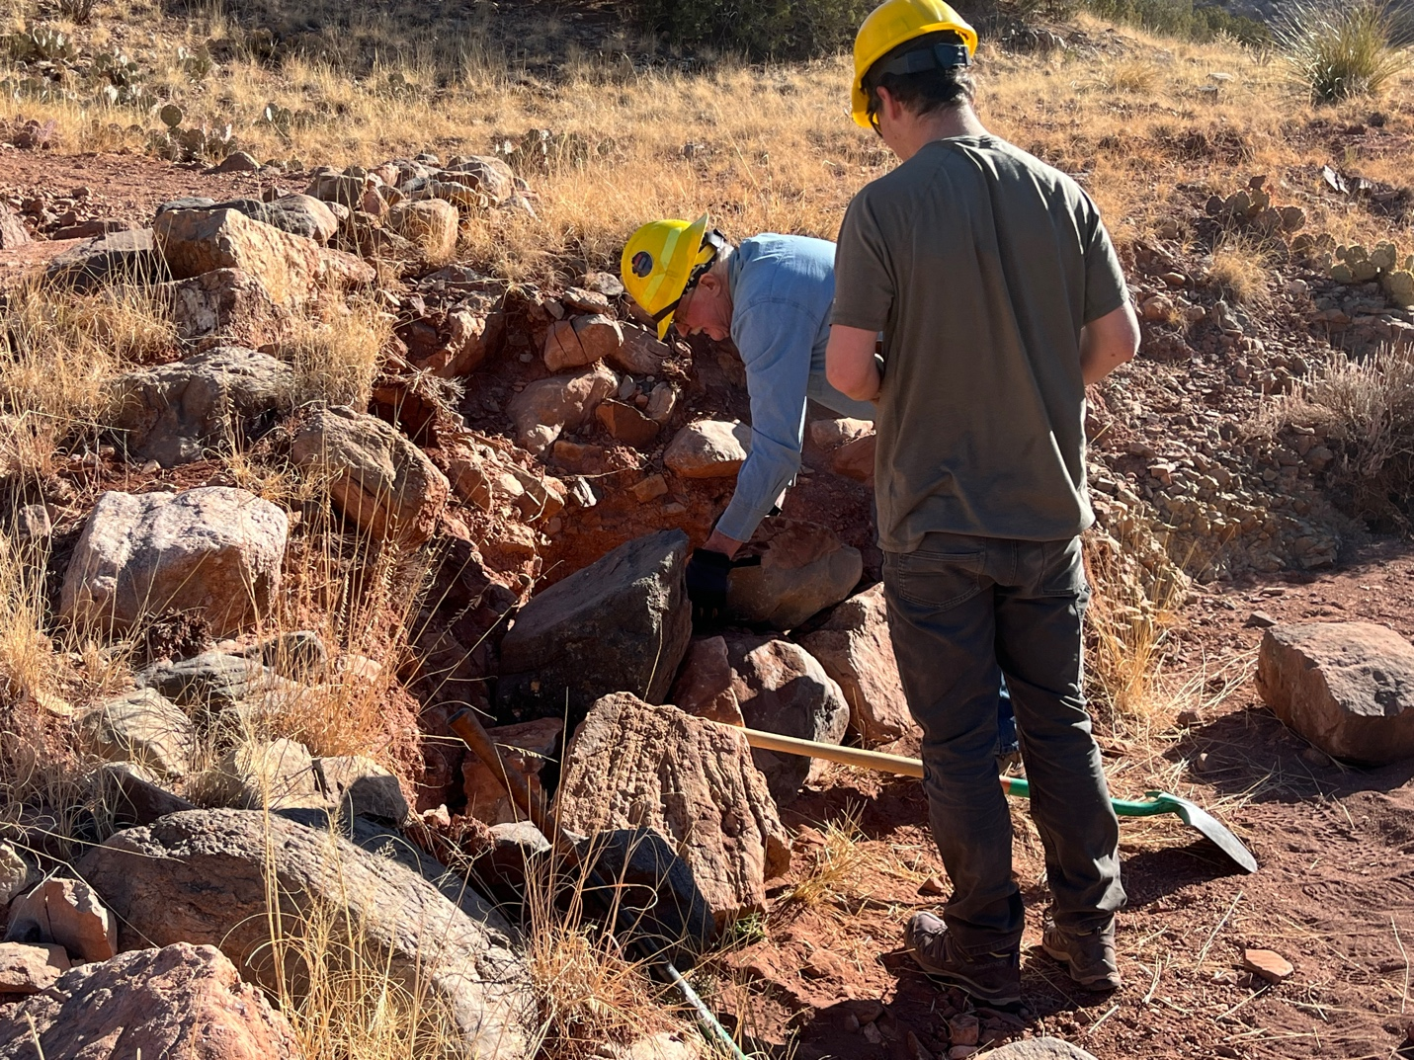

Eric and Eric set the bottom group of rocks.
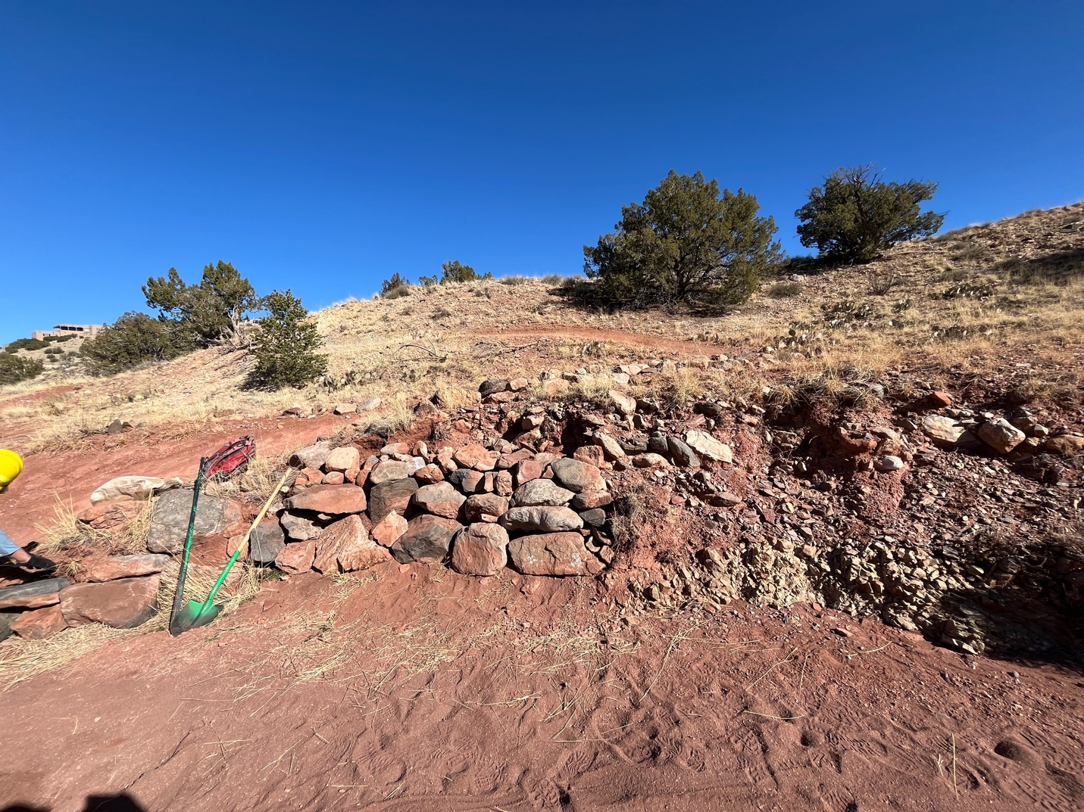

More rocks added and the wall starts to take shape.
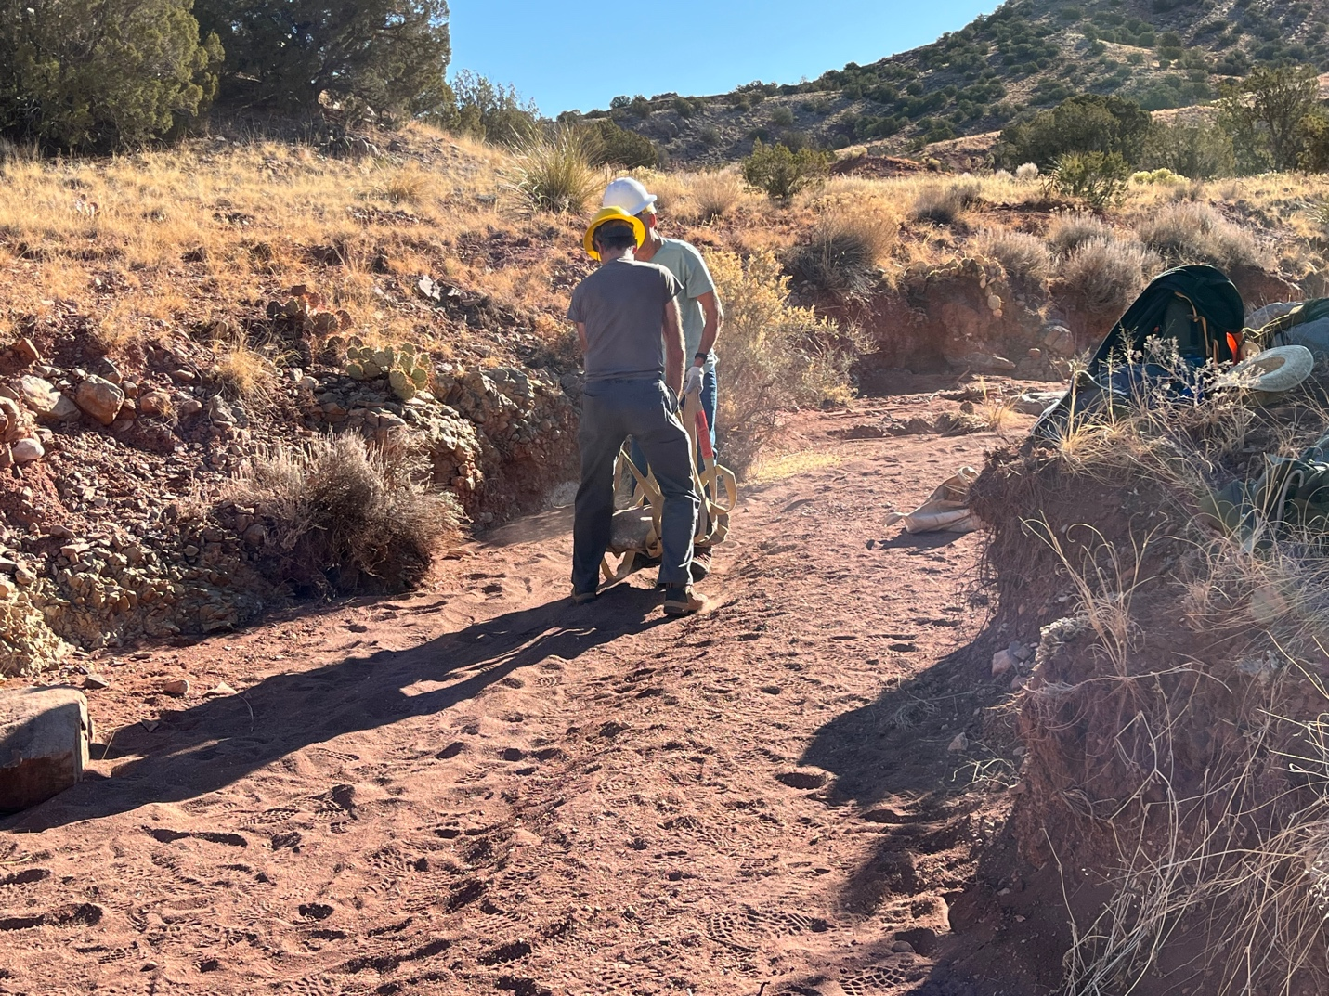

Roland and Andy hefting along.

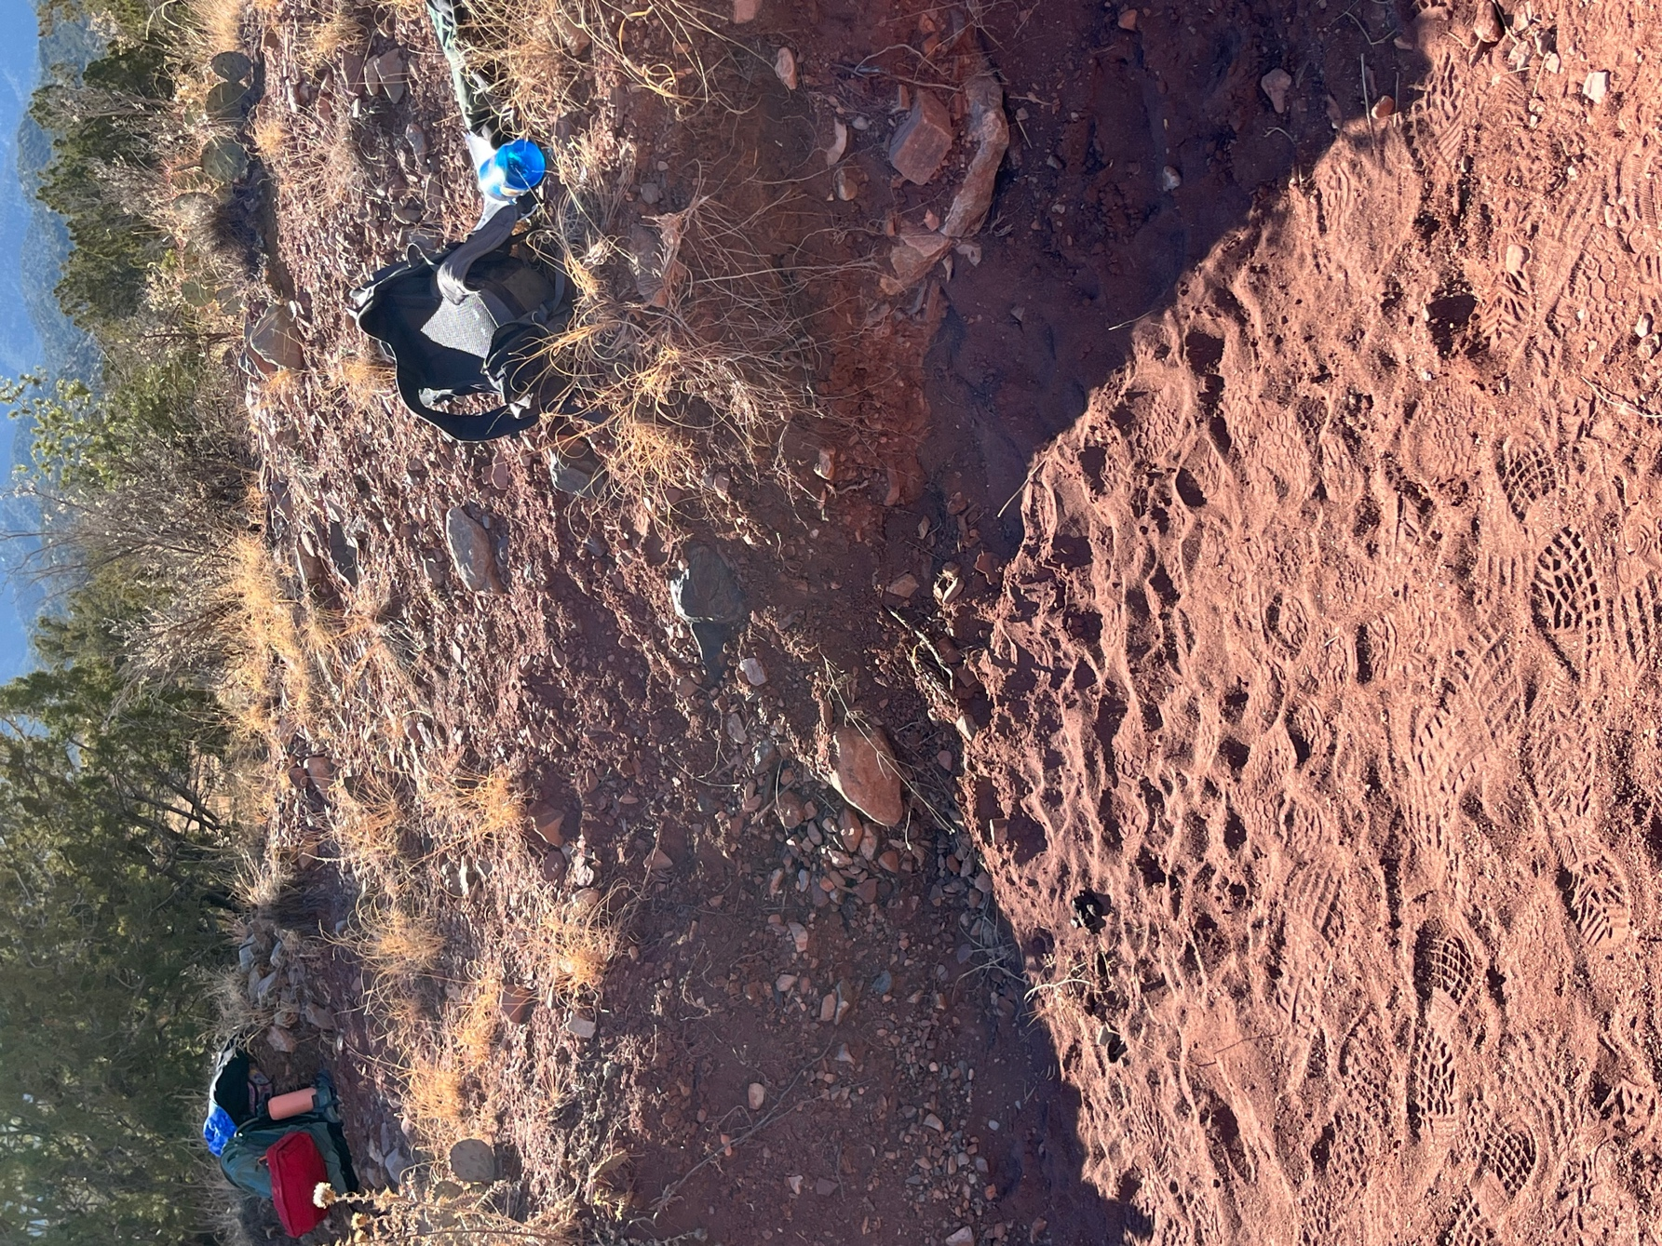

This is a before shot of one of the erosion areas that was walled.

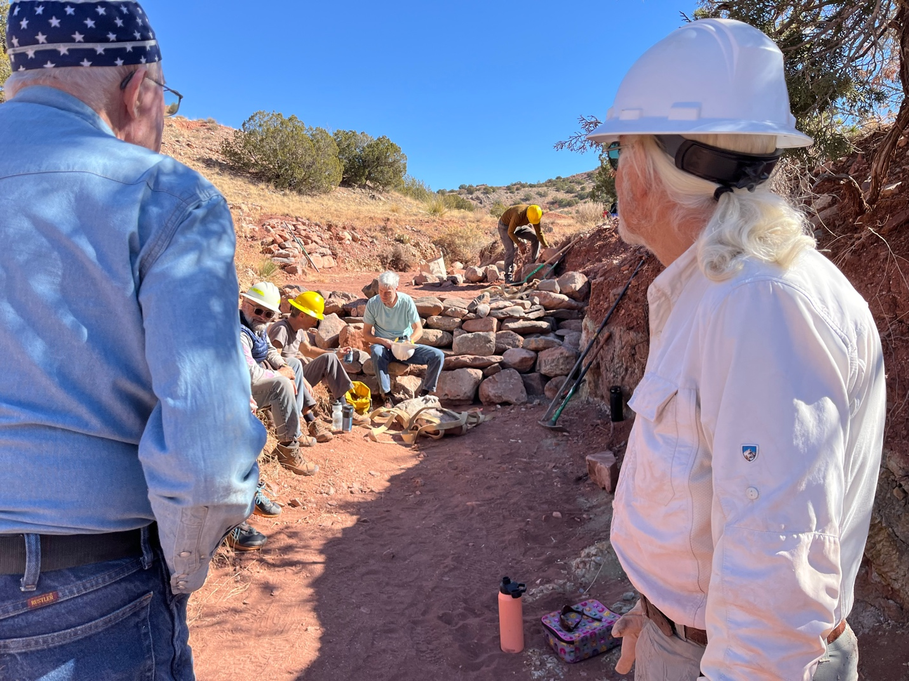

Taking a well-earned lunch break. Eric M. is trying to make everyone look bad by being the first to get up and at it again. There’s always someone….

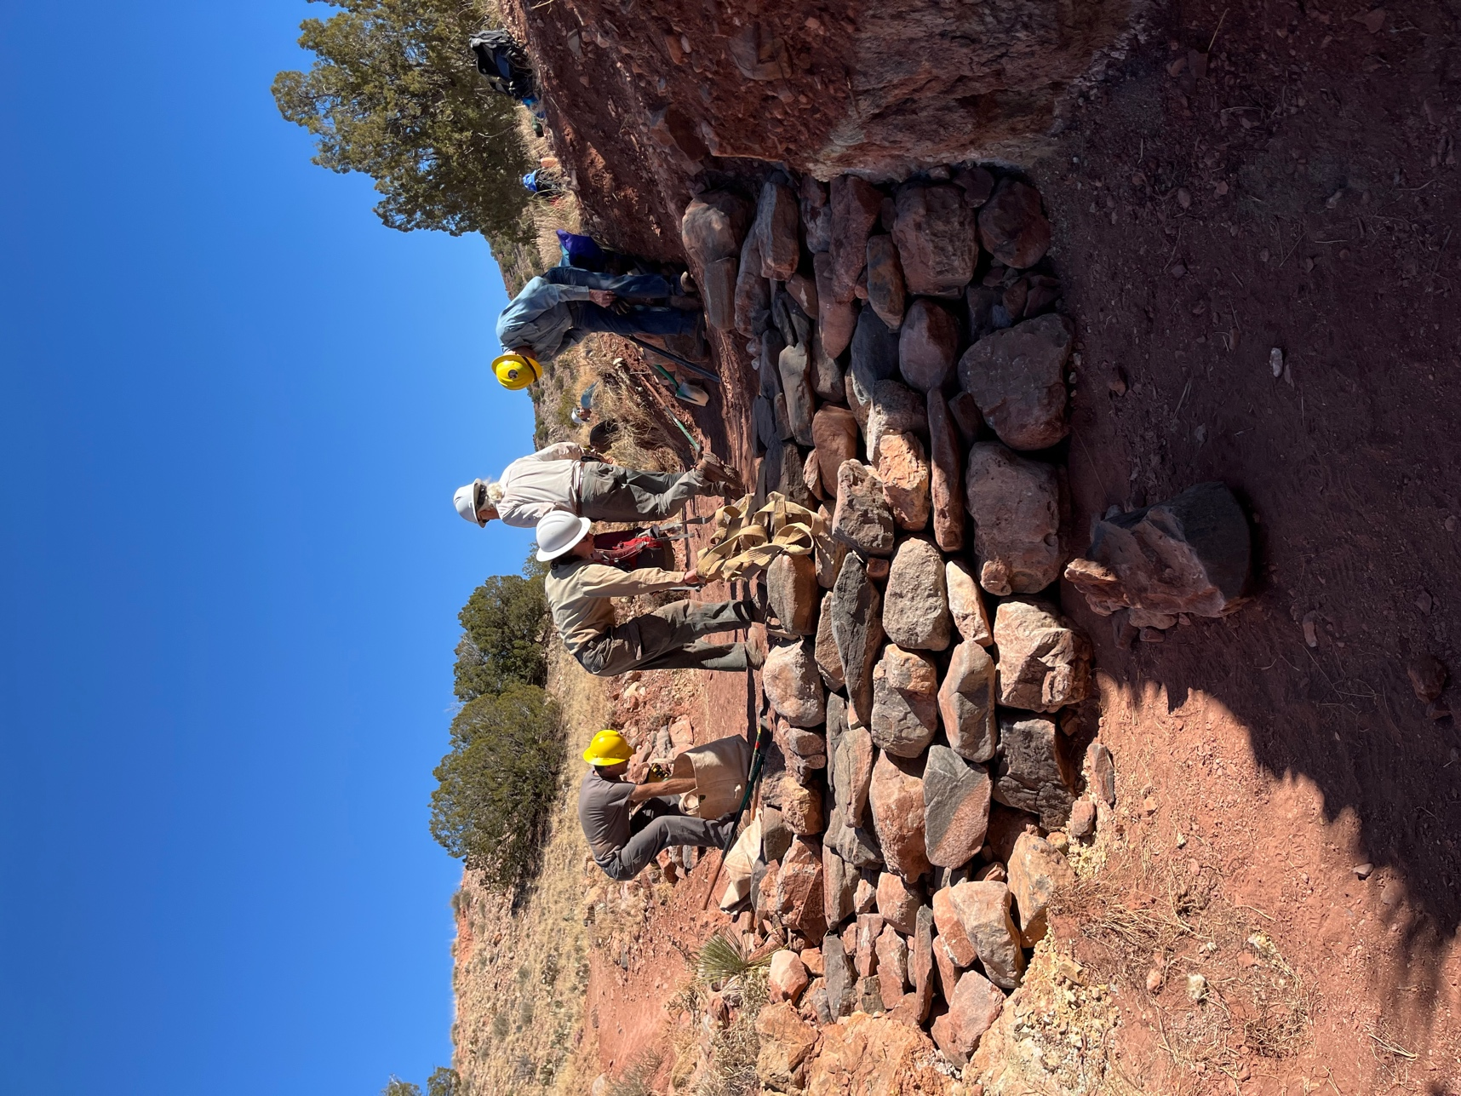

Hard to see all the detail but there is a small wall on the right where Eric R. is standing, another larger wall behind Roland on the left and another layer of wall almost finished in the middle. We still need to finish up the sides and top layer of this wall next week but everyone was ready to stop for the day.

