Thursday, 02/13/25- Chalk Dust: We were back on Chalk Dust in Placitas on Thursday, moving rocks and creating walls. Nine volunteers and Jen (SRD) finished the rock work started a week earlier. Once that job was done, we made about a 2-mile hike around Chalk Dust, Strip Mine and Side Track replacing signage and replacing a bend sign post. It was a perfect day with just a slight breeze kicking up in the afternoon.

Volunteers: Rich Fagioli, Jim Houle, Andy Ruddle, Roland Stumpf, John Braly,
Eric Russell, Bill Perkins, Eric Messerschmidt and Laura Leon
Pictures: Laura Leon

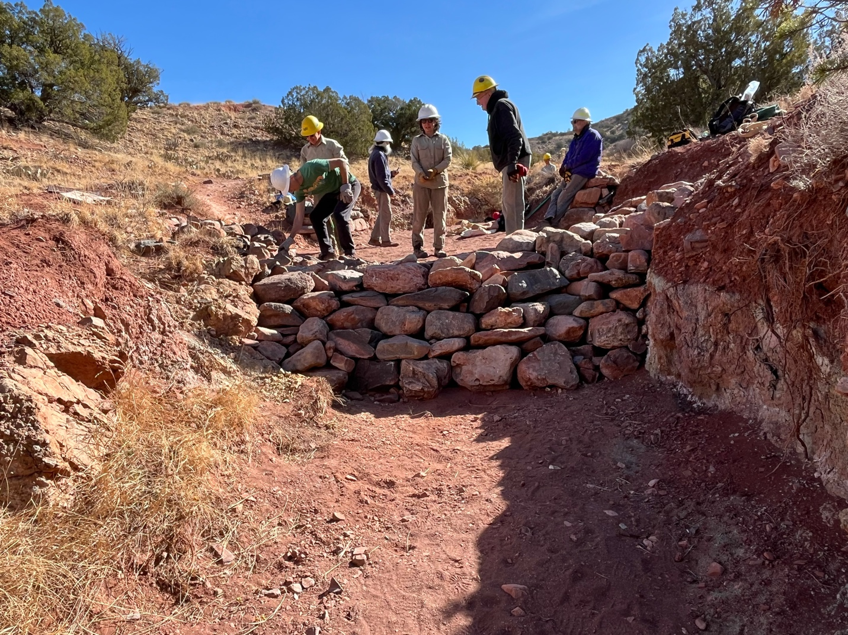

Finishing up rock work where the gabion was.

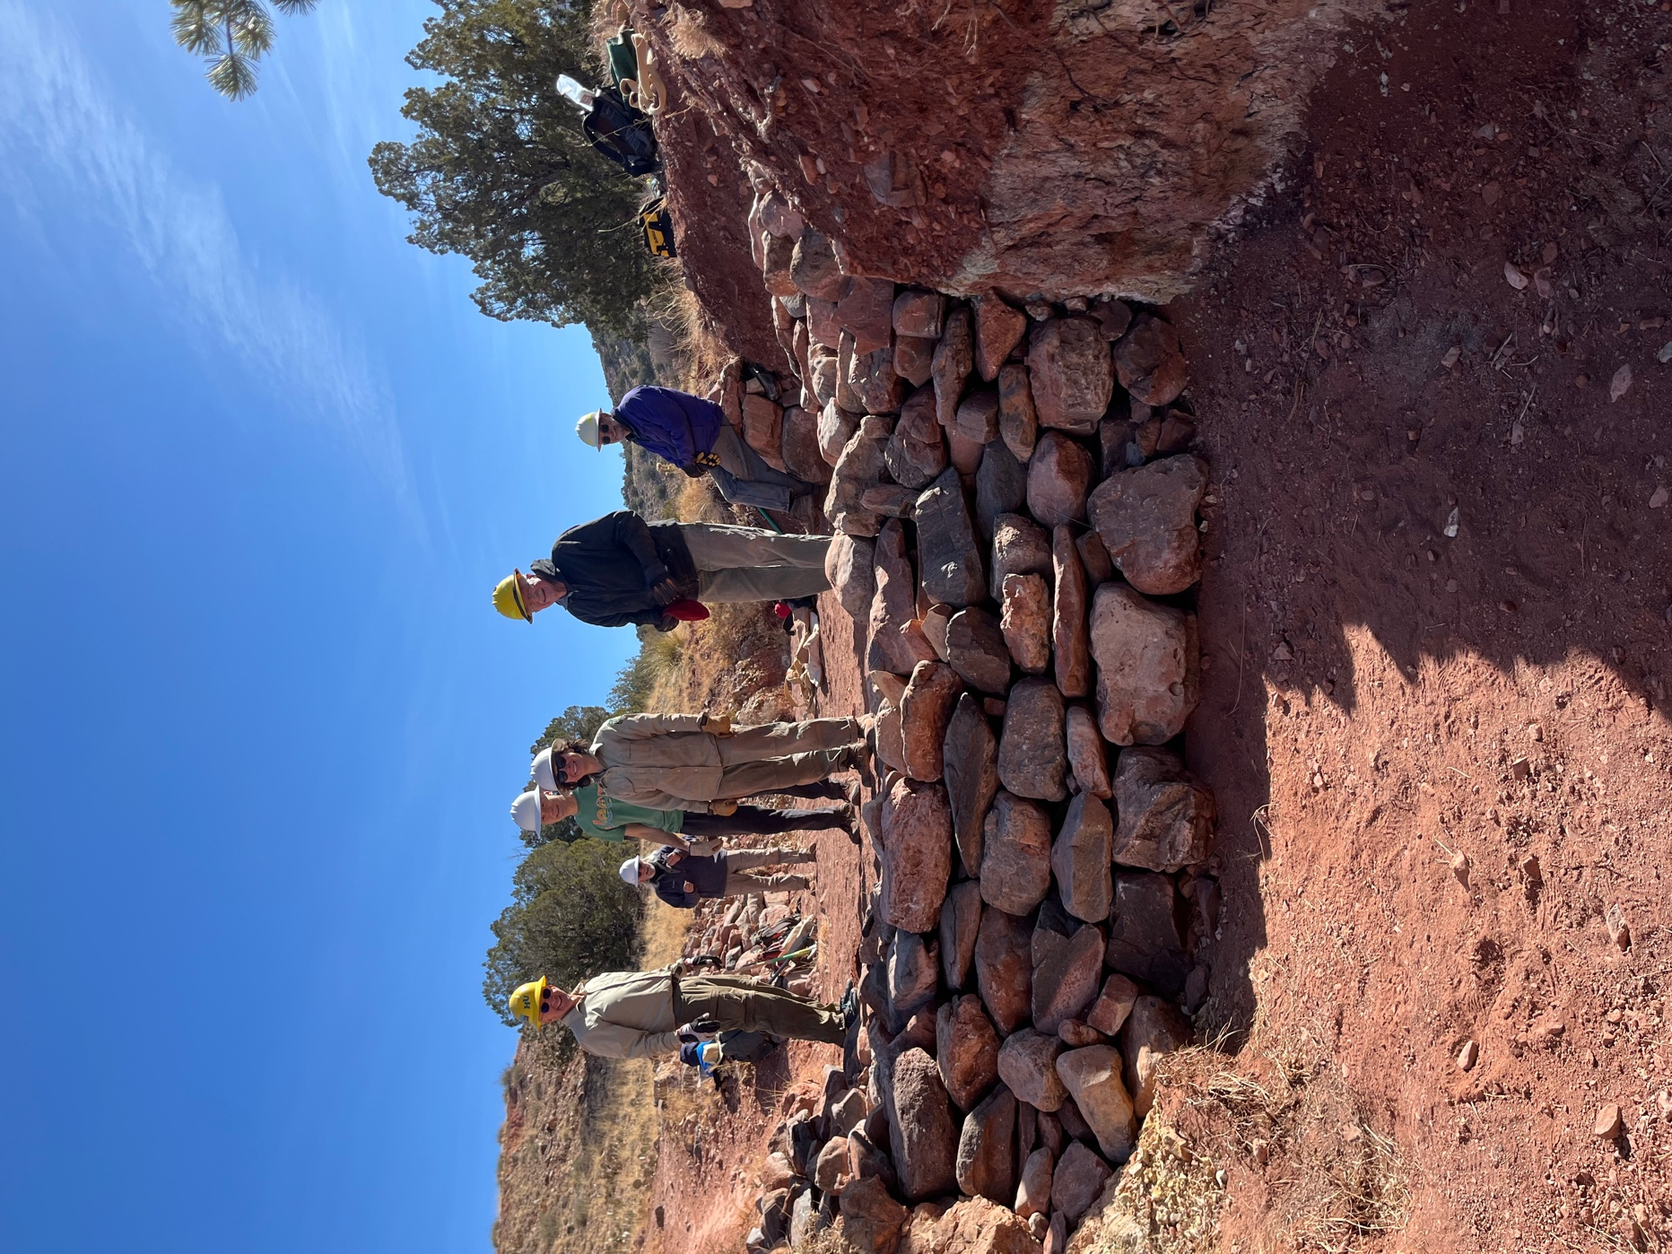

Everyone is all smiles – (left to right) John, Bill, Andy, Jen, Eric R. and Jim.

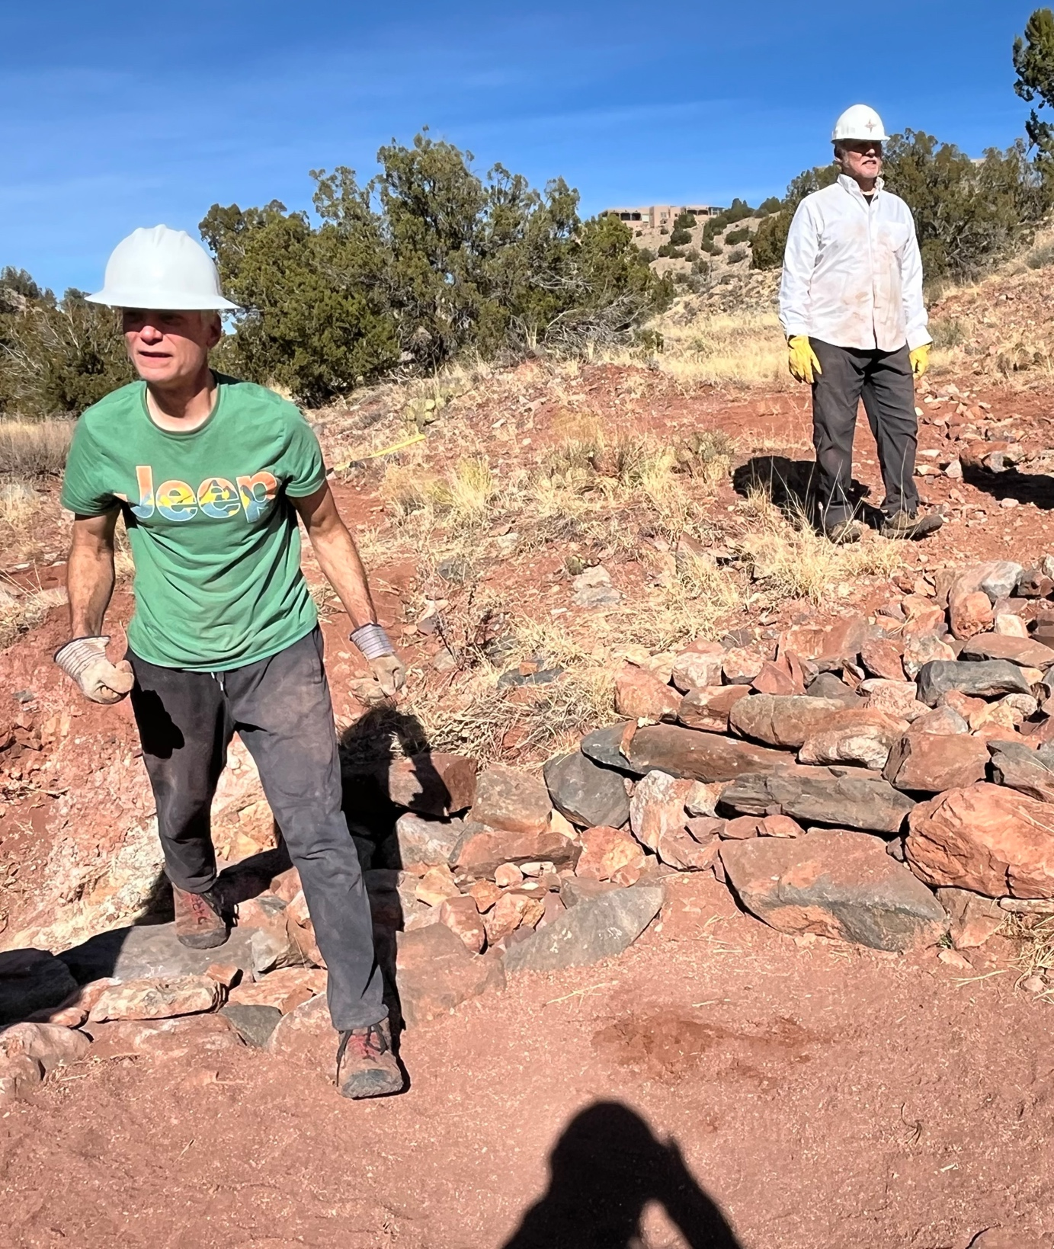

Andy and Rich stand on rock work leading into the arroyo- on the left side if you are below looking up. Please excuse the creepy shadow.
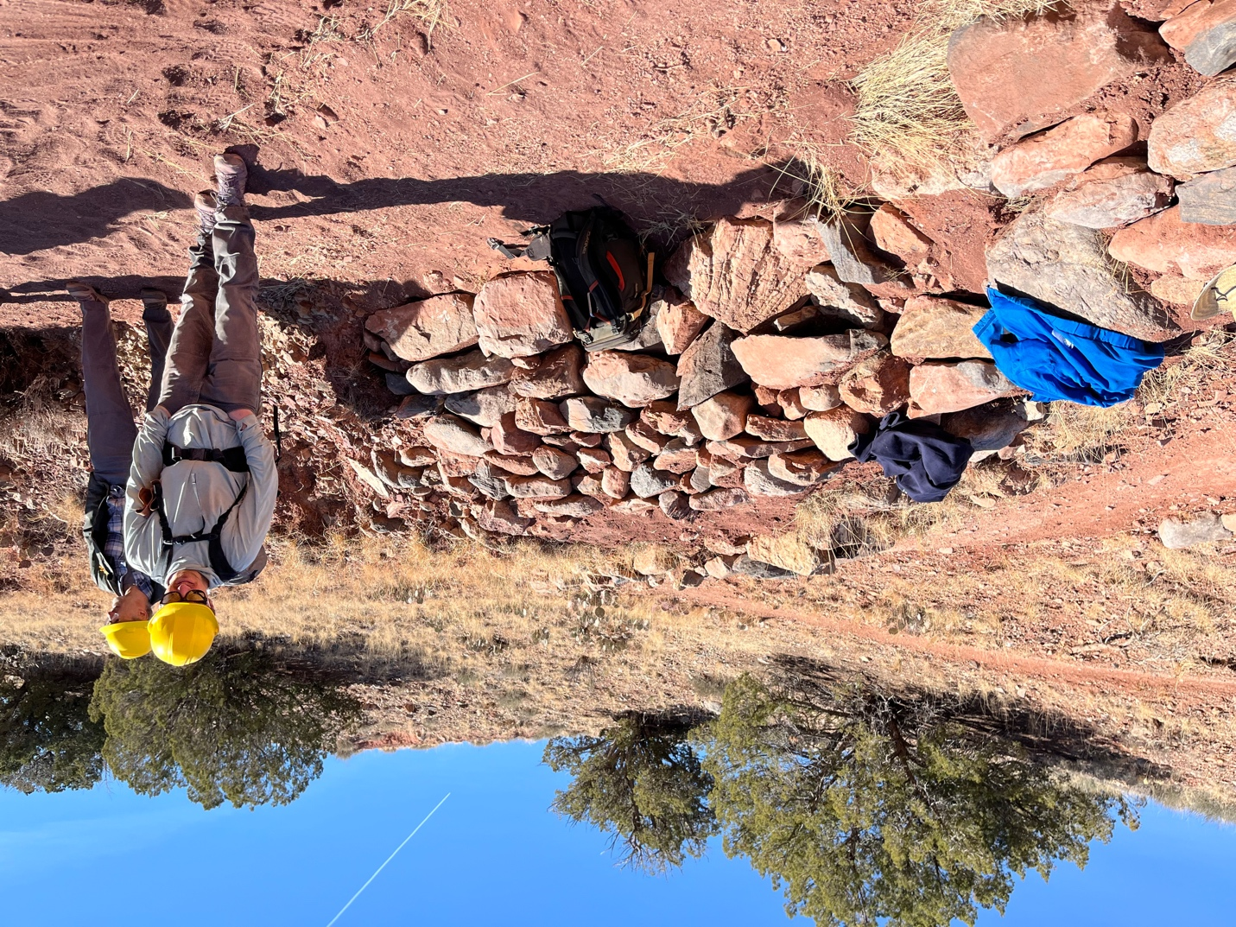

This is the rock work farther up from where Andy and Rich were standing in the last photo.

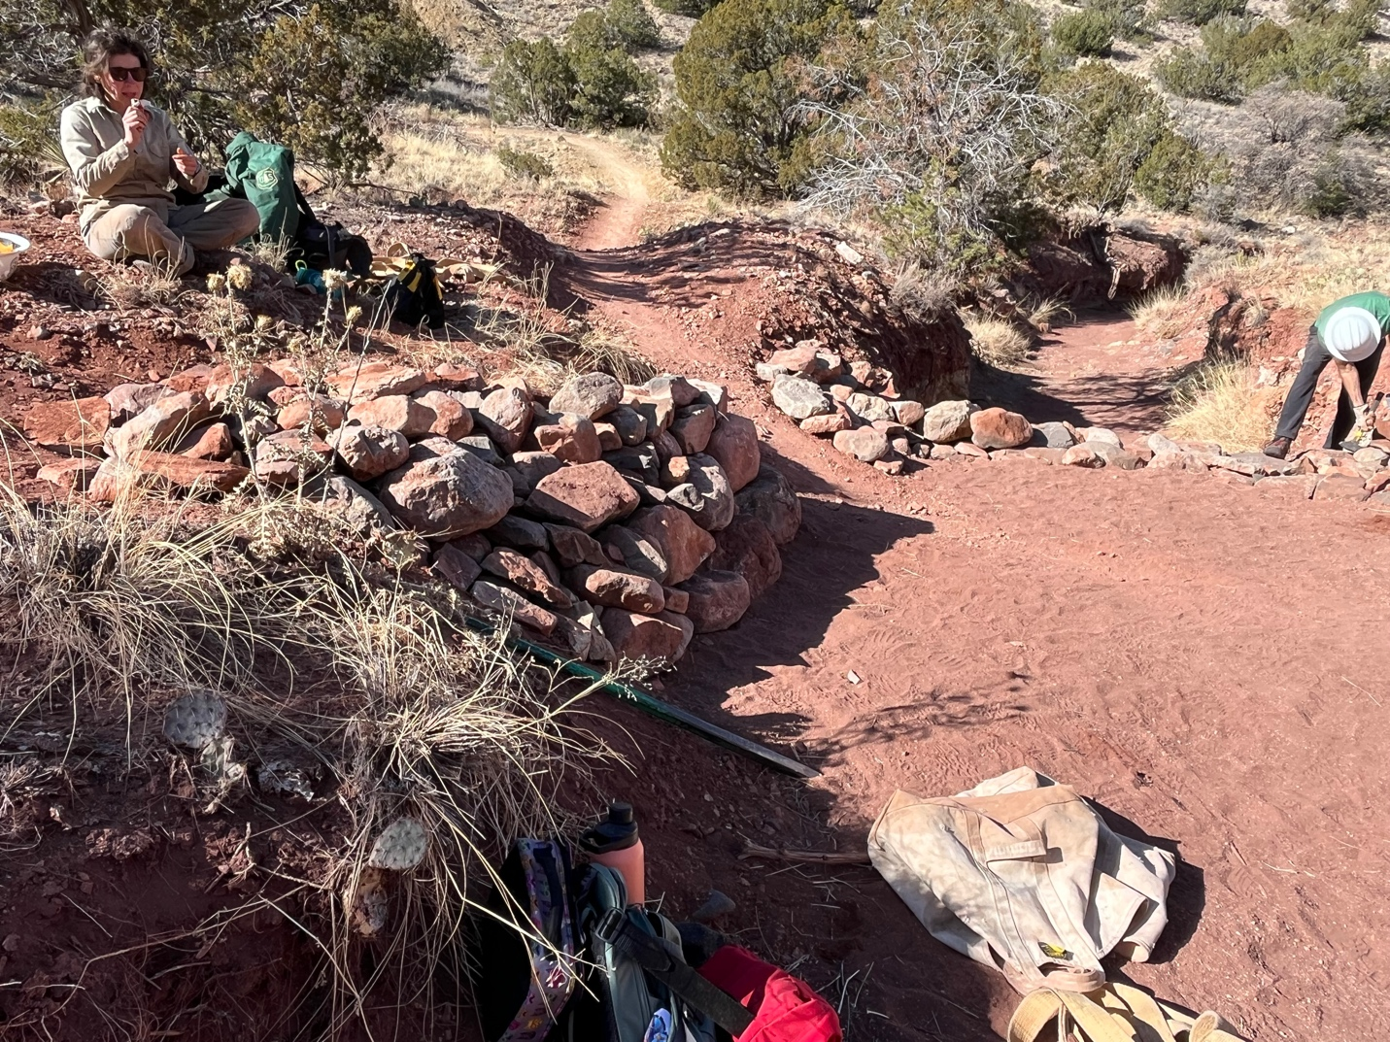

And this is the rock work on the right side of the arroyo if you are standing down below. We are really hoping this all lasts for a while….

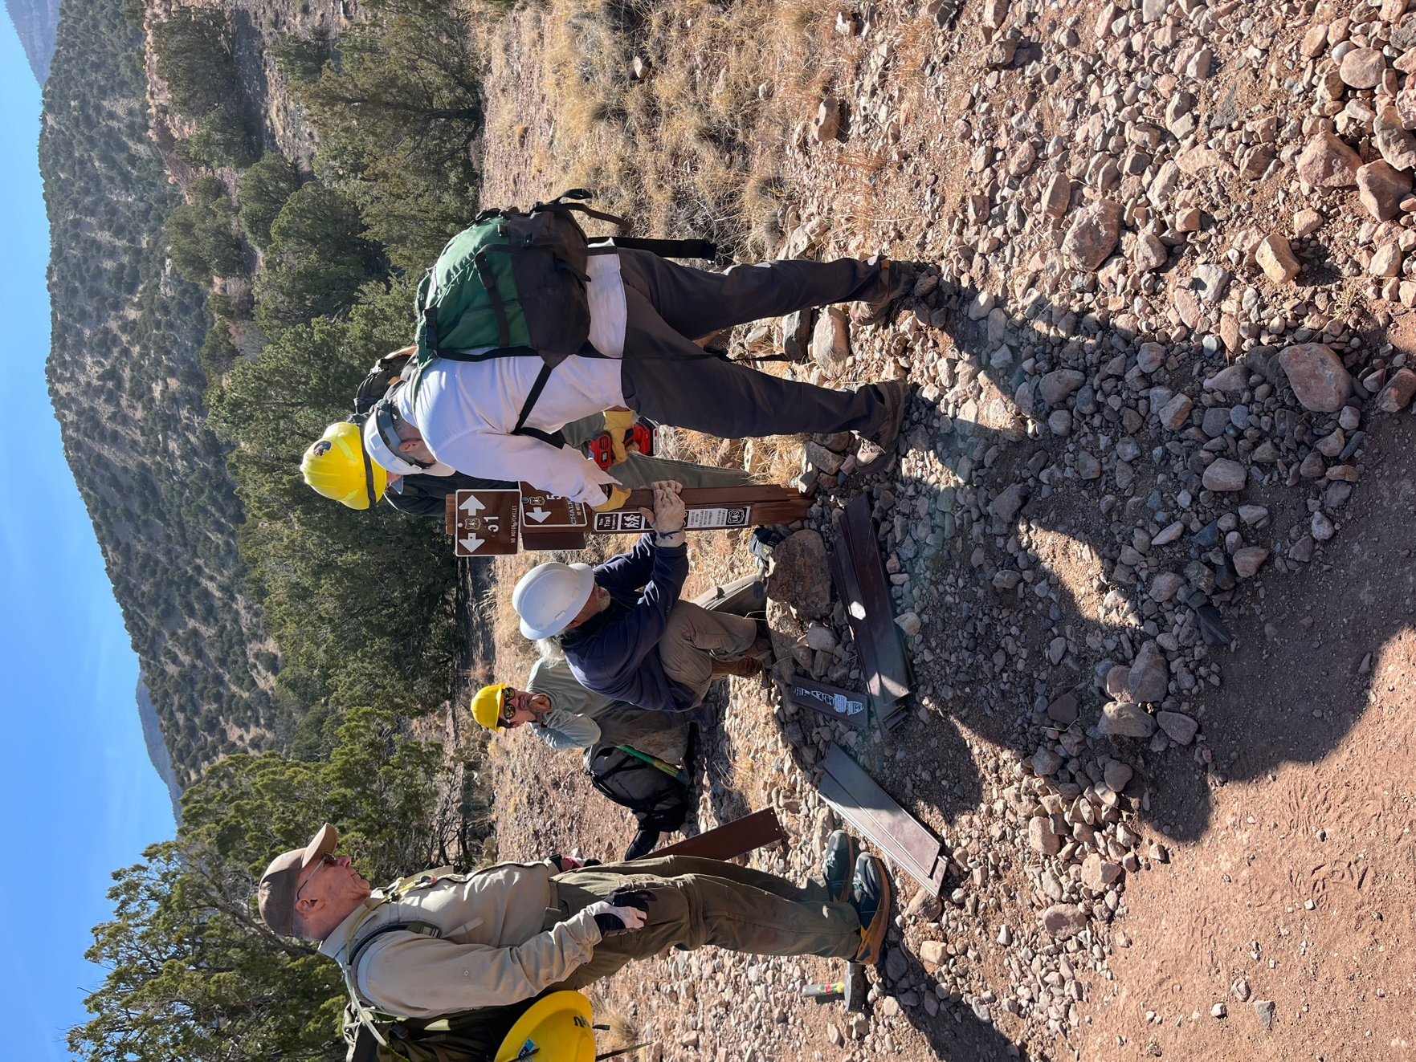

How many FOSM volunteers does it take to unscrew and sign and re-screw on a new one??? Left to right- John, Eric M., Bill, Eric R. and Rich.

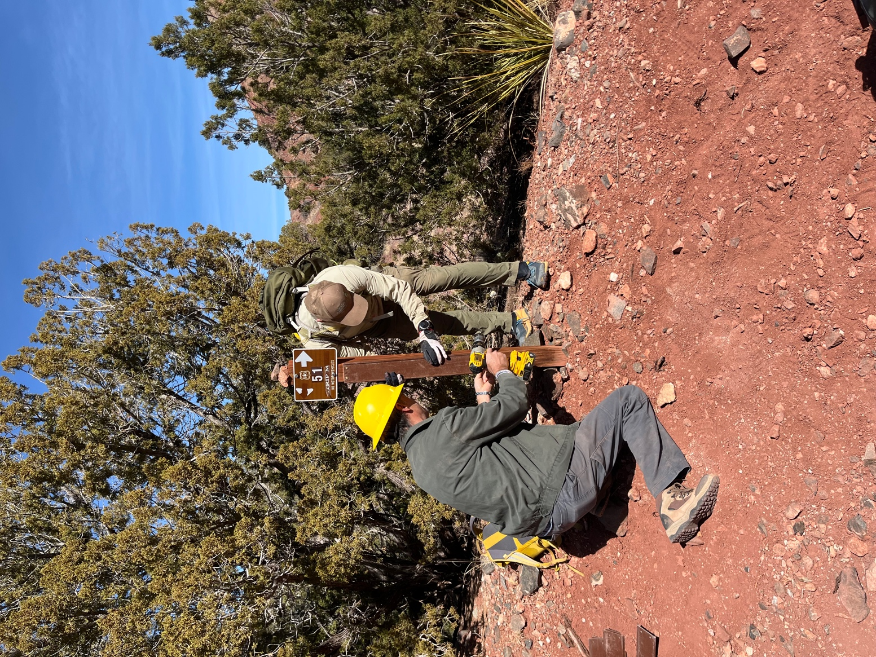

We got into a system where one group unscrewed and replaced the fiberglass piece and second group leapfrogged and did the same on the next sign. Laura came behind with cleaner and a new decal. Roland and John worked well together except for occasionally needing a referee. There was some smack talk on Roland’s part- big surprise.

