Trail Maintenance Report: Monday, February 10, 2025
Byron Garner

Our project February 10 was to clear five trees reported by Paul Karas on Survey (4) and 10K North ( 1) ranging in size from six to thirteen inches. With a crew of eleven, it was decided to split into two crews and "leapfrog" the Survey trees that were not far apart. Starting from Ellis trail head, we hiked on ice and crusty snow, crossing the highway and soon encountered our first unreported tree hanging high above the trail which required a bit of limbing but was otherwise stable with adequate clearance. Further on we find a double leaner, one of which was stable enough to leave and the second requiring a carefully placed rope and some judicial sawing. Meanwhile, the first crew continued on to the first reported and largest tree of the day (13 in) and limbed that in preparation for the crosscut crew to follow. The forward crew hiked on to clear the remaining three Survey trees. After catching up to us, the crosscut crew continued on to clear the 10K North tree a short distance beyond the junction with Survey. Some minor brushing and intrusion cutback was also done. By lunch time the wind had shifted unfavorably and the snow was softening adding challenge to the hike out. In spite of the trail conditions, we had a productive day and can report Survey clear. Our crew included Paul Karas, Phil Cromer, Dave McCreery, Rav Nicholson, Silke Bletzer, John Cooper, Bill Perkins, Chuck Logan, Steve Roholt, Jen Medina-Grey USFS and Byron Garner. Photos: Silke Bletzer, Paul Karas and Byron Garner

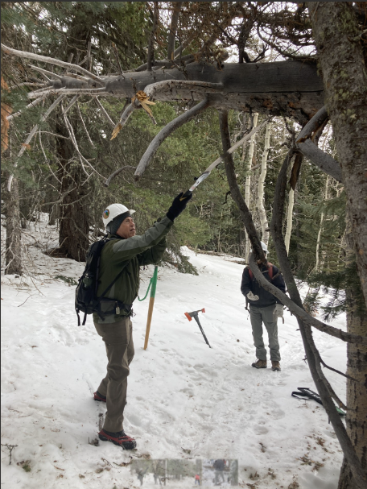Bletzer
John Limbs the high overhang

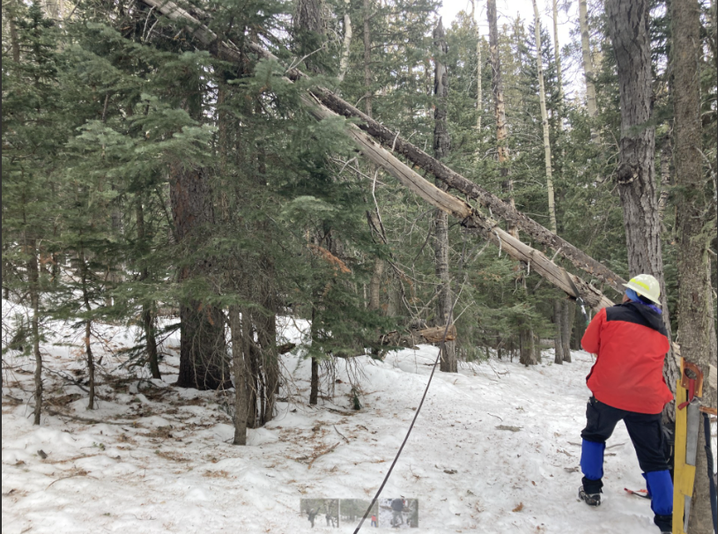Bletzer
Dave on the first cut of the double leaner

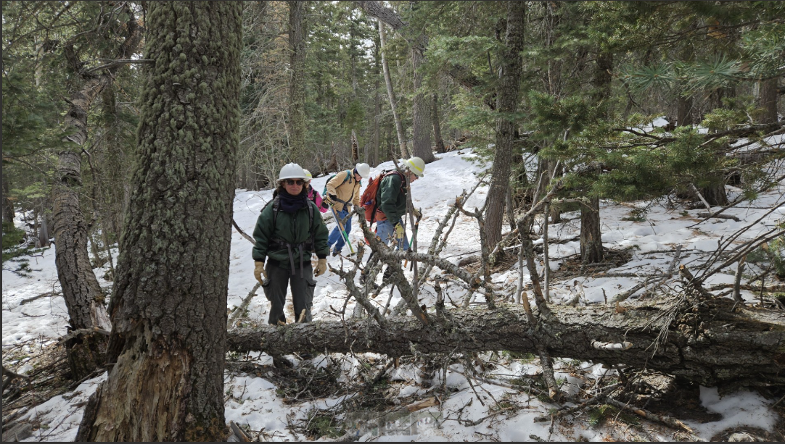
Karas
Let the limbing begin

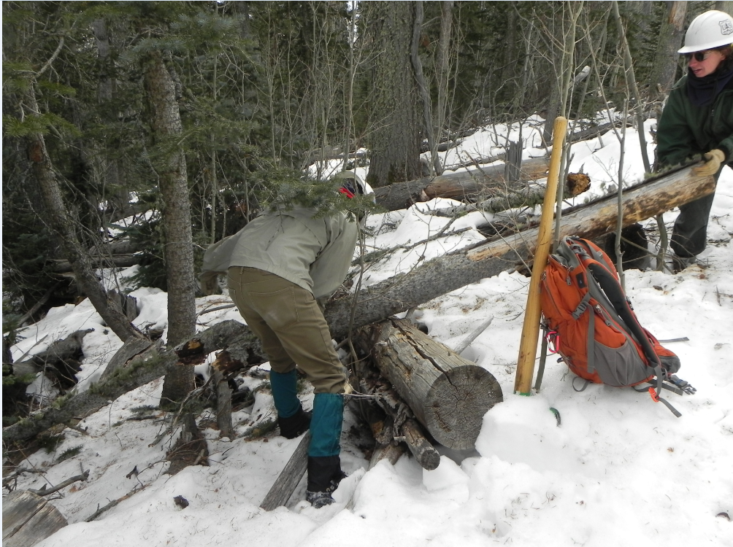

Paul and Jen put on the final touches

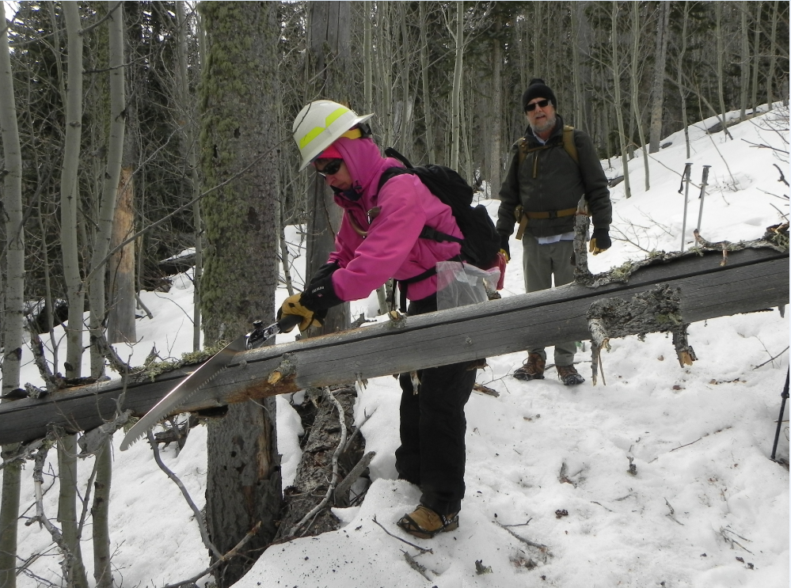
Rav warms up the Katana

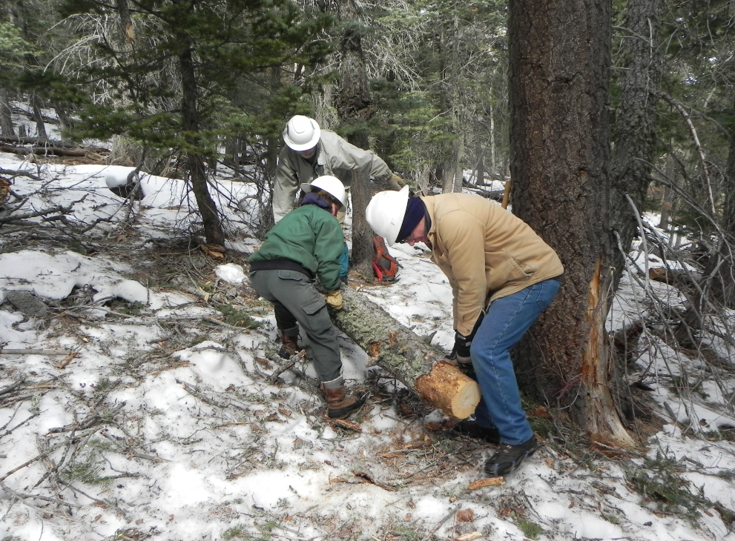

Jen, Paul and Chuck clear the way

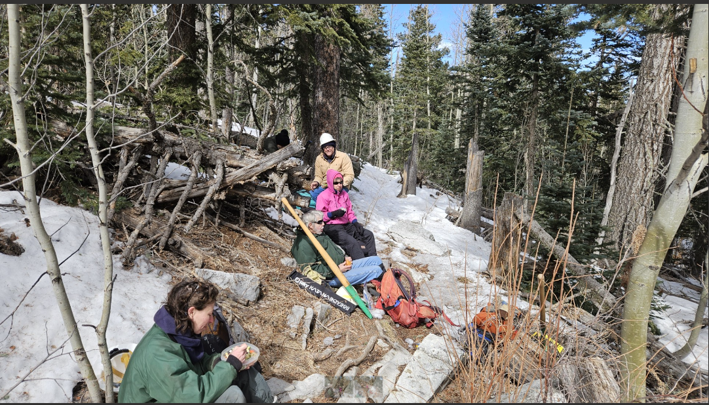Karas
An unexpected oasis of warmth for lunch

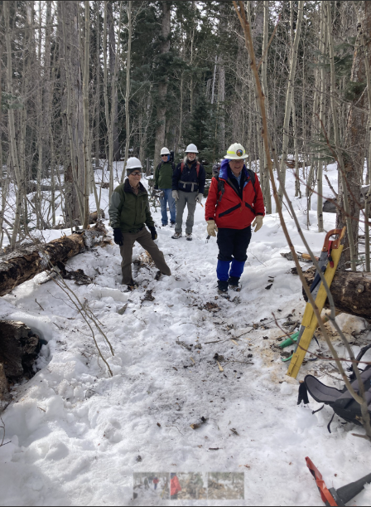Bletzer
The crosscut team John, Steve, Bill, Dave and Silke with camera

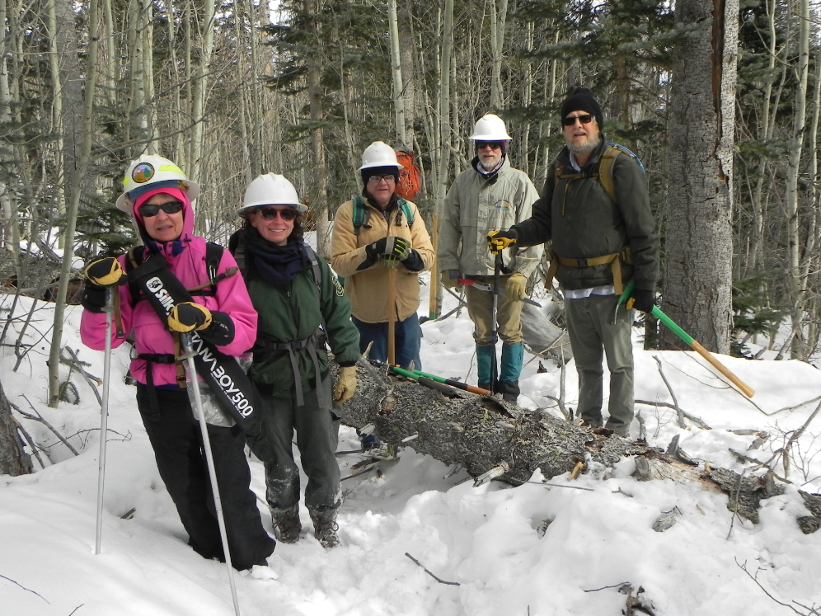
Team one: Rav, Jen, Chuck, Paul and Phil

