Report of FOSM Project to Remove Graffiti from the Juan Tabo Picnic Area

CCC Shelter on Saturday, February 22, 2025

Sam Beard

On Saturday, February 22, Sim Cook and Sam Beard removed three large graffiti tags and four smaller tags from the walls and floor of the Juan Tabo Picnic Area CCC shelter. Large orange tags were on the stones above the fire place in the southwest corner, and a large red tag was on the stones in the northwest corner. A large charcoal tag was on the floor, and four small orange tags were on walls and a window sill.

Sim and Sam used the World’s Best Graffiti Removal System chemical for stone and mortar to remove the painted tags. After the gray residue was washed off the stones with water, some orange and red color remained, but it was not as visible to the volunteers as the amount that is shown in the photos.

Sam and Sim did not find any other tags on the exterior of the shelter, nearby boulders, or on the adjacent restroom.

Project photos are presented below.

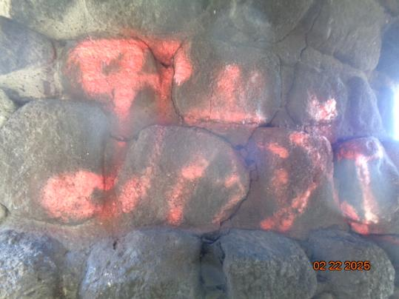

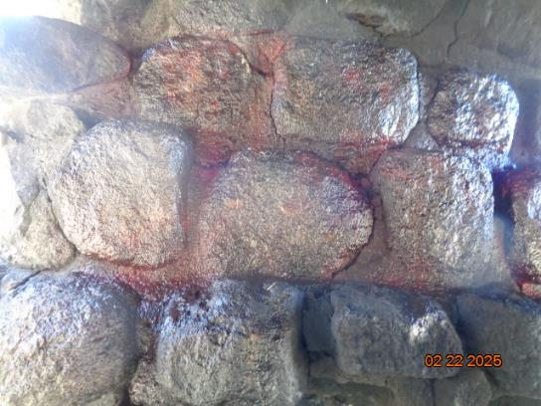

Top – Orange graffiti on stones above the fire place in the southwest corner of the

Juan Tabo Picnic Area CCC shelter. Bottom – Stones after most of the tag was removed. The

photo shows more remaining paint than was visible to the volunteers. All photos by Sam Beard

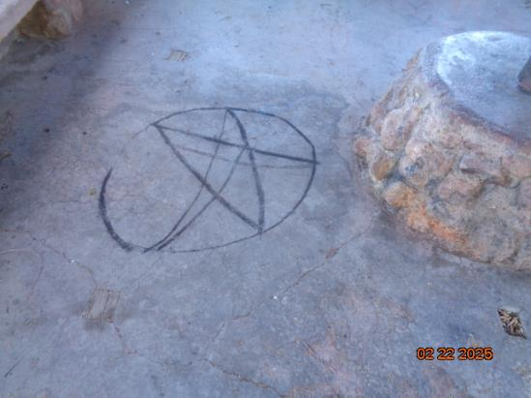

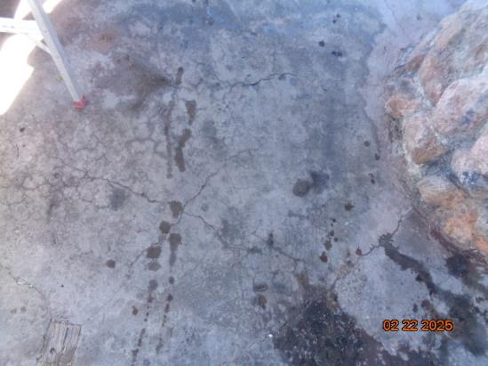

Top – Charcoal tag on the shelter floor. Bottom – Floor after the charcoal was removed

with water.

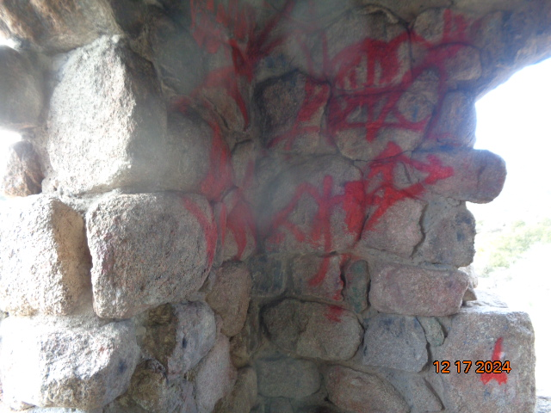

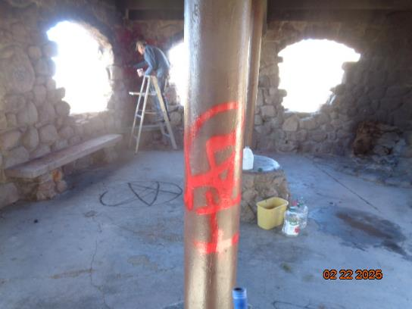

Top – Red graffiti tag in the northwest corner of the shelter. Bottom - Interior of shelter

showing Sim Cook applying graffiti removal chemical on stones with red tags.

Sim returned on Sunday and painted over the red tag on the post with brown paint.

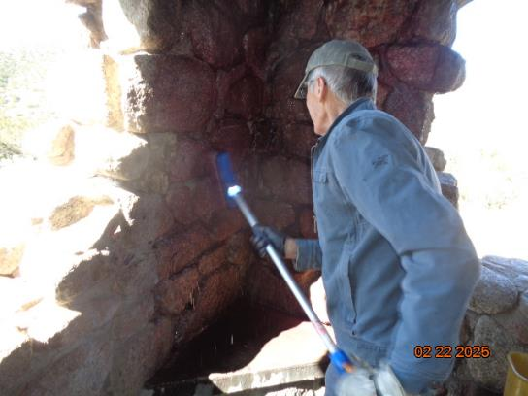

Sim using a mop and water to remove the gray chemical and graffiti residue in the northwest corner.