Thursday, 02/27/25- North Faulty: Out of the western foothills and rocks and back to the easter side of the mountain and soil! North Faulty aka North Mystery Trail was the focus of work on Thursday. Eleven volunteers met Jen (SRD) at the pullout parking area just past Doc Long and hiked up, up, up the trail about a half a mile to the first reroute section. Another cold start led to another beautiful day. We need the rain but the working conditions have been beautiful. A few areas of the new trail were still frozen but the group made good progress. As the group snaked upwards, the slope became more pronounced and the section that will be our starting place next week will be a challenge due to slope, rock and snow.

Volunteers: Bruce Hansche, Jim Houle, Claudia Bergsohn, Roland Stumpf,
John Braly, Eric Messerschmidt, Larry Larrichio, Luis Cuadros, Rich Fagioli,
Bill Perkins and Laura Leon
Pictures: Bruce Hansche and Laura Leon

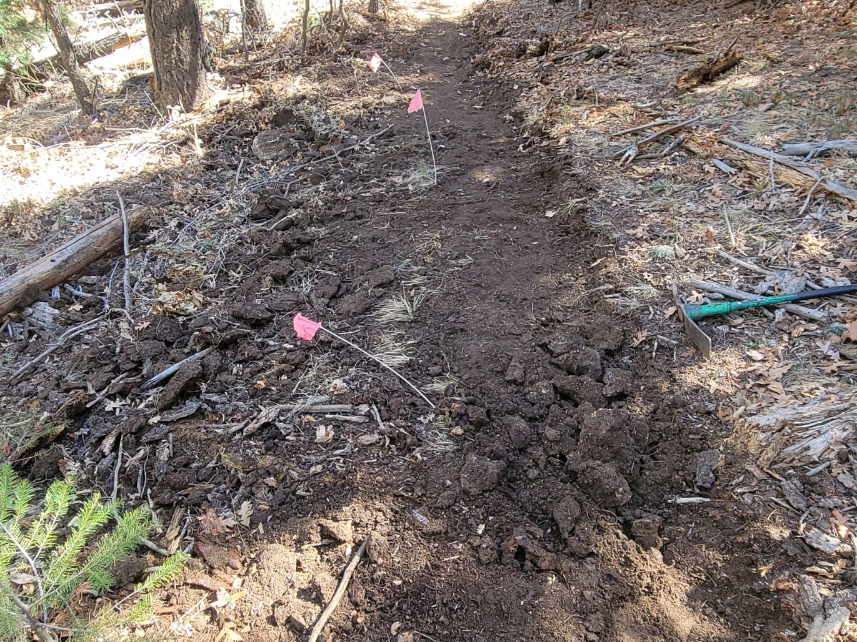

Most of the soil was great for working but every now and then there was some still frozen.
The chain gang gets started:

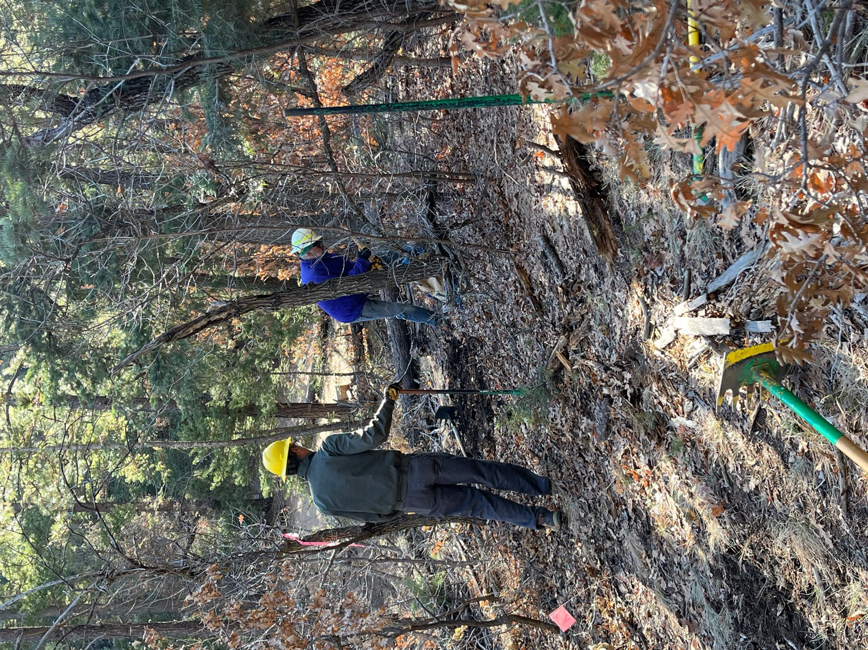

Roland and Jim

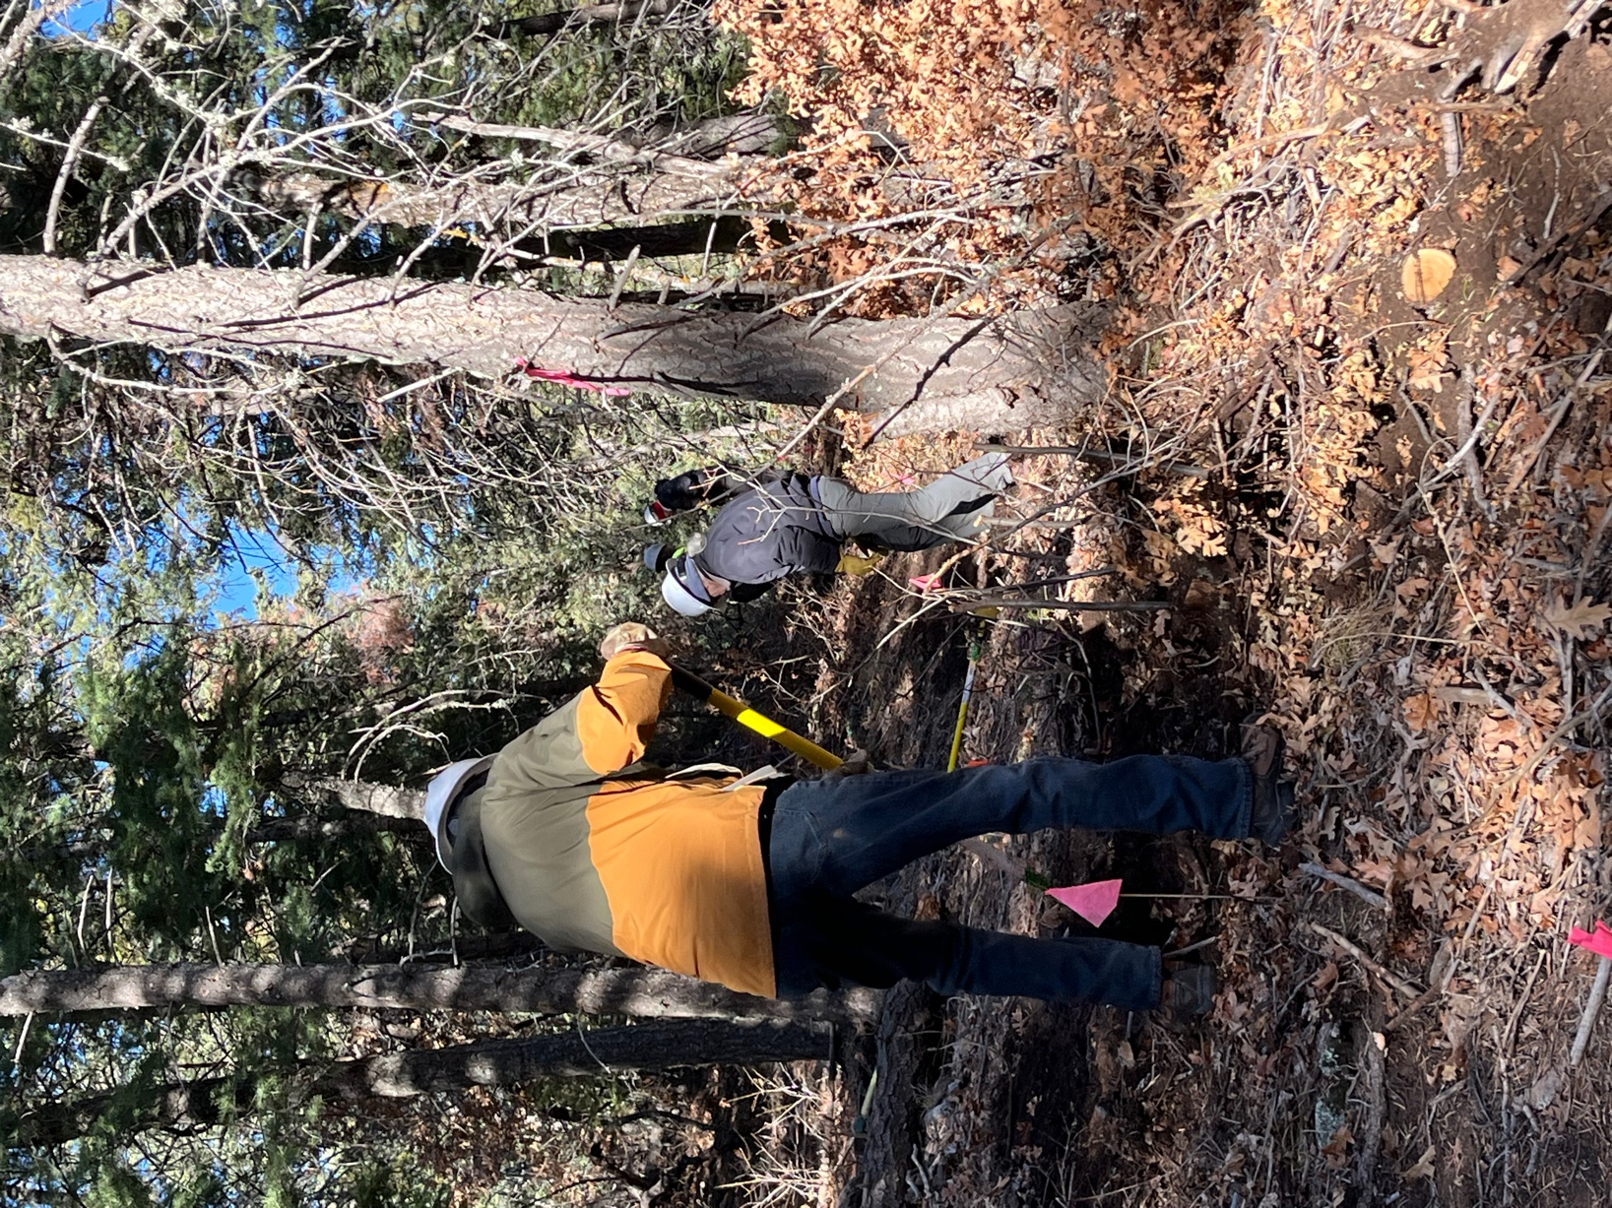

Bruce and Bill

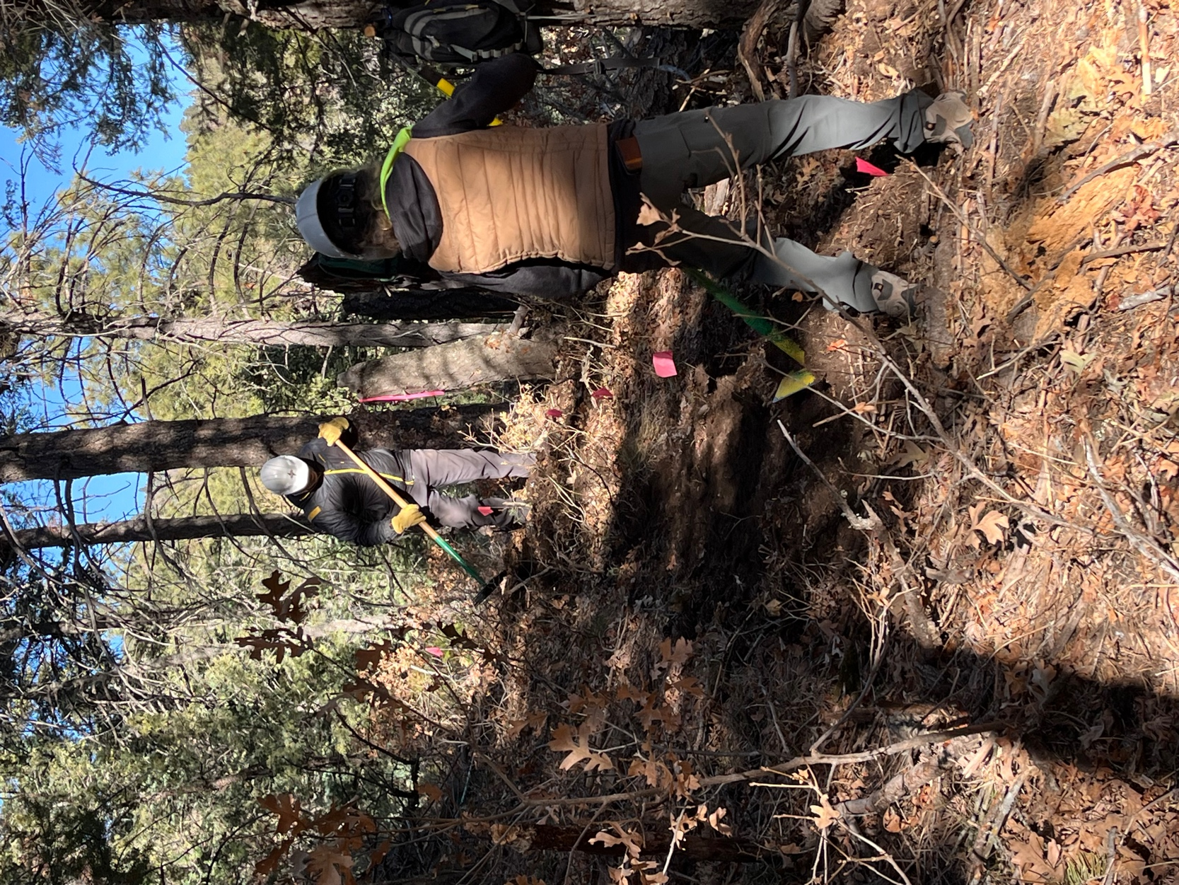

Claudia and Rich

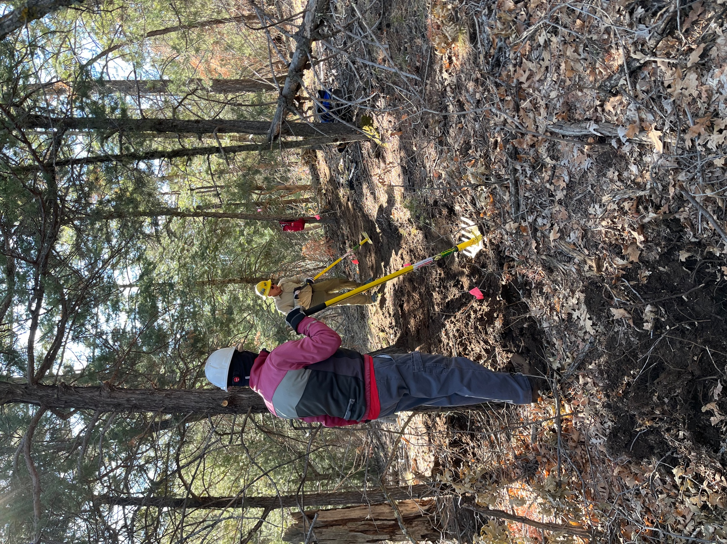

Larry and John

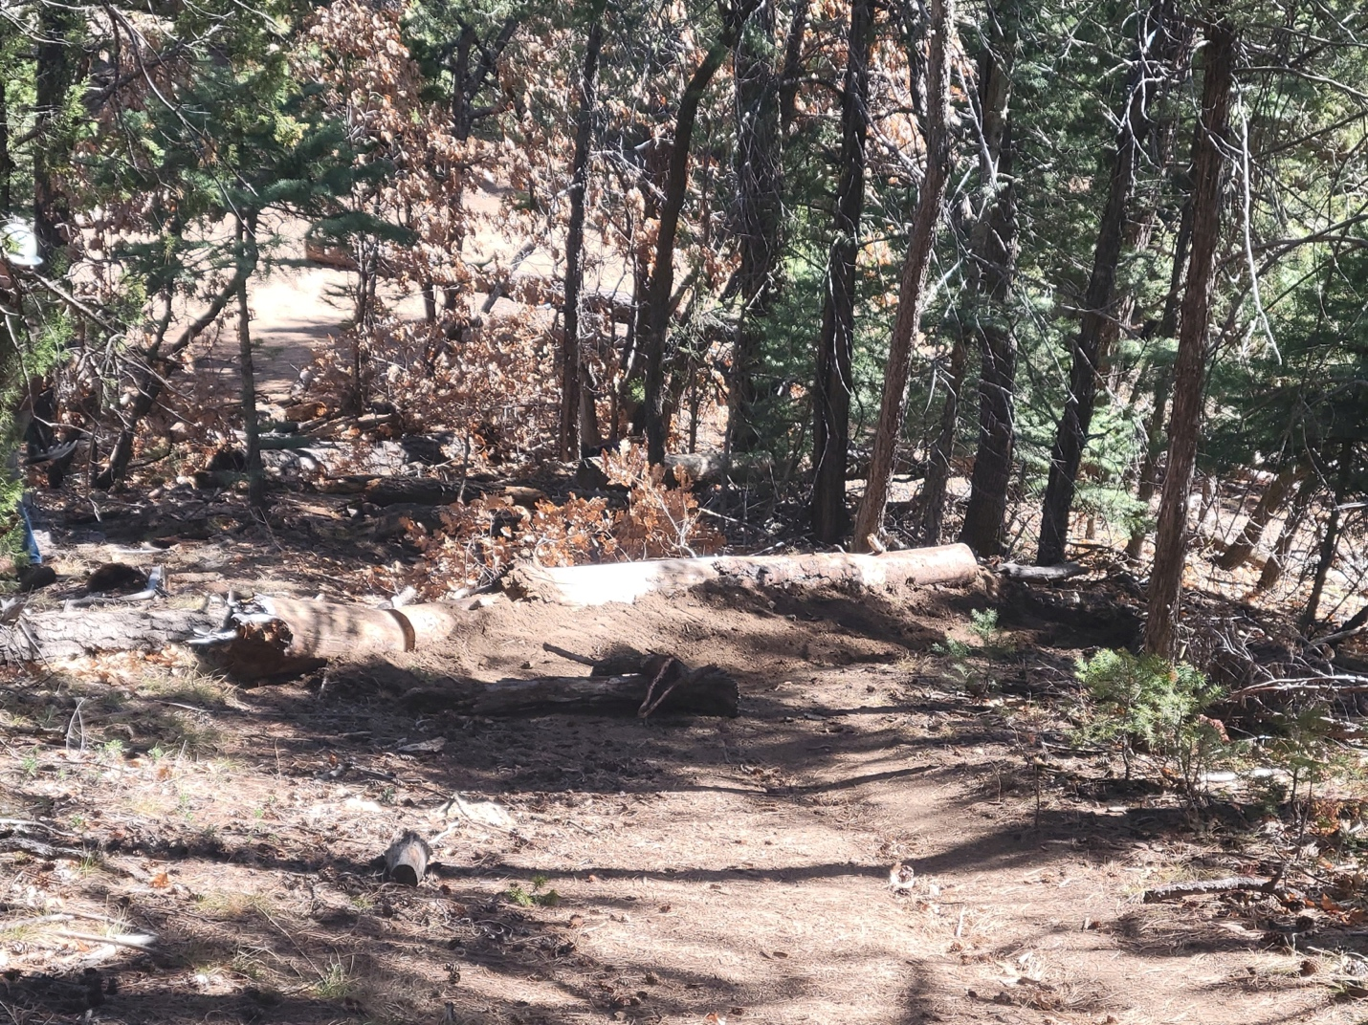

Starting to obliterate and create some check dams on the old trail.

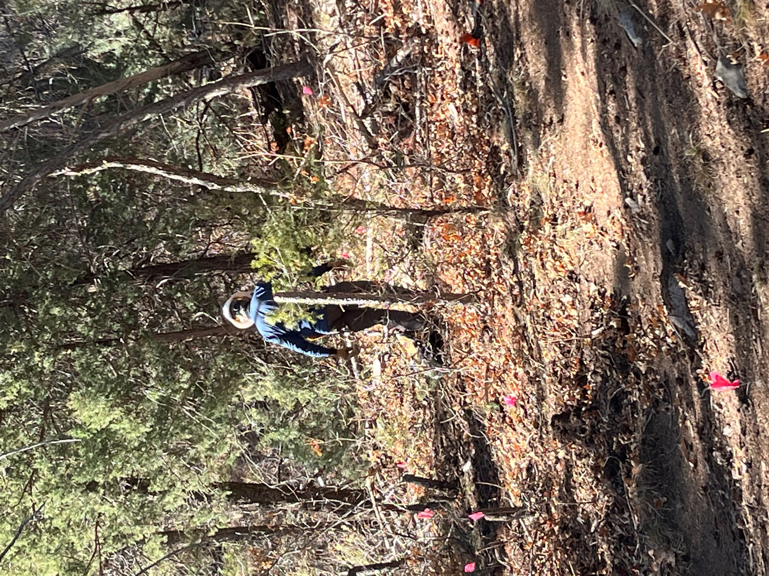

Luis clears debris before digging new trail.

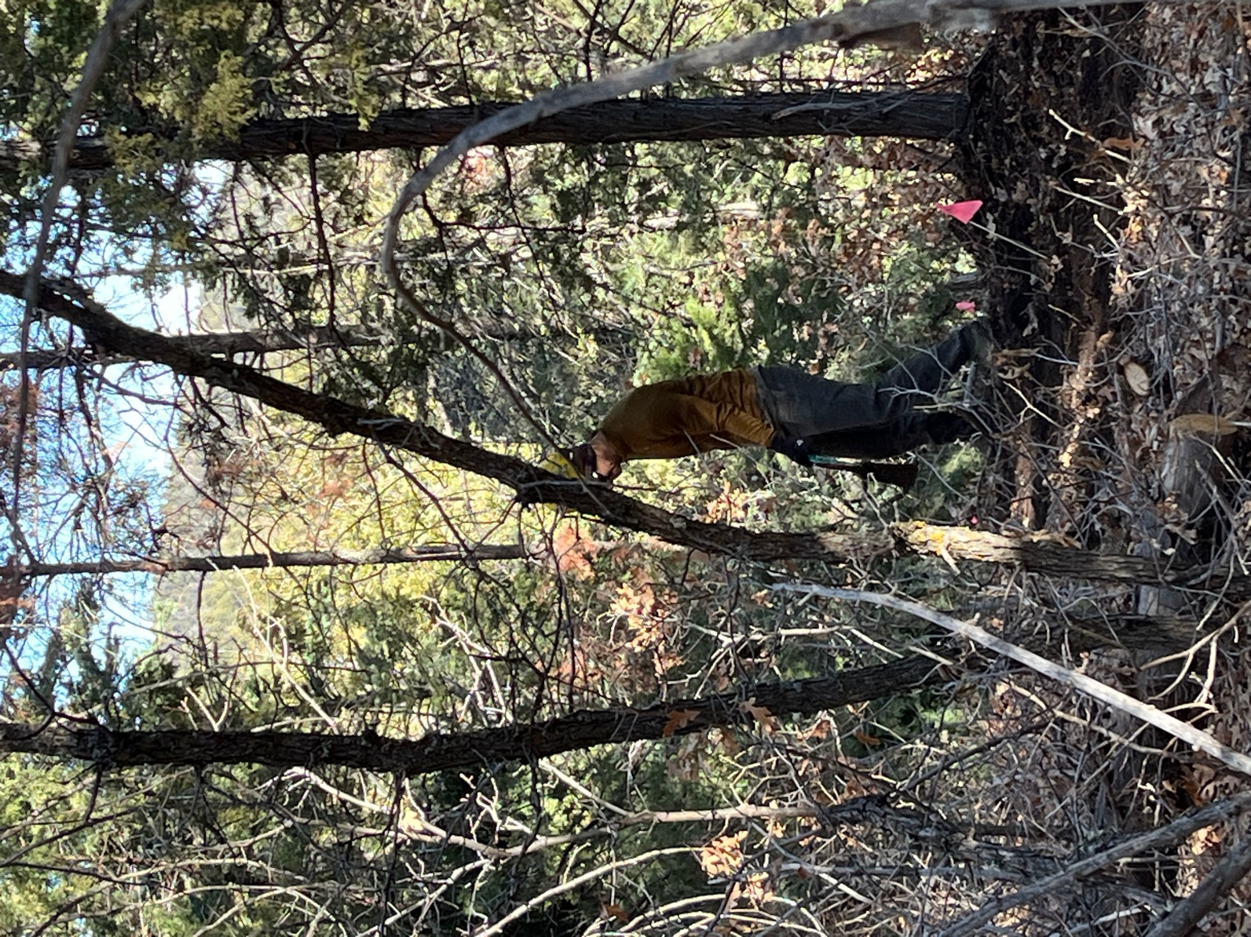

Eric M. works a curve.
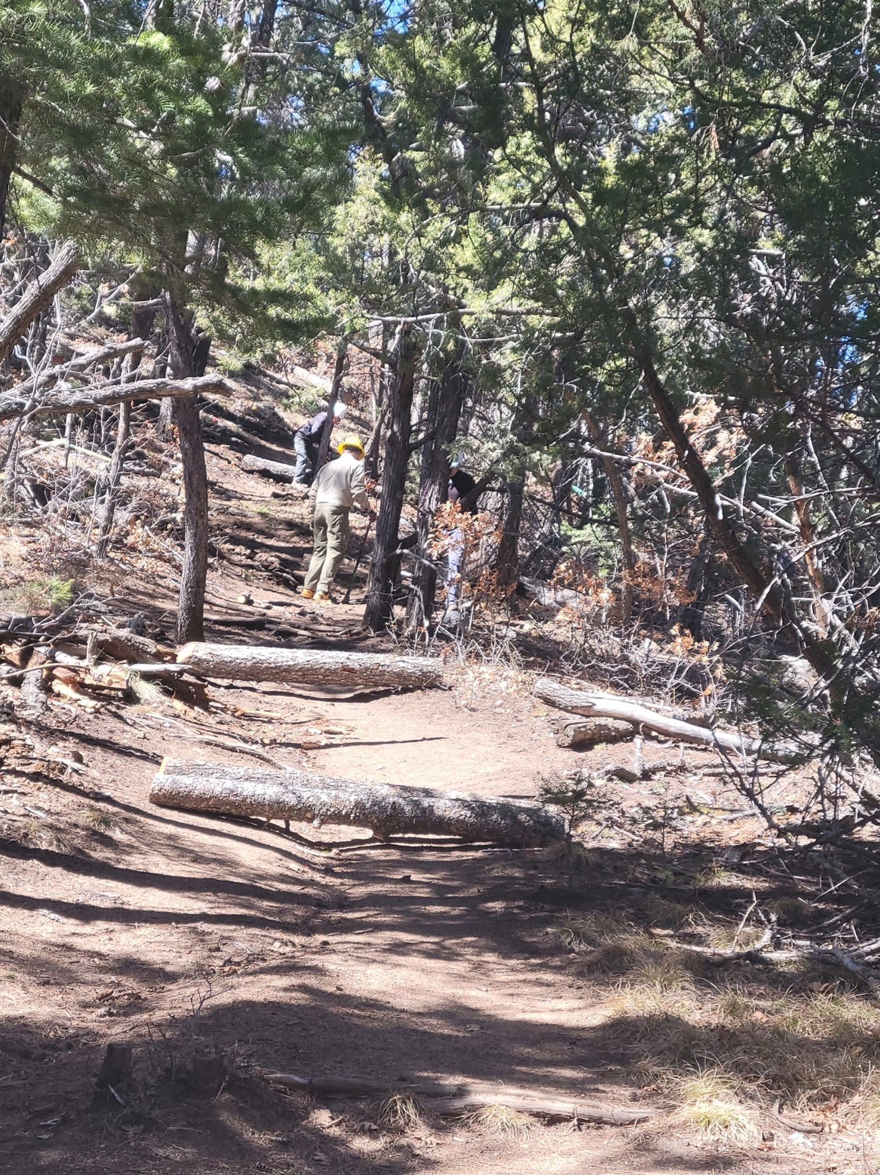

Old trail- trying to stop the erosion with check dams.

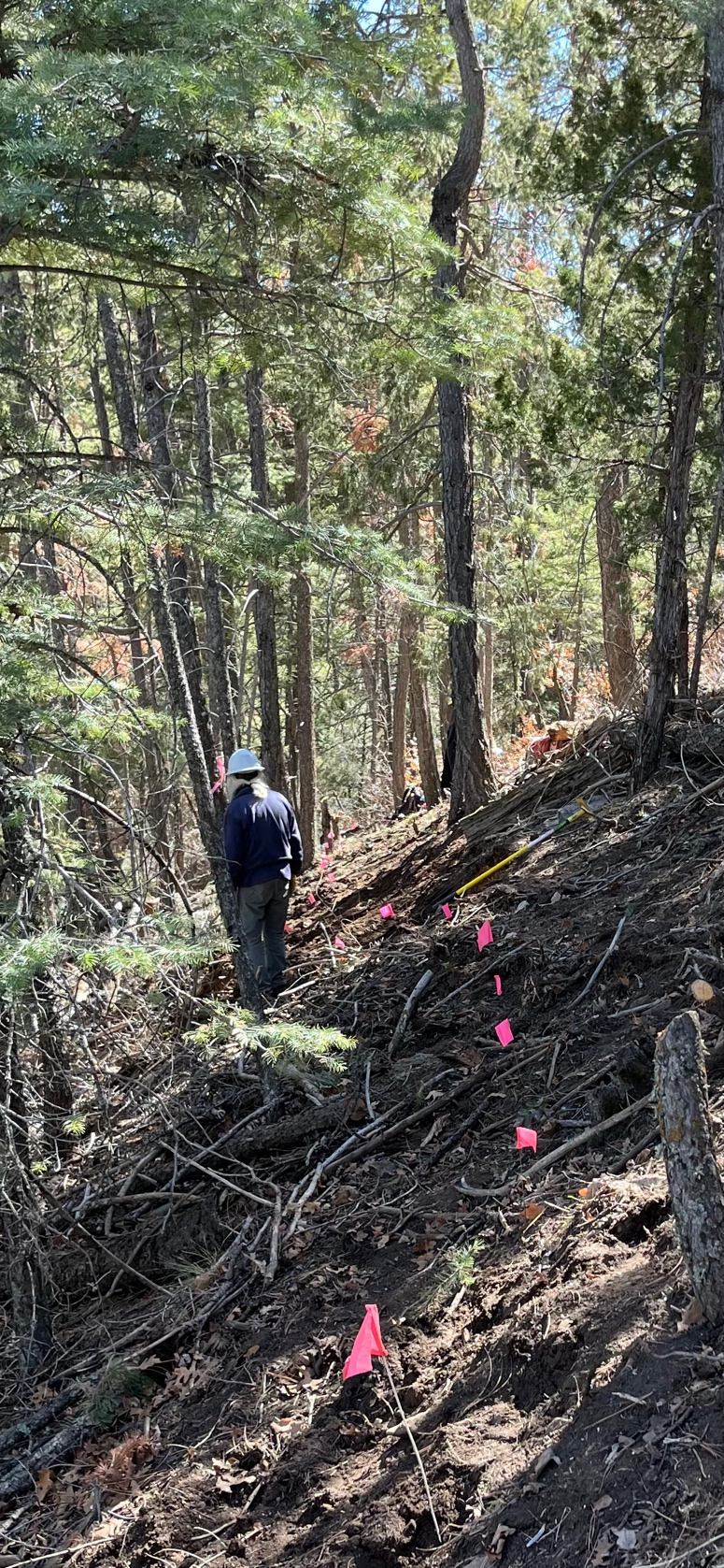

The higher the trail, the steeper the slope.

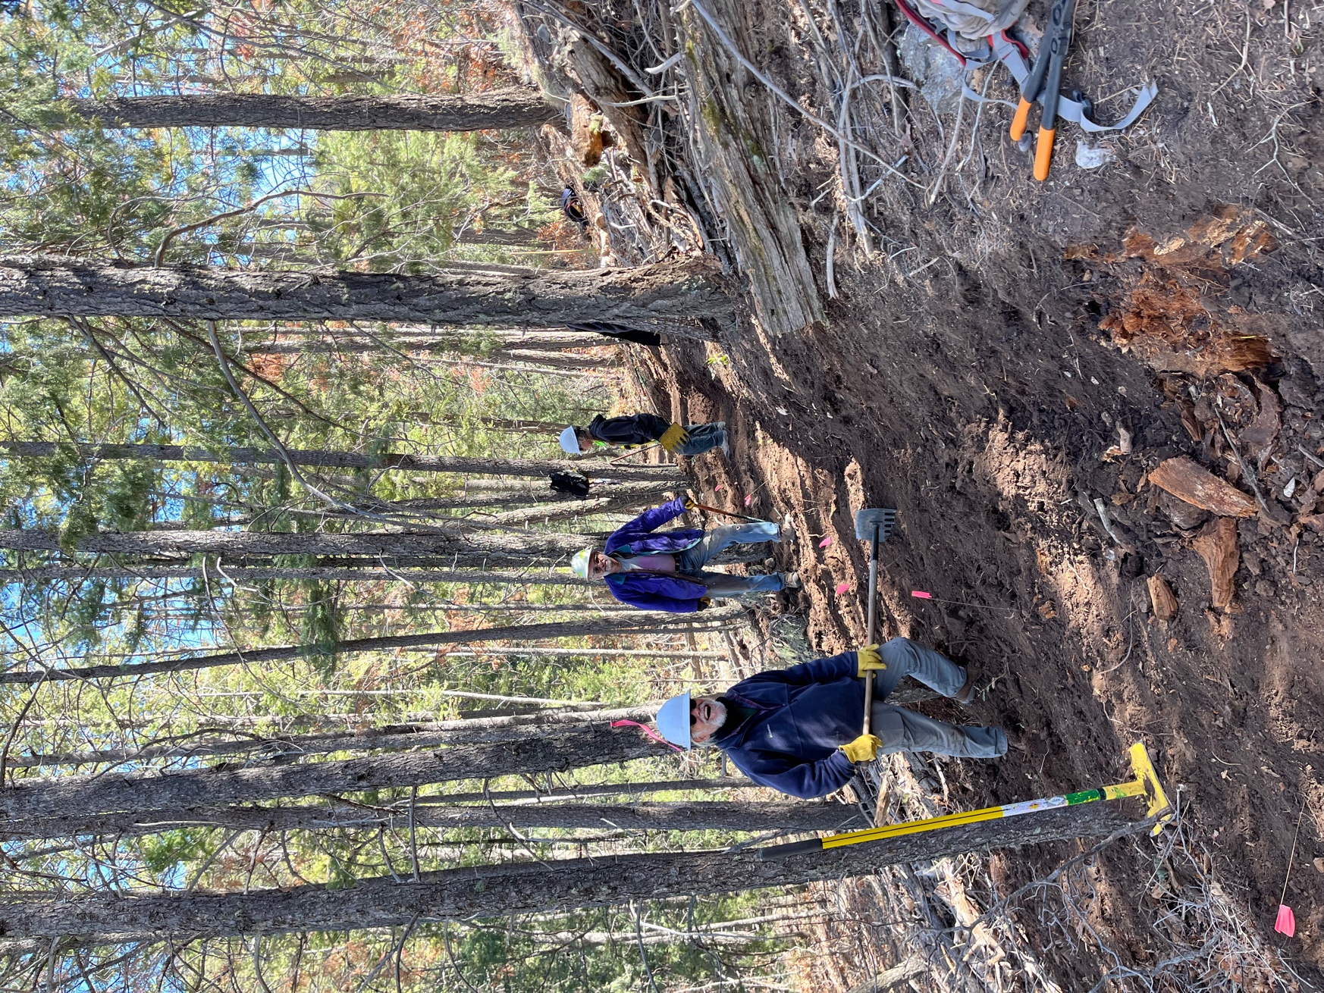

Quitting time!!

