**Report of Removal of Graffiti Tags on Boulders**

**East of Copper Trailhead on Tuesday, March 5, 2025**

Sam Beard

On Tuesday, March 5, an impromptu Paint Crew of Sim Cook, Cliff Giles, John McNett, and Sam Beard worked four hours removing graffiti tags from boulders in three areas located east of Copper Trailhead on the west side of Sandia Mountain. John is a new FOSM member, and he worked on his first project today.

The crew worked at the following locations:

1. **First Large Boulder** – Tags on this first boulder are shown in the photographs on pages 3 through 11. Tags on this boulder were bright green, purple, and pink. Almost all the paint on the three lower large tags was removed with the World’s Best Graffiti Removal System (WBGRS) chemical for stone and mortar surfaces. Some of the green tag high on the north side of this boulder was removed by John standing on a ladder, but parts of this tag are still visible. John could not find a safe route to a place where he could work safely on a large green tag very high on the west side of this boulder.
2. **“Goof Off” Crew** - While Sim and Cliff were working at another site, a group of four hikers with several large spray cans of Goof Off graffiti remover stopped at the first boulder. This group hikes in the foothills and attempts to remove tags with Goof Off. While chatting with them, we learned that they had not been successful in removing the tags on this first boulder. We were successful in removing most of these tags. Our experience at this boulder indicates that the WBGRS chemicals are better than Goof Off.
3. **Tags on a Trail South of the First Boulder** – A hiker told the crew that there were tags along a trail south of the first boulder. Sim and Cliff hiked to these tags and removed the ones shown on page 12.
4. **Boulder with Gray House Paint over Black Tags** – At the third location where the FOSM crew worked, Sim removed most of a small black and silver tag. Adjacent to this tag, the crew worked on two black tags covered with thick gray house paint. Recent experience at another location indicated that the WBGRS chemicals do not remove house paint; therefore, we used Kleen paint stripper to remove some of the gray house paint on a small tag and a large tag. We also applied WBGRS stone chemical to the small tag here in an effort to remove more of the gray paint. The chemical for stone removed none or little of the remaining gray paint. After rinsing the gray paint tags with water, we saw that the gray paint was not removed in the deep crevices in the very rough granite boulders. The photos on pages 14 through 16 show that the areas covered with gray paint are still visible.

The results of this project showed the following:

1. The WBGRS chemicals successfully removed most of some colors that Goof Off did not remove.
2. The Kleen paint stripper removed only some of the gray house paint on the very rough granite. Paint stripper usually easily removes paint on smooth surfaces.
3. FOSM volunteers need to develop procedures to remove thick house paint that has been applied over spray graffiti on rough surfaces. Apparently, an earlier unknown crew was not successful in removing the black spray tags; therefore, they painted over these tags in an effort to make them less noticeable.
4. **The FOSM graffiti removal crew does NOT paint over graffiti in an attempt to make it less noticeable.**

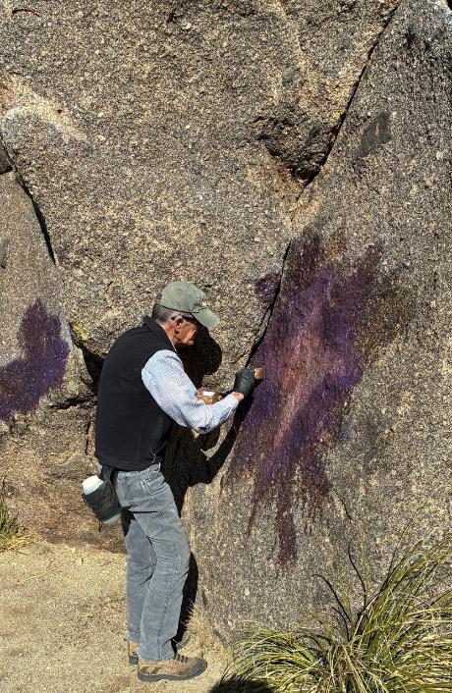

Sim Cook applying chemical to purple and pink tag at the first site.

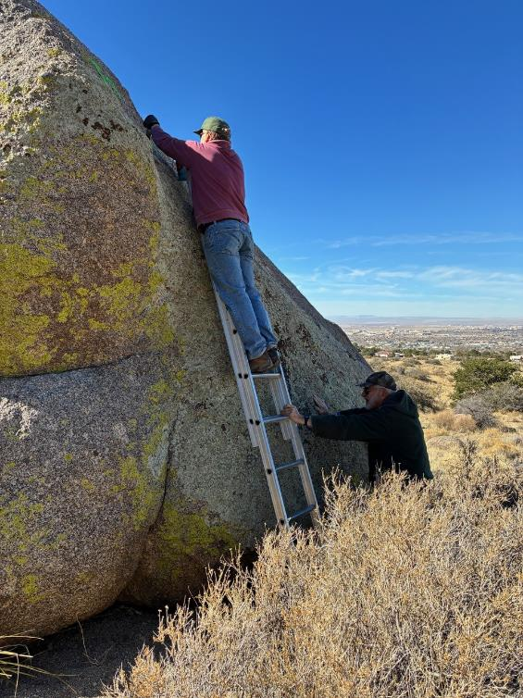

John McNett on the ladder applying chemical to green tag high on the boulder.

Sam Beard is holding the ladder.

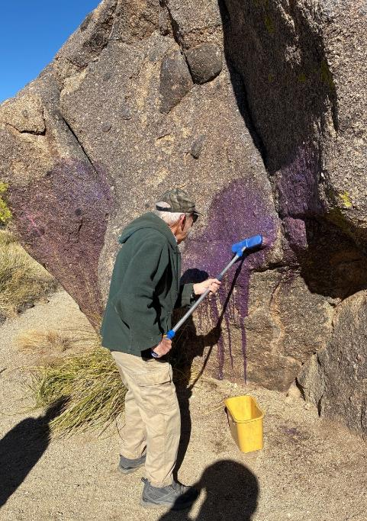

Sam washing off chemical and paint residue with water.

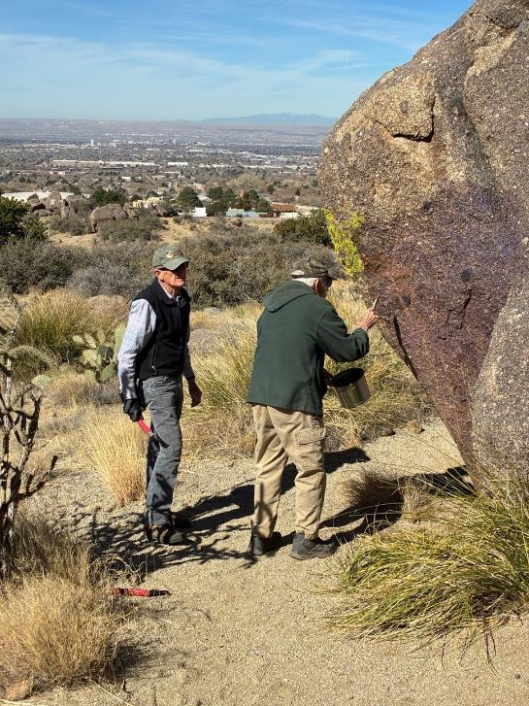

Sim watching Sam apply paint stripper in an attempt to remove more paint.

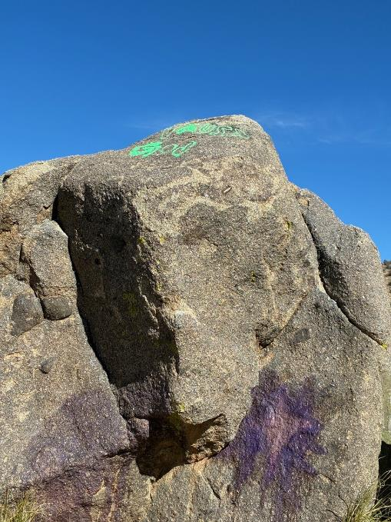Green tag on top of boulder that is too high for volunteers to work safely.

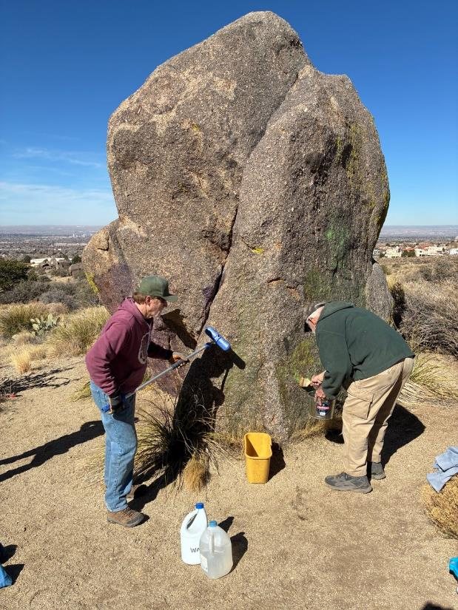

L to R: John rinsing chemical and paint off with water, and Sam applying more chemical

to a large tag on the east side of the boulder.

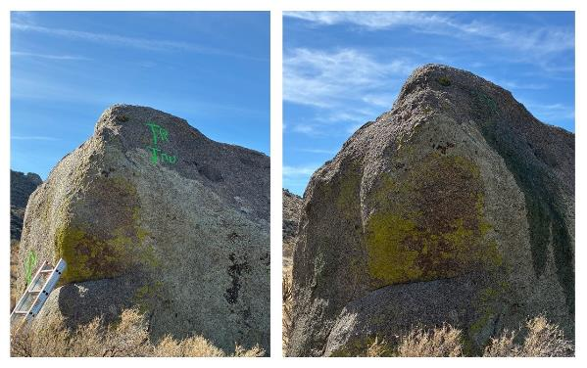

Before and after photos of this large boulder with green tag high on the north side.

Most of the green tag was removed by chemical applied by John on a ladder.

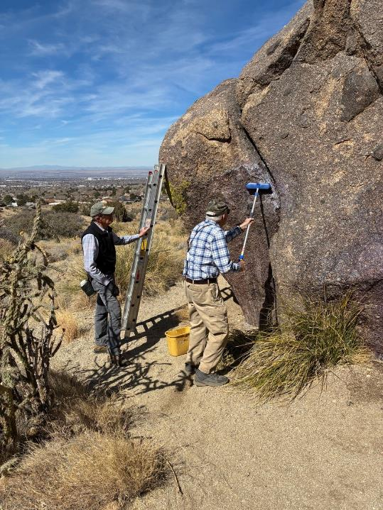

Sim observing Sam attempting to wash off residue of chemical and paint with water.

On the south side of these boulders, almost all the tags were removed, but a

light blue area remained around the edges.

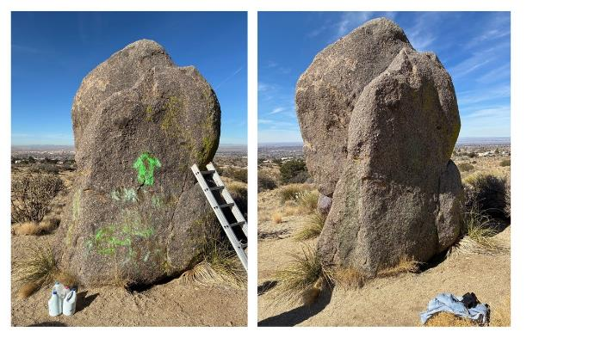

Photos show that all the bright green paint was removed

from the east side of this boulder

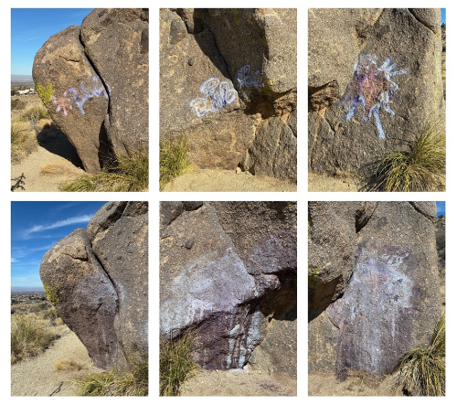

Before and after photos show that not all of the paint here was removed.

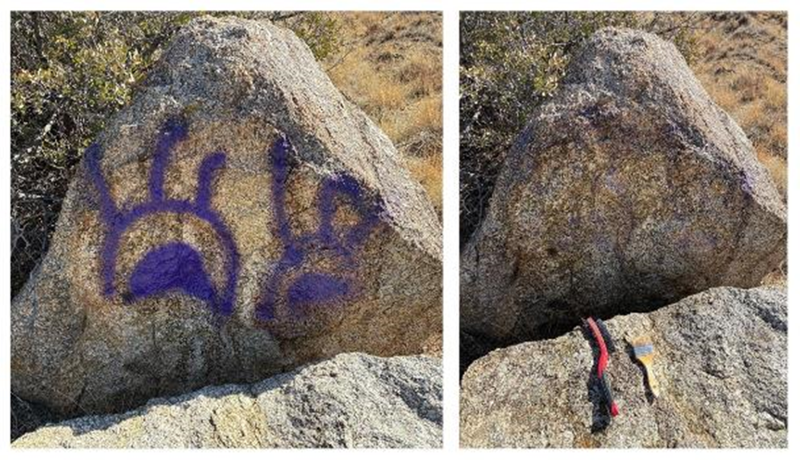

Before and after photos of tag on boulder south of the first boulder. Cliff and

Sim worked on this site.

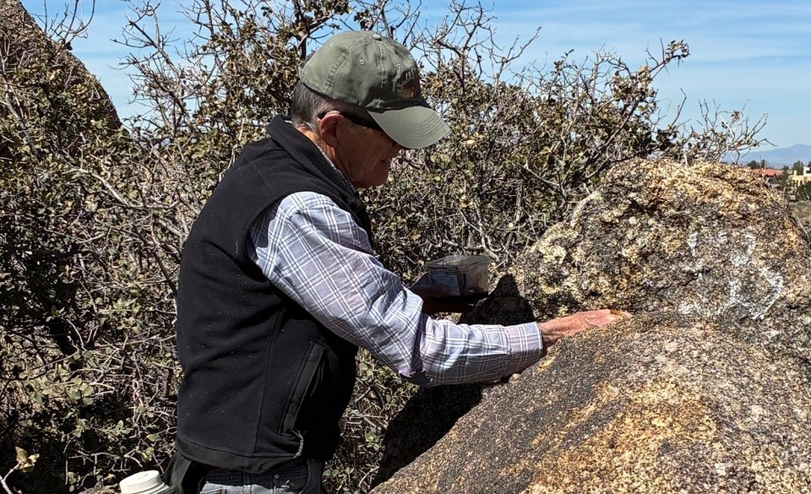

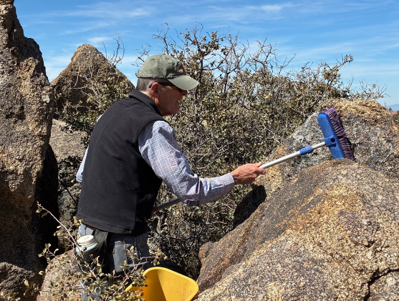

Top – Sim looking at silver and black tag on top of small boulder. Bottom – Sim using water to remove

the chemical and paint residue.

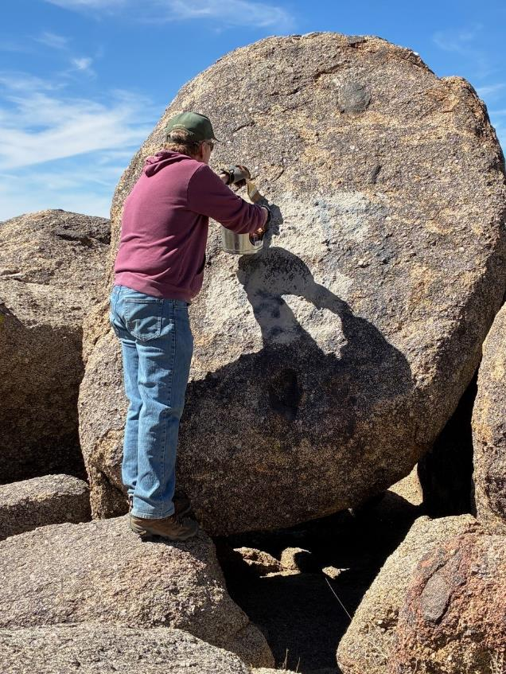

John applying paint stripper in an attempt to remove gray house paint on this large boulder. The graffiti-removal chemical removes spray paint but not thick house paint.

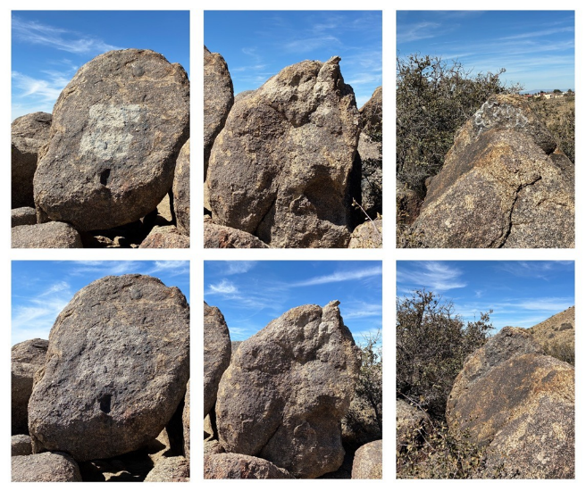

Before and after photos of three boulders at the third site where we worked.

Only some of the gray house paint on the two left boulders was removed after

using both paint stripper and graffiti removal chemical. The silver and black

tag on the right boulder was removed with the WBGRS chemical for stone.

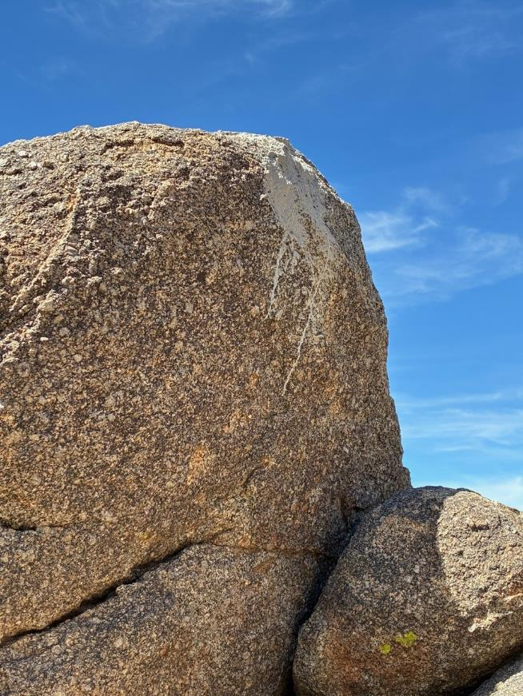

The gray house paint on this boulder was too high for the volunteers to safely remove.