Thursday, 03/06/25- N. Faulty Trail: Our group of twelve volunteers met Jen and Canyon (SRD) at the N. Faulty reroute #1, about ¾ of a mile up, up, up from the parking area on Crest Highway. The weather was overcast all day. The winds started out light but by the time we hiked out they were roaring in the tree tops!
We did manage to work the full day as the trees kept us sheltered from the worst of the wind. We continued working on reroute #1 and we still have at least another day to go on it. There were some very rocky, frozen and highly sloped areas to work this week but we ended up in some nice soft duff on fairly level ground at the end of the day. And best of all the hike out is down, down, down!

Volunteers: Bruce Hansche, Jim Houle, Claudia Bergsohn, Roland Stumph,
Rich Fagioli, Luis Cuadros, Larry Larrichio, Eric Russell, Mike Madden, Laura Leon,
Bill Perkins and John McNett

Pictures: Laura Leon

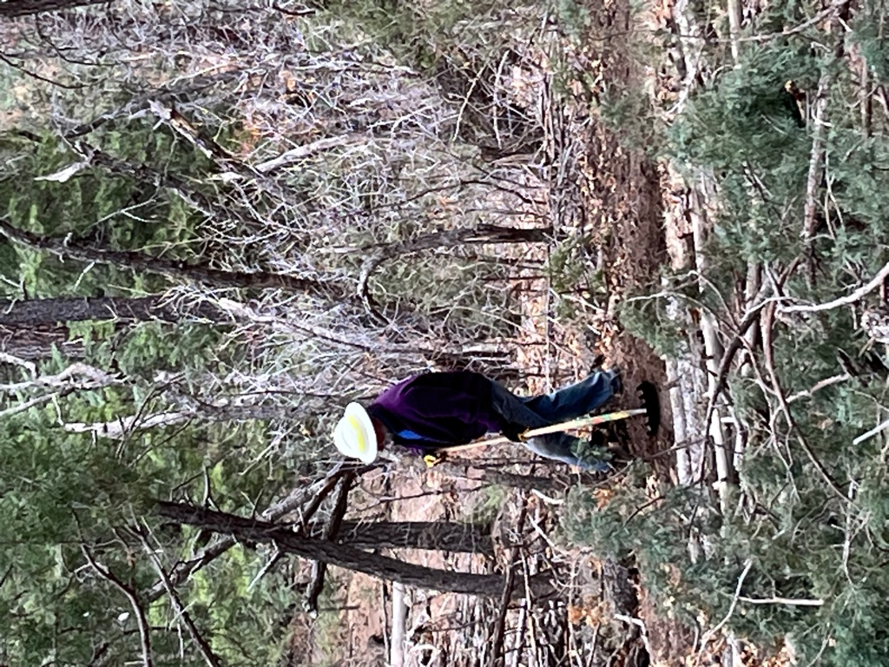

Jim started with some cleanup work on last week’s sections.

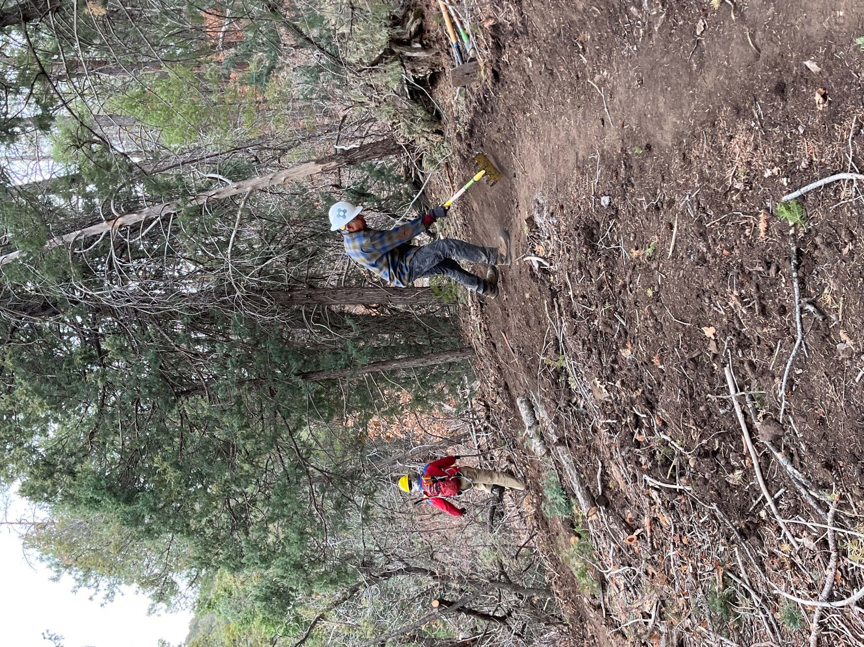

Luis reworked some of the curves and Mike - Mr. Brushing, clipped along the edges of the trail.

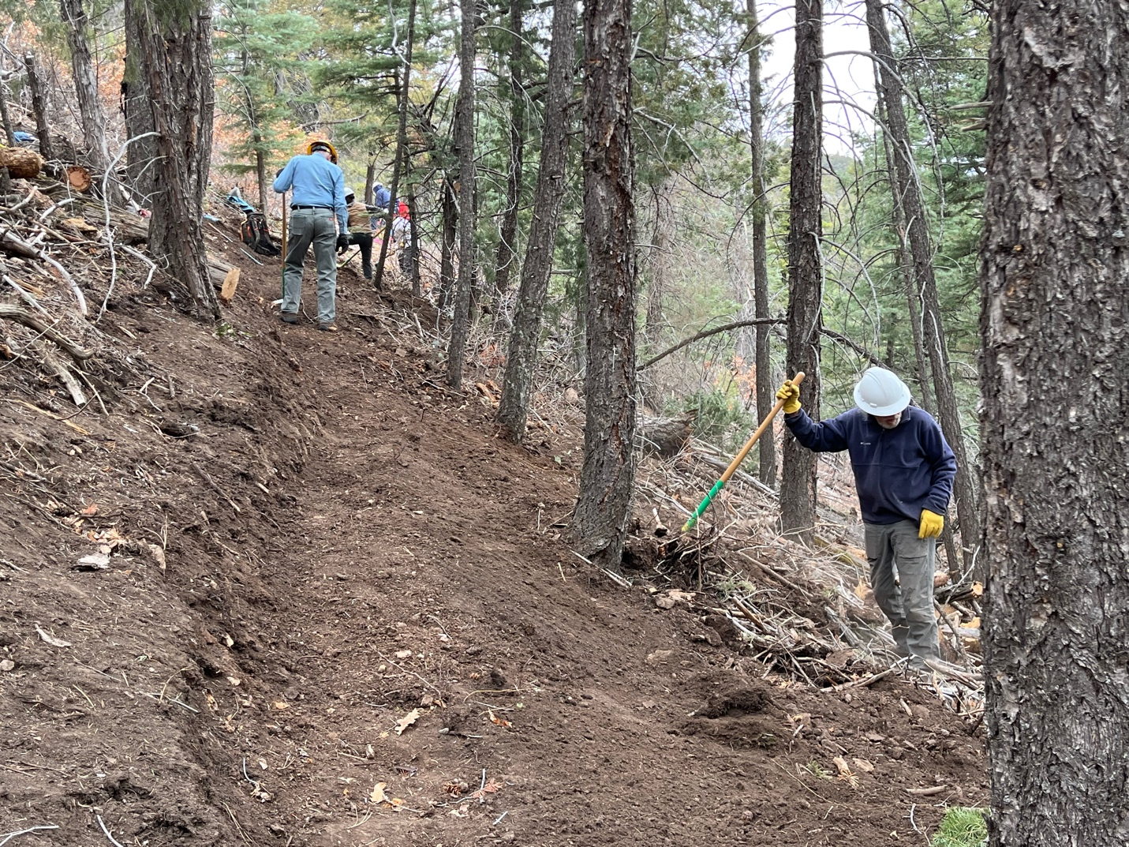

Bill worked on the back sloping of last week’s sections while Eric starts in on the next section.

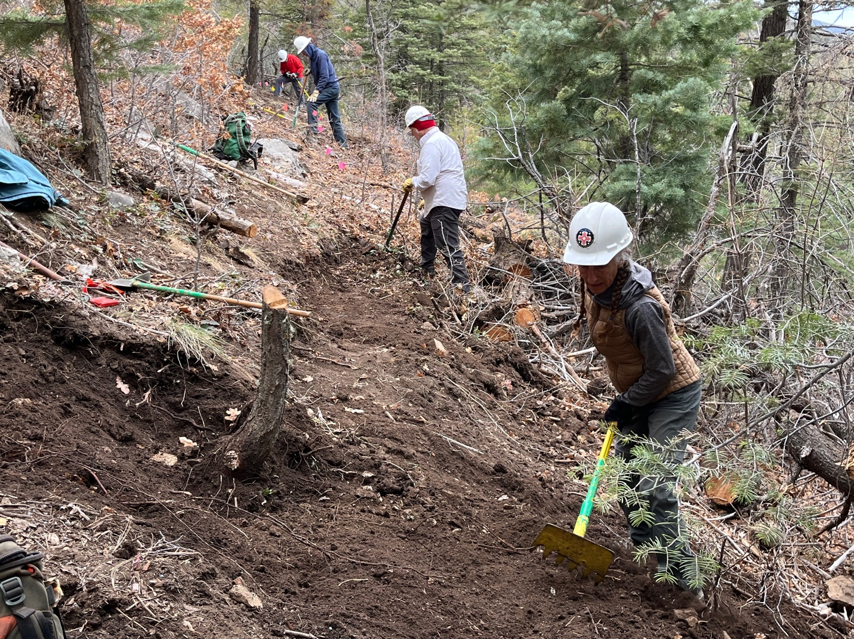

Claudia found a stump!
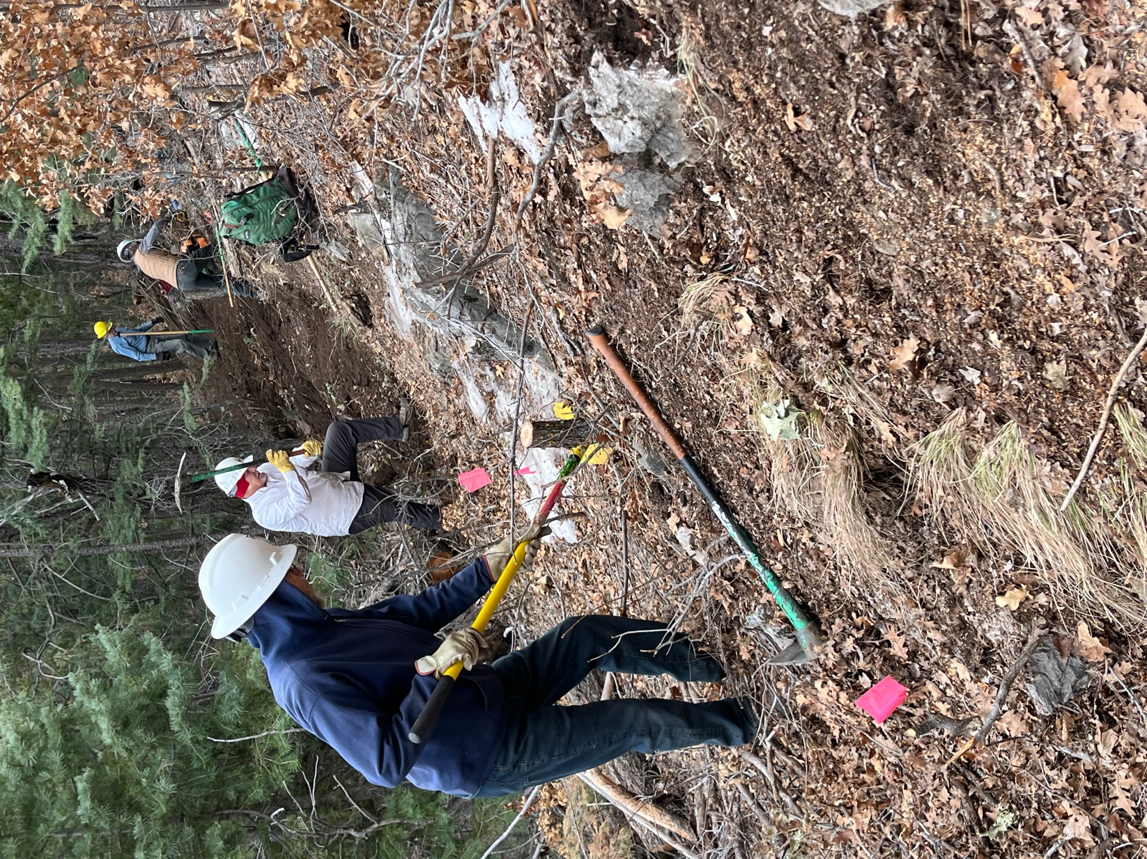

Bruce and Rich had a cold (still some snow!), rocky, frozen ground section and it was on a slope to boot!

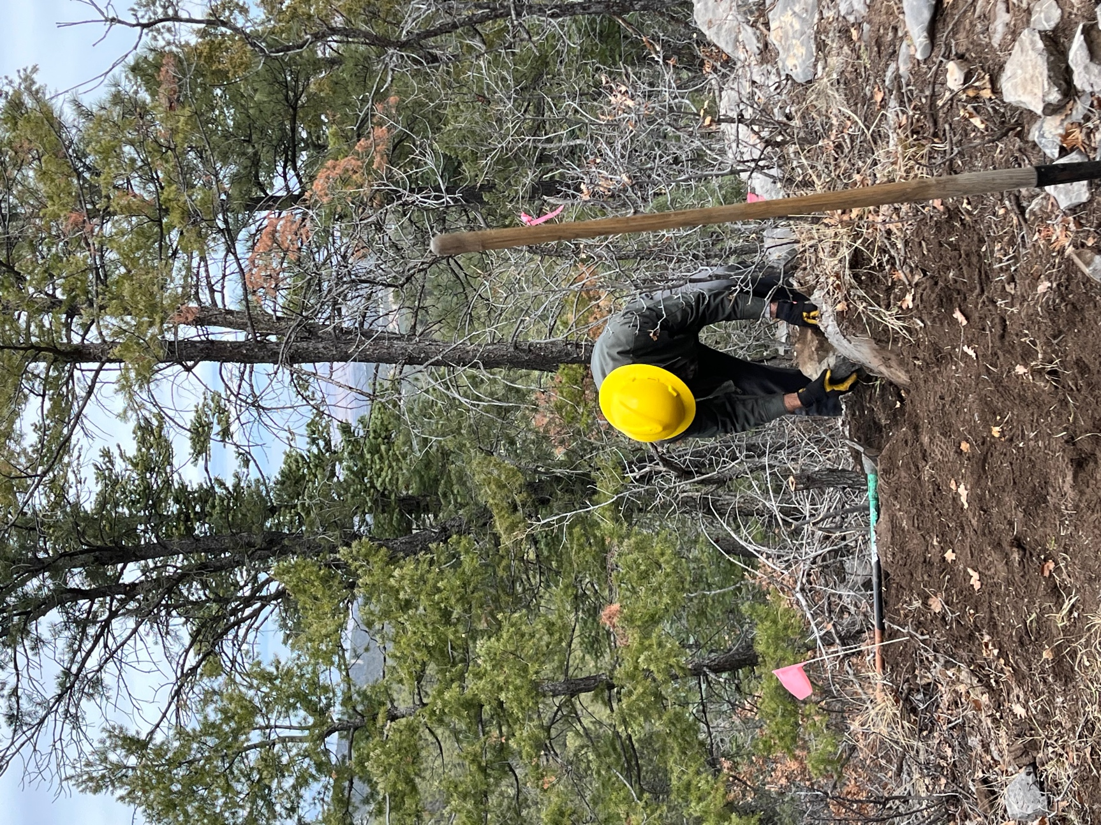

Roland worked on making a rocky section into manageable steps.

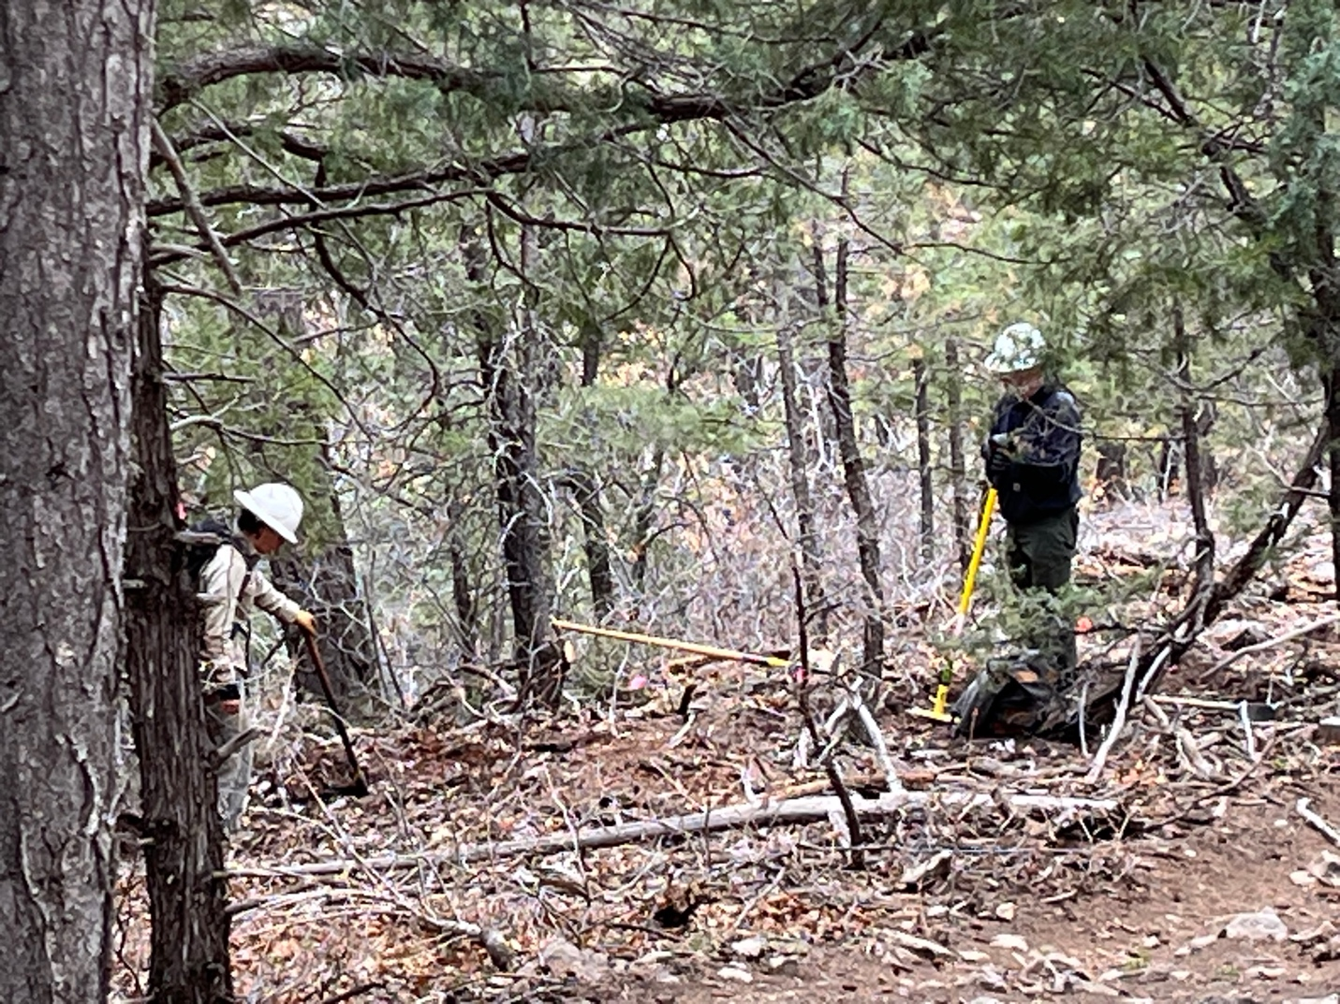

Jen shared trail building wisdom with John, our new digger.

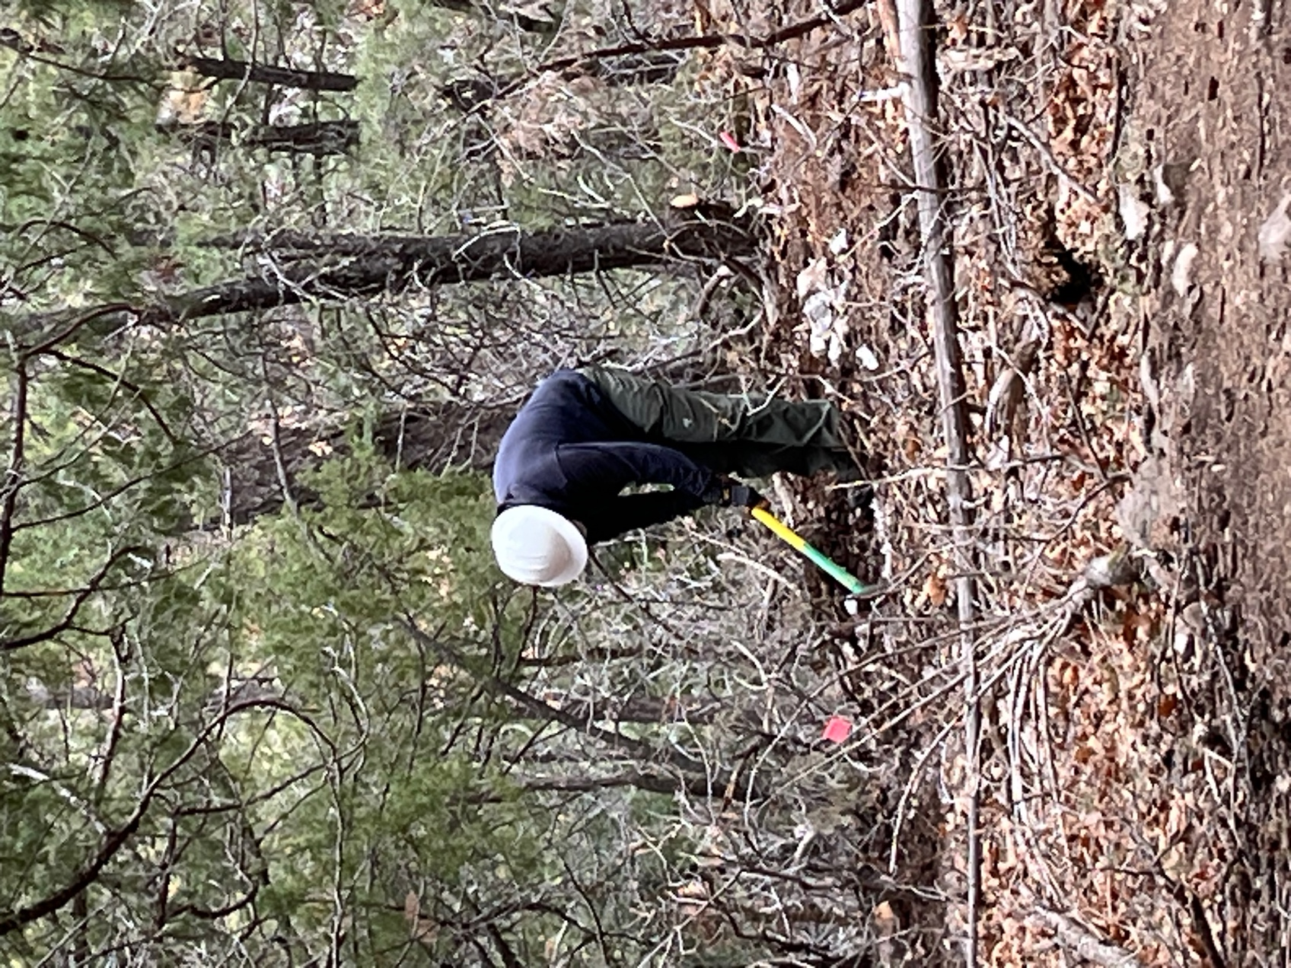

John smashed off the top of a rock.

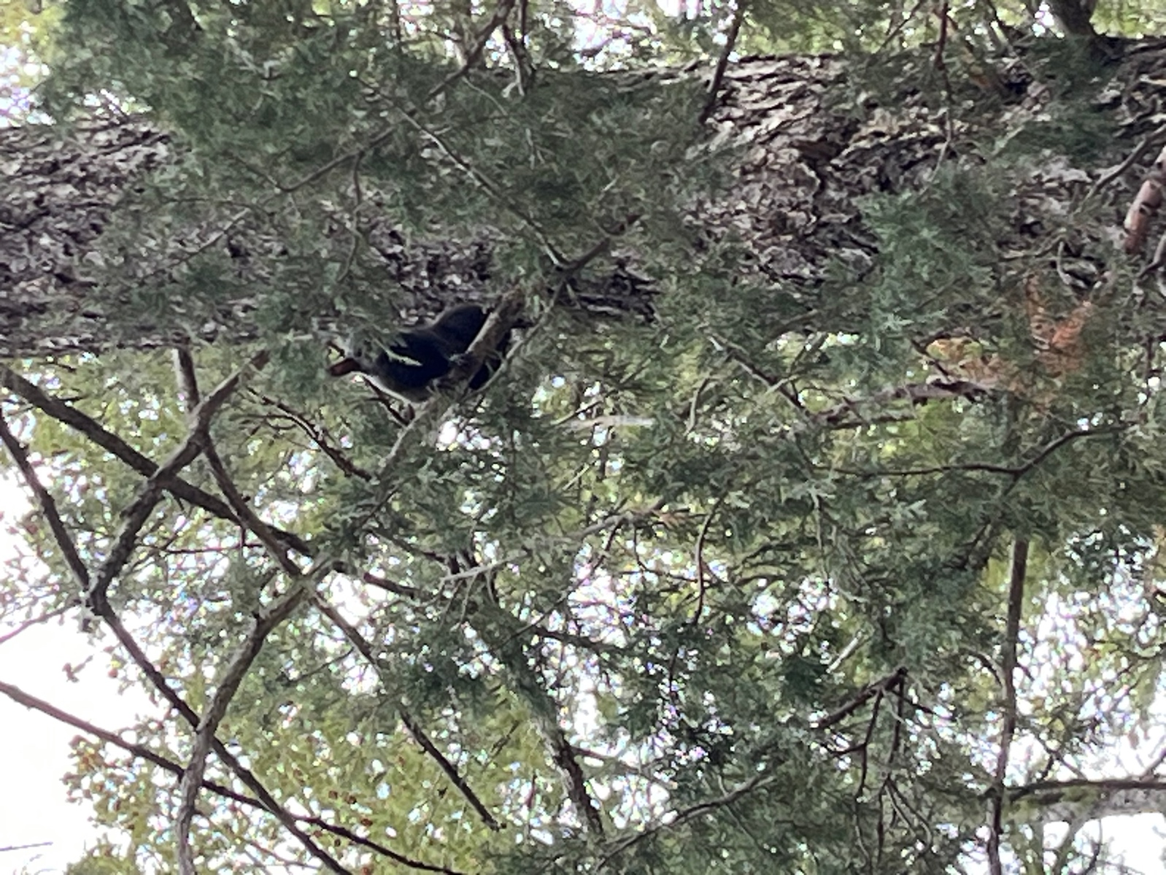

An Abert’s Squirrel shared it’s feelings about us being its space.

