Thursday, 03/13/25- N. Faulty: A blustery day but the sun was out and the crew was able to make good headway. Jen (SRD) and 11 volunteers continued work on the first reroute section of N. Faulty. Last week’s work was perfected and the rest of the crew continued working on new sections. Jen and Laura flagged the last section of reroute #1 and then cleared the corridor and dismantled a shelter and fire ring. Some sections of the reroute have been very rocky and that requires more time while some sections are fairly soft and duffy and the work goes quickly. We hope to finish reroute #1 next week.

Volunteers: Rich Fagioli, Mike Madden, Bruce Hansche, Jim Houle, John McNett, Roland Stumph, John Braly, Eric Russell, Tony Pachelli, Larry Larrichio and
Laura Leon

Pictures: Laura Leon

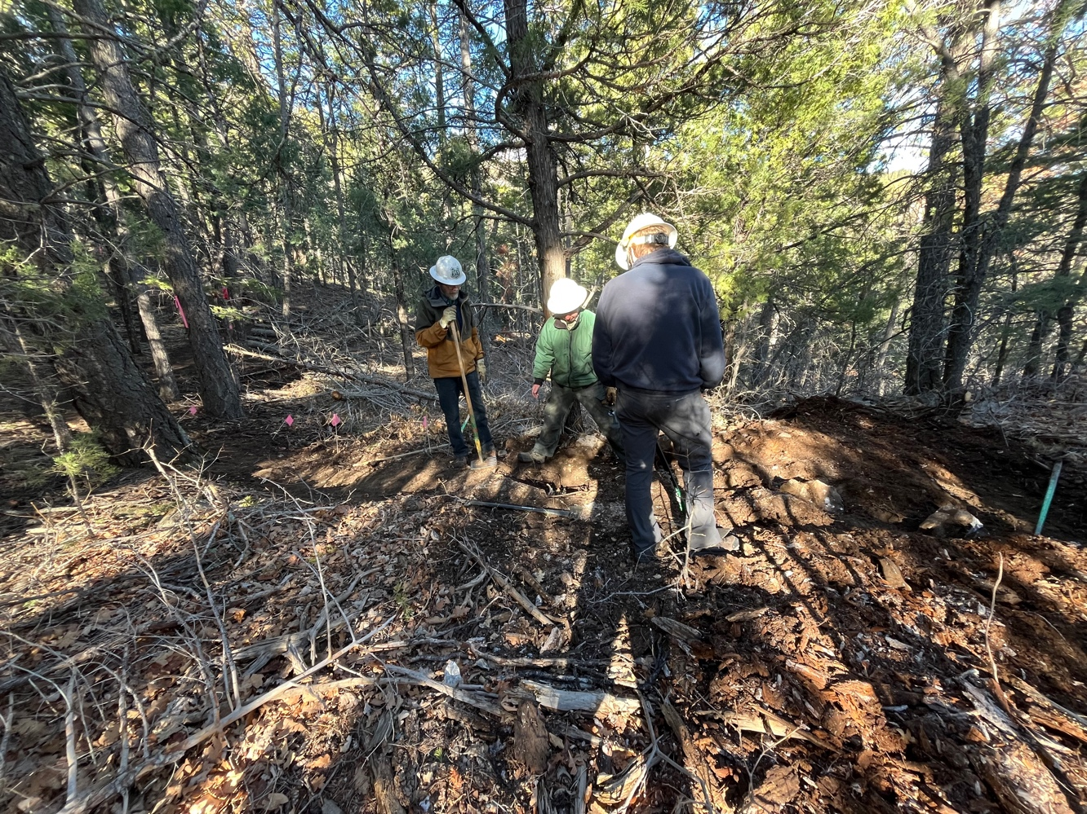

Early morning sunshine created shadows on a big stump hole, over which Bruce, Jen and John M. debated the best fix.

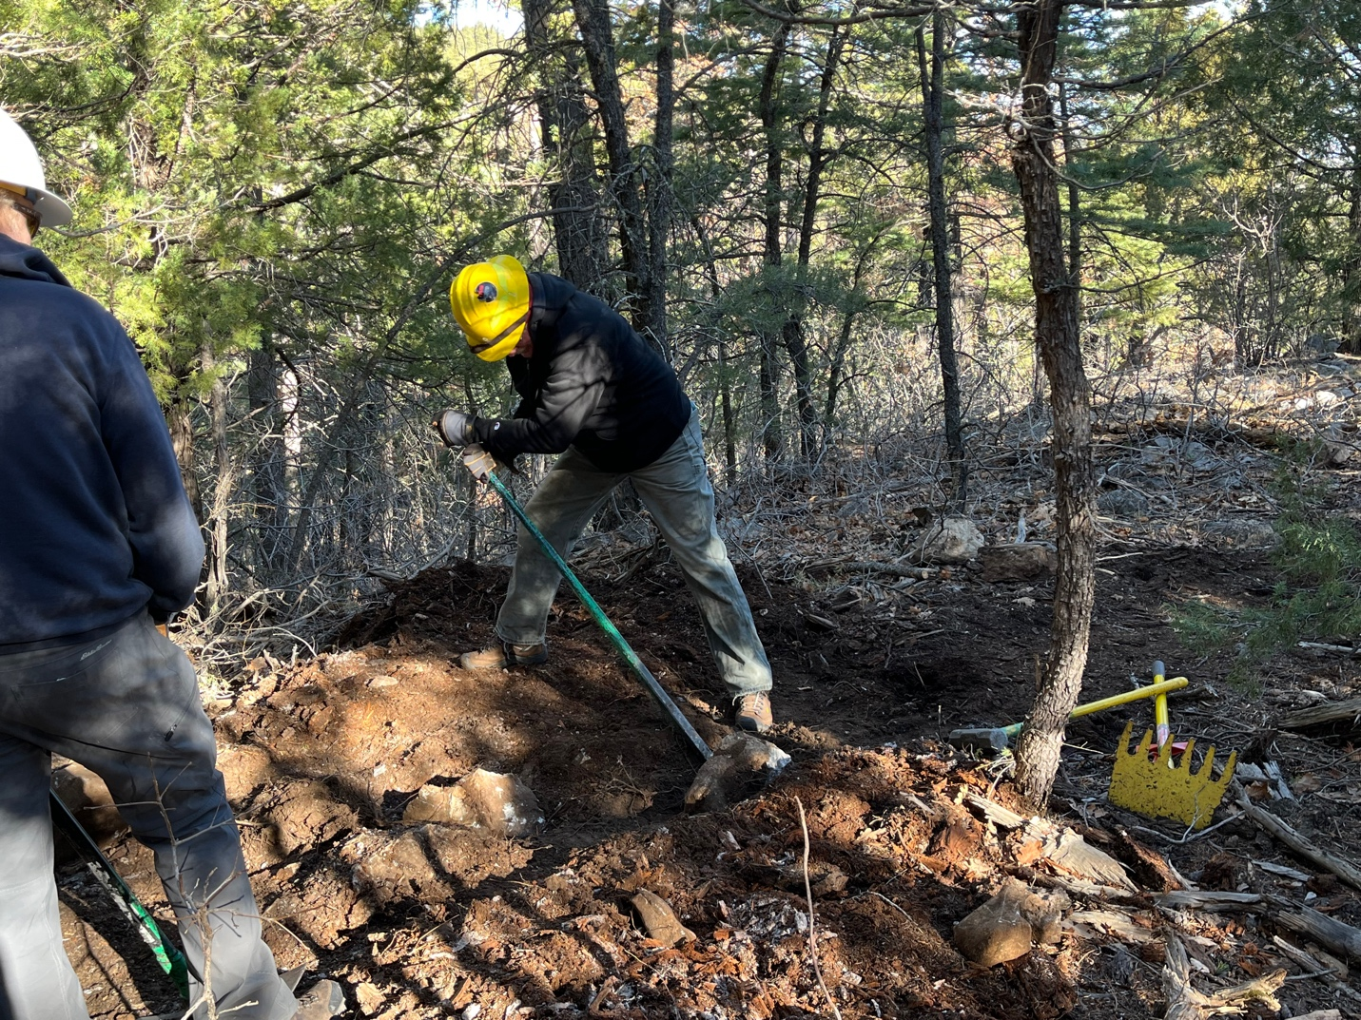

Eric dug out a rock which was then used to fill another hole. Rearranging nature.

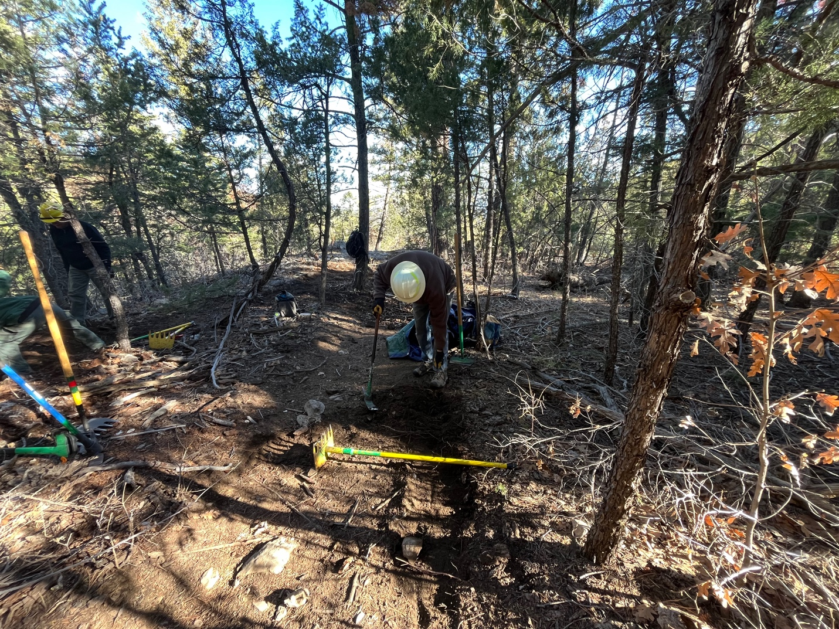

Jim dug up and transferred soil from the old trail to a rocky area of new trail.

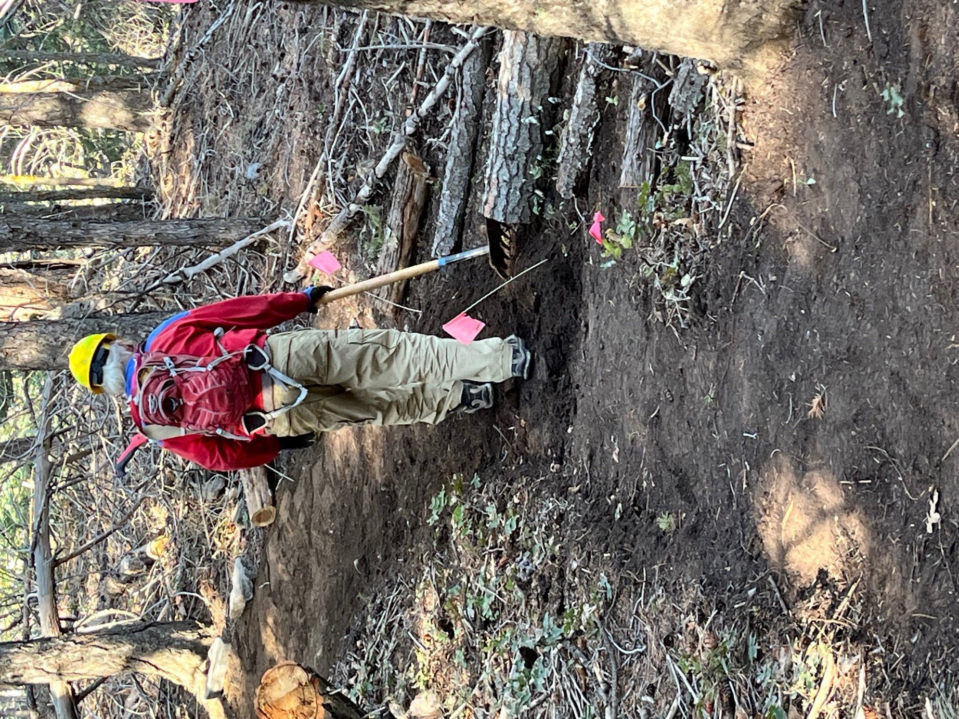

Mike walked and cleaned an area of new trail.

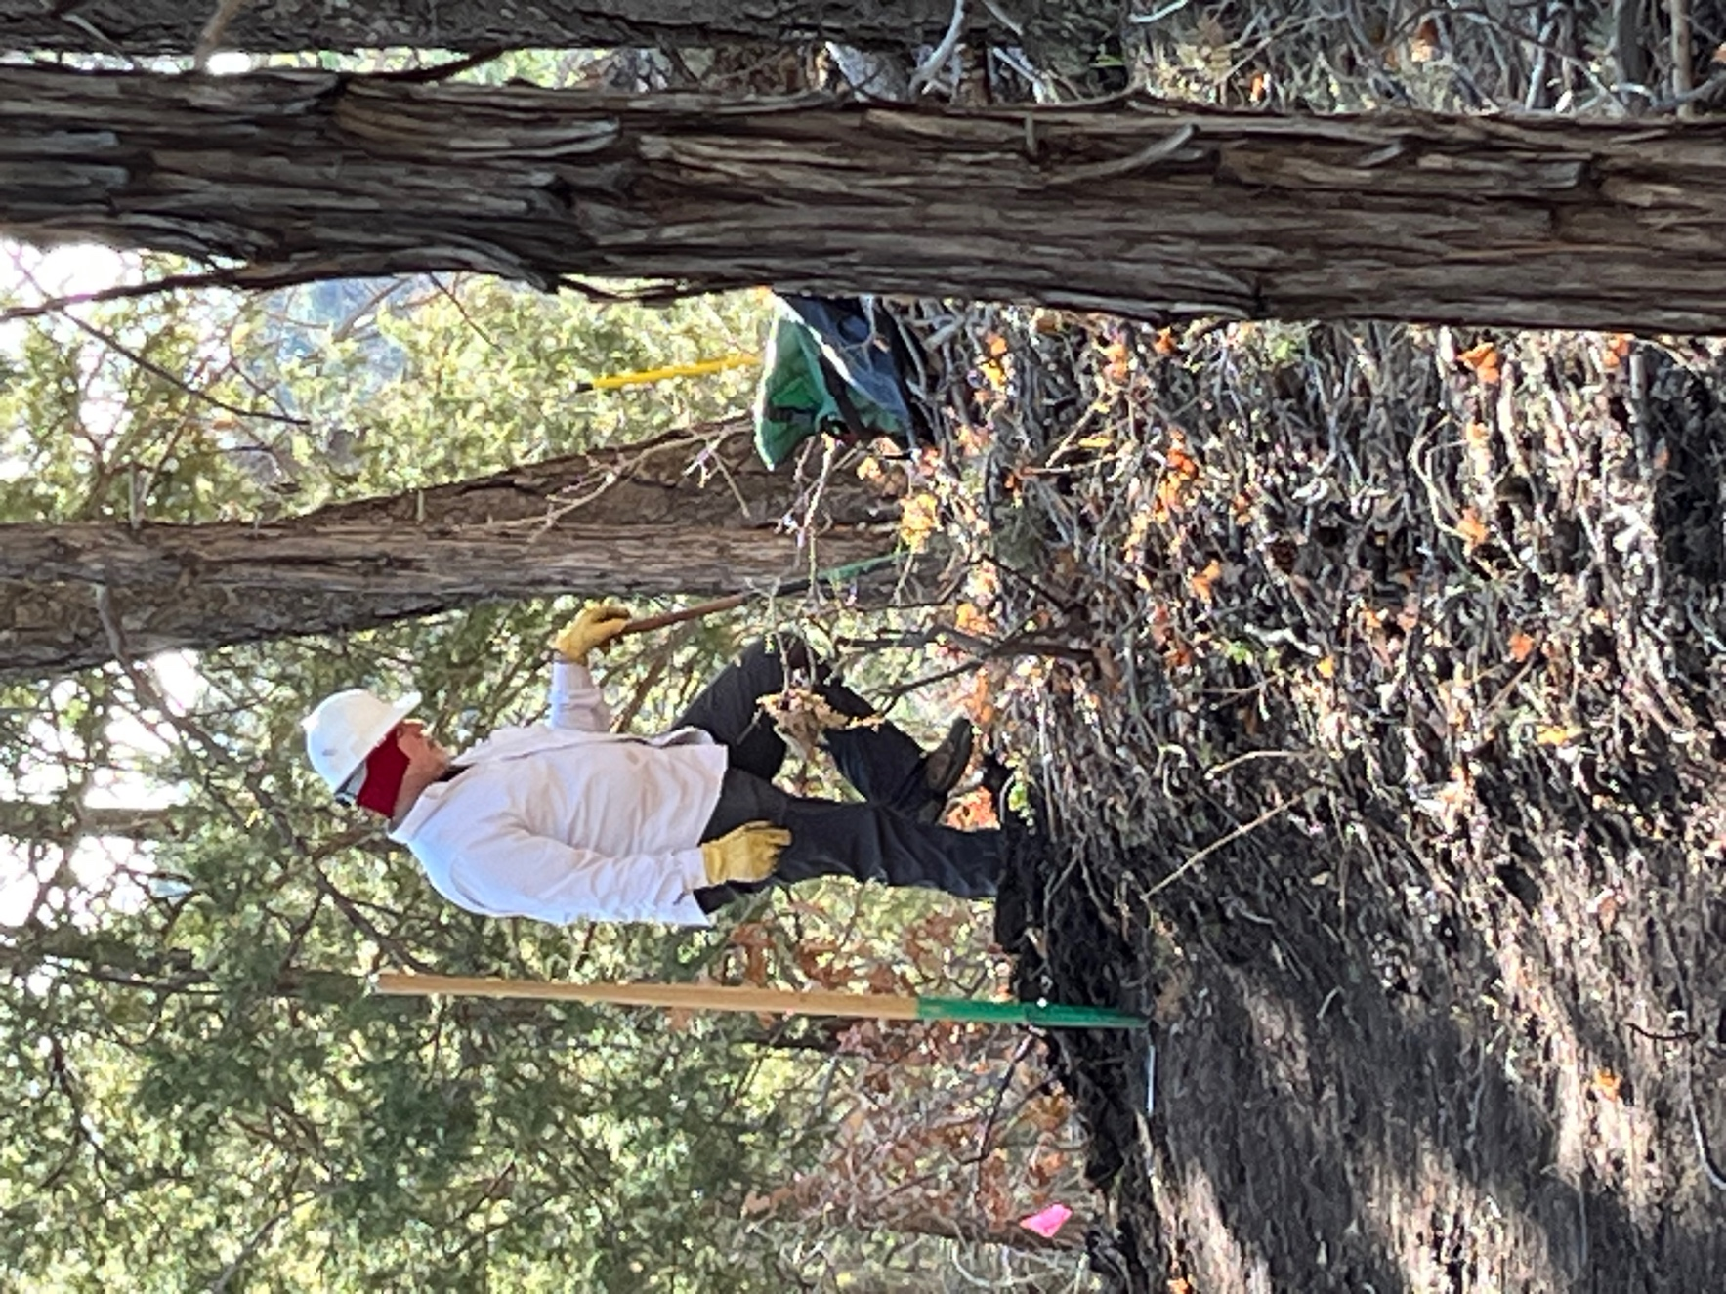

Rich worked an area where new trail crossed over old trail.
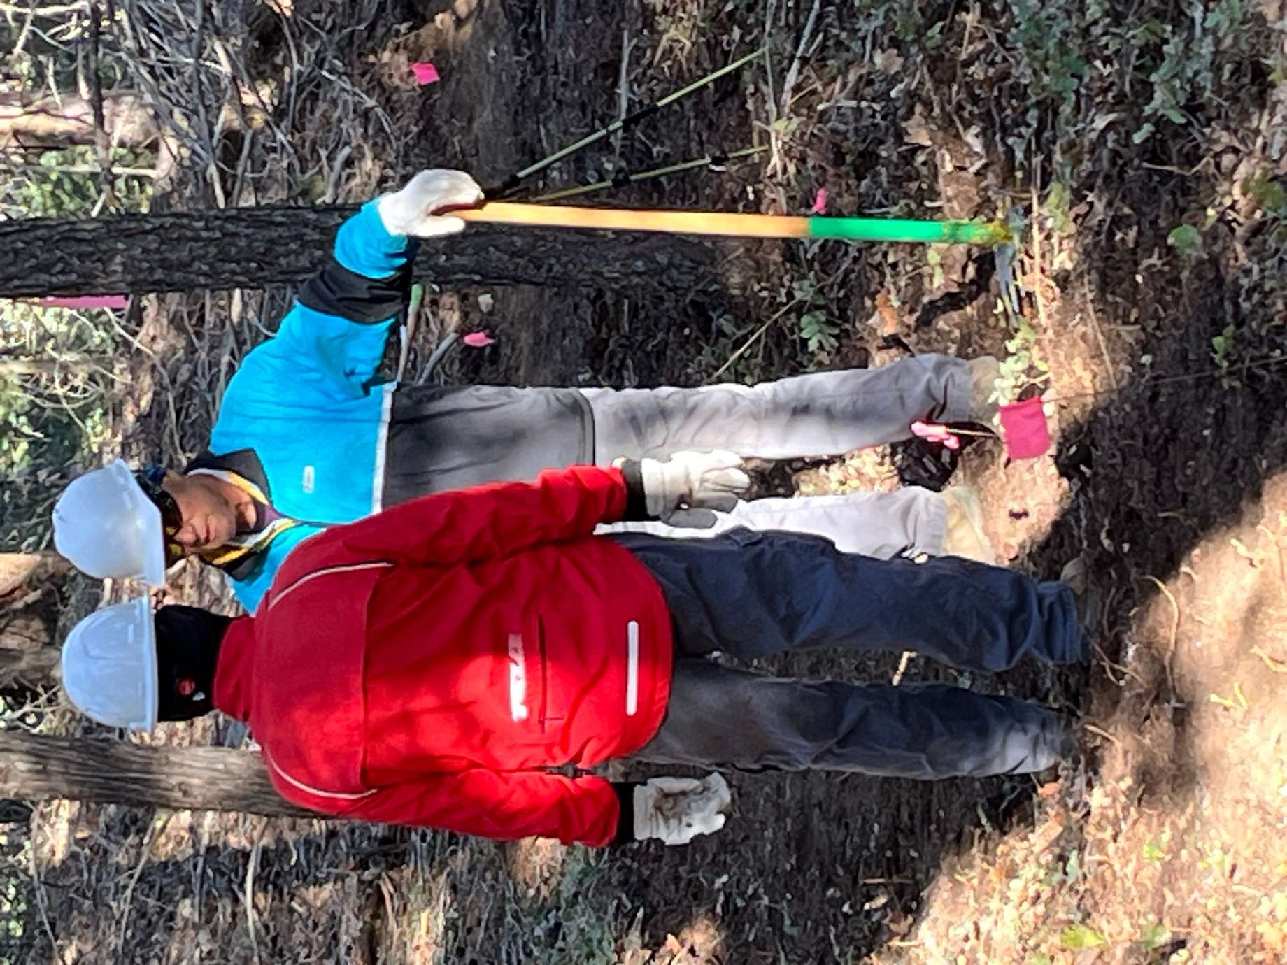

Tony and Larry talked over stuff.
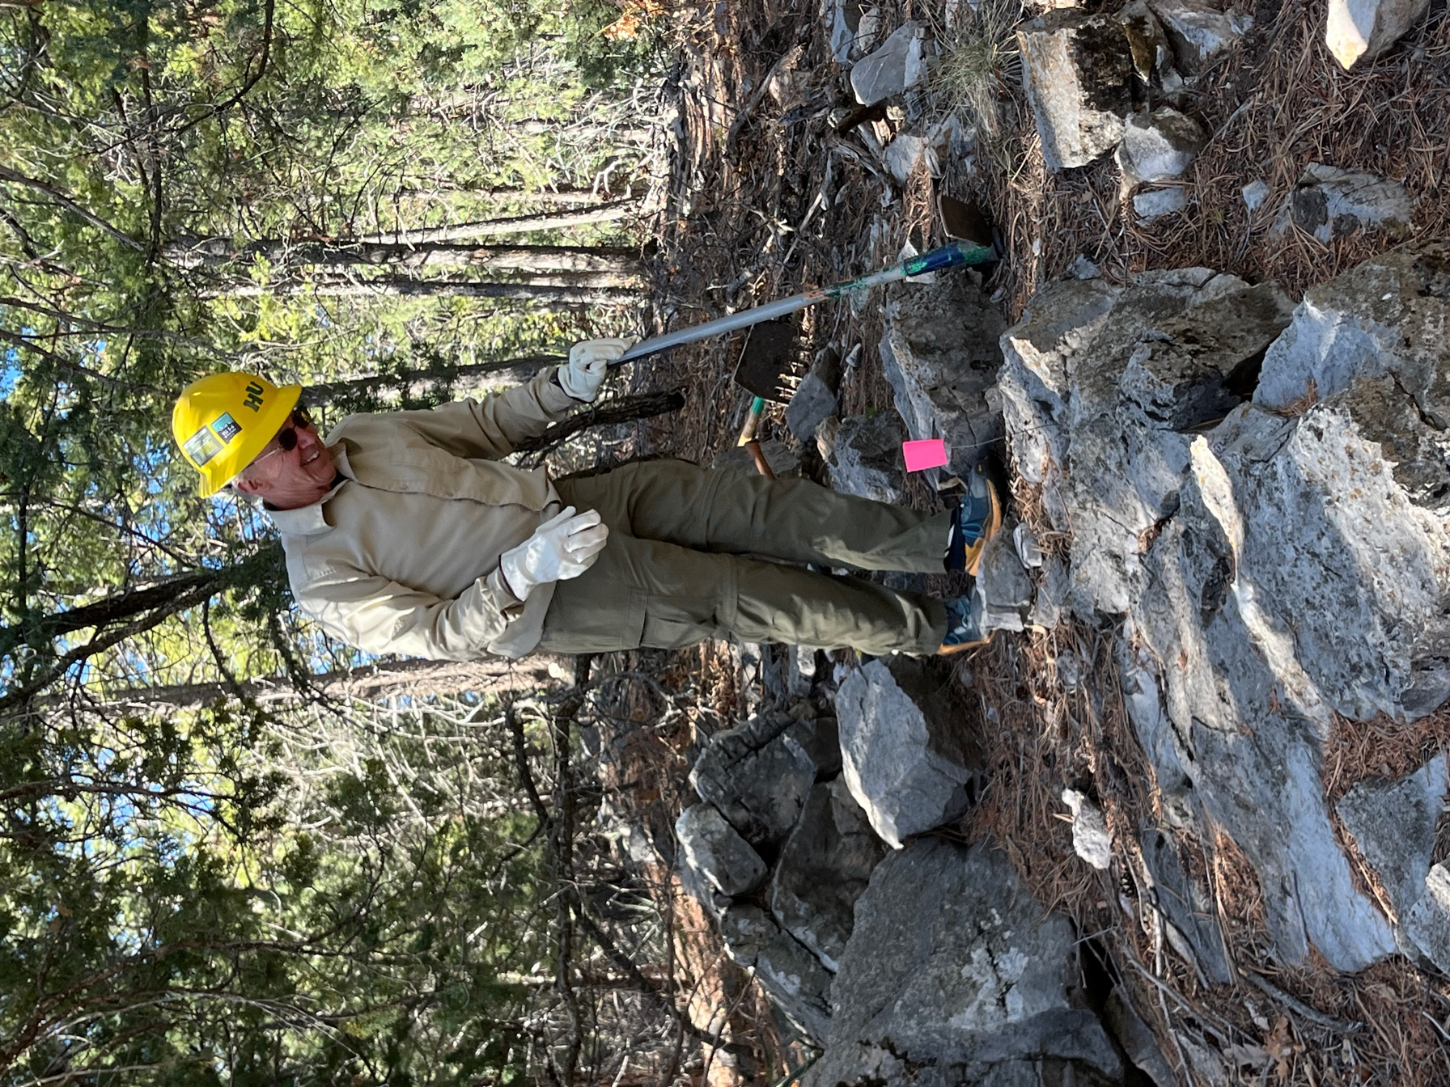

John B. loved the idea of working this rocky area.

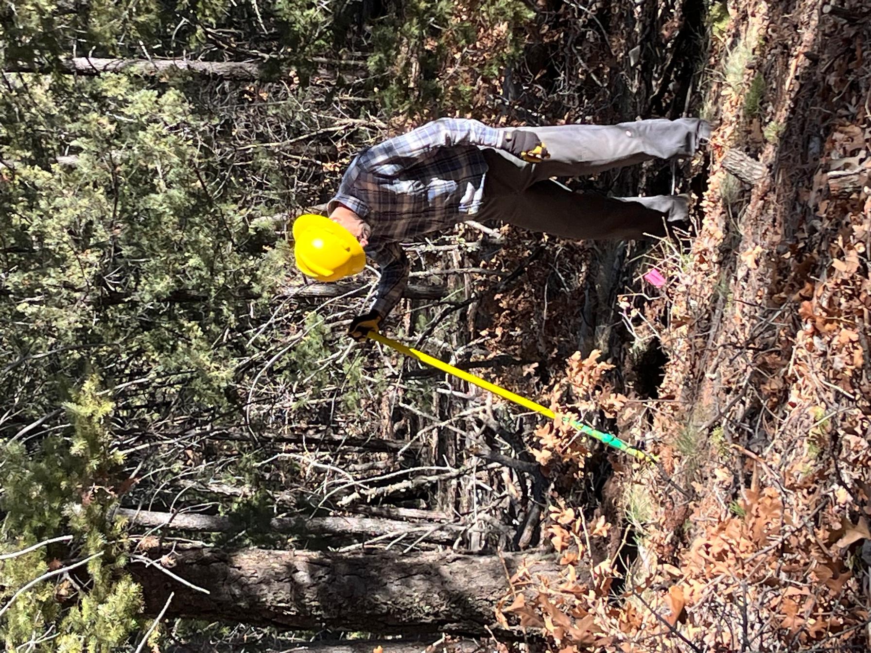

Roland encountered stumps- stumps for Stumpf.

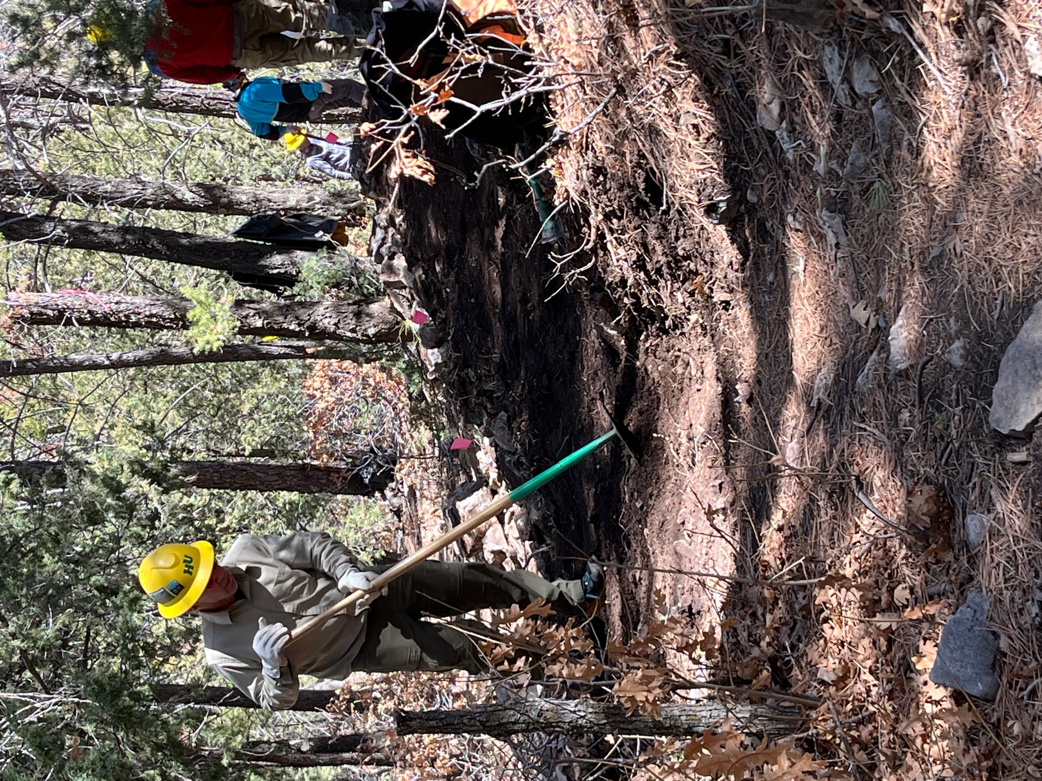

Rocks cleared; John B. connected new trail to the old trail.

