Thursday, 03/20/25- North Faulty: Brrrr… It was a very cold start on Thursday! My car said 22 degrees so we took off right away to get moving and stay warm. Eleven volunteers and Jen (SRD) were able to finish reroute #1 and then we moved all the tools to reroute #5 which is about 2.5 miles from the parking area. We should be working there for a couple of weeks. The winds earlier in the week knocked down several trees onto the trail but the weather on Thursday turned out to be great for us once it warmed up. There were lots of birds singing in the trees making the long hike out a delight.

Volunteers: Luis Cuadros, Mike Madden, Bruce Hansche, Jim Houle, John McNett,
Bill Perkins, John Braly, Eric Russell, Tony Pachelli, Claudia Bergsohn,
and Laura Leon
Pictures: Laura Leon and John Braly

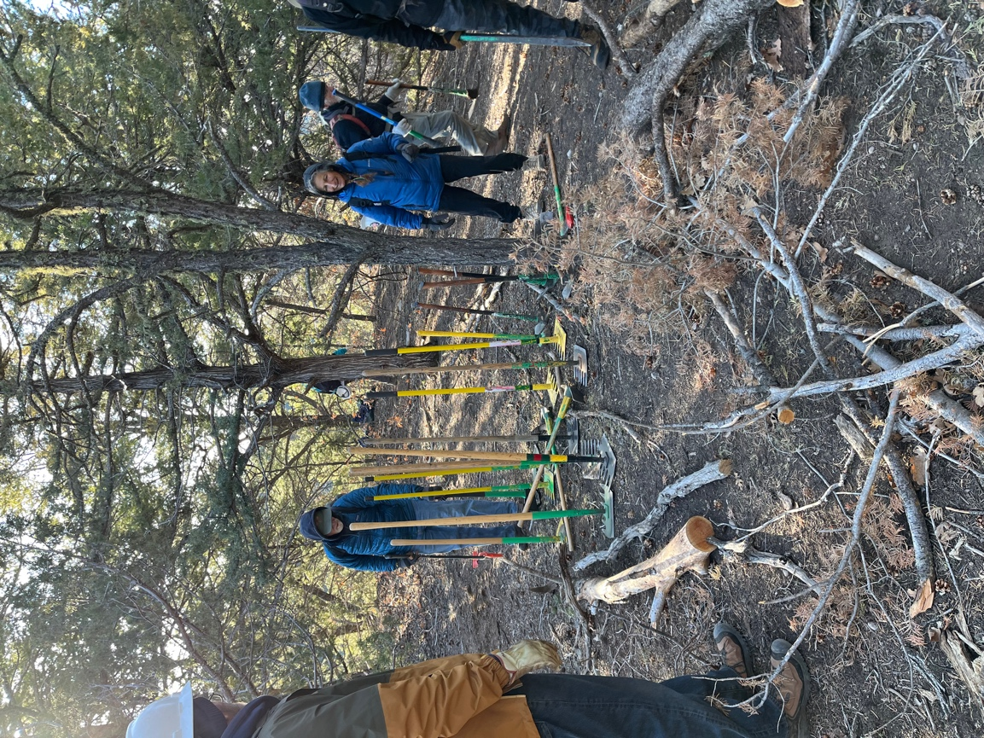

Tools out and everyone was ready to get to work finishing reroute #1.
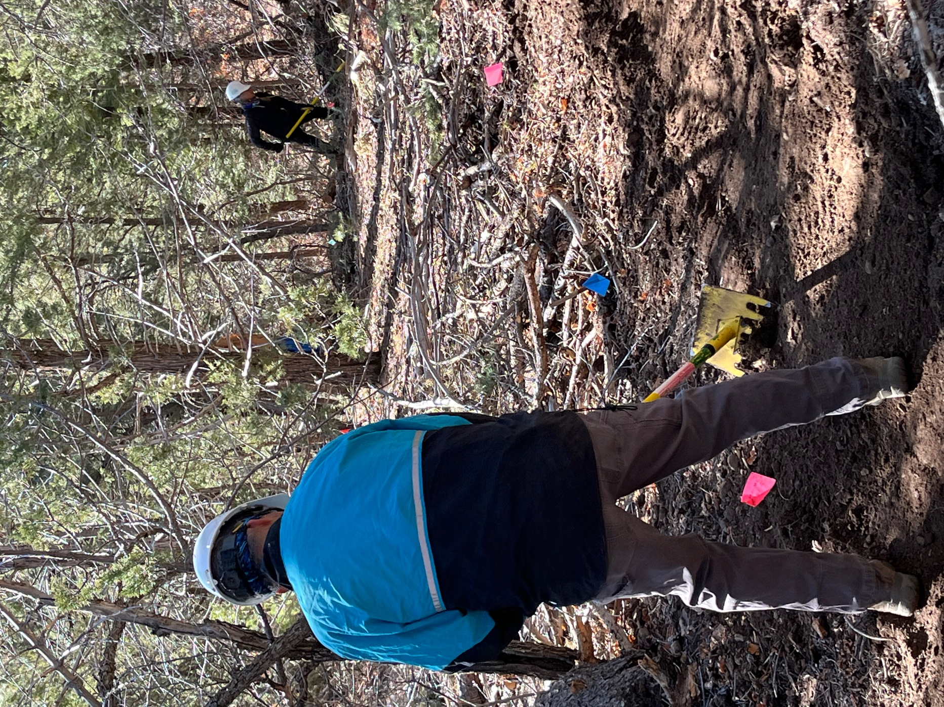

Tony and Claudia worked trail through the woods.

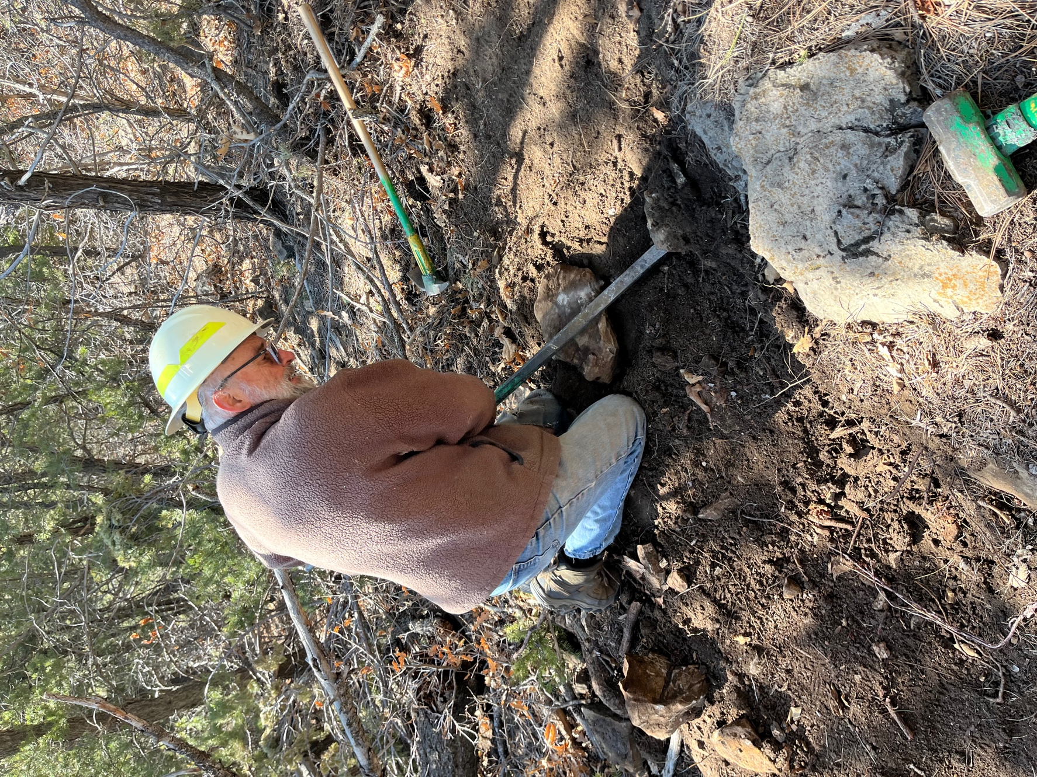

Jim and Luis got to play with rocks!
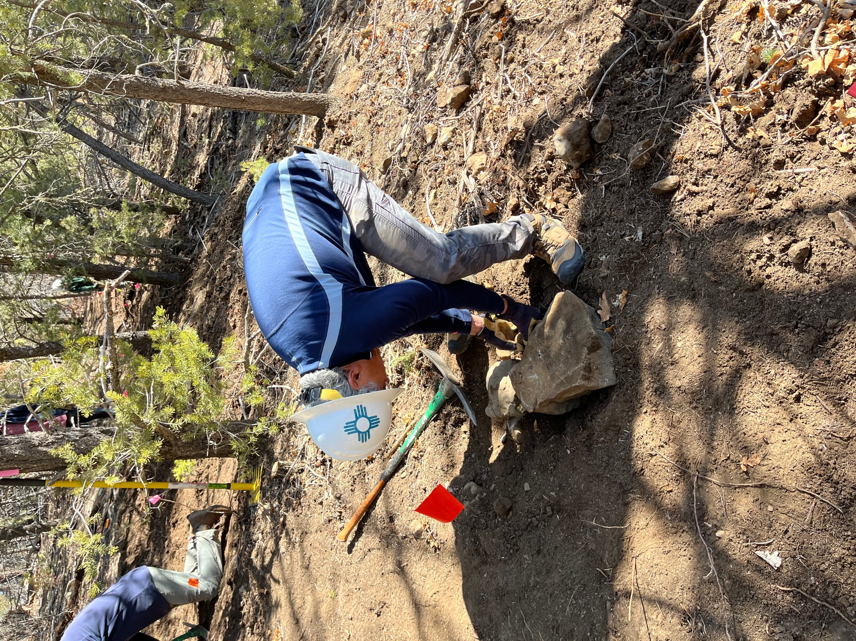

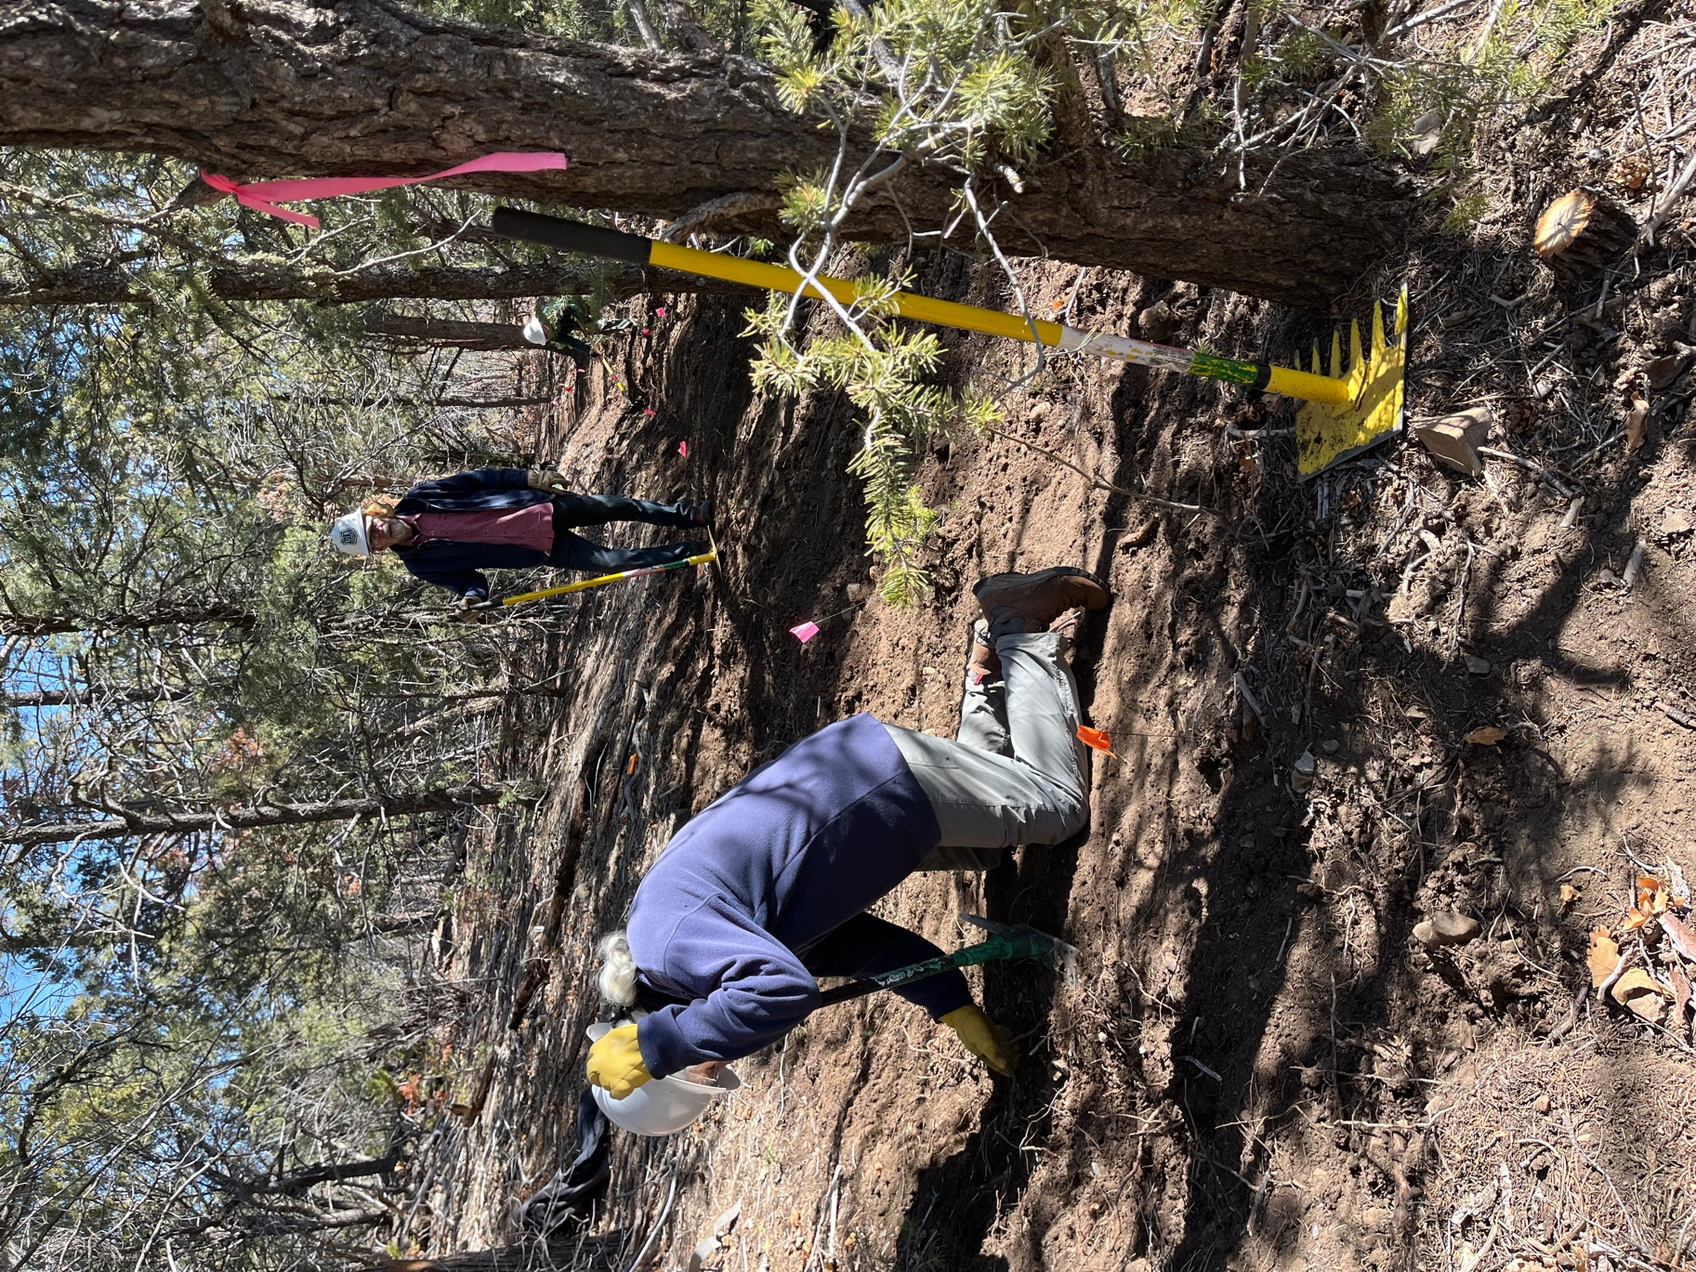

Bill demonstrated his careful trail cleaning technique.

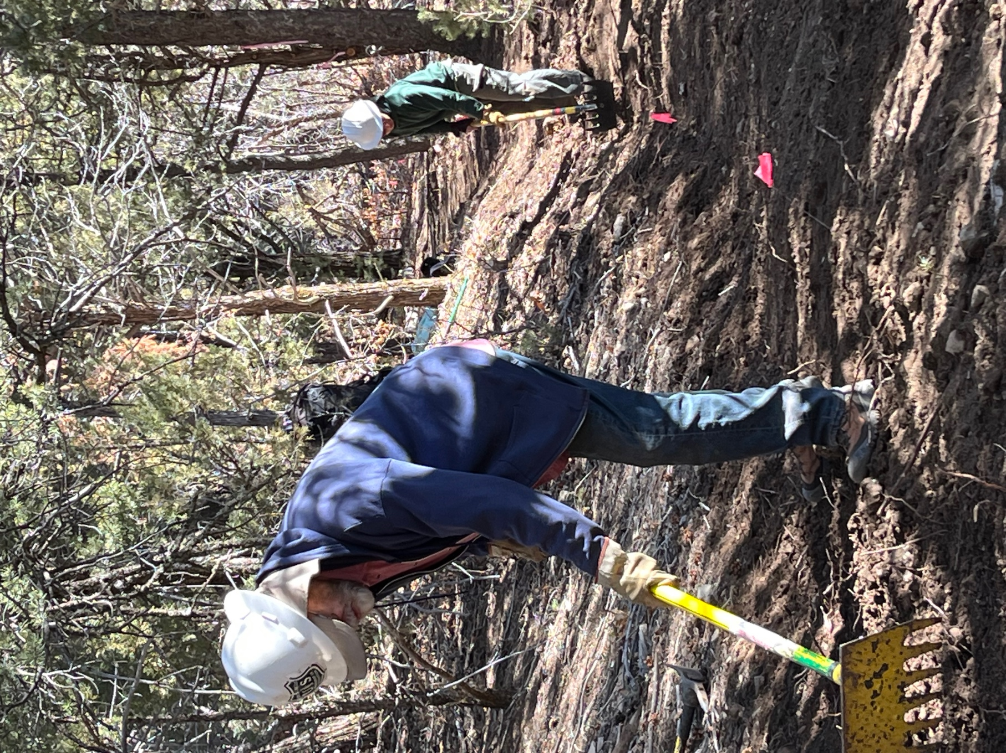

Bruce and Jen connected up sections of reroute #1 trail.

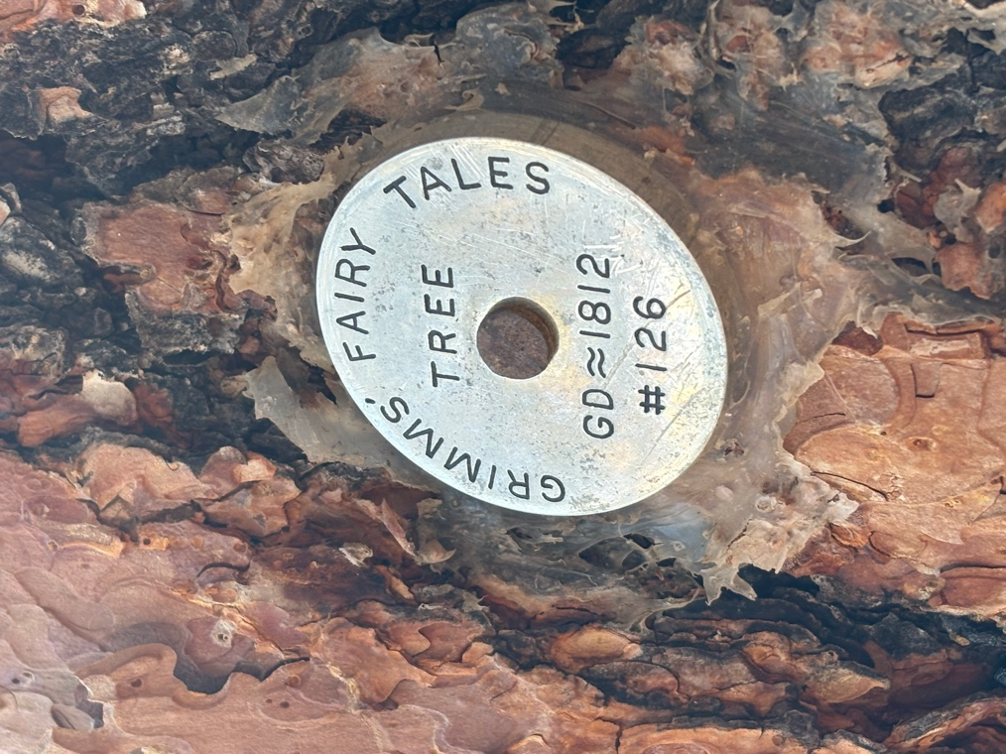
Tony and Jim found treasures at the stash site.

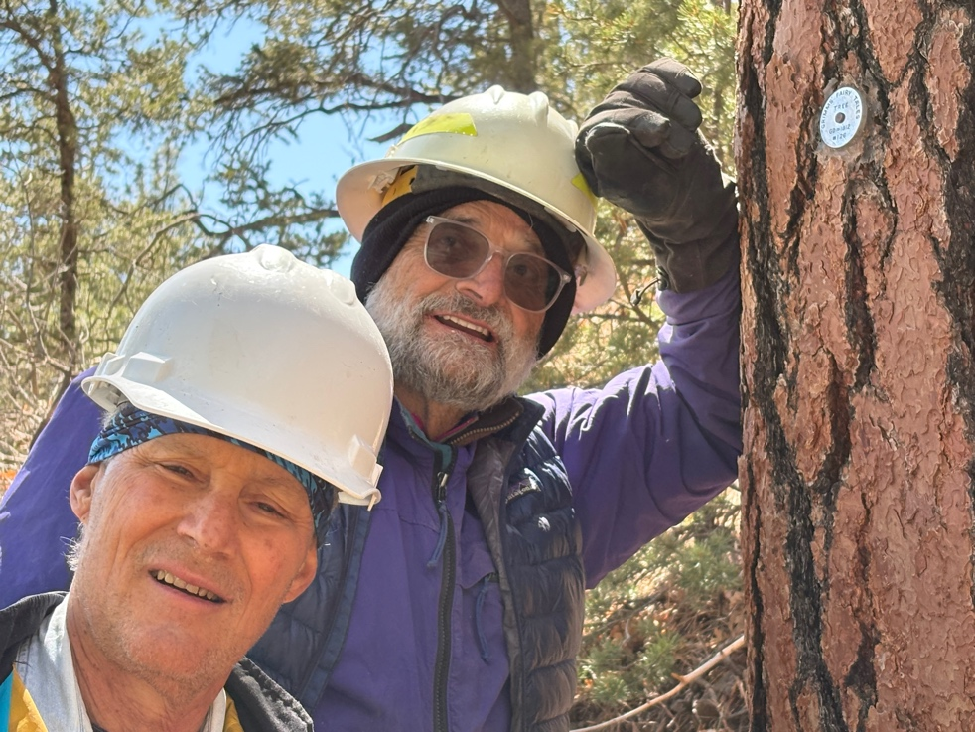
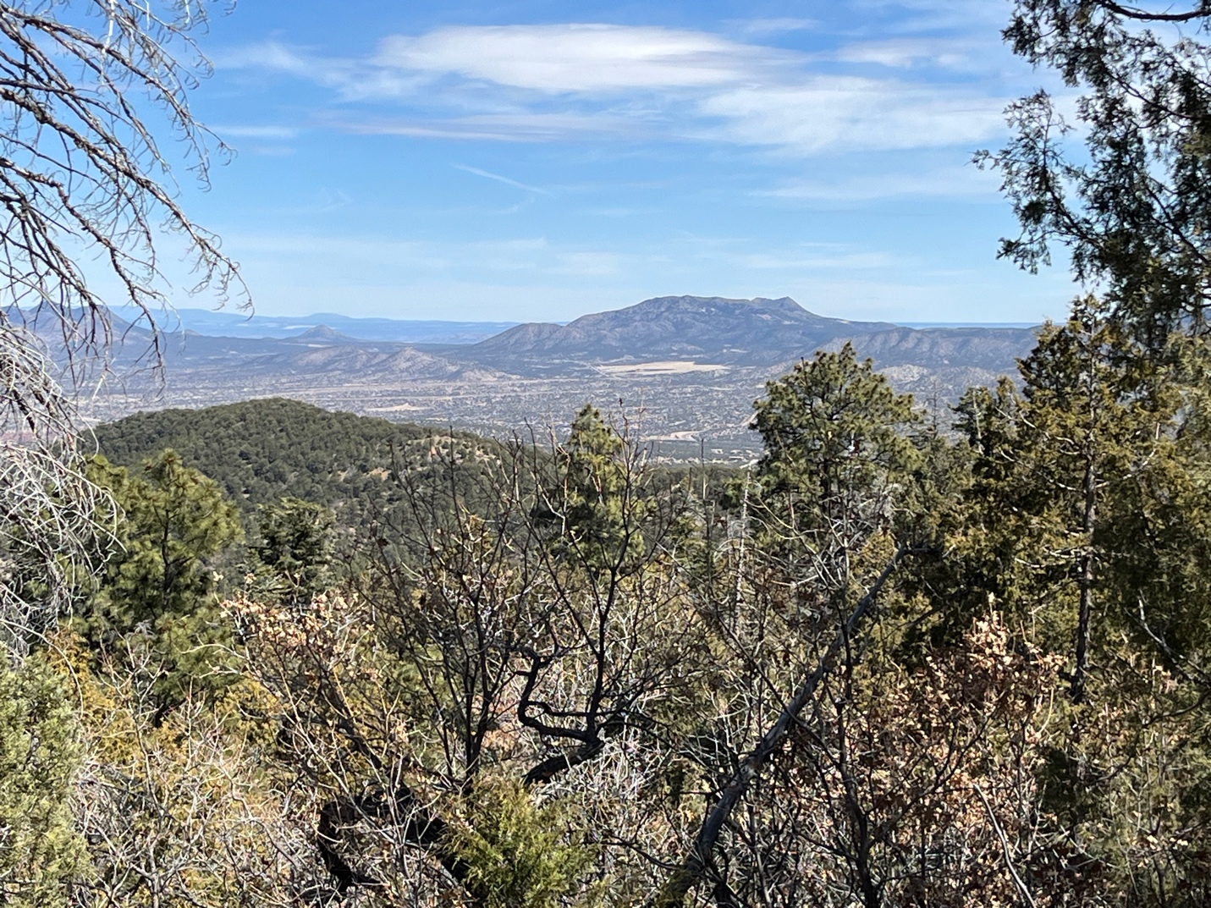

We had a view of great vistas on the hike back to the cars.

