**Report of FOSM Volunteers Felling Hazard Trees in Doc Long and Cienega Picnic Areas on Wednesday, March 19, 2025**

Sam Beard

On Wednesday, March 19, five FOSM volunteers felled five hazard trees selected by Canyon Young, SRD Trails and Wilderness Manager, in Doc Long and Cienega Picnic Areas. The tree diameters ranged from12 inches to 25 inches. Most of the trees behind the locked gate on Cienega Road were limbed and bucked. One large pine tree in Doc Long PA is near the Crest Highway was limbed but not bucked, because the bucked wood would be easy to steal.

On future work days, we will fell a couple more trees, limb, buck, and split the logs and haul the split to a Mountain Christian Church wood lot.

Project photographs are presented below.

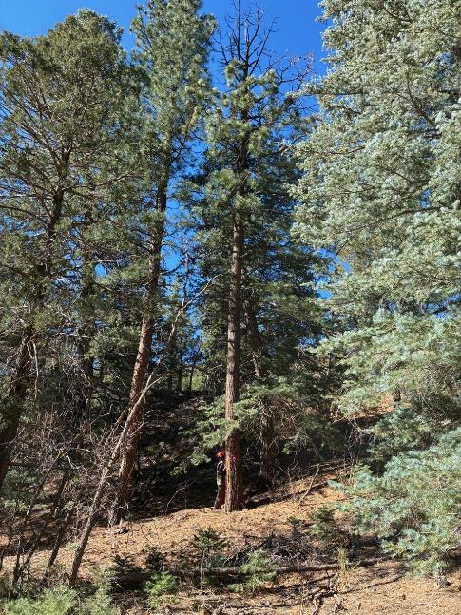

Tall hazard tree with dead top on old paved road near Doc Long Picnic Area.

All photos by Cliff Giles

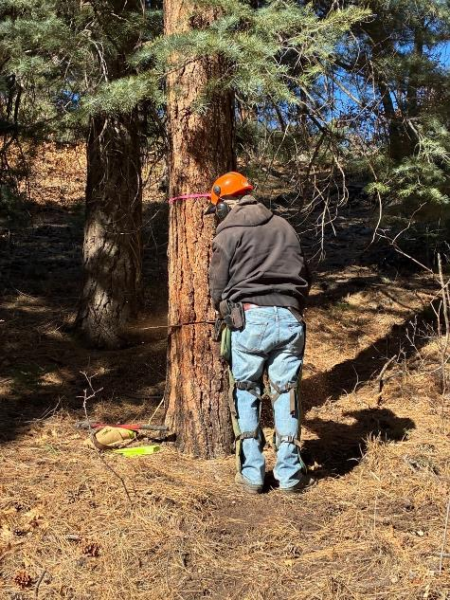

Jerry Carroll felling the tall pine.

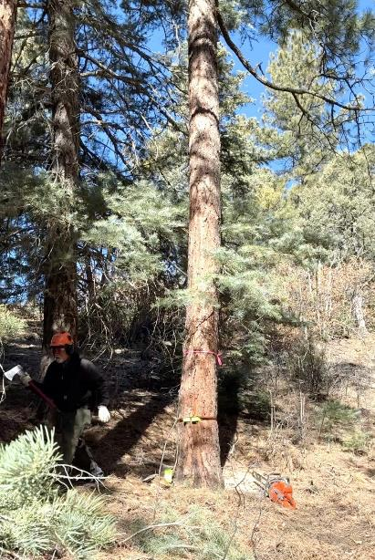

Jerry running away from tree that he has just felled using wedges.

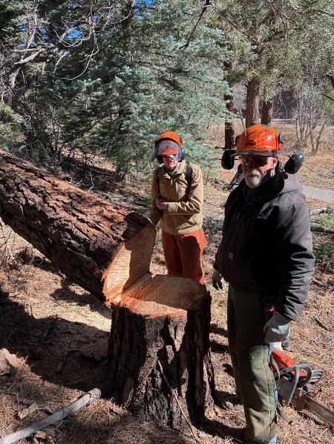

Sim Cook and Jerry Carroll “reading the stump”. Examination of the stump reveals the depth of the face

cut, thickness of the hinge wood, and height of the stump shot. Face cut depth is usually 1/3 of the diameter.

The stump shot is the height of the felling cut above the horizontal base of the face cut.

The purpose of the stump shot is to prevent the rapid movement of the cut end back across the stomp.

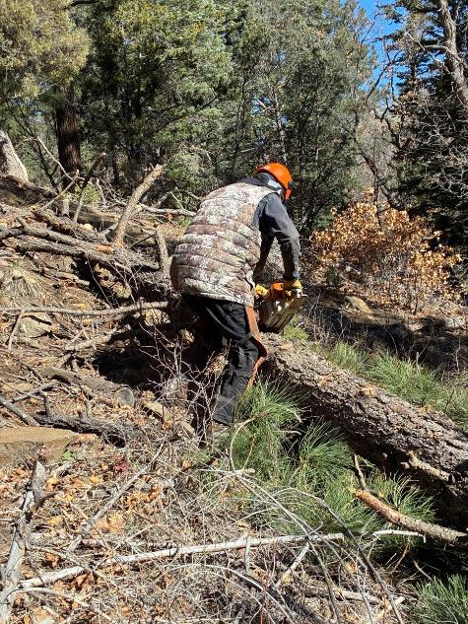

Dan Benton limbing the felled pine tree.

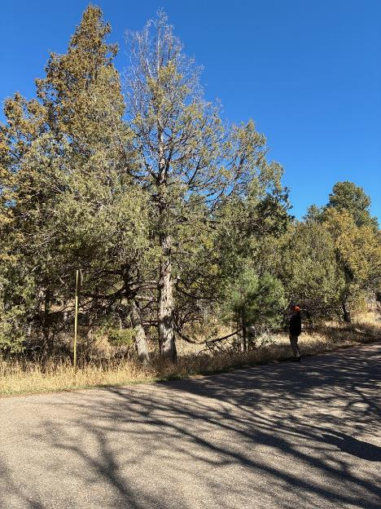

Rocky Mountain juniper hazard tree with a dead top at the tee intersection

at the entrance to Cienega Picnic Area.

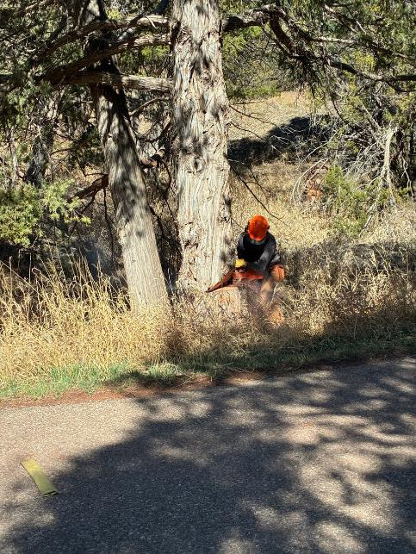

Dan Benton making the face cut in the large RM juniper.

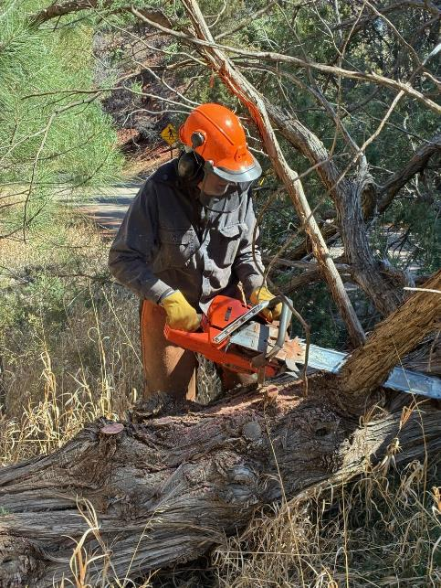

Dan limbing the felled juniper.

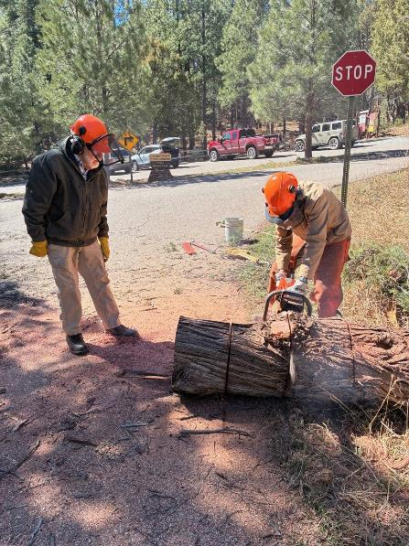

Sim Cook bucking the large RM juniper.

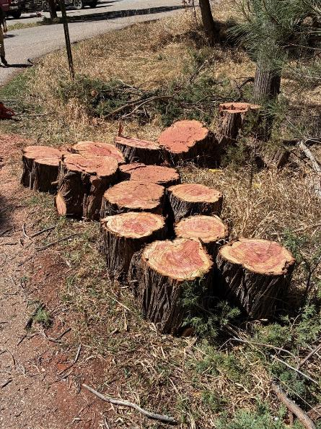

Rounds from the felled RM juniper. These rounds will be split with Lou Romero’s power splitter

and hauled to the Mountain Christian Church wood lot. Wood Ministry church member will

distribute the wood to East Mountain families who need wood to heat their homes.

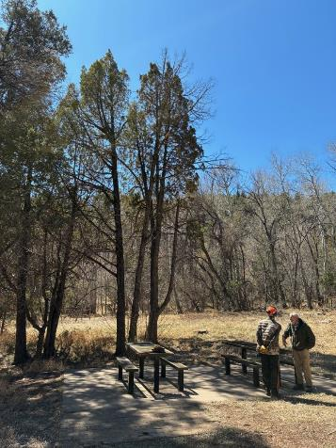

Dan Benton and Sam Beard at the leaning dead juniper behind the picnic table in Cienega

Picnic Area above the upper parking lot.

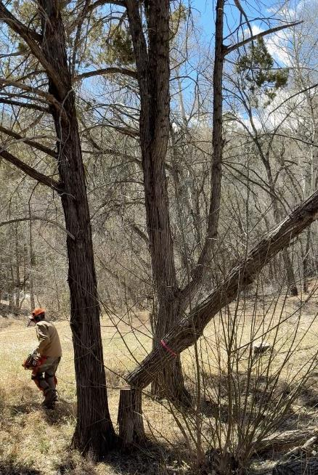

Sim Cook running away from the hazard tree he has just felled.

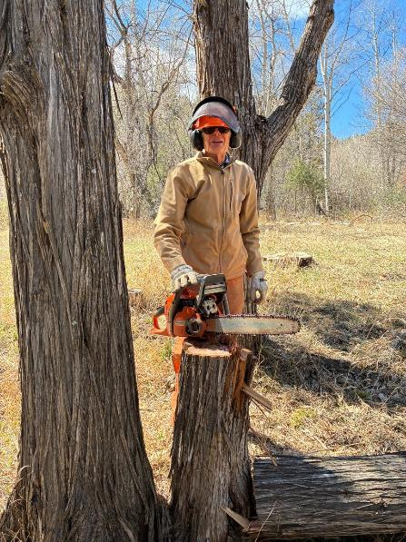

Sim at the stump.

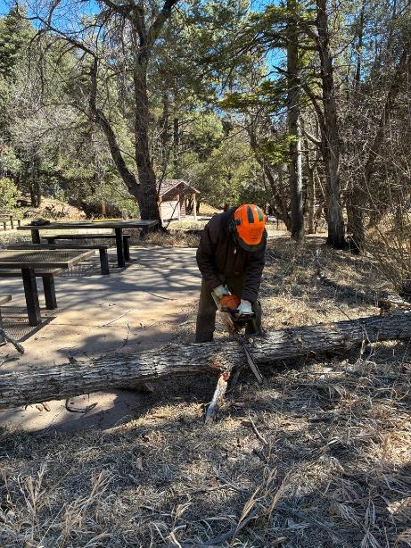

Jerry Carroll bucking the juniper that Sim has just felled.

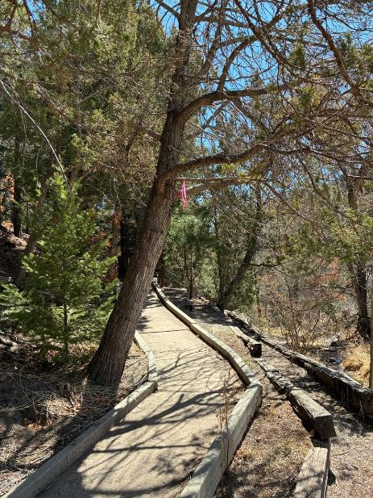

Leaning dead RM juniper over Cienega Nature Trail.

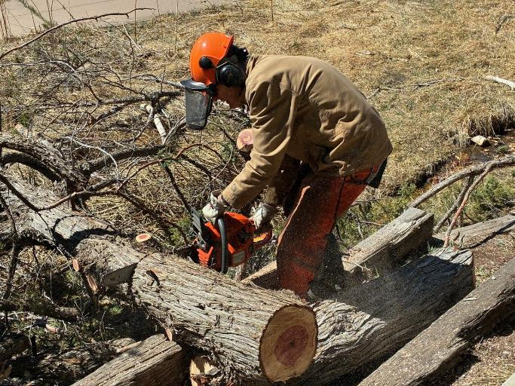

Dan Benton bucking the juniper that Sim just felled.

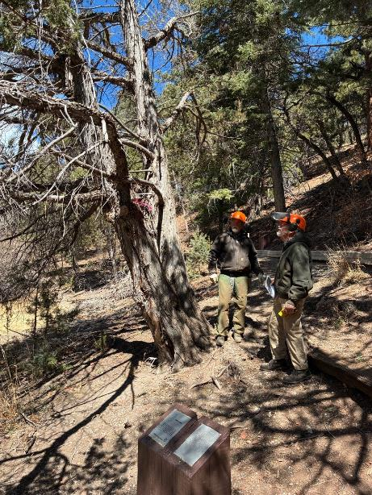

Jerry and Sam looking at the dead RM juniper with two trunks near the Nature Trail.

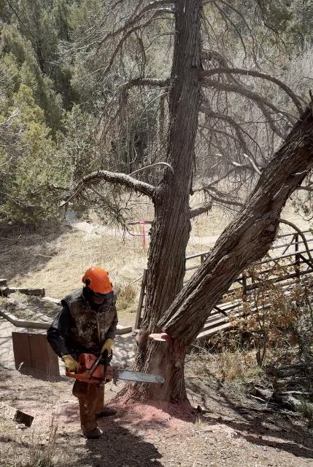

Dan running away from the juniper he has just felled.

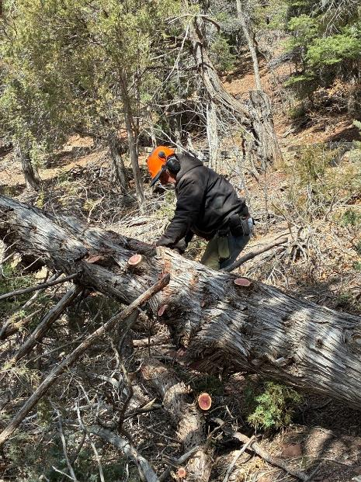

Jerry limbing the large juniper felled by Dan.

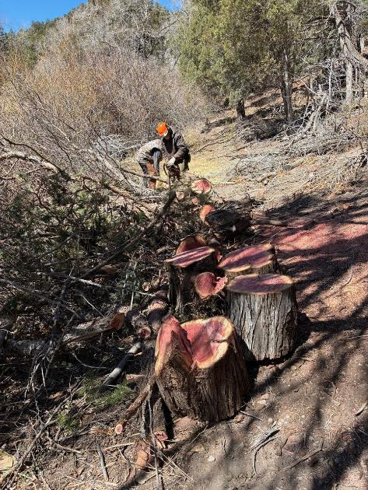

Dan and Jerry bucking the large juniper with the rounds in the foreground.