**Report of FOSM Splitting Hazard Tree Rounds in Cienega Canyon Picnic Area**

**on Wednesday, March 26, 2025**

Sam Beard

On Wednesday, March 26, seven FOSM volunteers split donation wood at three locations in Cienega Picnic Area. The volunteers had earlier felled and bucked trees that Canyon Young, SRD Trails and Wilderness Program Manager, had selected as hazard trees.

The volunteers were Lou Romero, Dennis Crowther, Dan Benton, Sim Cook, Rene Archer, Cliff Giles, and Sam Beard.

Projects photos are presented below.

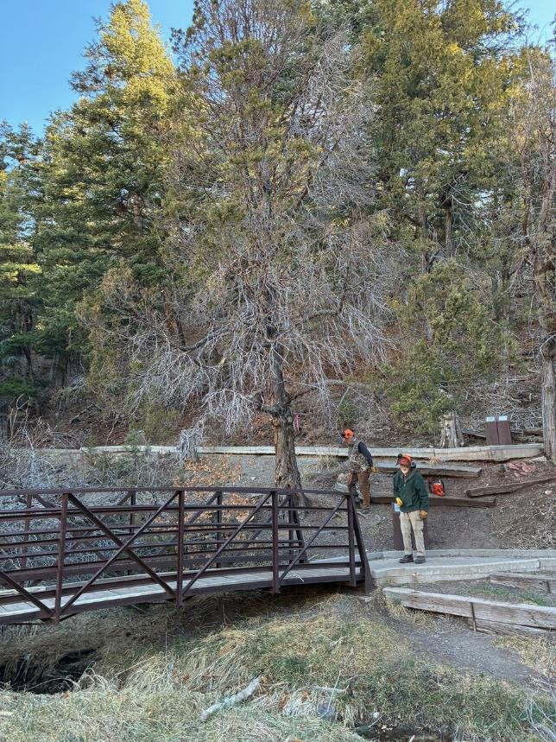

Dan Benton and Sam Beard at the lower bridge on the Cienega Nature Trail where Dan will

fell the large Rocky Mountain juniper on the hillside. All photos by Cliff Giles unless stated otherwise.

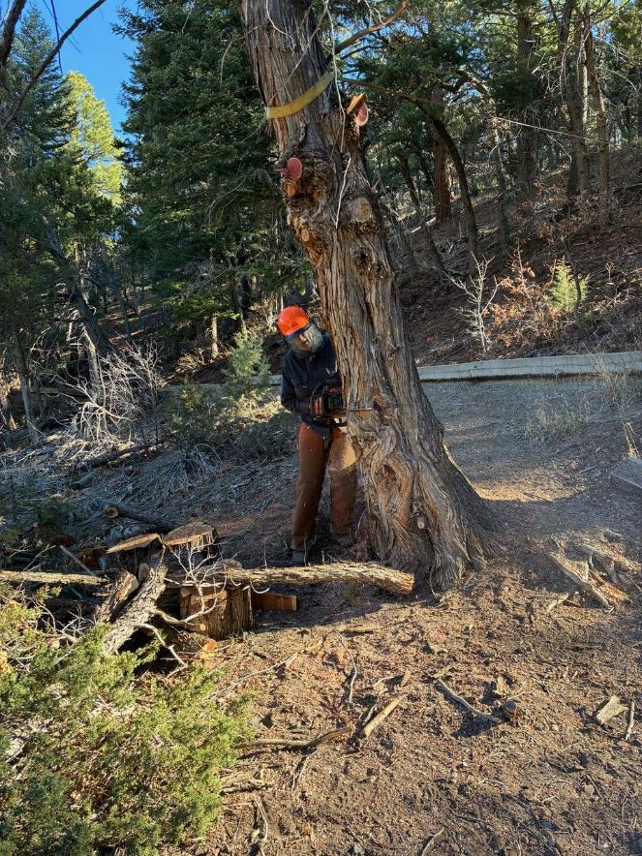

Dan beginning the face cut.

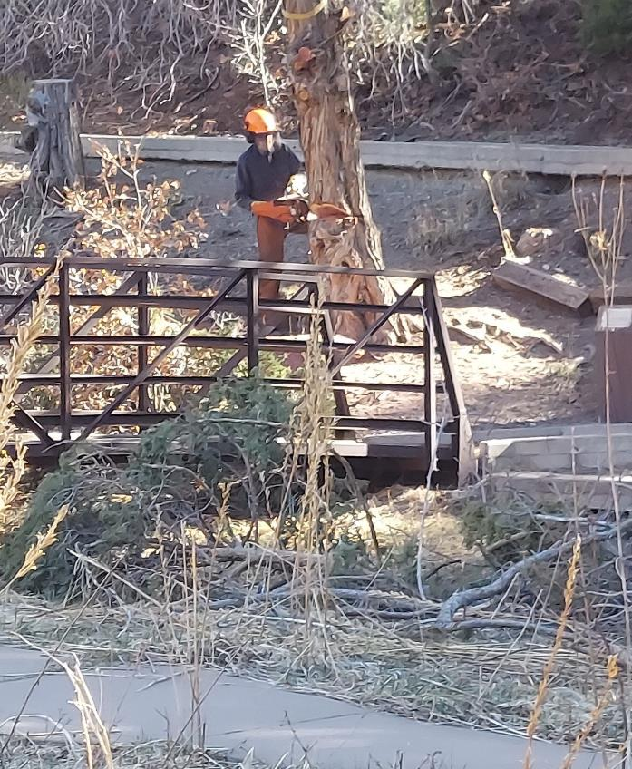

Dan has completed the face cut. Photo by Rene Archer

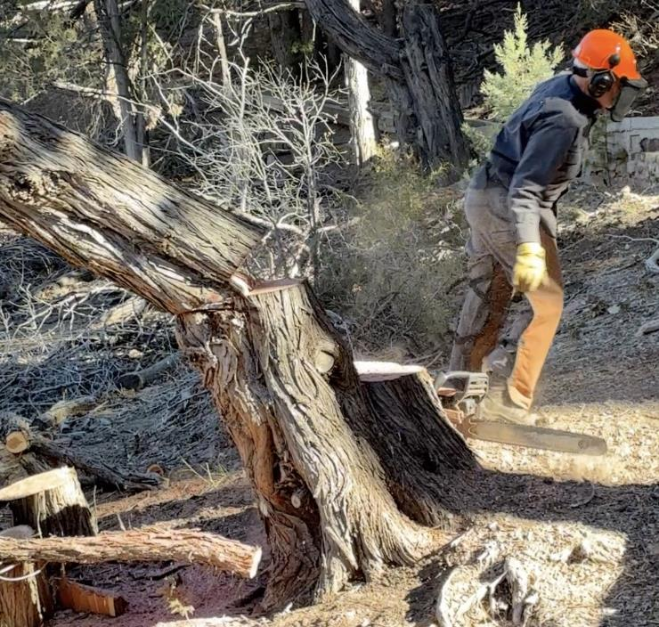

Dan running away from the falling tree.

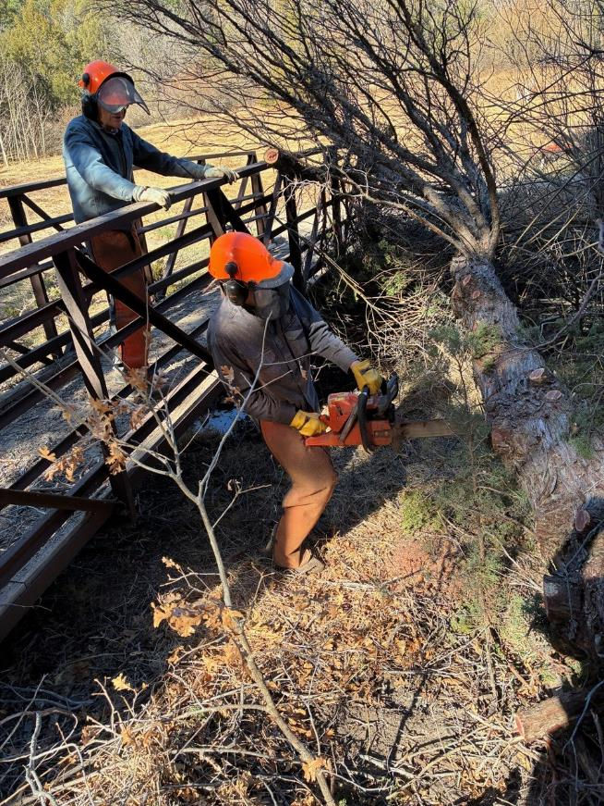

Sim Cook observing Dan bucking the trunk and limbing.

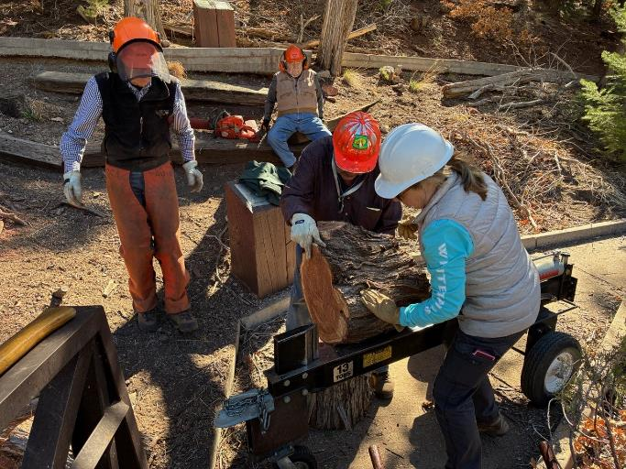

L to R: Sim Cook, Lou Romero, and Rene Archer splitting a large round

from the Rocky Mountain juniper.

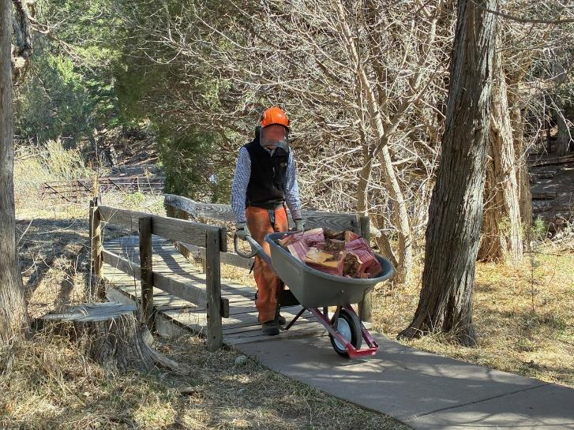

Sim moving split wood from the bridge to the road at the middle restroom.

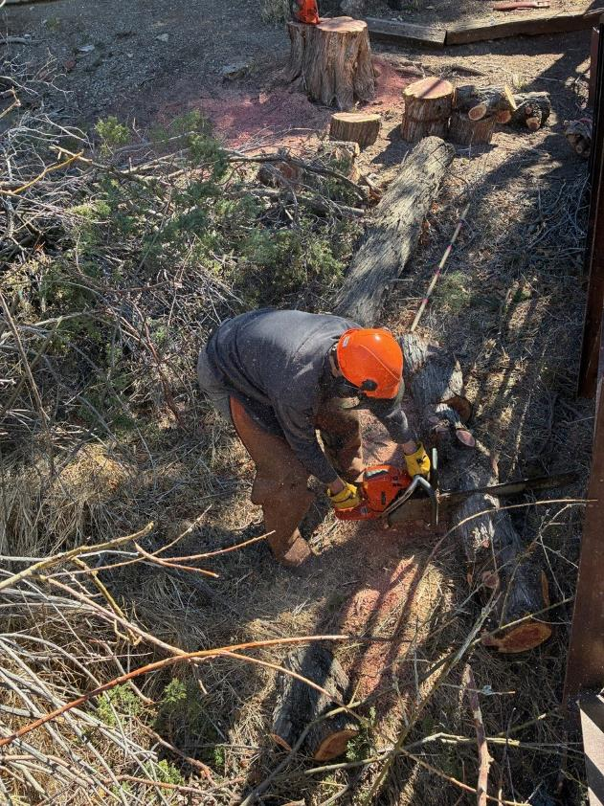

Dan continues bucking the trunk at the bridge.

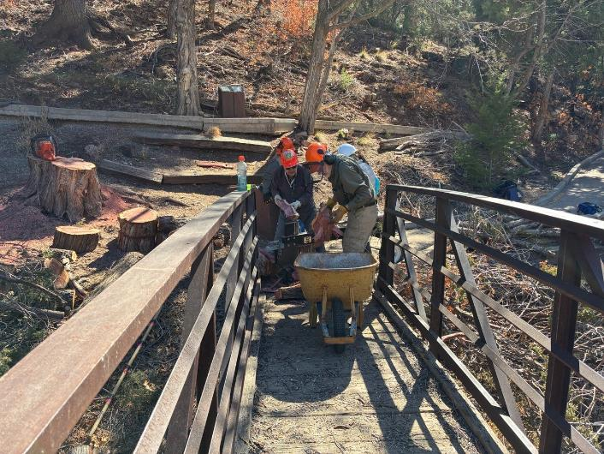

Lou, Sam, and Rene splitting rounds and loading the wheelbarrow.

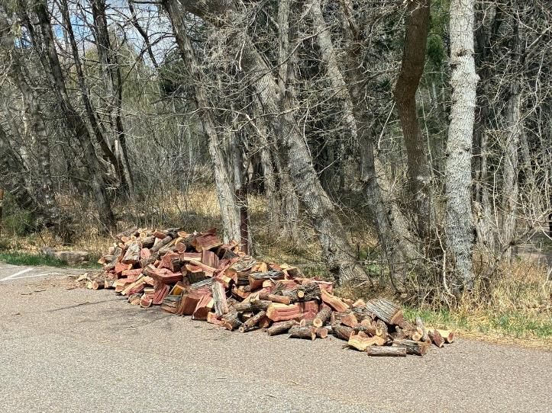

The large pile of split wood at the middle restroom.

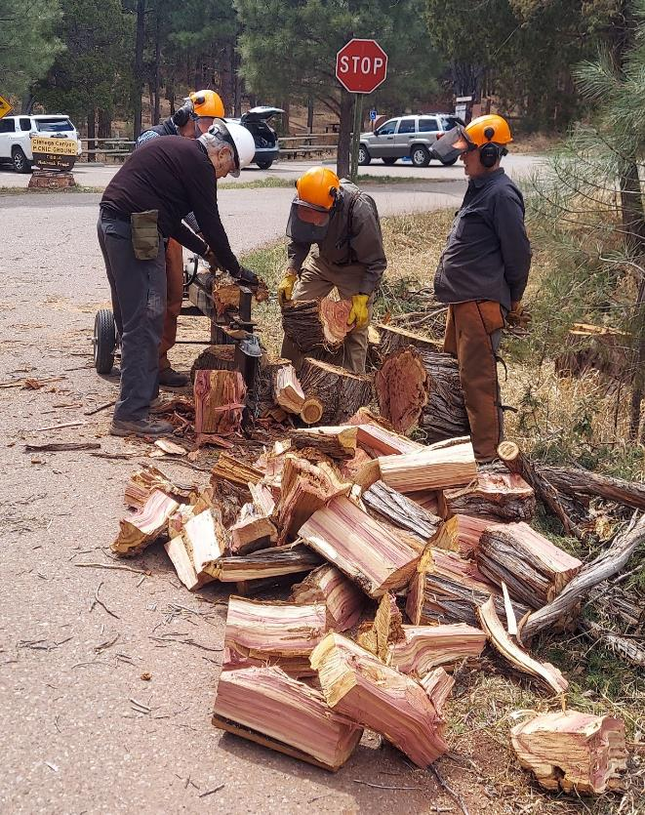

Sim, Cliff, Sam, and Dan splitting wood at the tee intersection at the entrance to Cienega PA.

Photo by Rene Archer

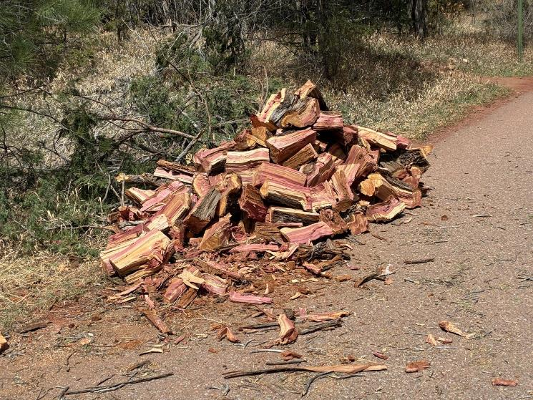

Pile of split wood near where Acequia Trail crosses the road.

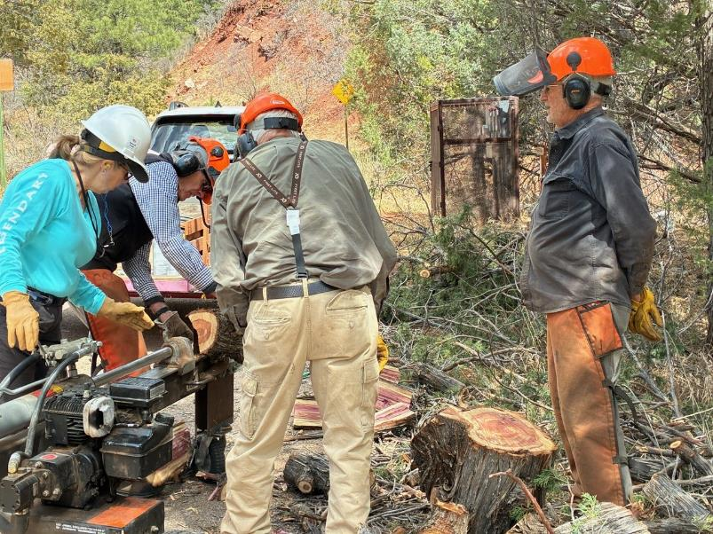

Rene, Sim, Sam, and Dan split wood on the other side of the road using Lou’s power splitter.

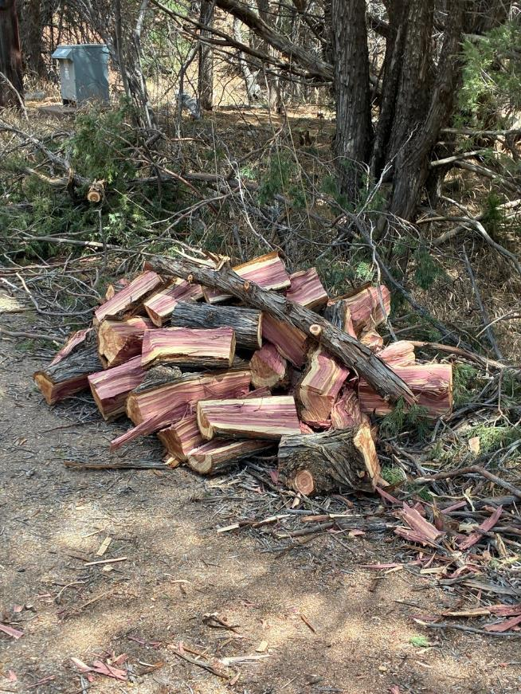

The last pile of wood split in Cienega Canyon Picnic Area on Wednesday.

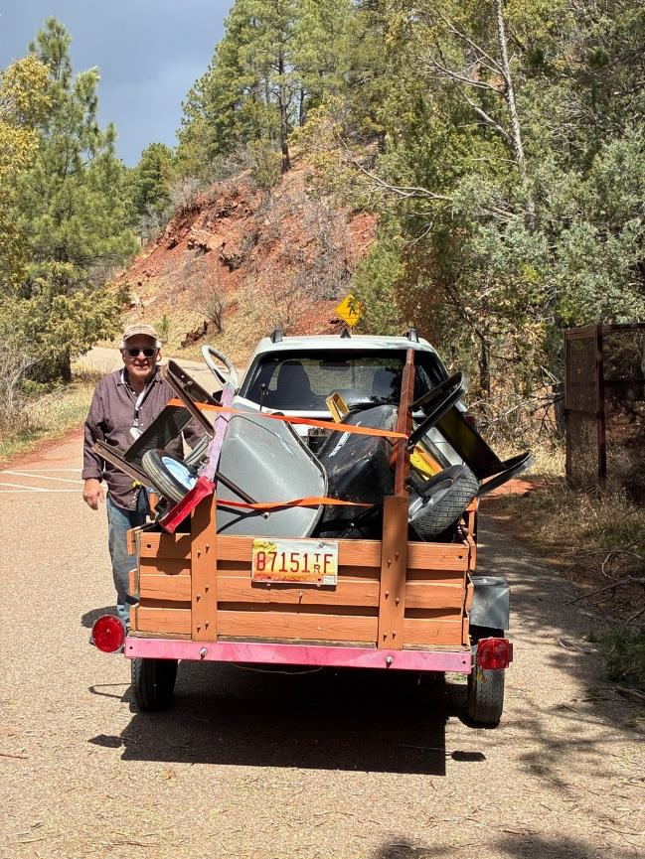

Lou is ready to haul his splitter and other equipment to the FOSM Guard Station.