Thursday, 03/27/25- North Faulty: A nice day for a hike! Eleven volunteers and Jen (SRD) headed out on North Faulty to reroute #5. It was bit of a hike but fortunately the tools were stashed so the burden was not bad. Jen and Laura worked on flagging the steep slope and once the tools were out and the crew was ready, work commenced. It was tricky getting purchase to start swinging tools as the slope was steep and the ground was either loose rocks or ponderosa needle duff. It was definitely a slippery slope! The group had lunch looking out on a beautiful vista with a nice light breeze. A few folks took a short break after lunch to see some of the really old trees with medallions on them but then it was back to work. Progress was slow but steady and we have several more weeks of work in this area.

Volunteers: Bruce Hansche, Laura Leon, Jim Houle, Claudia Bergsohn,
John McNett, Eric Russell, Bill Perkins, John Braly, Byron Garner, Luis Cuadros,
and Rich Fagioli.

Pictures: Laura Leon

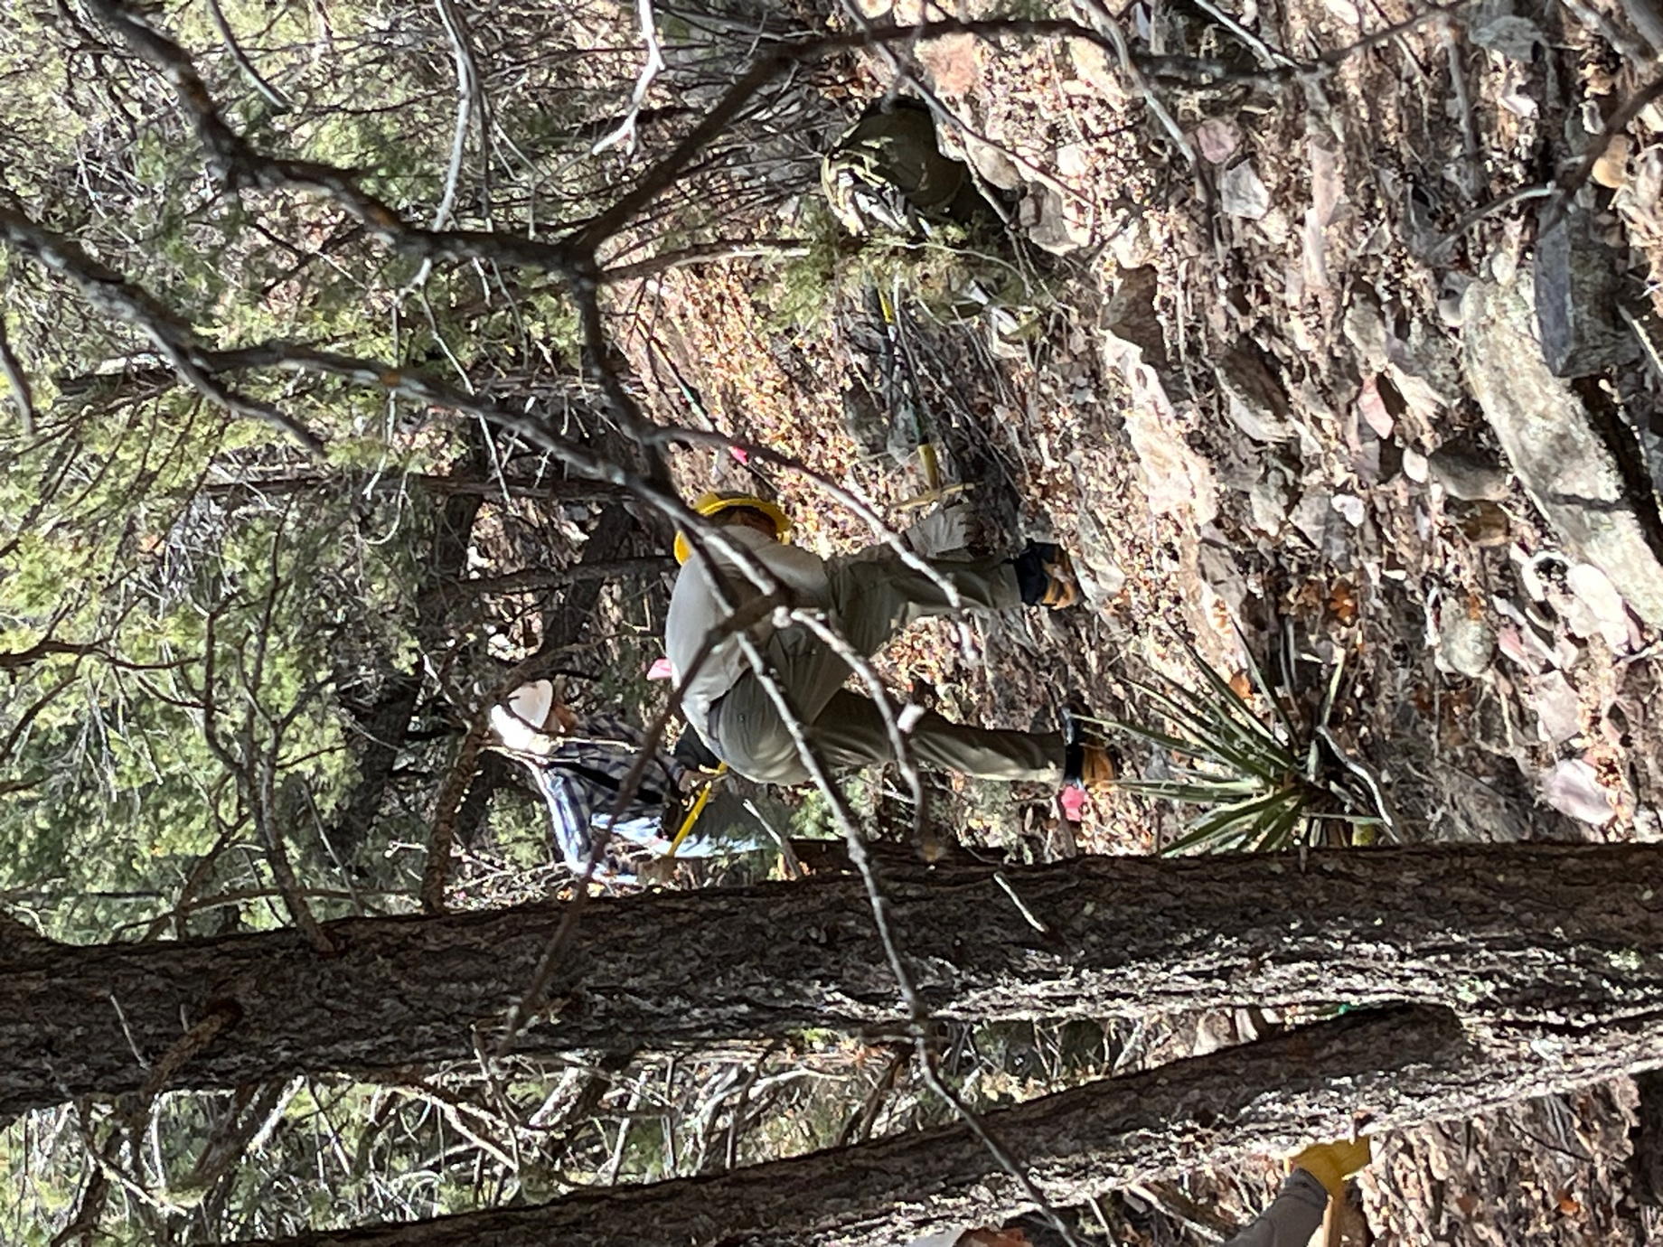

John B. and Bruce got to work on a rocky section.
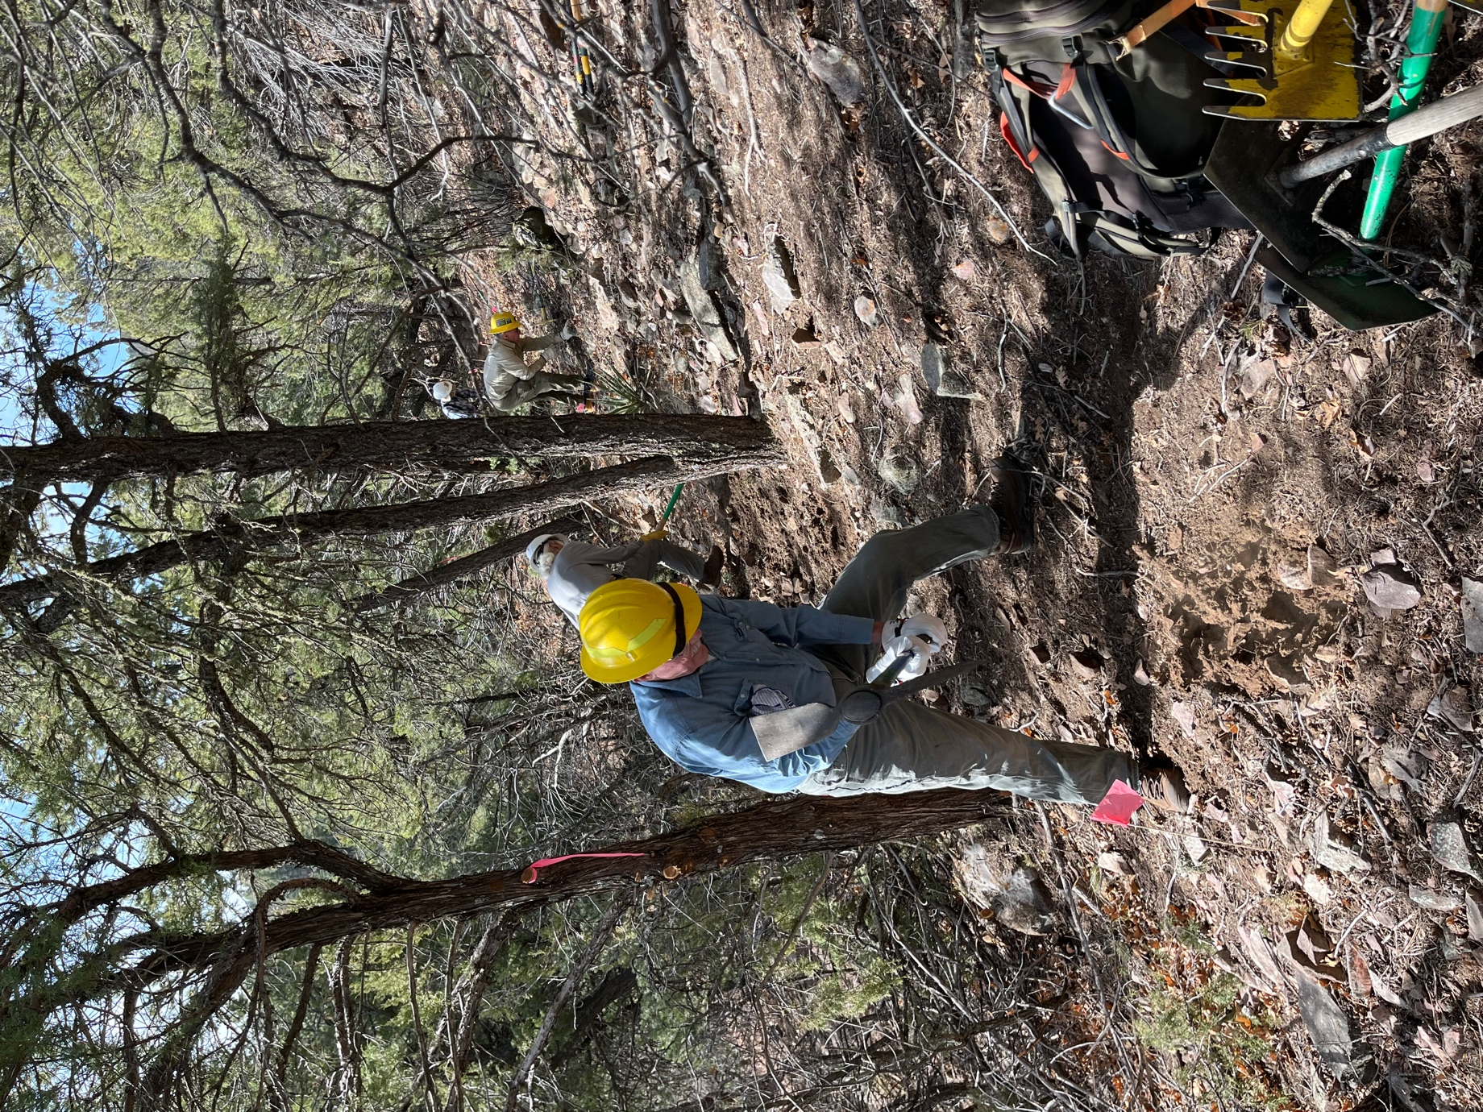

Eric and Bill worked another rocky area.

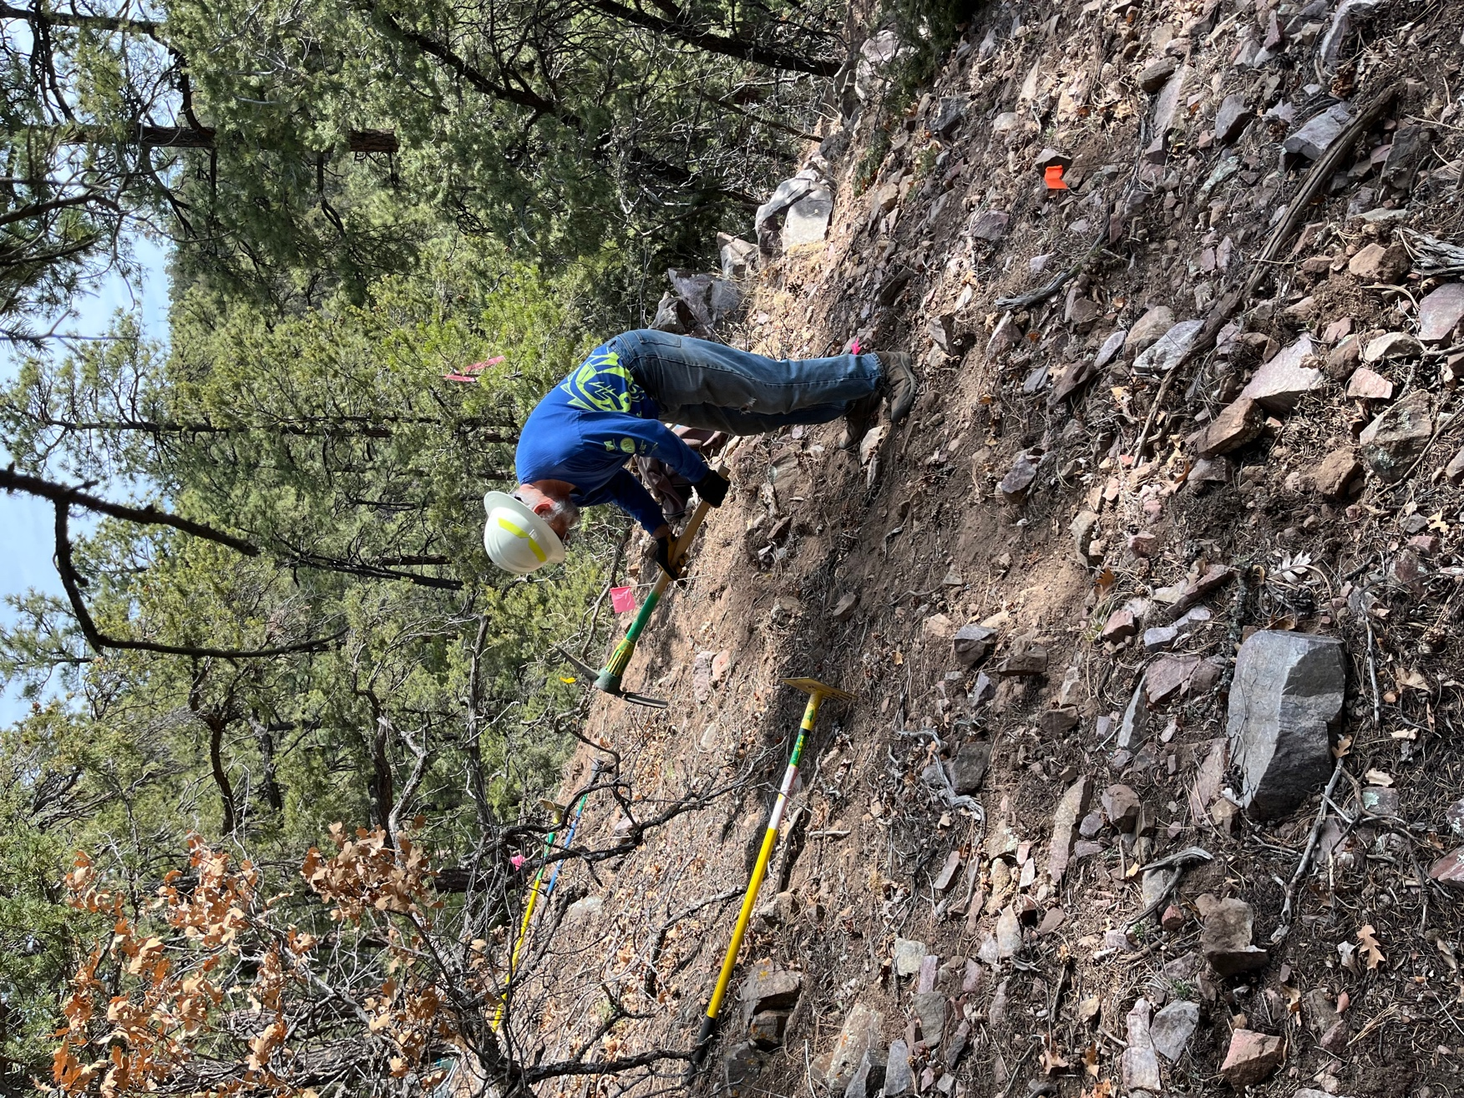

Jim was looking for rocks to smash- most of them just slid down the slope.
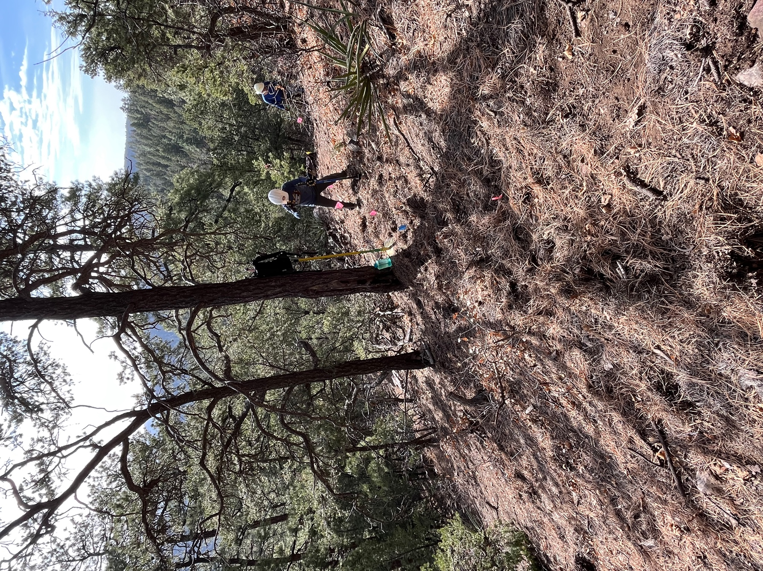

Claudia started in where the ponderosa duff started.

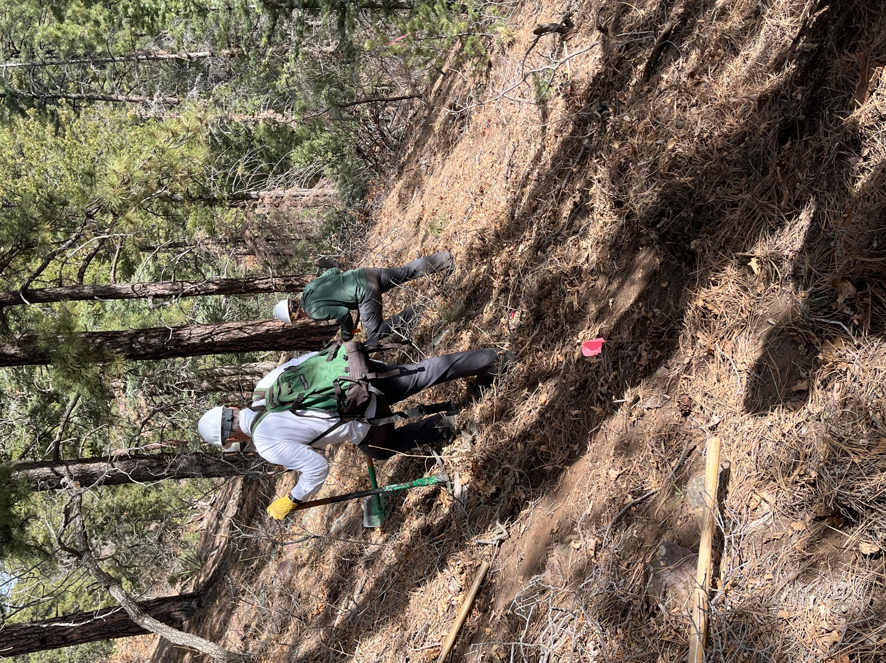

Rich and John M. tried to get a footing so they could start work.

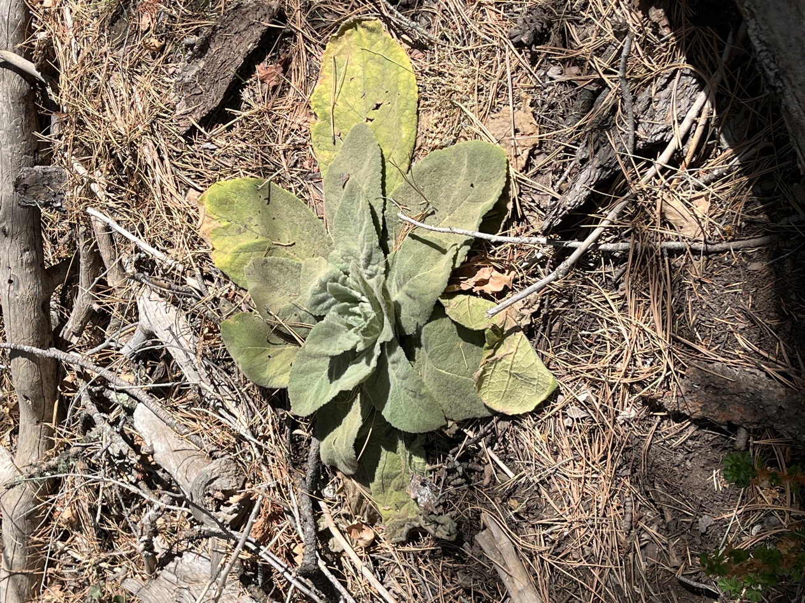

Some mullen growing in the duff.

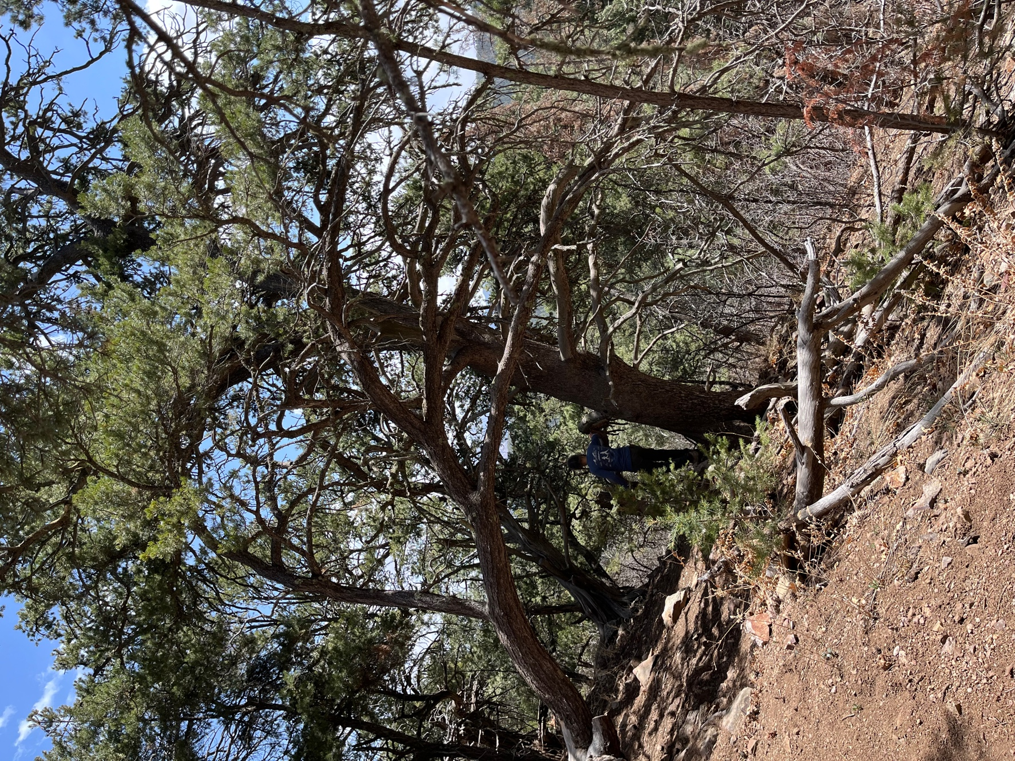

Claudia near some large old pinions.
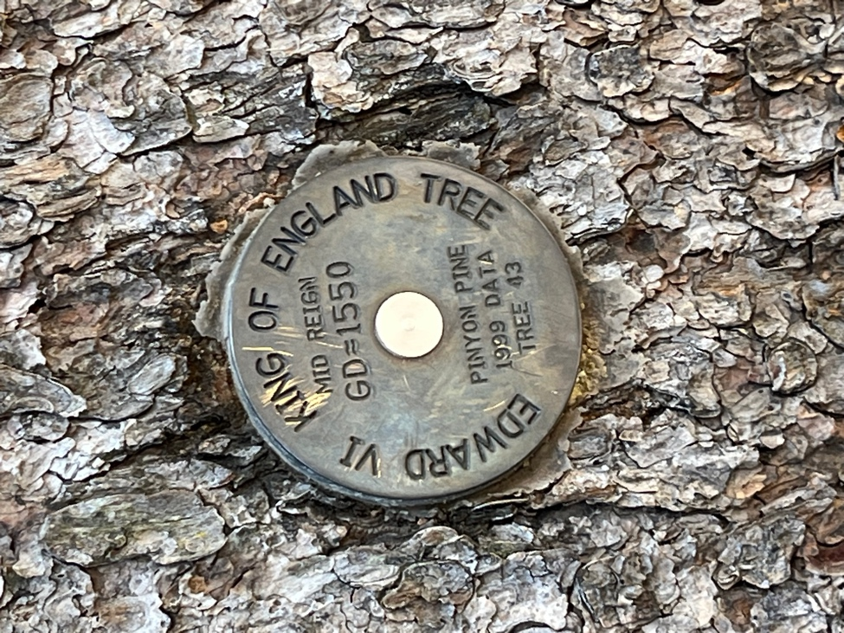 Medallions mark some really old trees>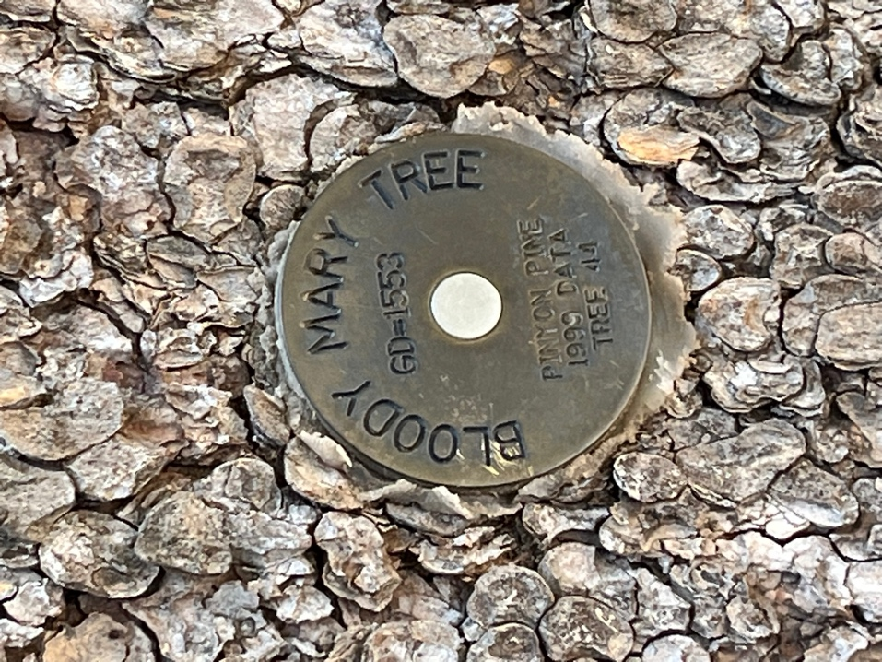
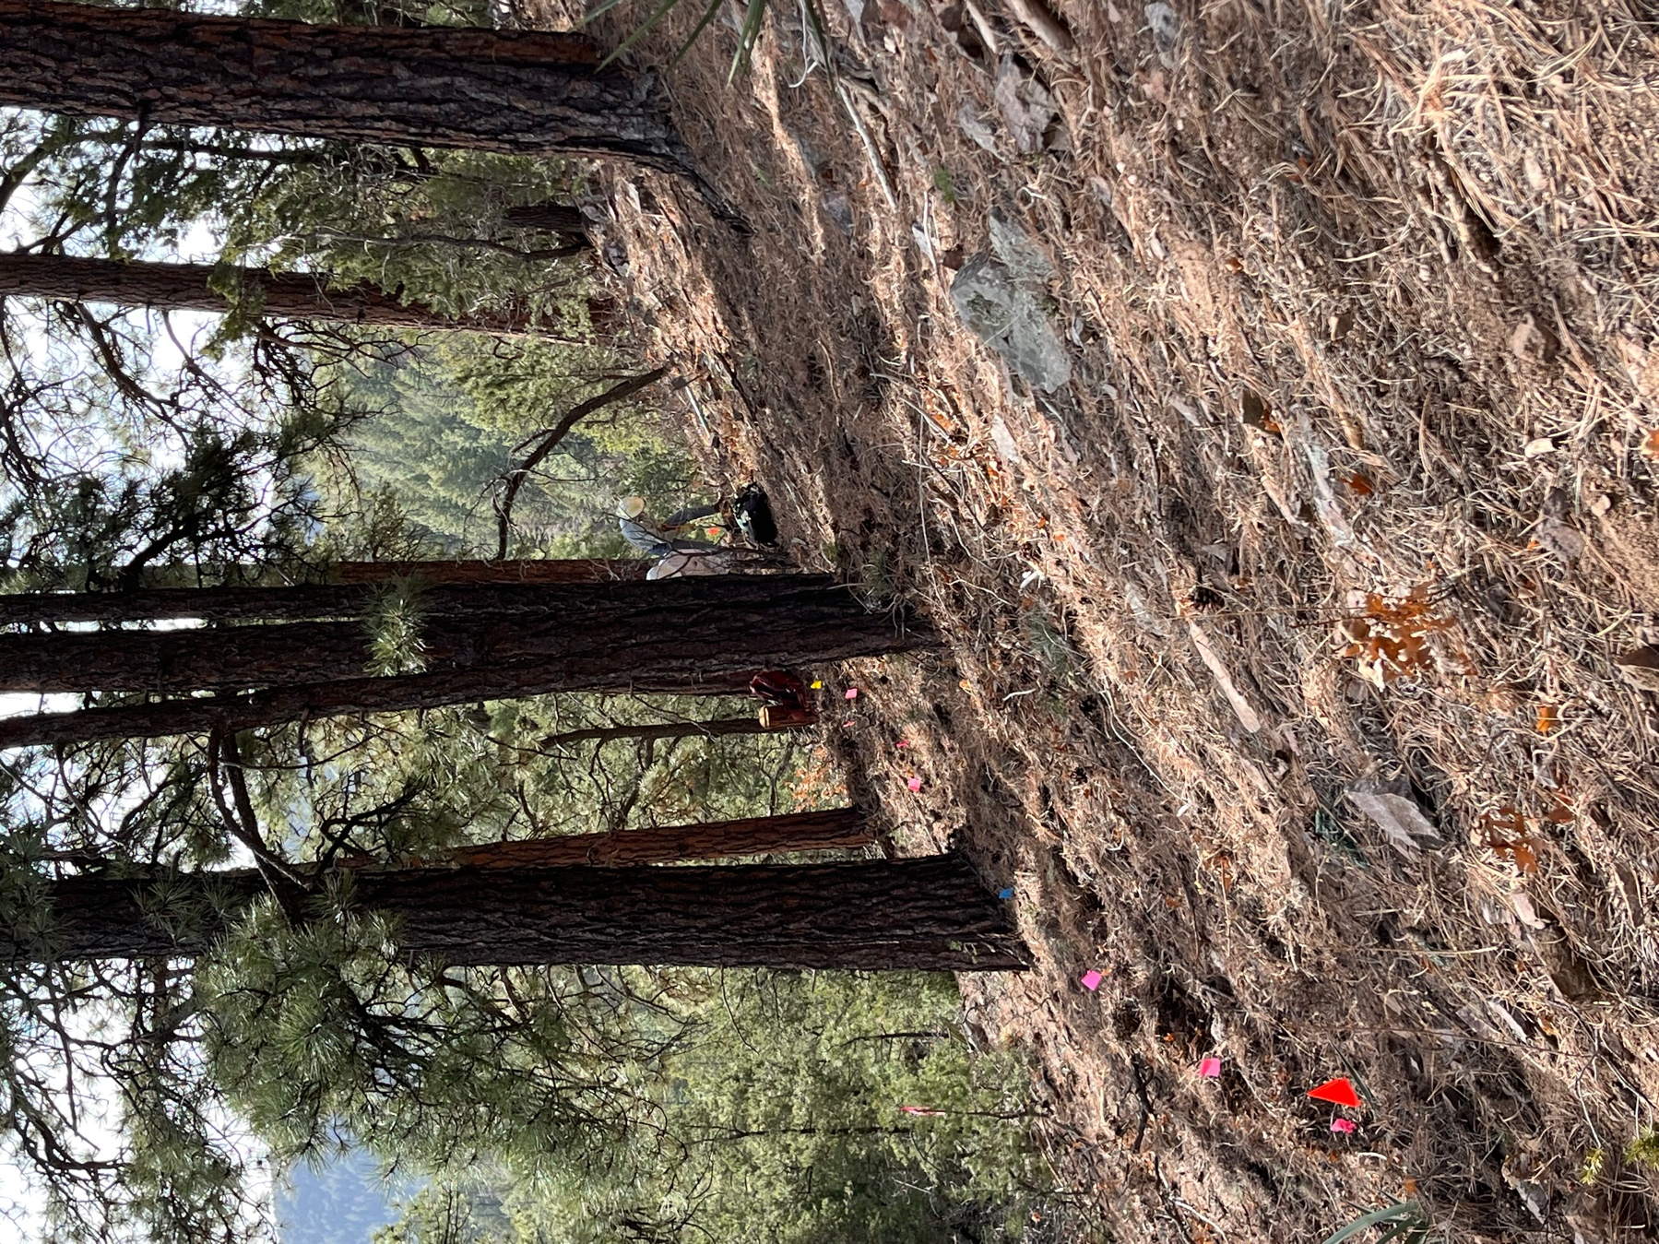

Byron was back to the grind after lunch- why is it always so much harder after lunch??

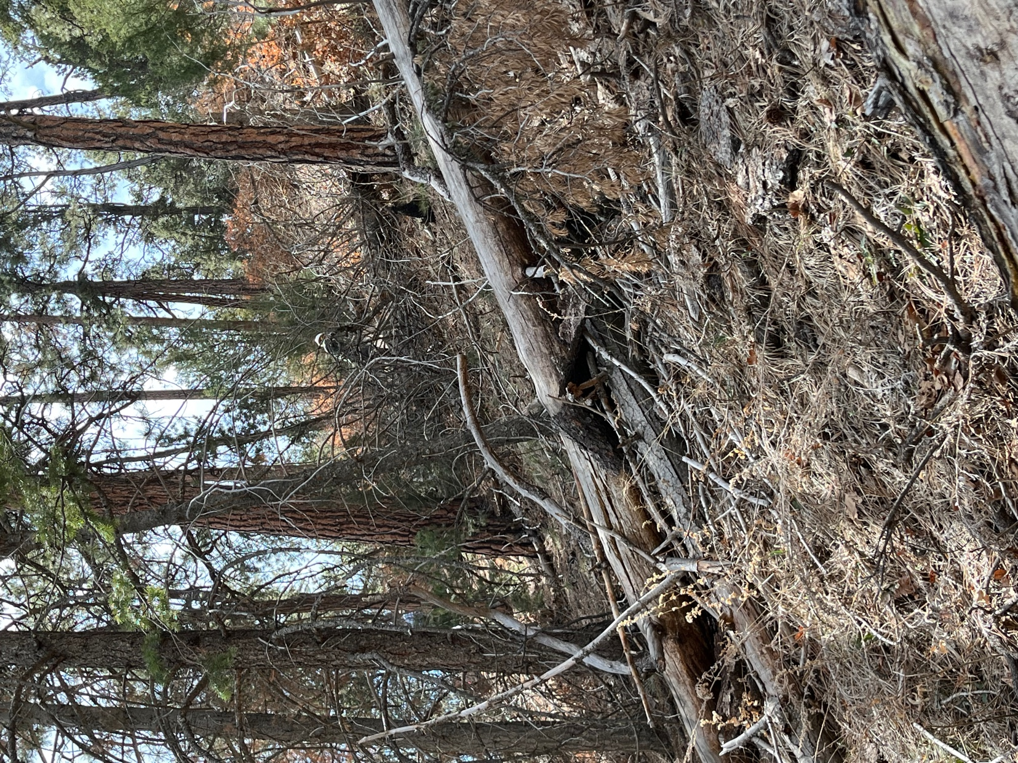

This shot is looking up to the new trail from the old trail.

