**Report of FOSM Project to Restore the Large Cibola National Forest Sign on the Crest Highway**

**below Doc Long Picnic Area, Saturday, March 29, 2025**

Sam Beard

On Saturday, March 29, Michael Arndt and Sam Beard completed the first part of a FOSM project to restore the large Cibola National Forest sign on the Crest Highway below Doc Long Picnic Area. Earlier Sam had noticed that the top board on the uphill side of the sign was missing. It was found on the ground beside the sign. The longer top board on the downhill side of the sign was removed, because it was being held in place by one nail.

The two boards were taken to the FOSM Guard Station where they were restored with System Three epoxy paste and liquid epoxy. Two coats of USFS brown paint were applied to the two boards. On Saturday, Michael and Sam installed four pieces of pressure treated 4 x 4 lumber on the second board down between the two sides with 4-inch timber screws, and the top tapered boards on both sides of the sign were reinstsalled with screws. The north end of the third board down on the uphill side was also resecured with screws.

The next step in restoring the sign will be to paint it with brown paint.

Project photos are presented below.

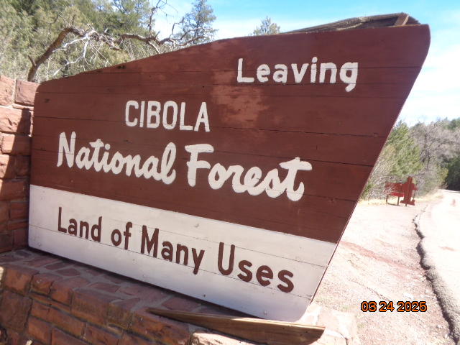

The short-tapered board (at the bottom of the photo) on this side of the sign fell off and was found on the ground beside the sign.

All photos by Sam Beard

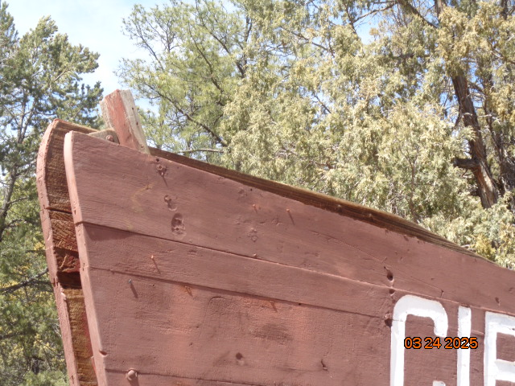

Both tapered top boards of the sign were taken to the FOSM Guard Station for restoration.

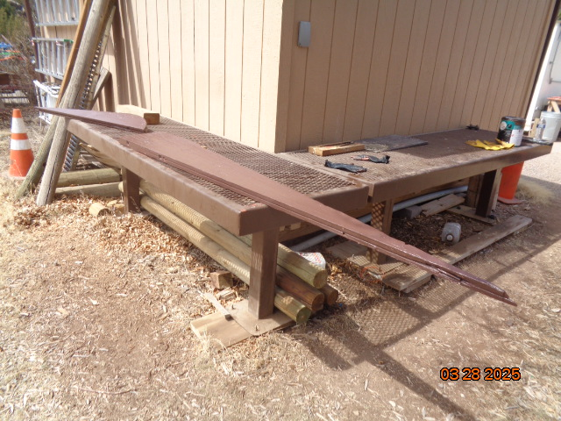

Cracks in the boards were filled with epoxy paste. After the boards were painted with a coat of epoxy liquid,

two coats of USFS brown paint were applied.

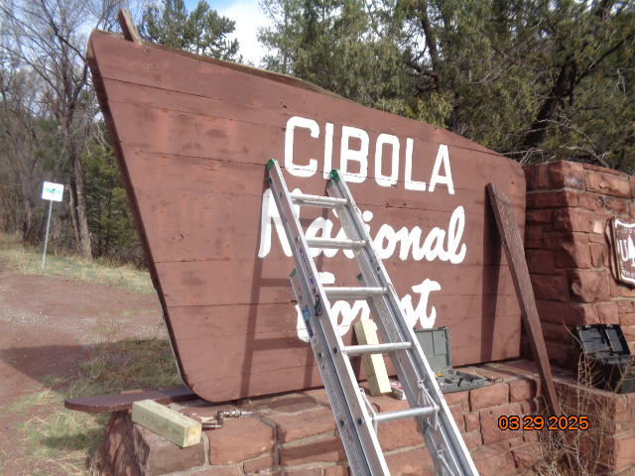

The restored top board on the right is ready to be reinstalled on the downhill side of the sign.

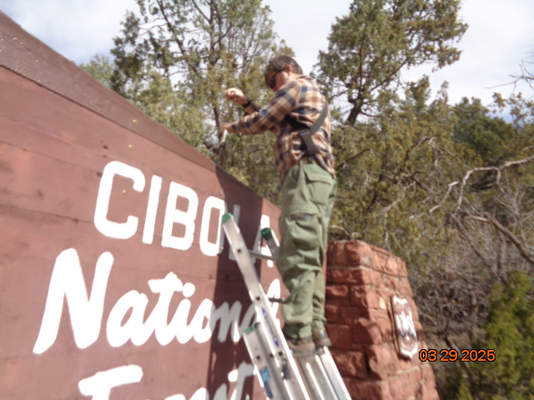

Michael is drilling a hole to install the last screw in this top board.

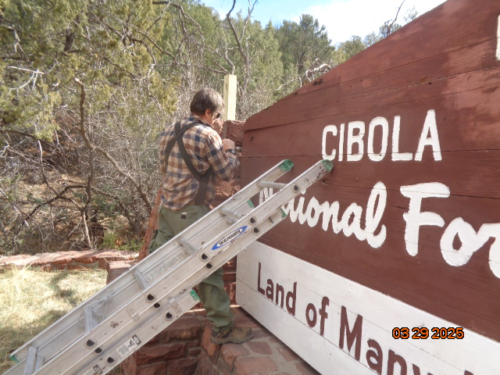

Michael is working on securing the end of the third board which is protruding out from the other boards.

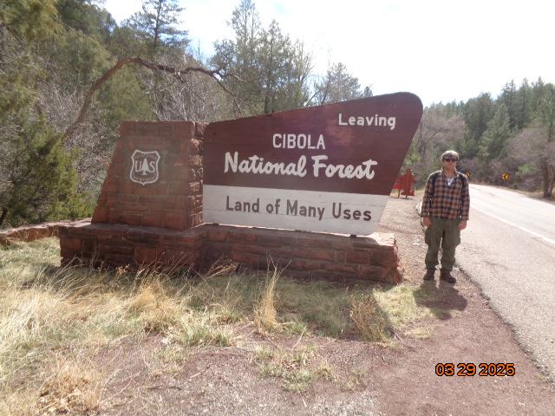

The top tapered boards on both sides of the sign have been restored and reinstalled.