**Report of FOSM Project to Split and Haul Donation Wood in Cienega Canyon Picnic Area on Wednesday, April 2**

Sam Beard

On April 2, FOSM volunteers processed three piles of bucked wood in Cienega Picnic Area and loaded the wood on Mike Oliver’s trailer to be taken to the Mountain Christian Church woodlot. The Wood Ministry will donate the wood to East Mountain families who heat their home with wood next winter.

After all the wood had been loaded on the trailer in Cienega PA, the crew moved to the top gate on the road to the picnic are where they bucked three trees that had been felled as hazard trees last year. This bucked wood was split and hauled to a pile at the gate. It will be hauled in Mike’s trailer to the woodlot later this spring.

The volunteer working on this project were Sim Cook, Stuart Cook, Sam Beard, Lou Romero, Dan Benton, Jerry Carroll, Cliff Giles, and Mike Oliver.

Project photos are presented below.

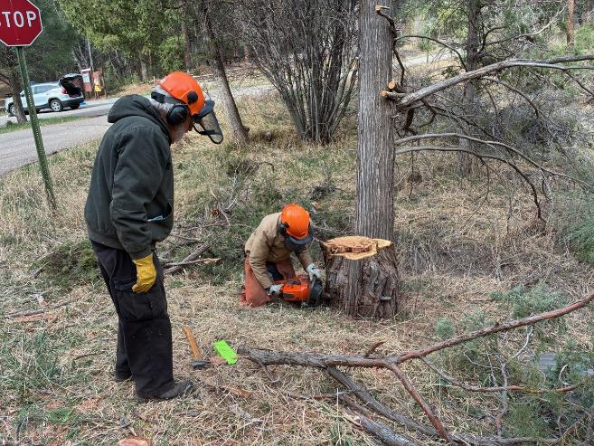

Sam Beard observing Sim Cook low stumping in Cienega PA where a hazard tree was

recently felled. All photos by Cliff Giles

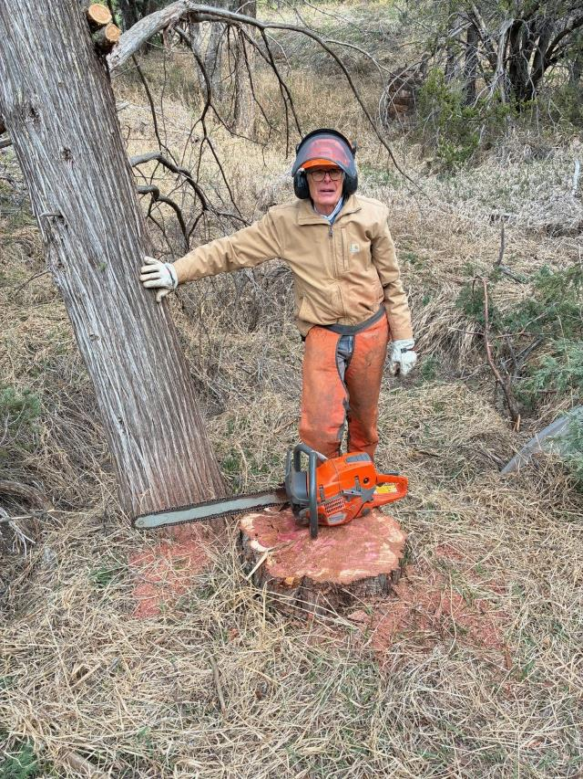

Sim and a chain saw at the site where he cut a stump lower. The diameter

of the stump was just slightly greater than the length of the chain saw bar.

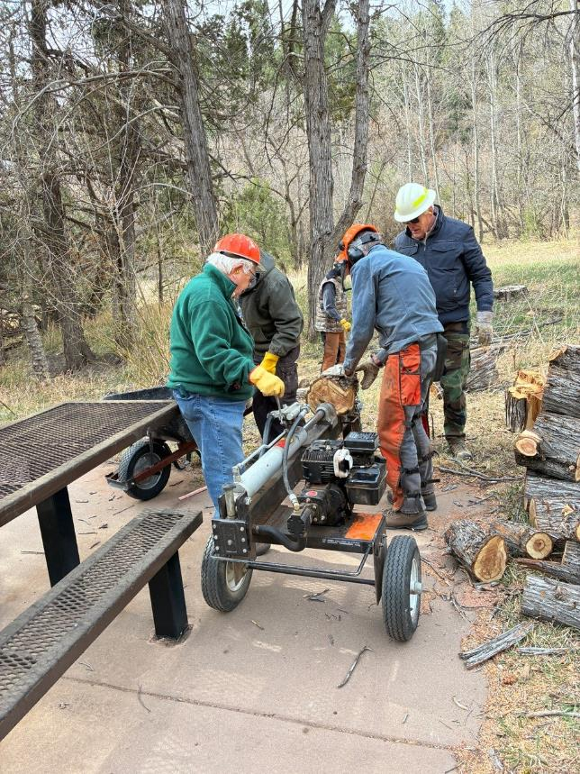

L to R: Lou Romero, Sam Beard, Sim Cook, and Stuart Cook using Lou Romero’s power splitter

to split wood in the upper part of Cienega Picnic Area.

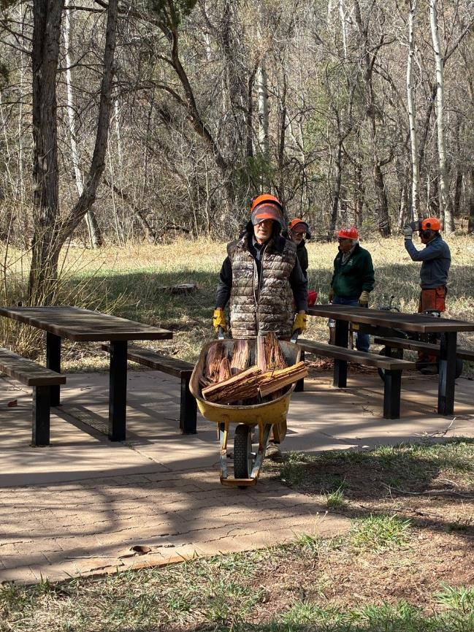

Dan Benton hauling wood to Mike Oliver’s trailer in Cienega PA.

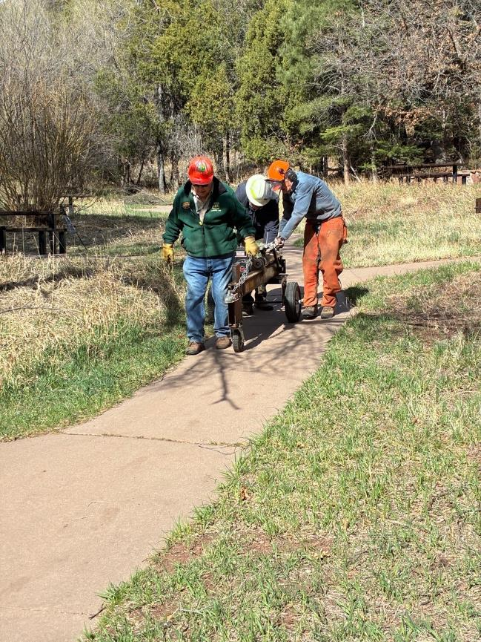

L to R: Lou Romero, Stuart Cook, and Sim Cook moving the splitter down to the parking lot.

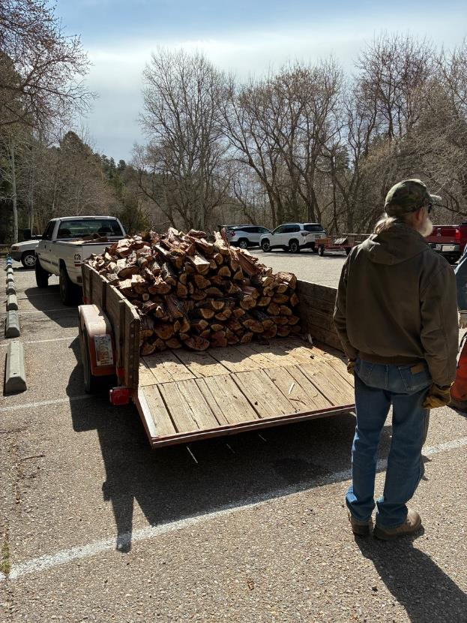

Mike Oliver’s trailer is almost full of wood to be hauled to the Mountain Christian Church wood

lot. The church Wood Ministry will donation this wood to East Mountain families who heat their homes

with wood next winter.

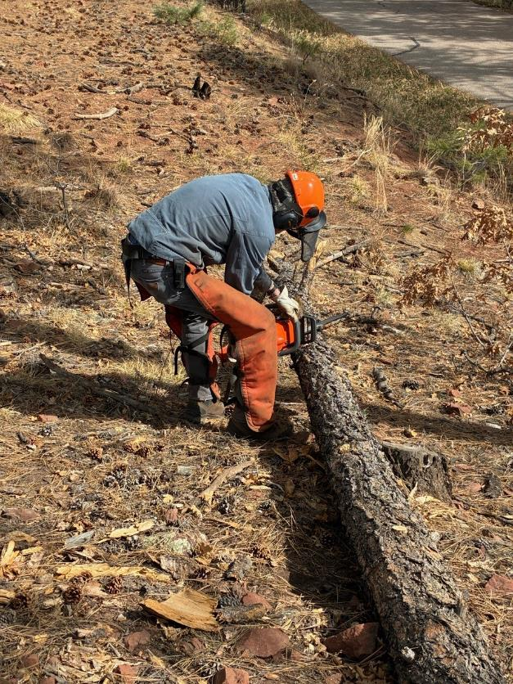

Sim Cook bucking a log near the upper gate on the Cienega PA Road.

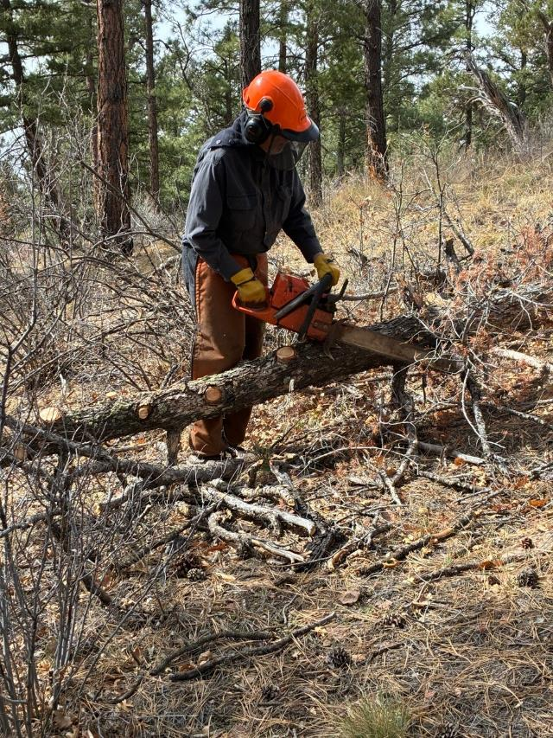

Dan limbing a Douglas fir log.

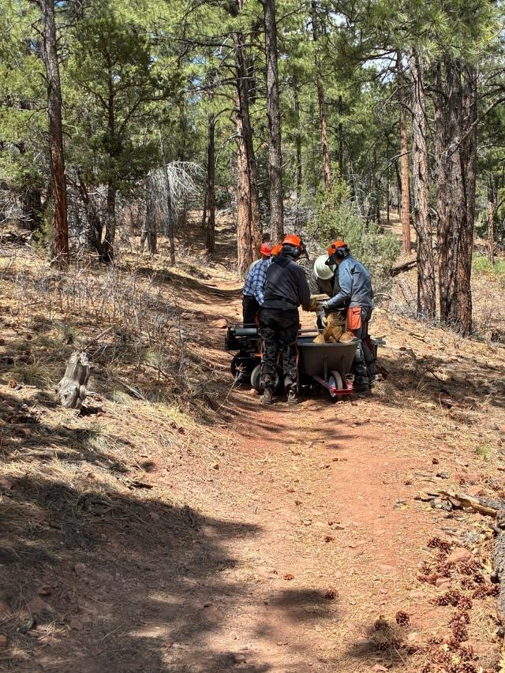

L to R: Sam Beard, Dan Benton, Stuart Cook and Sim Cook splitting wood and loading it

in a wheelbarrow.

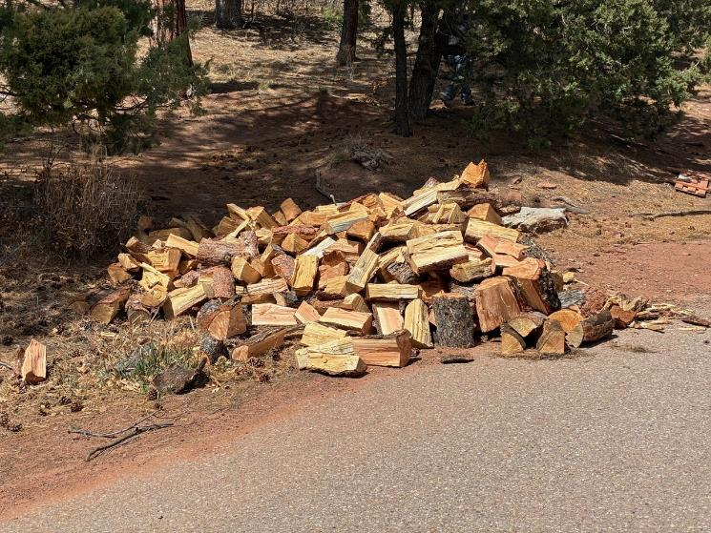

A pile of bucked and split wood at the upper Cienega PA Road gate. The wood will be hauled

to the church woodlot later.