**Reports of FOSM Projects to Paint Large Cibola National Forest Sign on Crest Highway**

**and Removing Very Large Graffiti Tag from Juan Tabo CCC Picnic Shelter Floor,**

**Tuesday, April 1, 2025**

Sam Beard

On Tuesday, April 1, FOSM volunteers Rick Buss, Pauline Ho, and Sam Beard painted the large Cibola National Forest sign on the Crest Highway near the east forest boundary. The top tapered board on each side had been restored with System Three epoxy paste and liquid epoxy before two coats of Forest Service brown paint were applied. These restored boards were reinstalled with screws on Saturday, March 29. The paint on the white letters was in better condition than the brown paint; therefore, paint was applied only to brown areas.

After painting the National Forest sign, the three volunteers drove to the west side of the mountain and removed most of a very large graffiti tag on the floor of the Juan Tabo Picnic Area CCC stone picnic shelter. This tag is shown in the photos on pages 8 and 9. The various parts of the tag covered most of the floor of the shelter and was the largest tag that the FOSM crew had ever removed. In addition to the tag in the center of the floor, tags were located in the south and west and parts of the floor.

Photos of both projects are presented below.

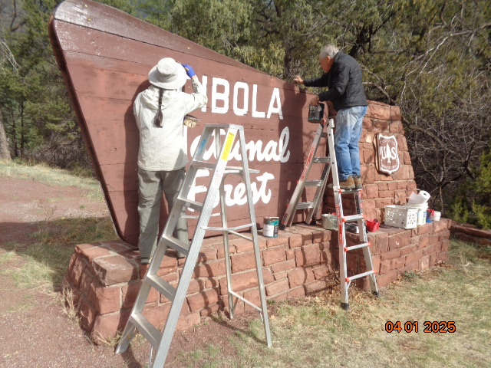

Pauline Ho and Rick Buss are painting the east side and top edge of this large Cibola National Forest sign on the Crest Highway

near the forest entrance. All photos by Sam Beard unless noted otherwise

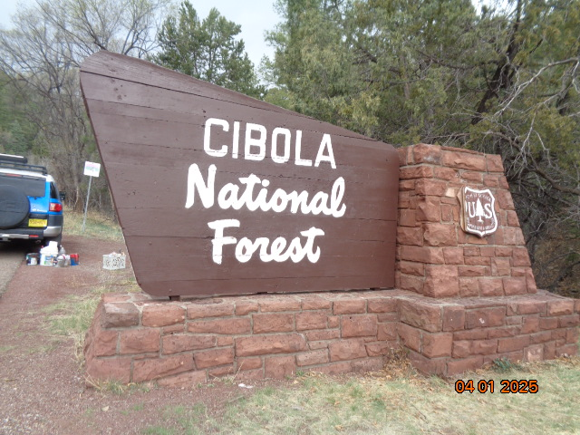

The east side of the sign has been painted with USFS brown paint.

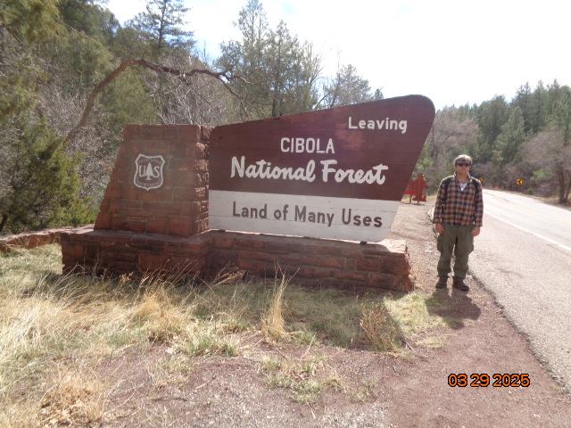

Volunteer Michael Arndt standing beside the sign before it was repainted. Note the faded color in the upper

center of the sign on this upper side.

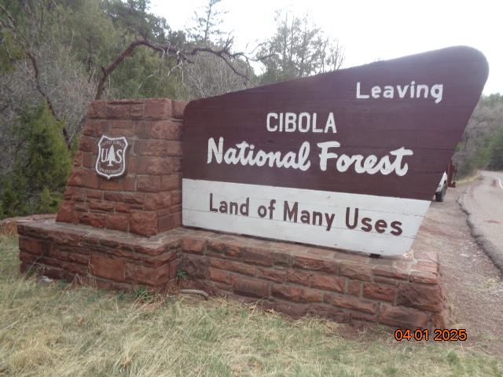

The upper side of the repainted sign.

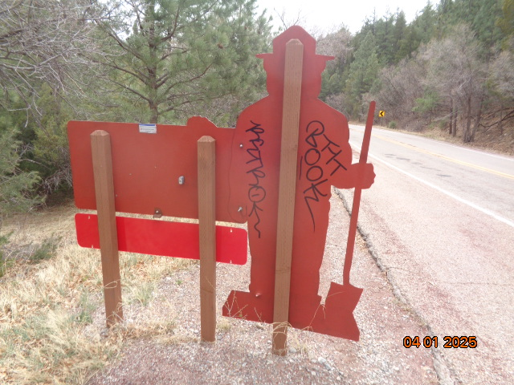

Graffiti tag on the back surface of this Smoky Bear sign. We first applied Sensitive Surface chemical

designed to be used on painted surfaces, but it removed all the paint down to the metal. We then painted

the back surface with brown paint.

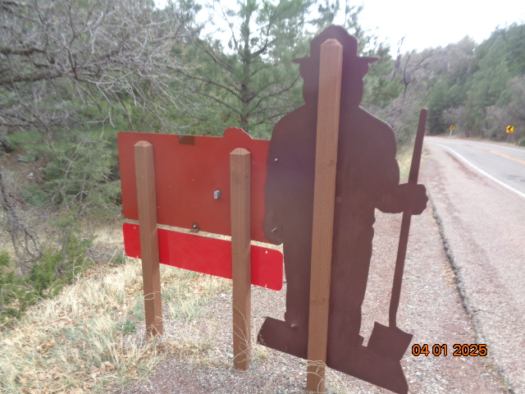

The back of the sign painted with USFS brown paint.

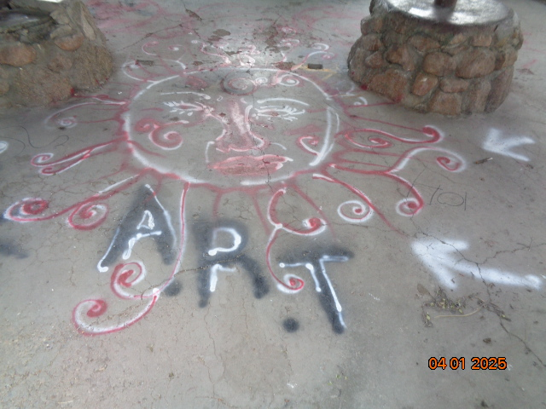

The exceptionally large graffiti tag in the center of the shelter floor.

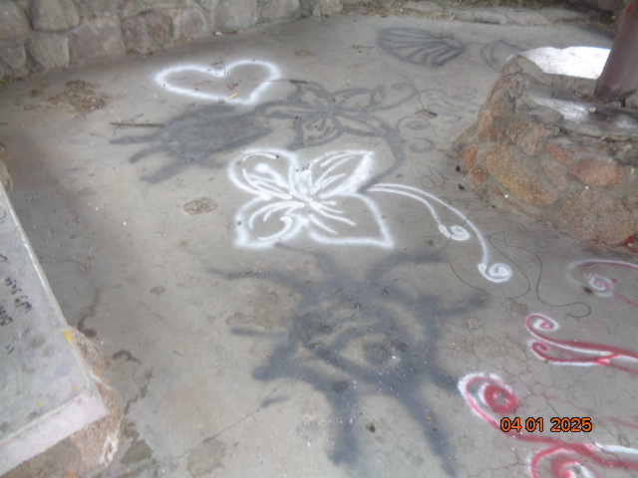

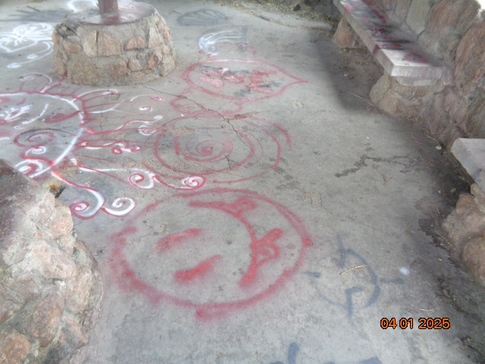

Top – Tags on the south side of the floor. Bottom – Tags on the west side of the floor.

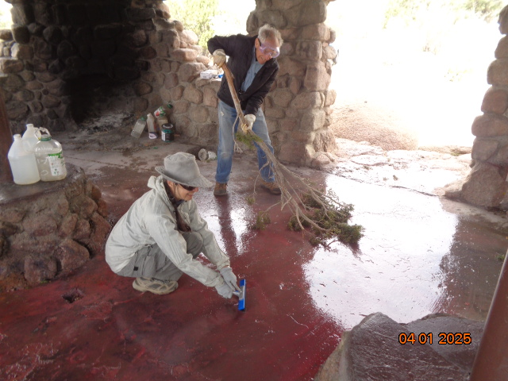

Rick sweeping spray paint, chemical remover for use on concrete, and rinse water out the front door with a juniper

branch we found in the shelter. Pauline is using a brush to scrub tag paint off the floor. Later that day, I purchased a

brush on a long handle to move water off surfaces.

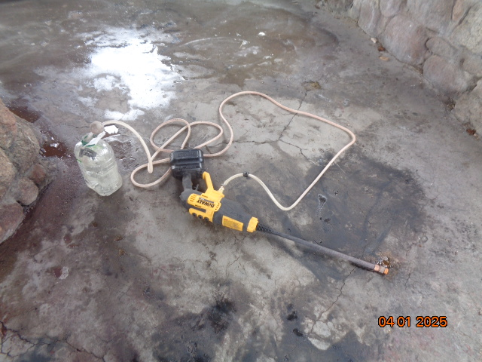

The FOSM battery-powered low-pressure washer that was used to apply rinse water. After the washer stopped operating

properly, Rick found a small filter in end of the suction hose that was clogged with debris. After the filter was cleaned,

the washer operated properly again. Note that most of the tag paint has been removed from this south side of the floor.

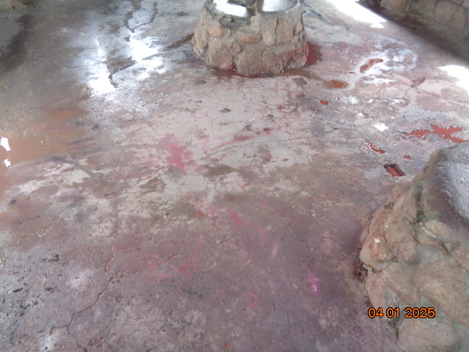

Most of the tag paint has been removed from the central part of the floor.