**Retaining Wall on Embudito Trail**

On Tuesday 4/8/25, 4 brave fellows joined SRD trails foreman Jen Medina-Gray on a hike 1.75 miles up the Embudito trail to stabilize a collapsing switchback. A rock retaining wall was constructed from the base of the switchback to ensure the upper half of the switchback would be stabilized for many years to come. Thank you all for your dedication and hard work on this project!

Volunteers: Luis Cuadros, Rich Fagioli, Eric Russell, and Jeff Huser

Photos: Rich Fagioli and Jen Medina-Gray

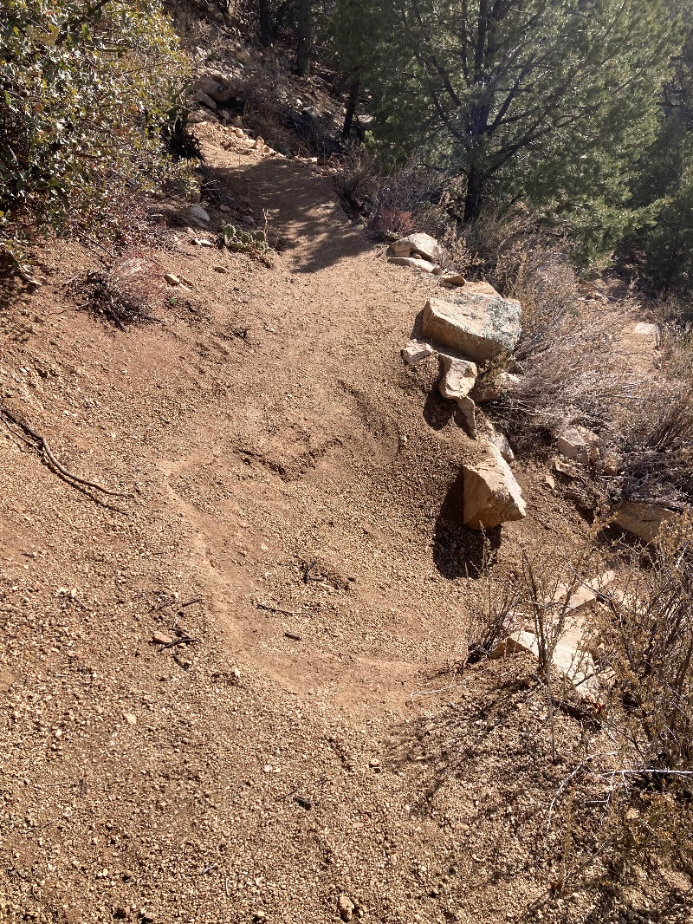 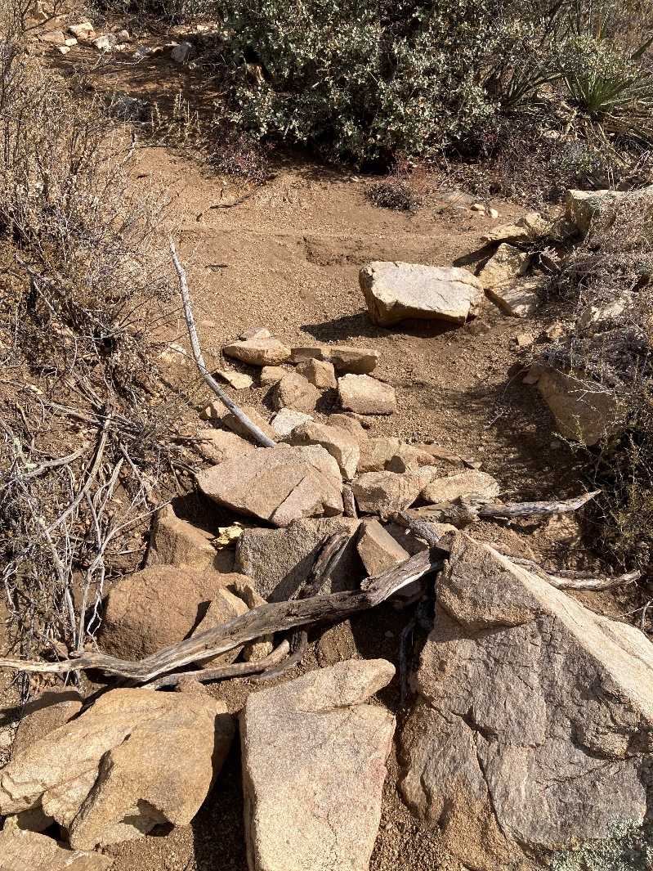

Before any work was completed. You can see that these rocks on the slope might have been holding up the tread at one point, but since there was not stabilization under them, they all slid down the hill. This is also the only spot on the switchback where there was no vegetation, and we suspect people were cutting the switchback here

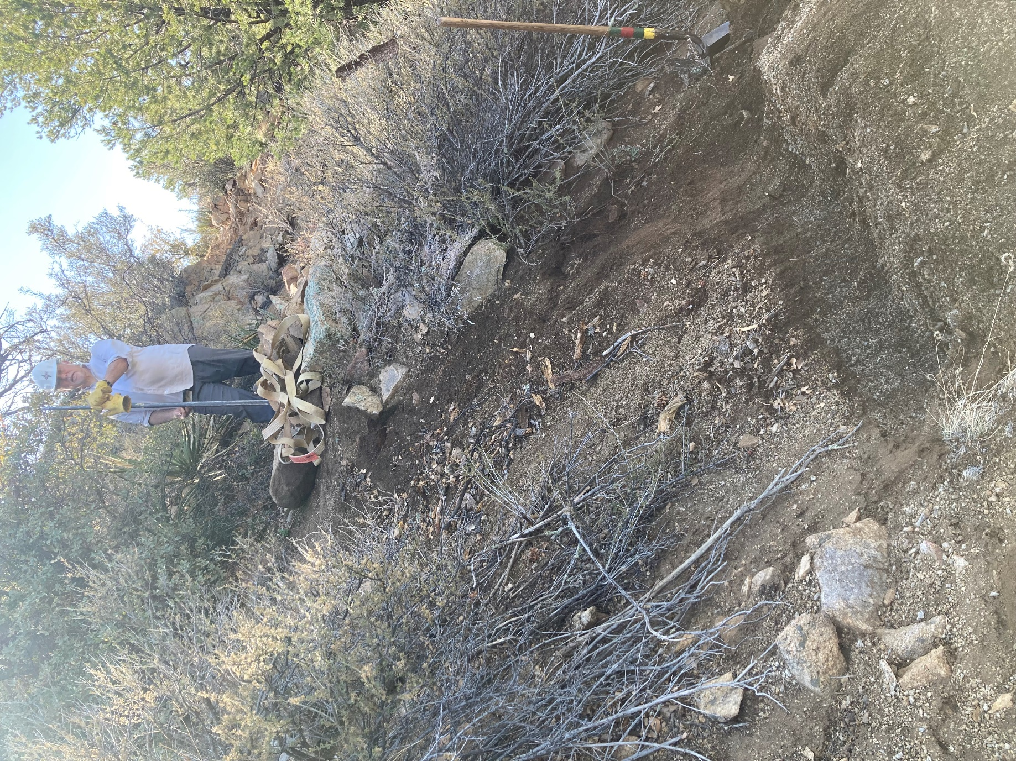

Loose rocks were removed from the side slope and we began to dig a home for our base course of rocks.

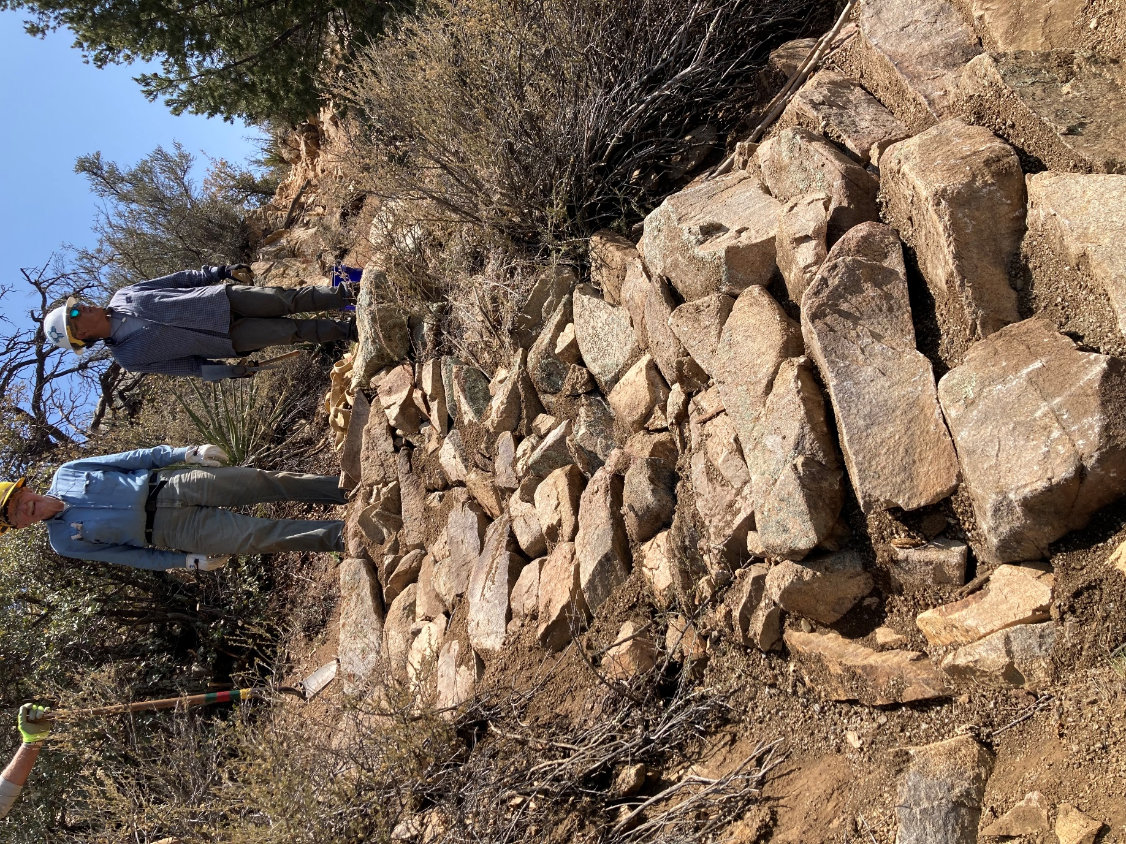 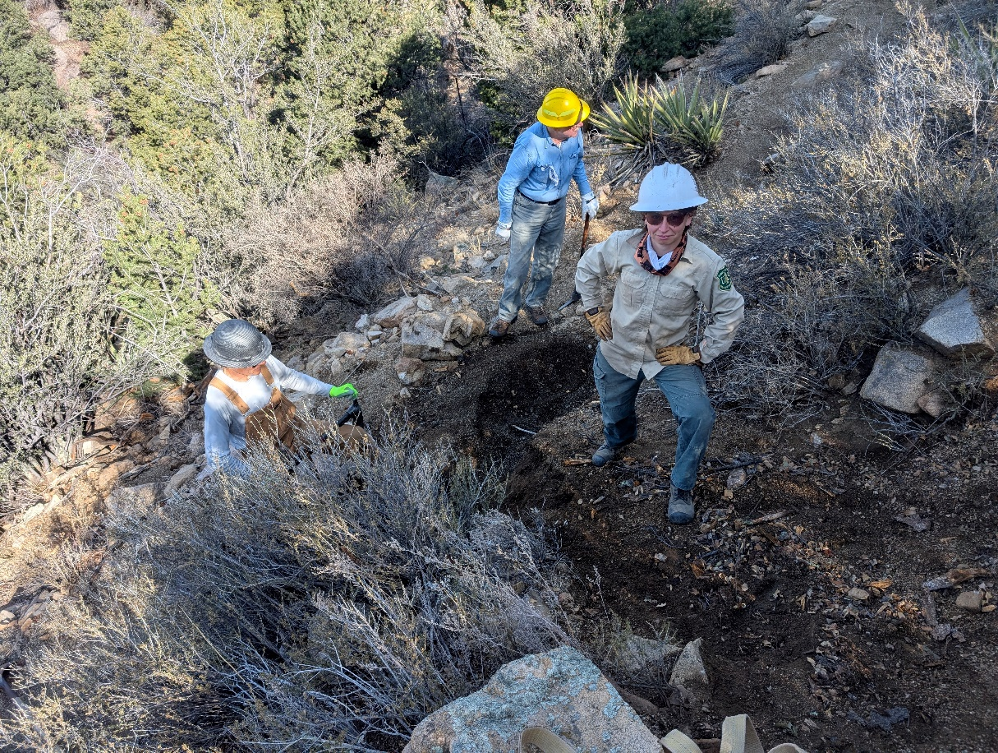

Retaining wall complete! We were very engaged with the work and I forgot to take any process photos.

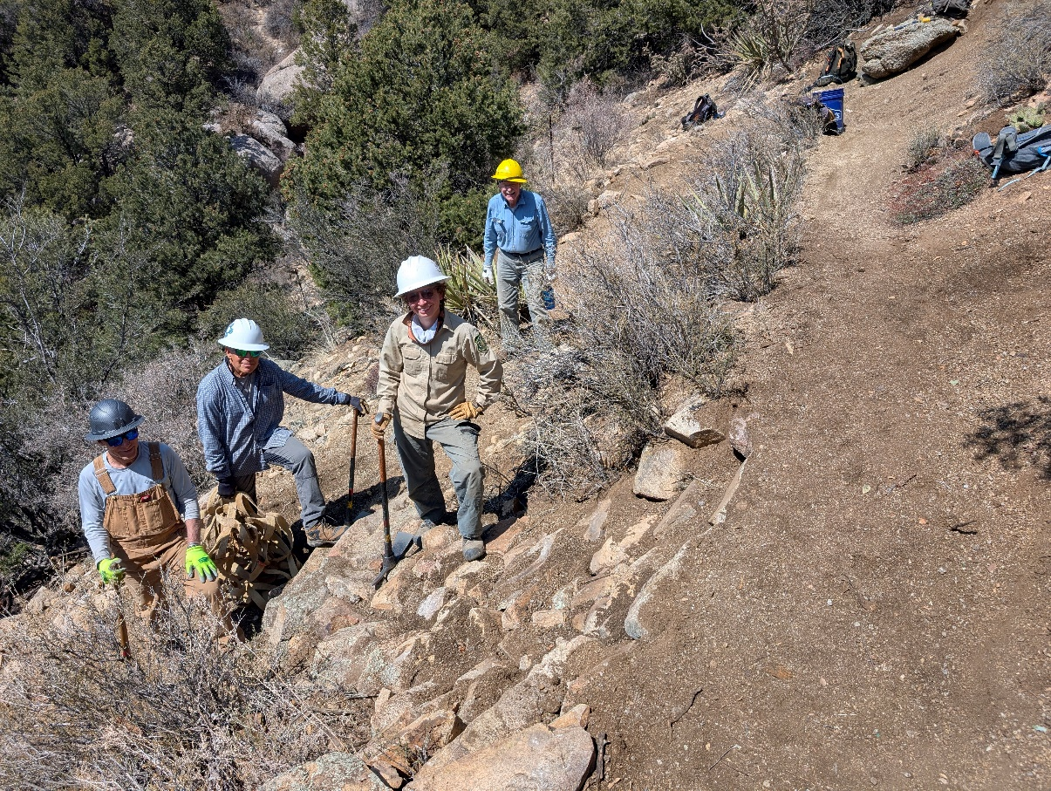

Another before and after shot taken by Rich. Thanks again all, superb work!