**Report of FOSM Project to Process Wood in Doc Long Picnic Area and**

**at the Second Gate on Cienega Picnic Area Road on Wednesday, April 9, 2025**

Sam Beard

On Wednesday, April 9, seven FOSM volunteers bucked and split a large pine hazard tree that had been felled earlier on the old paved road in Doc Long Picnic Area. They then went to the second gate on the road to Cienega Canyon Picnic Area and loaded a pile of wood that had been bucked and split earlier. The wood was then hauled to the Mountain Christian Church woodlot east of the Triangle.

The volunteers were Cliff and Jody Giles, Sam Beard, Jerry Carroll, Sim Cook, Lou Romero, and Mike Oliver. Jody is Cliff’s son, and he was especially helpful with putting the heavy rounds on the splitter. Sap was dripping out of the rounds as they were split.

Project photos are presented below.

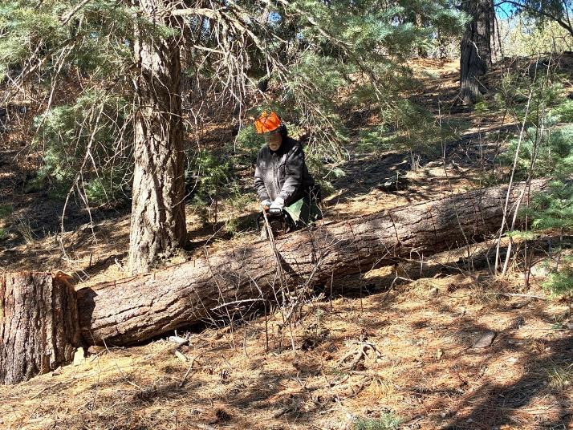

Jerry Carroll is cutting marks on the trunk of this large pine where sawyers will buck

the log into 12-inch pieces. All photos by Cliff Giles unless stated otherwise.

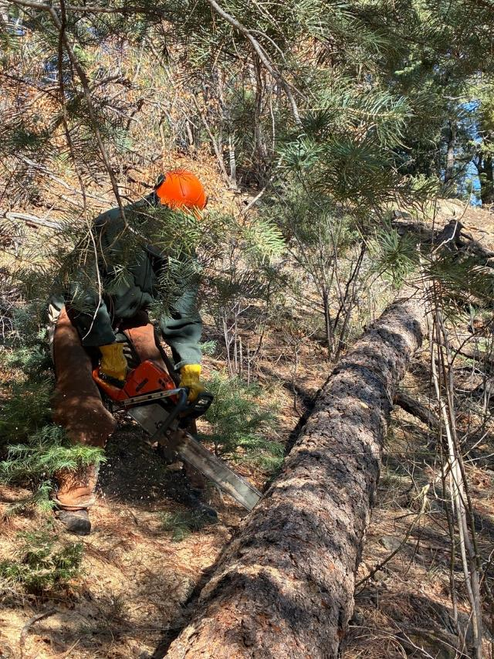

Sam Beard is bucking the log with one of the FOSM Husqvarna Model 572 saws with a 24-inch bar.

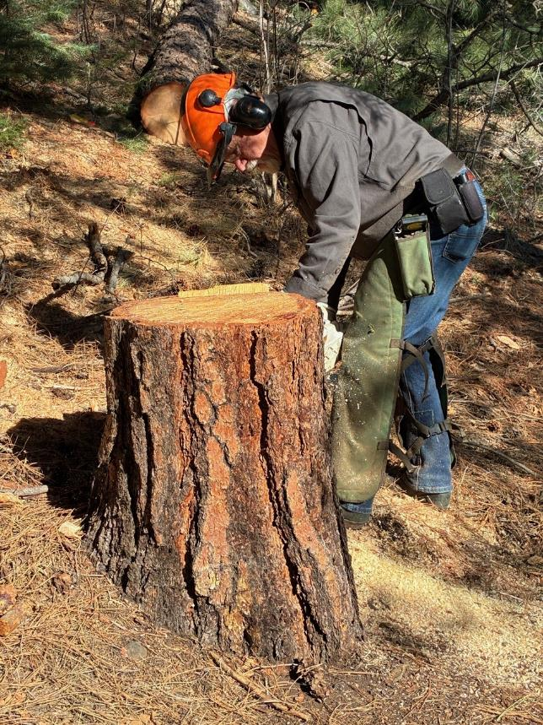

Jerry Carroll is beginning to cut this stump into two pieces. The top piece will be 12 inches long.

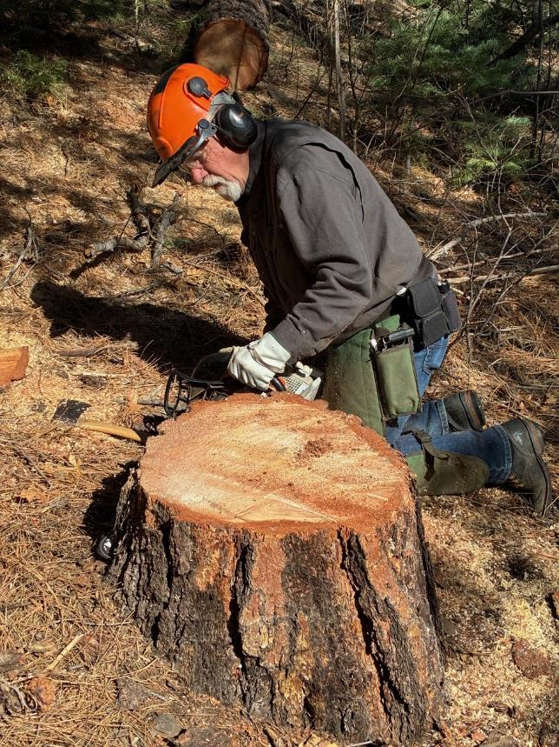

Jerry making the second cut just above the ground.

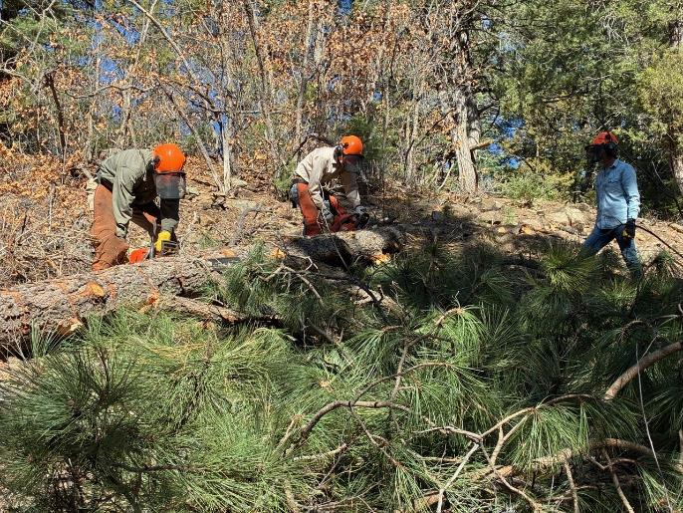

L to R: Sam Beard and Sim Cook are bucking the upper end of the log. Jody Giles is waiting

to move the bucked pieces down to the splitter.

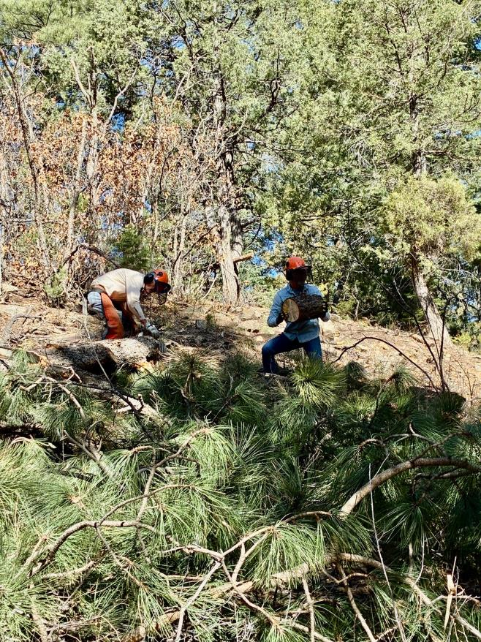

Jody is preparing to roll the round down to the splitter.

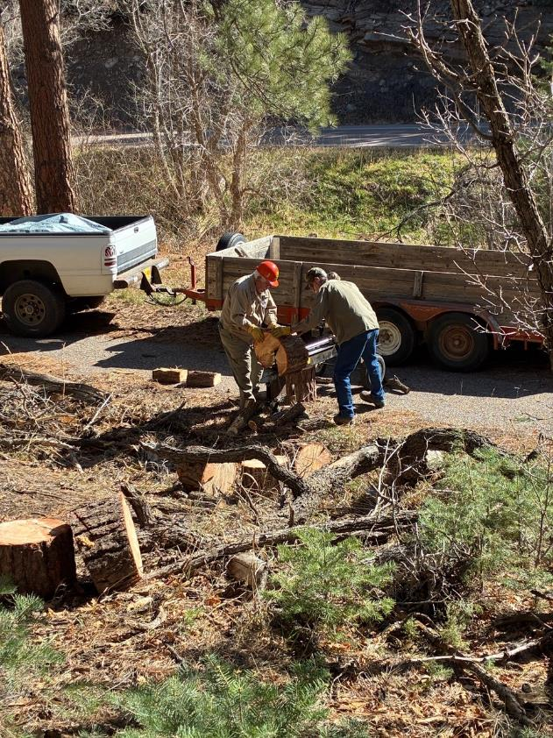

Lou Romero and Mike Oliver, member of the Mountain Christian Church Wood Ministry,

are beginning to split the rounds and throw them into the Mike’s trailer.

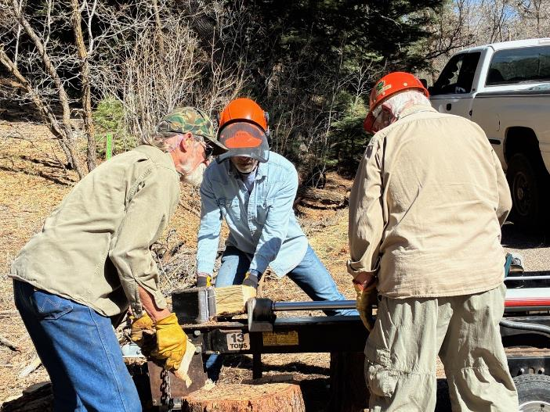

Mike, Jody, and Lou continue to split rounds with Lou’s splitter.

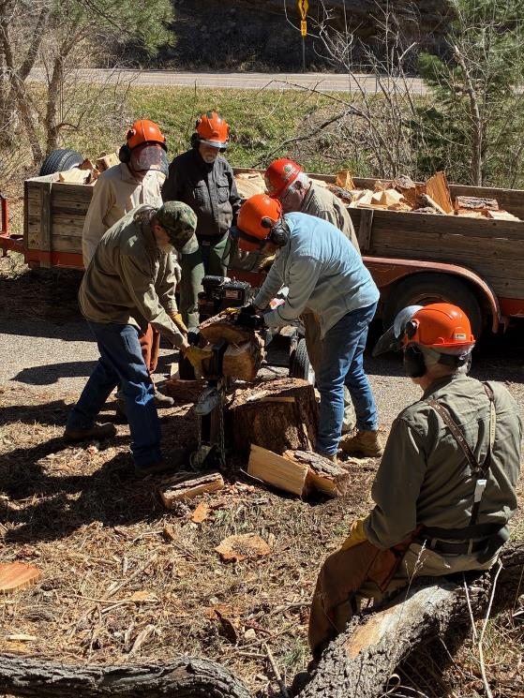

Sam is observing Mike, Sim, Jerry, Jody, and Lou split the rounds and throw them into the trailer.

This pine was green with a dead top, and the rounds were very heavy. The volunteers would

initially put a round on one of the rounds on the ground beside the splitter and then move

it up onto the splitter rail.

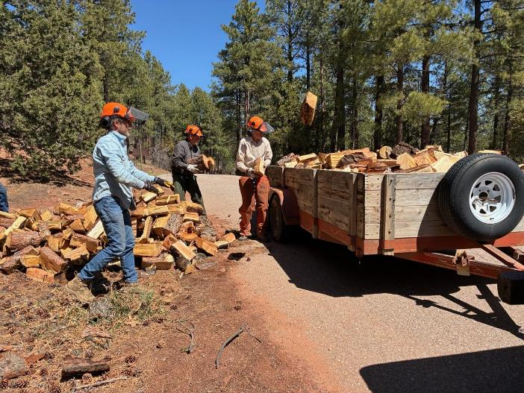

Jody, Jerry, and Sim are loading wood split earlier onto the trailer at the second gate

on Cienega Road.

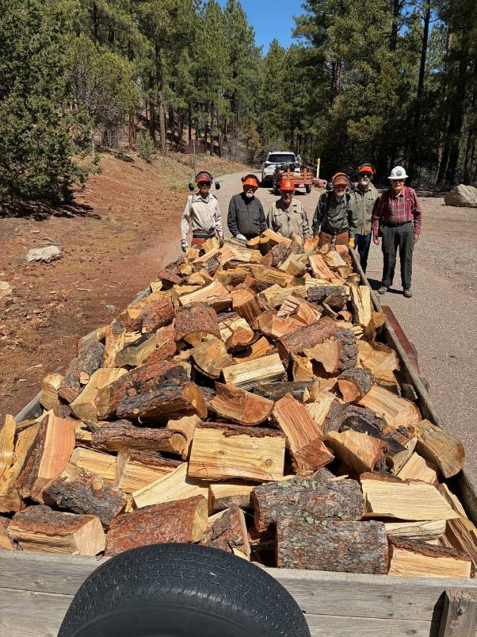

A full load of wood ready to be hauled to the church wood lot. The church wood ministry members

will donate it to families who heat with wood in the East Mountain area. L to R: Sim

Cook, Jerry Carroll, Lou Romero, Sam Beard, Mike Oliver, and Cliff Giles.

Photo by Jody Giles