Thursday, 04/10/25- North Faulty: After the snow last Saturday we were expecting some remaining snow and some mud and found neither! The weather was great, almost too warm in the sun but 12 volunteers and Jen (SRD) soldiered on at reroute #5. We are about half way through the reroute- making slow progress due to the steep slope. We forge ahead and then spend the next week going back to widen and work on the up and down slopes. We’ll get there!

Volunteers: Eric Messerschmidt, Rich Fagioli, Byron Garner, Bill Perkins,
John Braly, Eric Russell, Luis Cuadros, Claudia Bergsohn, Laura Leon,
Jim Houle, John McNett and Tony Pachelli

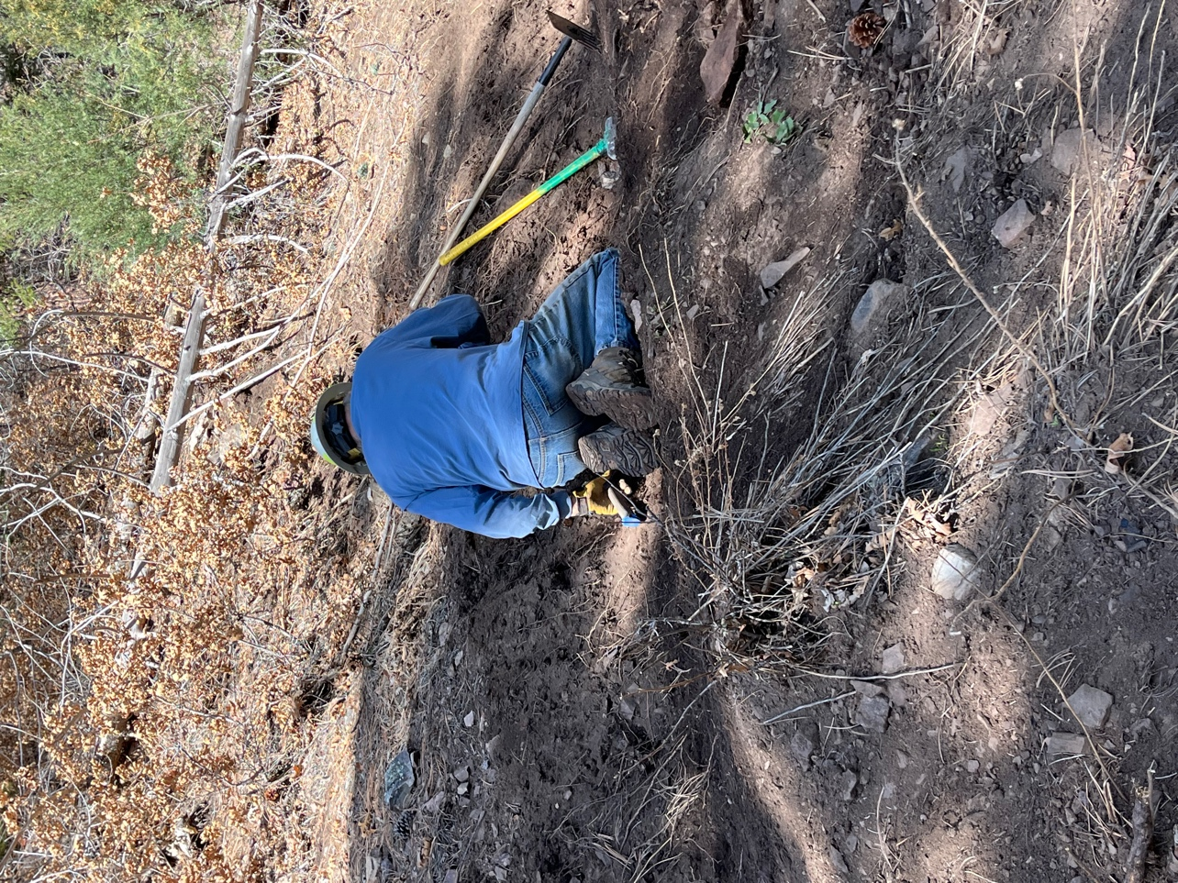

Jim worked the trail.
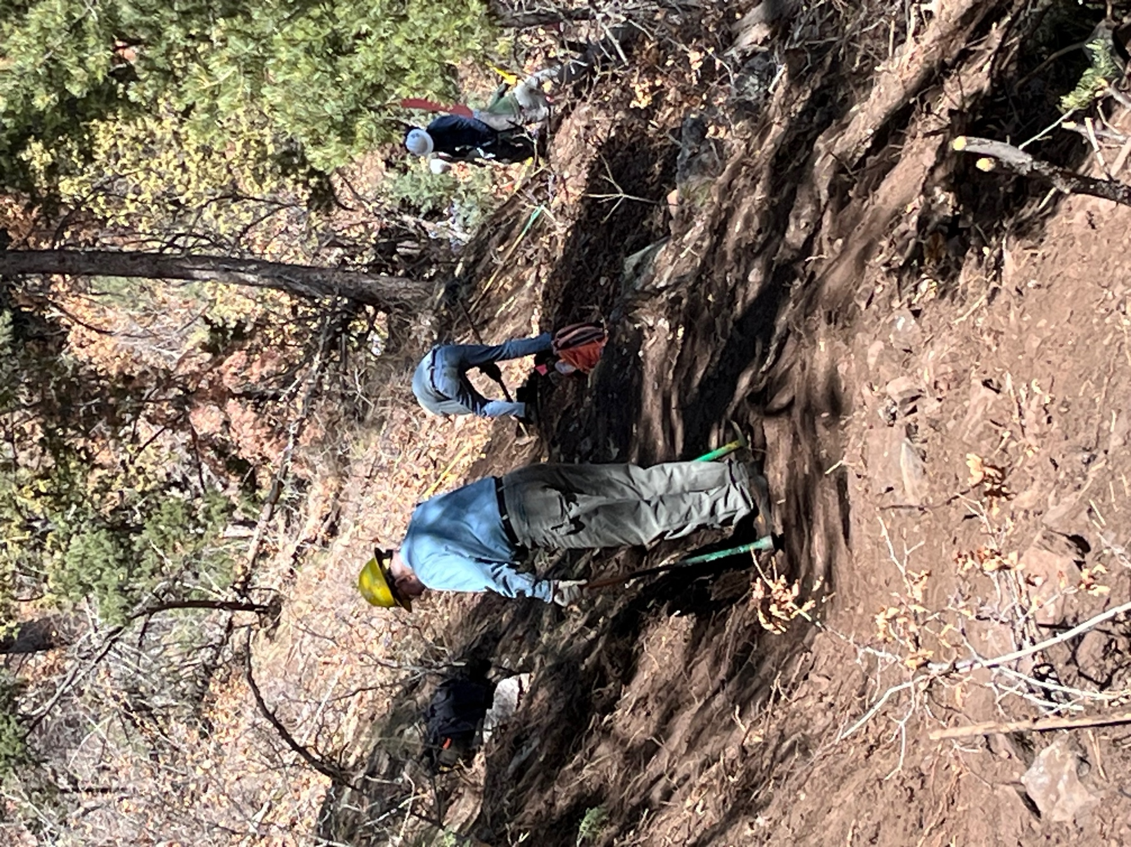

Eric R. and other crew members worked on the slope.

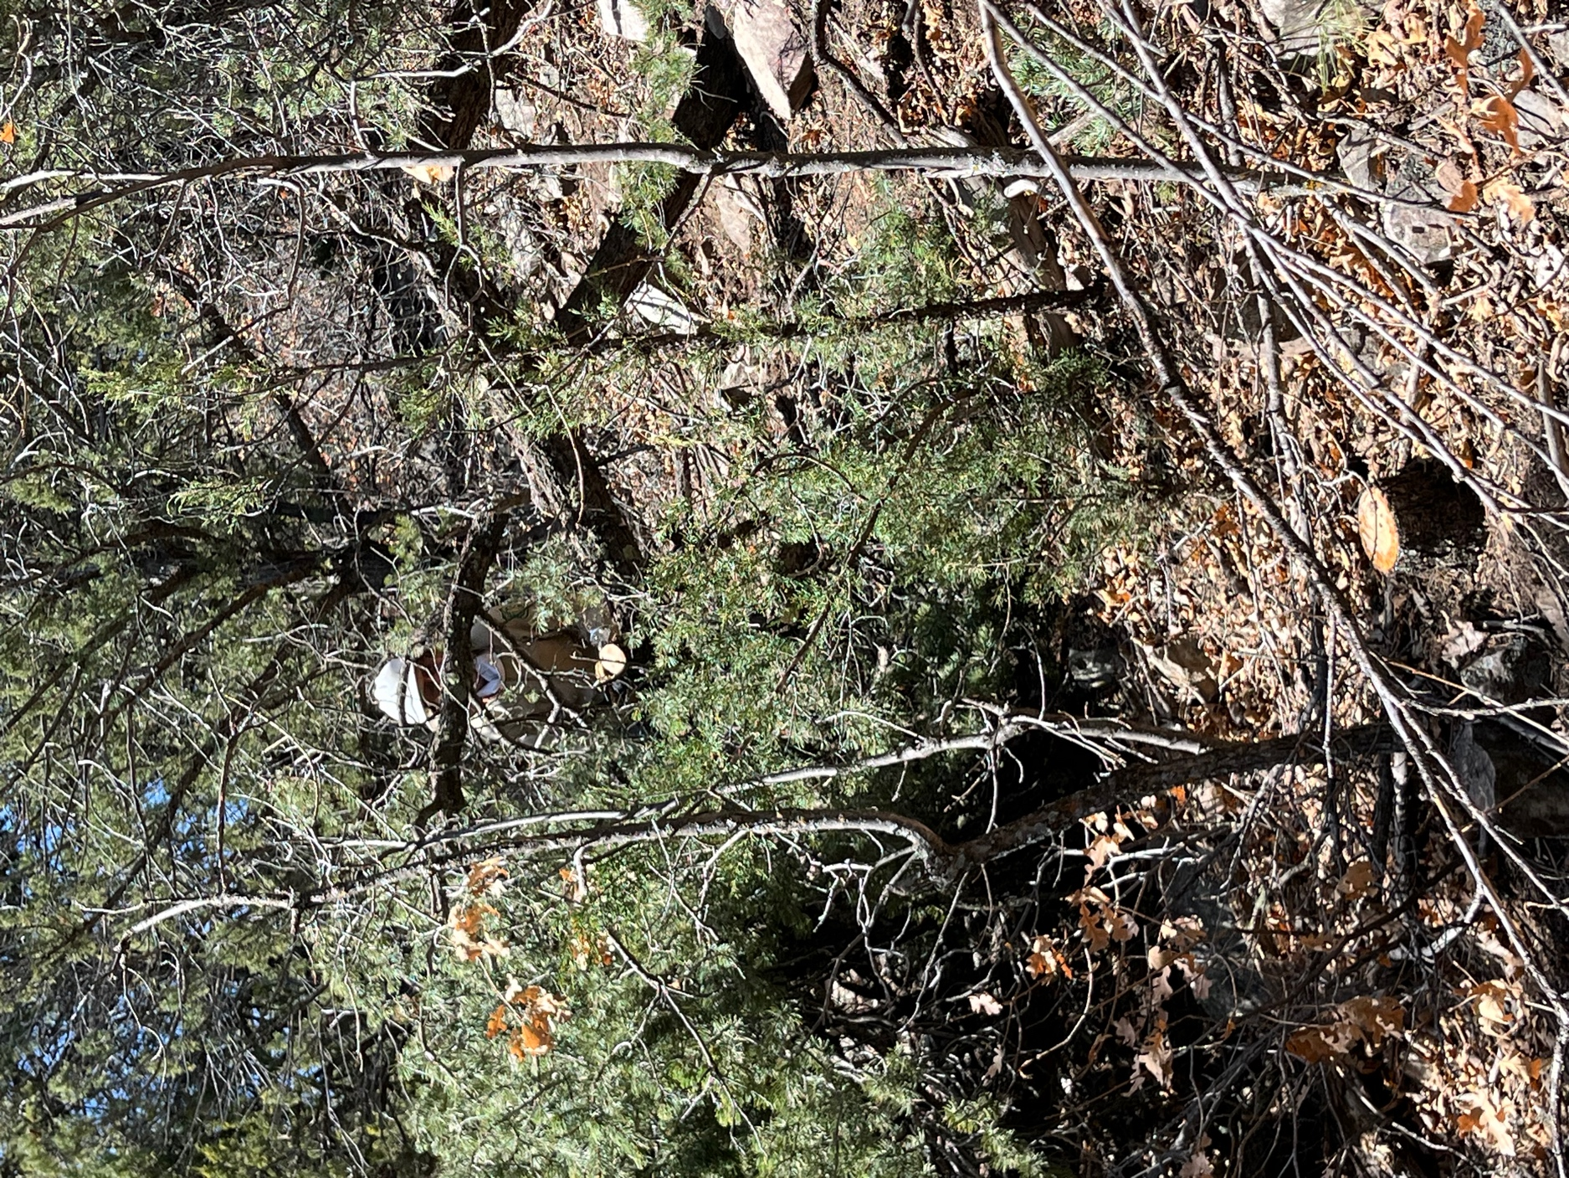Jen cut down some trees…
and then John M. and Laura helped limb and move them off trail.

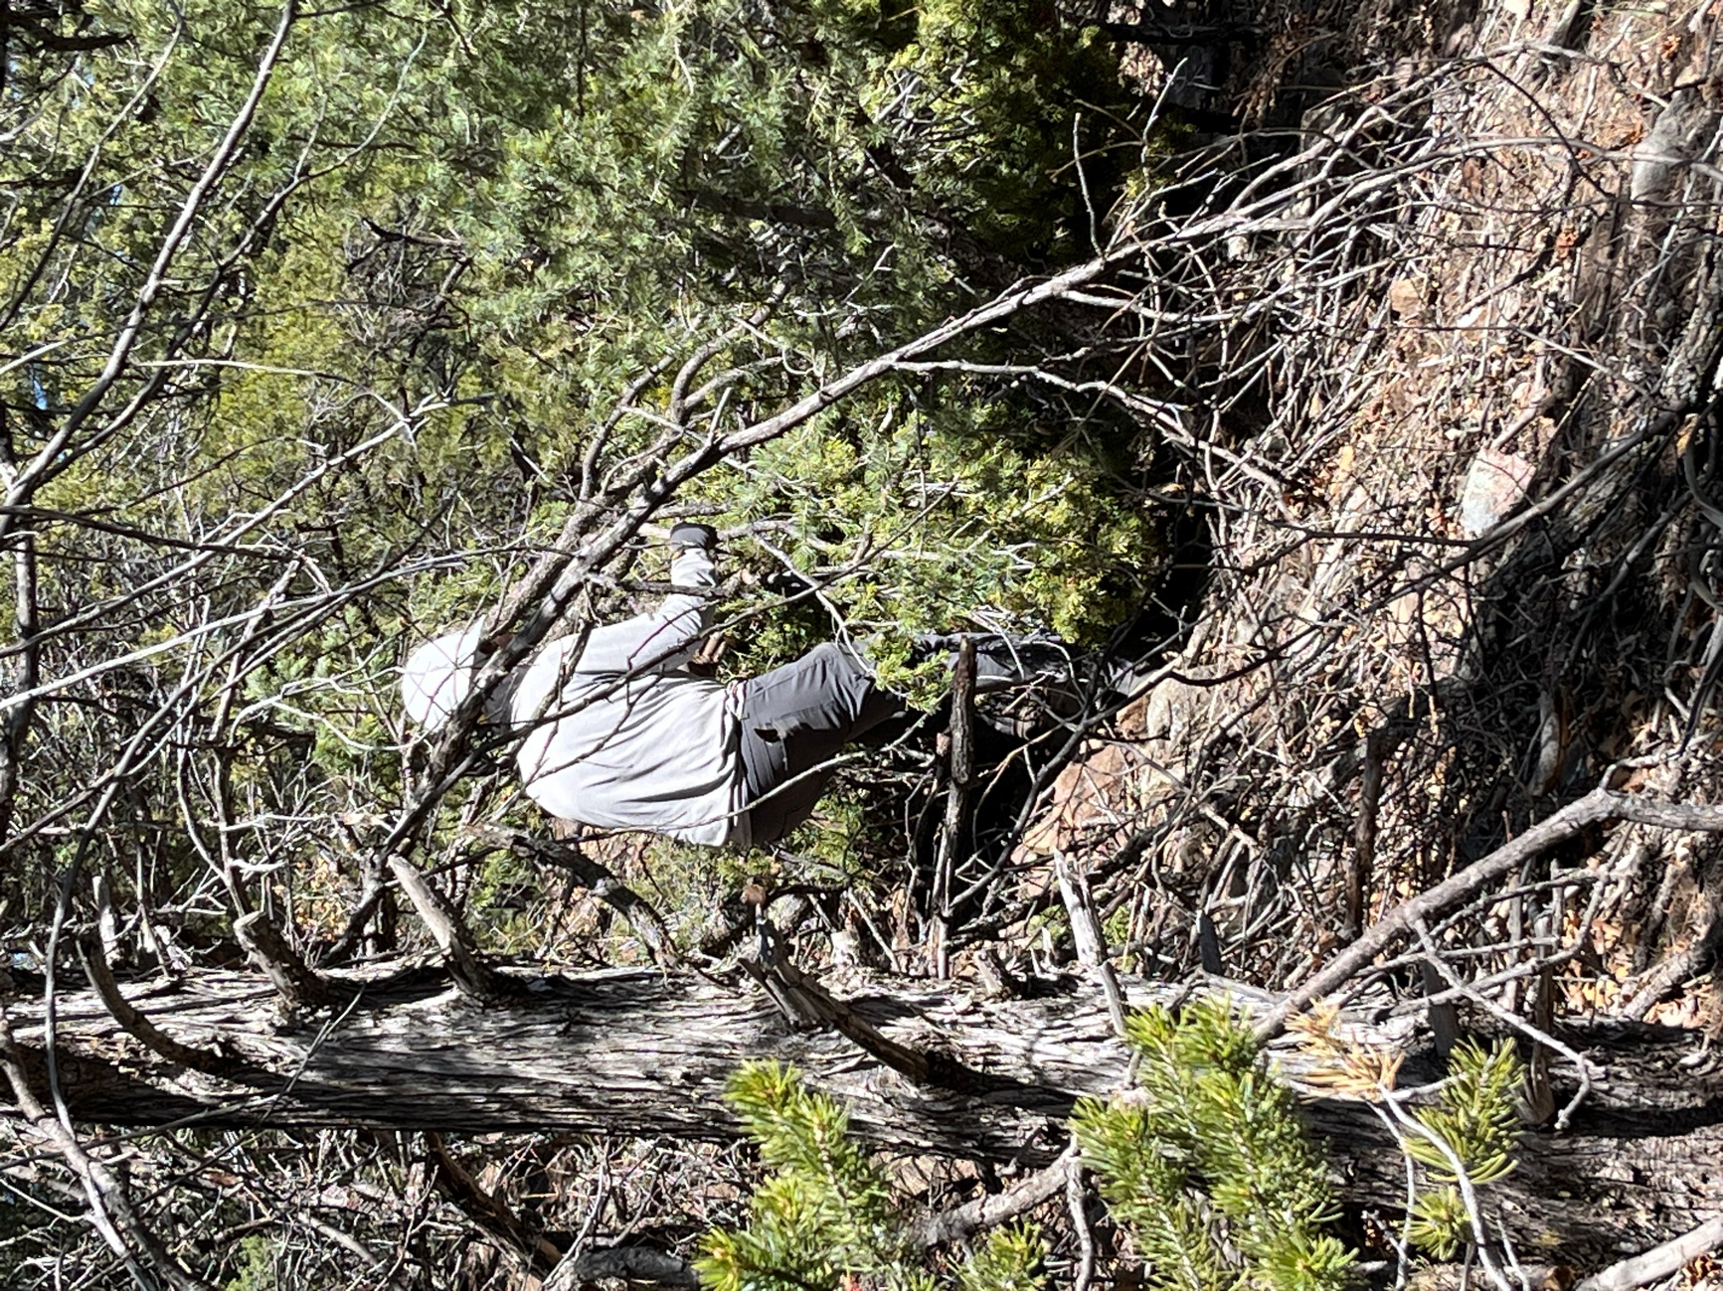

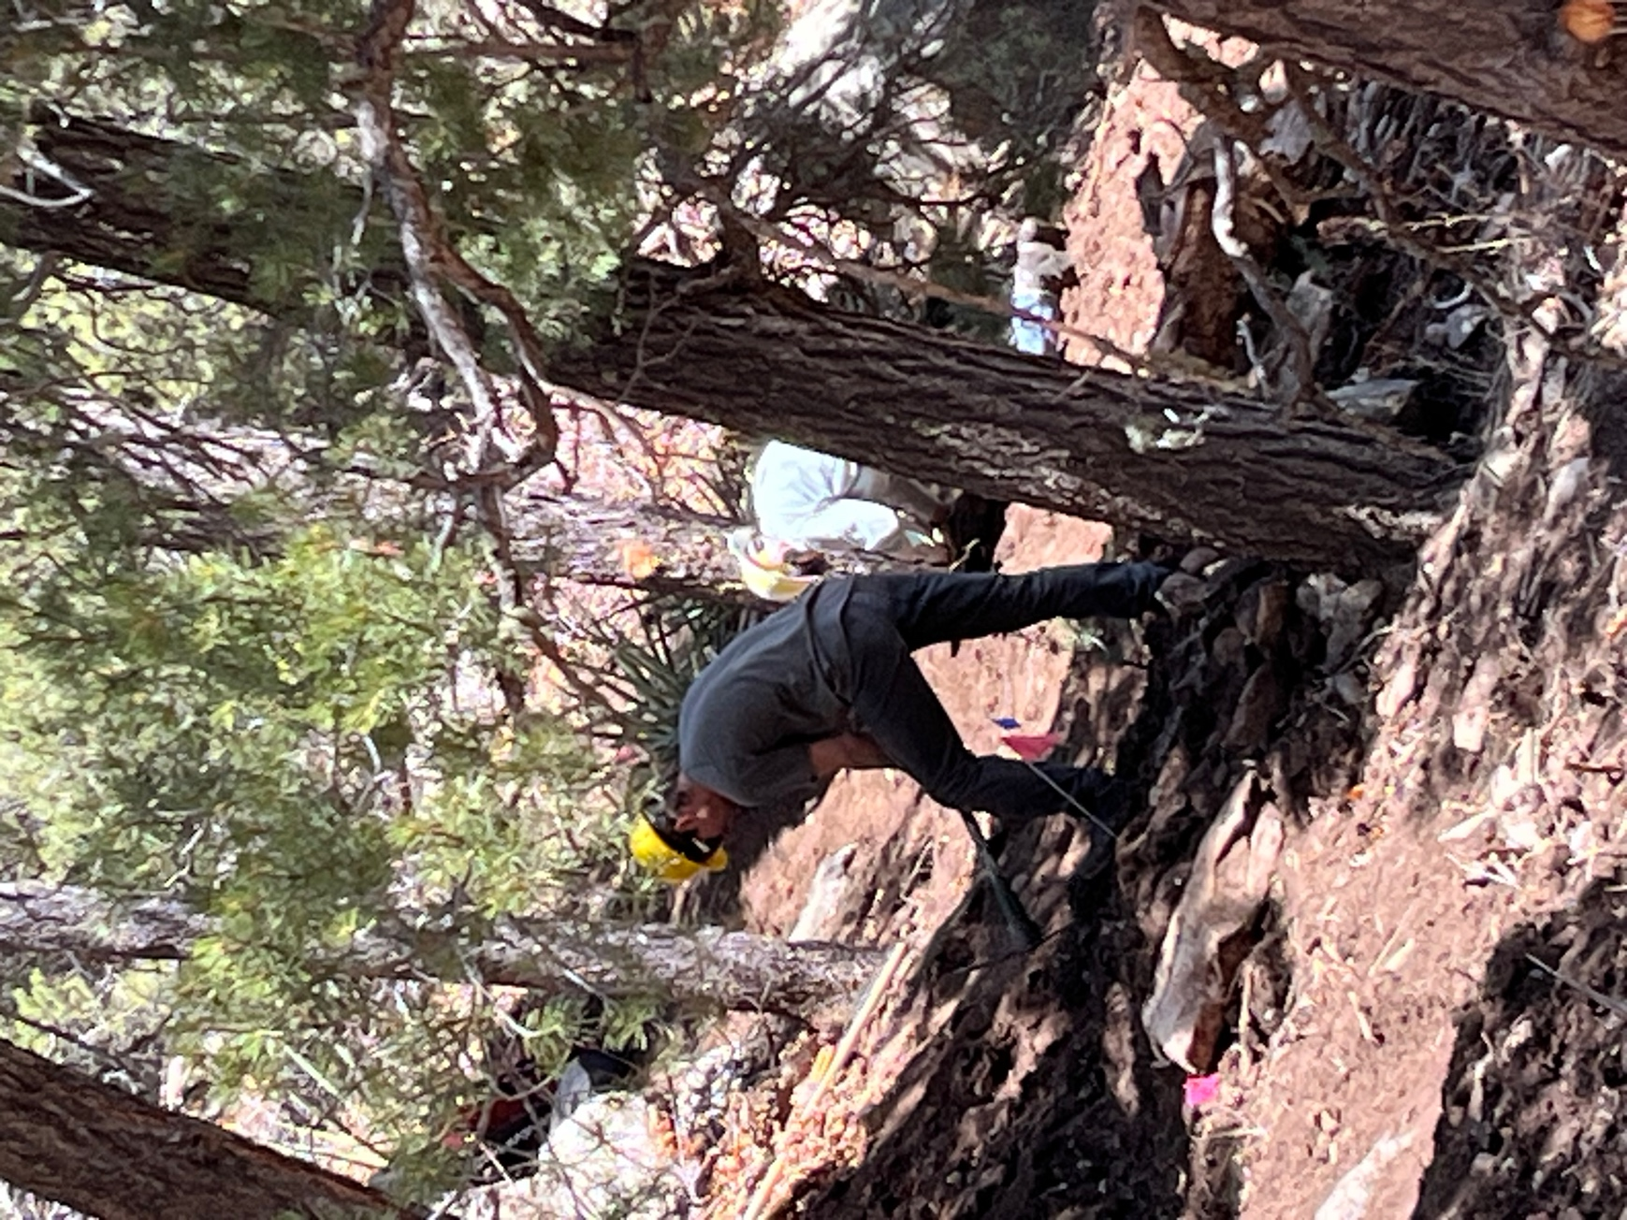

Eric M. and Byron worked slope just past the bend.
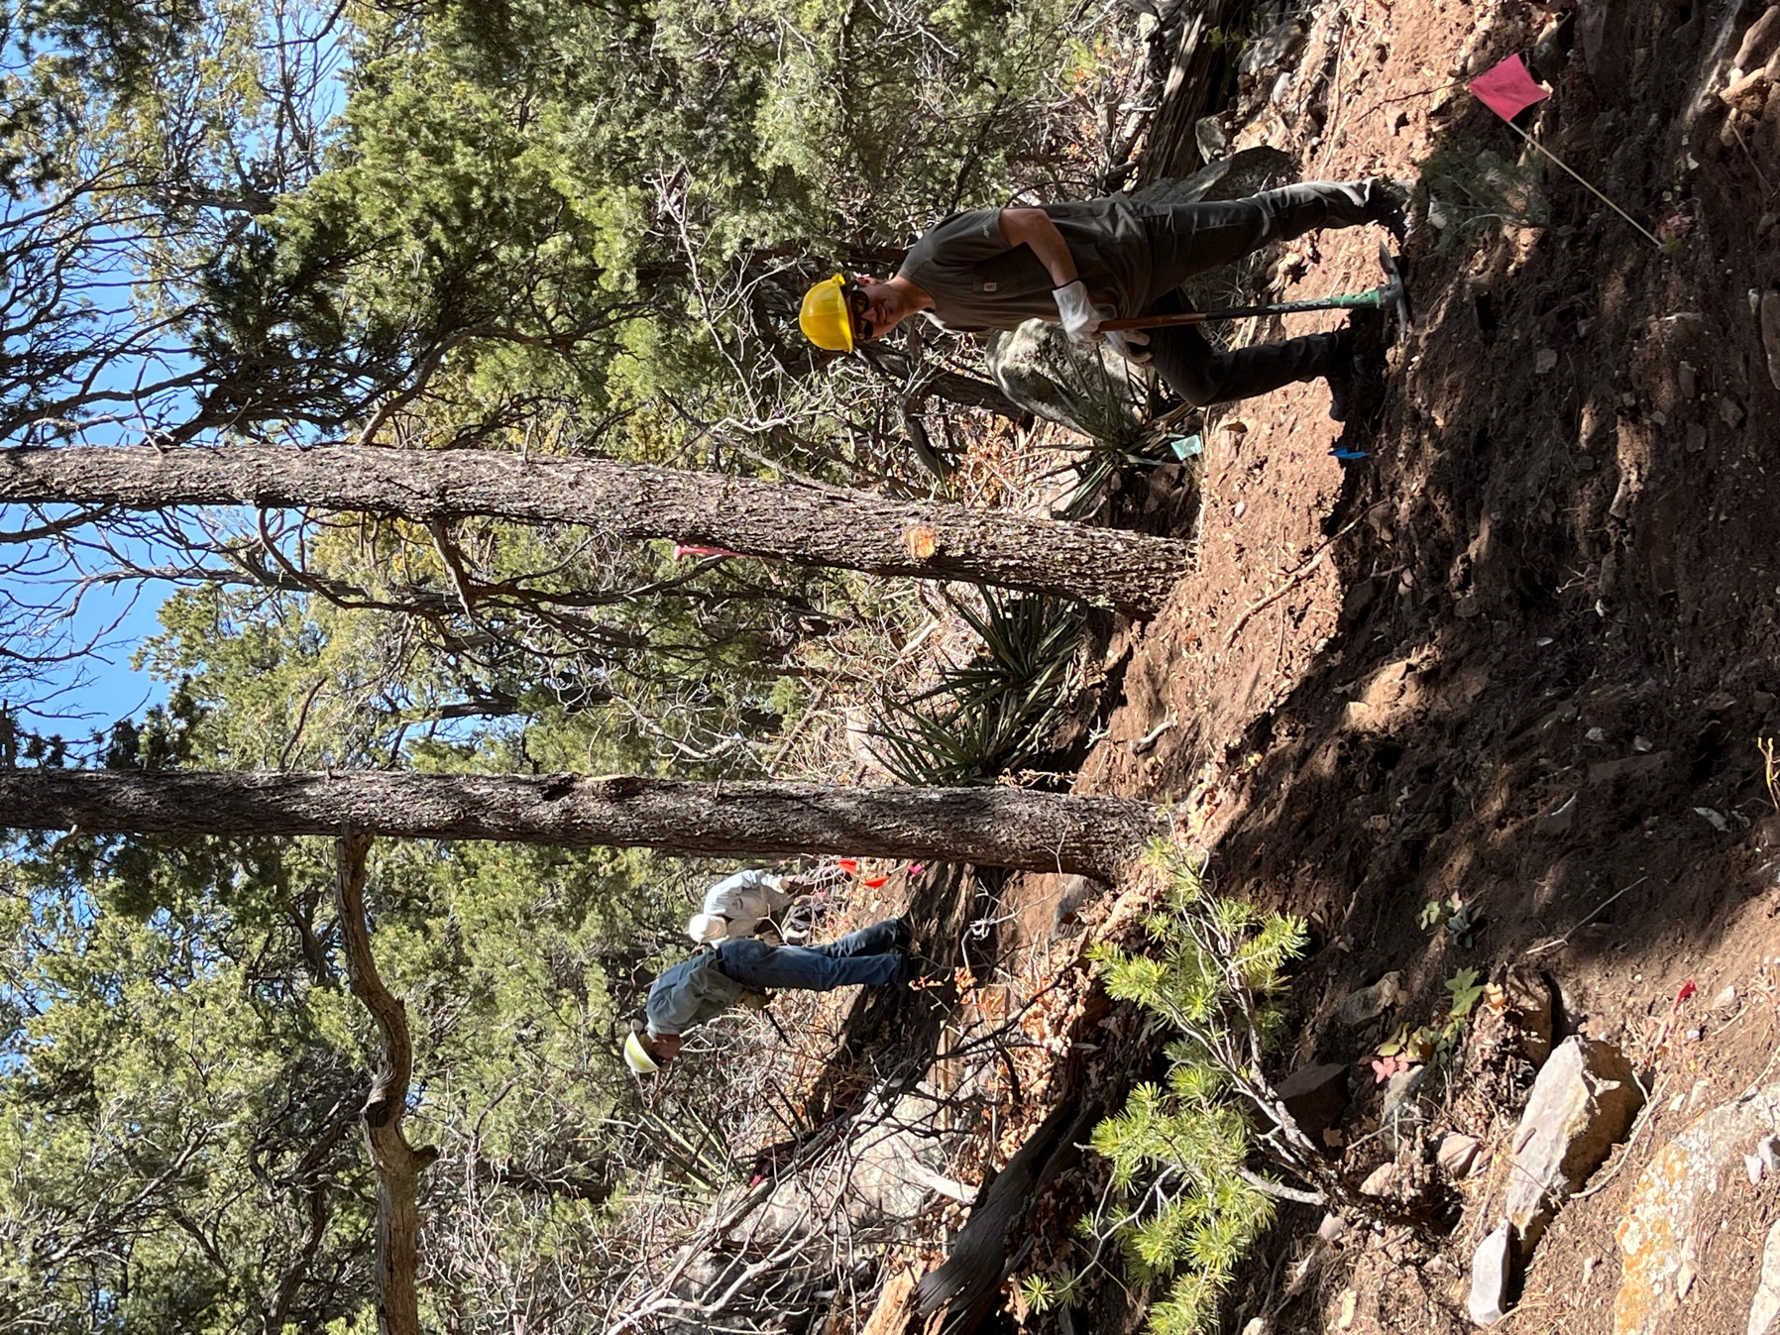

Tony was at it too!

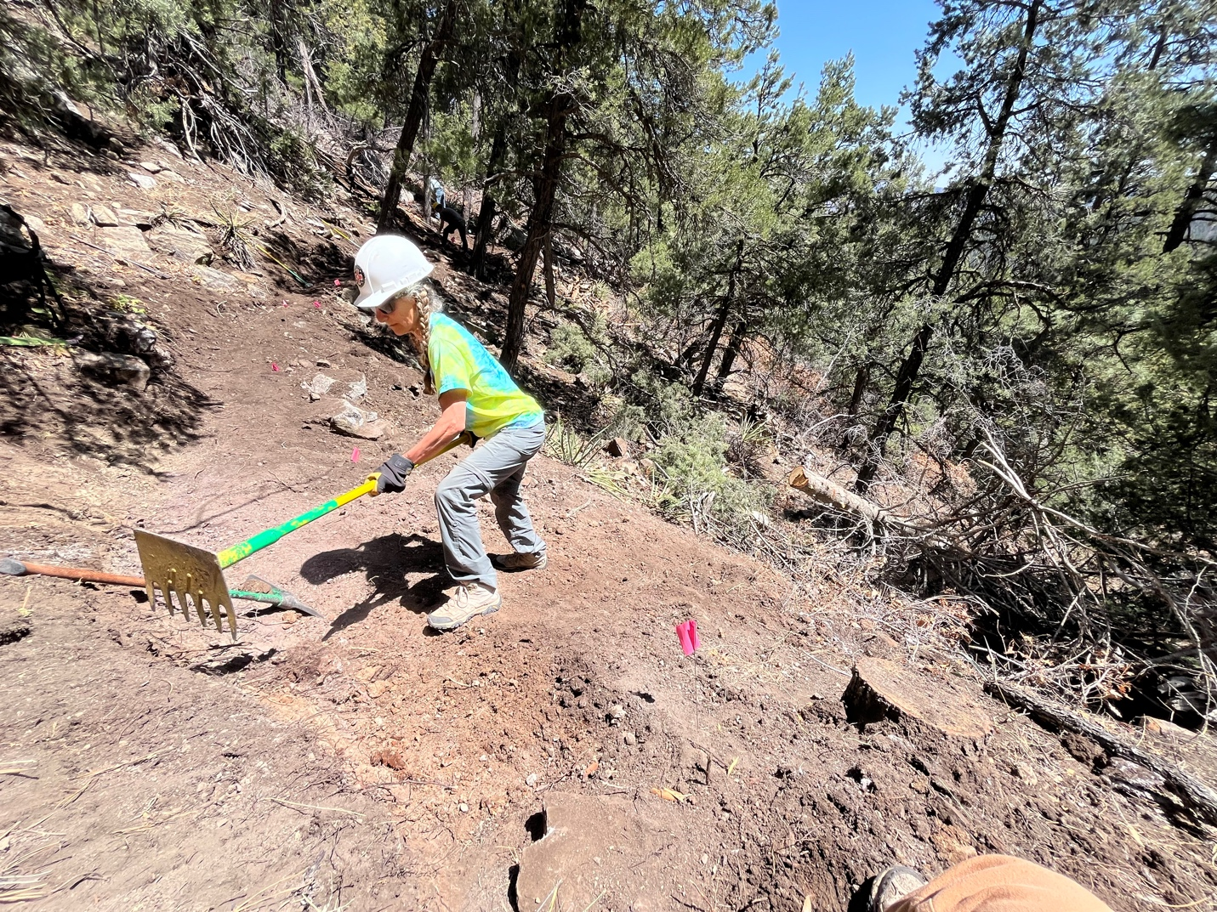

Claudia had to work in the sun but invented a way to push dirt downslope by running it down with her feet.

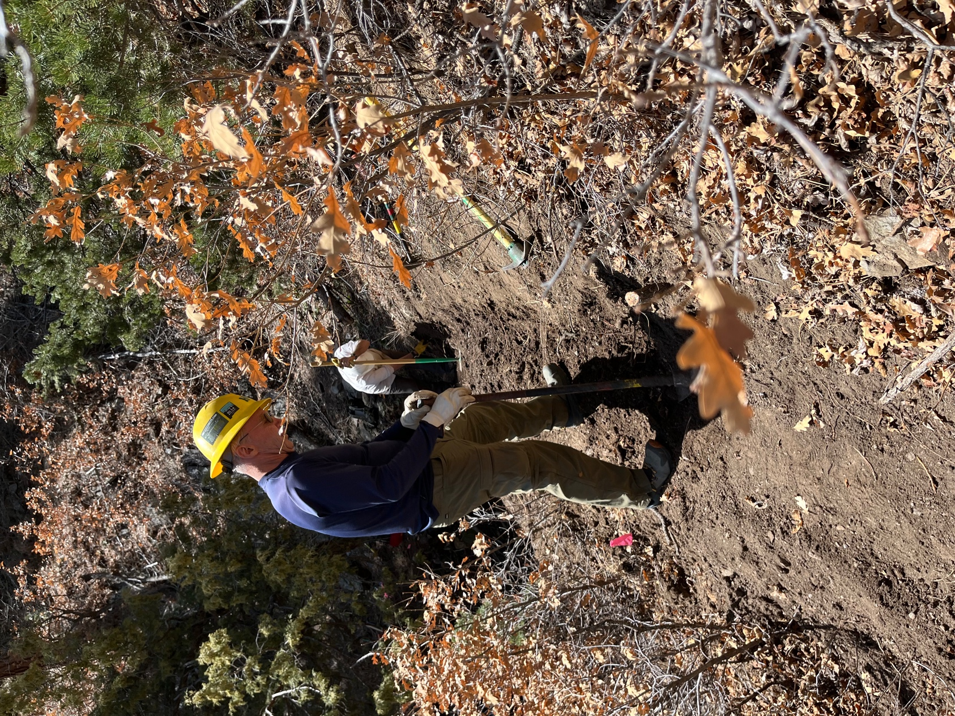

John and Rich worked through the sunny section and the oak until quitting time.

