**Report of FOSM Project to Remove Graffiti from the Lower Restroom**

**and Do Touch-up Painting on Three Picnic Shelters in Doc Long Picnic Area**

**on Tuesday, April 15, 2025**

Sam Beard

On Tuesday, April 15, four FOSM volunteers removed graffiti tags from the lower restroom and did touch-up painting on the three picnic shelters in Doc Long Picnic Area. Tags were removed from the following locations on the restroom: water fountain, three windows, bulletin board, door, and trash receptacle. Volunteers also did touchup painting on the two modern picnic shelters and the very old CCC shelter. Paint was applied where it had chipped off of columns and beams and where visitors had carved initials in the large wooden columns.

The volunteers were Cliff Giles, Pauline Ho, Rick Buss, and Sam Beard.

Project photos by Cliff Giles are presented below.

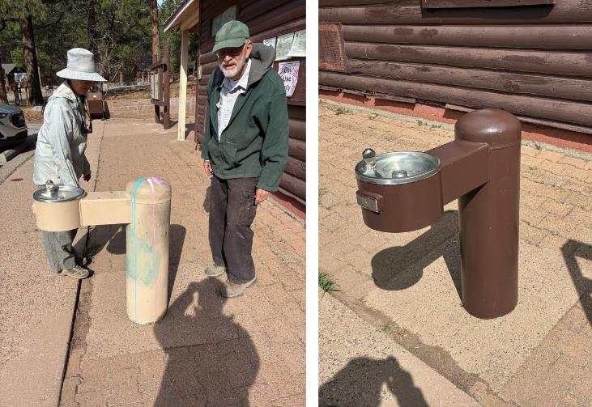

Before and after photos of the water fountain that had been tagged.

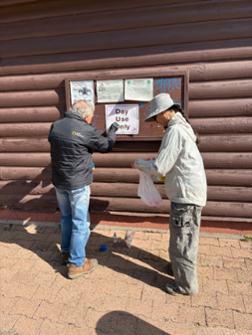

Rick Buss removing graffiti from white plastic sign on bulletin board.

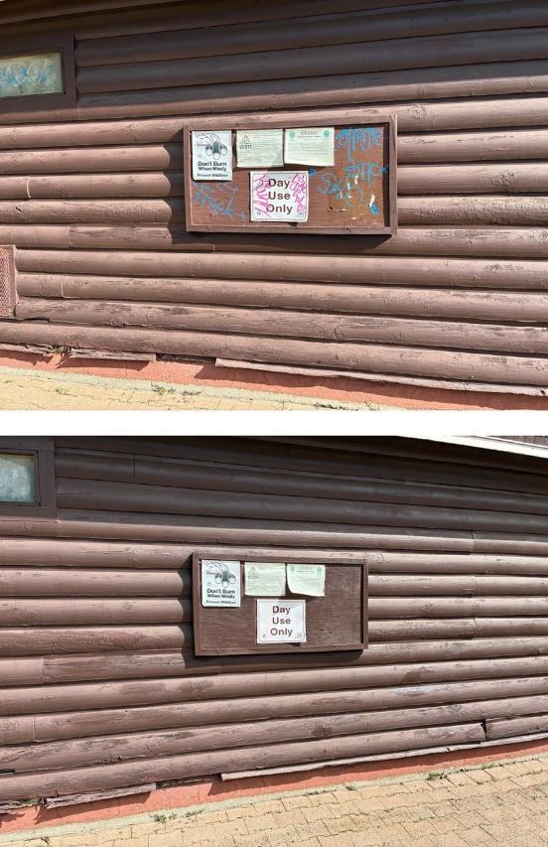

Before and after photos of the bulletin board that had been tagged.

Note that the tagger was careful to not put tags on the upper three signs.

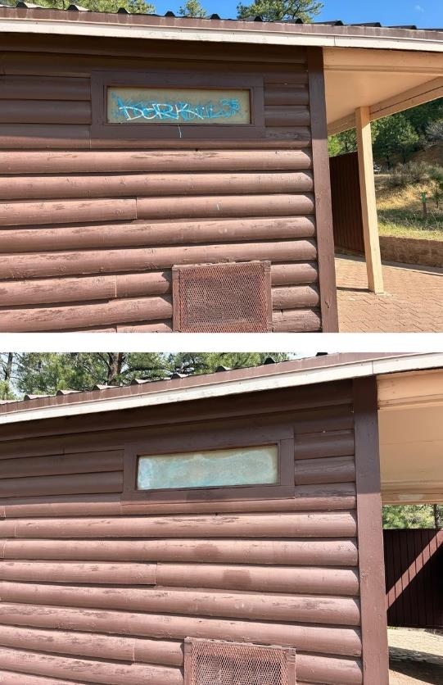

Before and after photos of this window in the men’s restroom. We learned that Goof Off

graffiti remover damages plastic translucent windows and leaves a white film. FOSM does

not usually use Goof Off. We were trying a spray can of this material that had been given to Sam Beard.

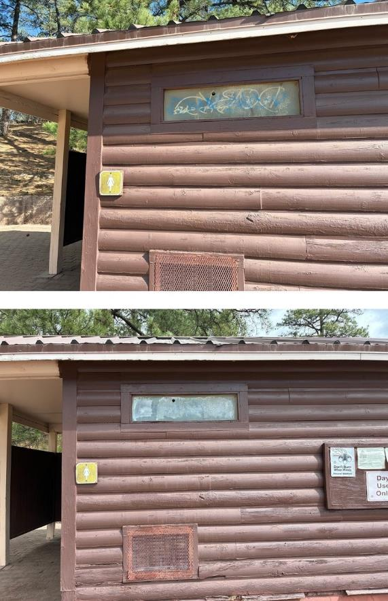

Before and after phots of front window in the women’s restroom

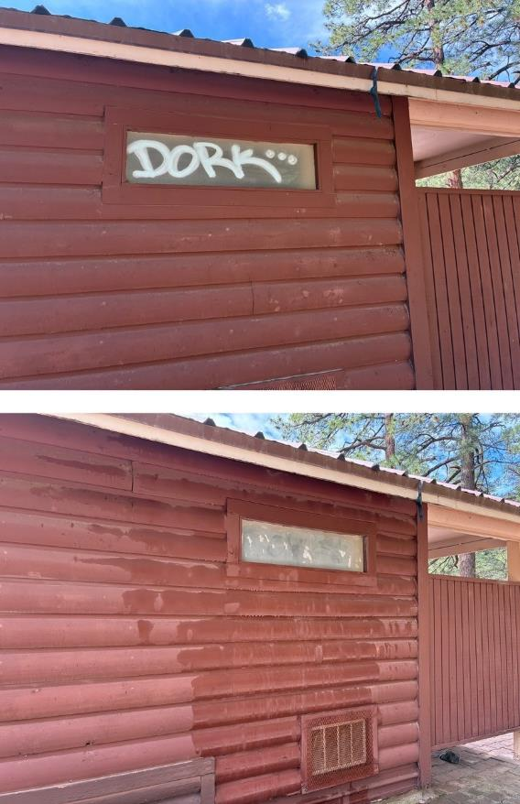

Before and after photos of back window in the women’s restroom.

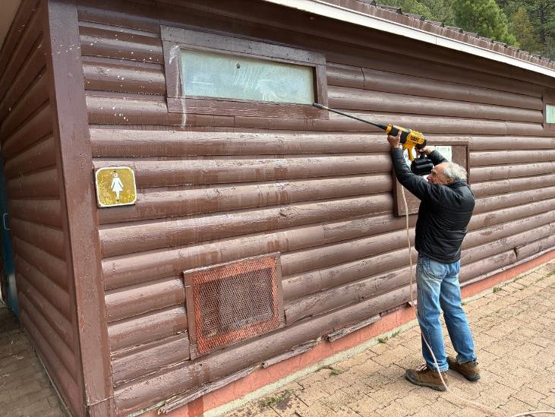

Rick Buss using the FOSM low pressure battery-powered washer to rinse paint and chemical

residue from window.

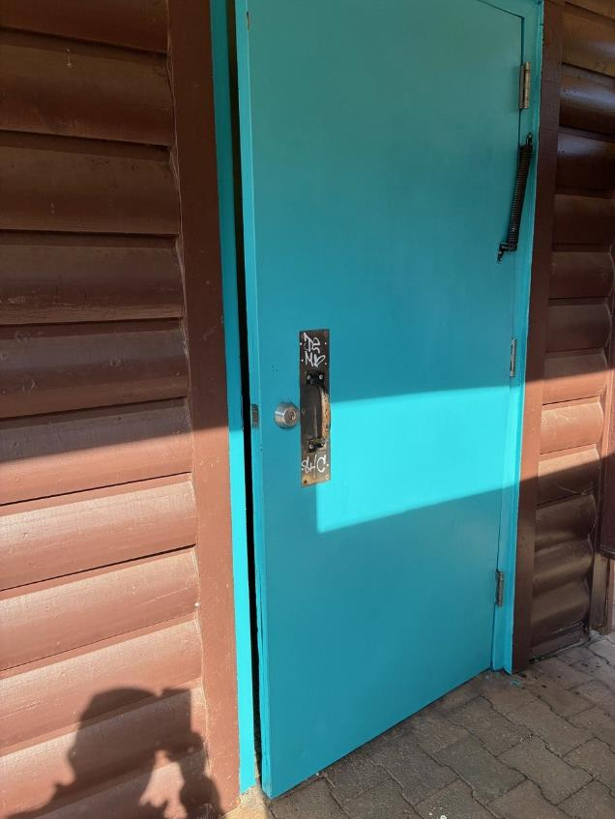

Tag on door to men’s restroom. The tag was later removed.

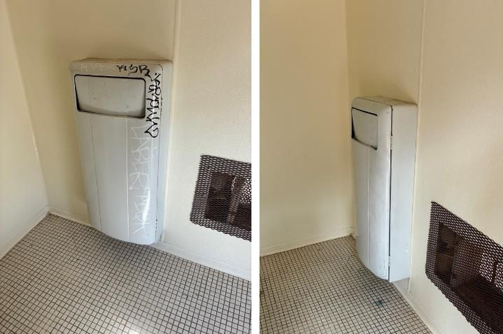

Before and after photos of trash container in men’s restroom.

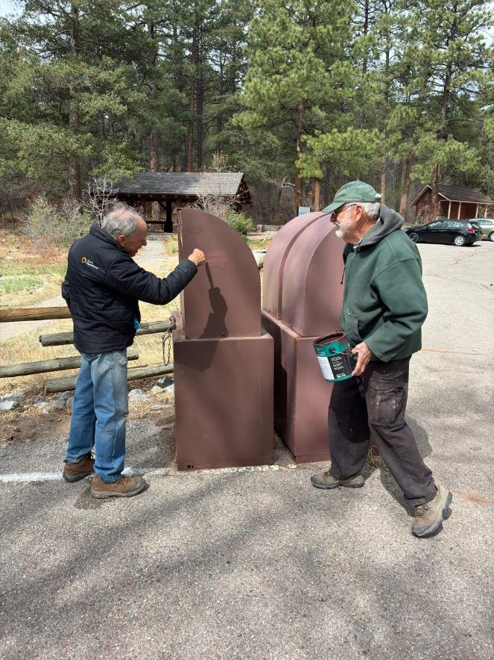

Sam Beard observing Rick paint over a white paper tag on a trash container.

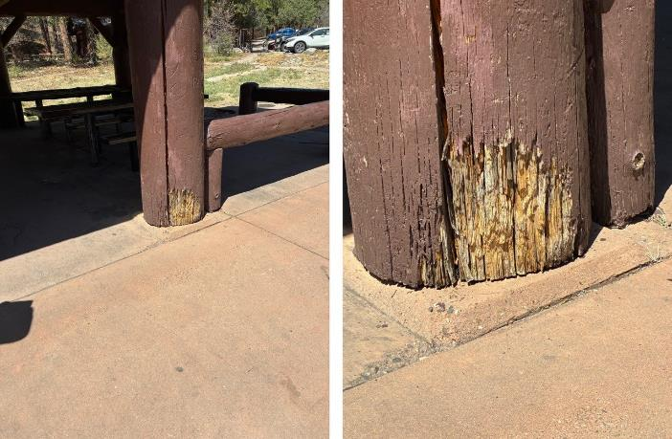

Views of decayed wood on lower part of large wooden column on modern picnic Shelter A.

Epoxy products will be used later to repair this damage and prevent further decay.

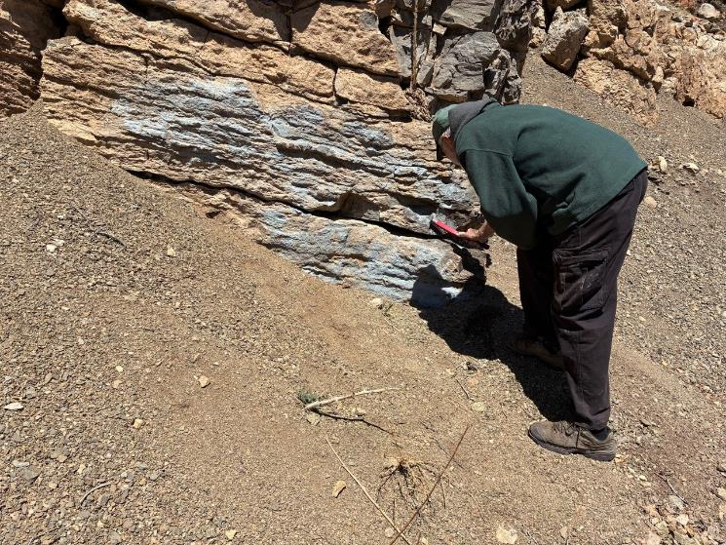

Several weeks ago, Sam Beard and Sim Cook had applied graffiti removal chemical on this gray house paint

on boulders beside the Crest Highway below the Ski Area. That chemical did not remove this paint.

Here, Sam is using a steel brush in an attempt to remove this paint after commercial paint stripper had

been applied to the boulders. It softened the paint some, but more stripper and scrubbing will be required

to remove this thick house paint.