**Graffiti/sticker removal along Crest Road, April 15, 2025 by Pauline Ho & Rick Buss.**

The attached Word document has photos of the work Rick and I did this afternoon at 3 places removing graffiti and or stickers. We finished around 3:30 pm.

Although we didn't inspect it closely, it looks like one of the restrooms in the upper Crest parking lot has quite a bit of white graffiti on the vent chimney. It's probably a good candidate for painting over at some point.

Cheers,

Pauline

1. **Stickers removed from sign near ski area.** When we worked on this last Oct, we didn’t have a tall enough ladder to remove the higher sticker, so we did that today. There was also a new sticker that we removed, along with some old tape marks.

Before After

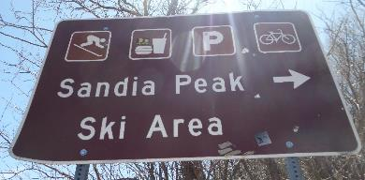 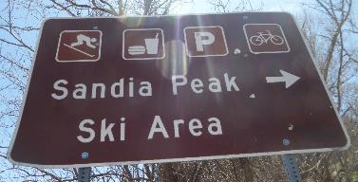

1. **Stickers removed from back of sign at Ellis parking lot**. We noticed these last October, but didn’t have a tall enough ladder to reach them that day. These had been baked on by the sun, so it was slow to remove them.

Before After

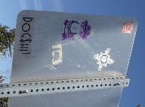 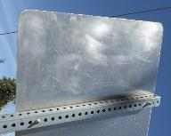

1. **Stickers and Graffiti removed from the backs of 2 signs in the Crest parking lot.**

Before After

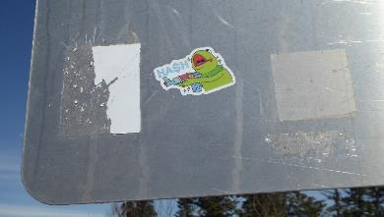 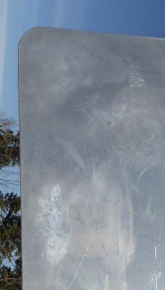

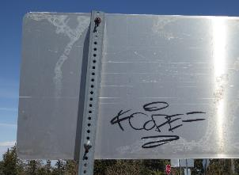 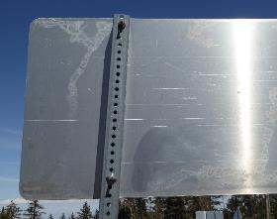

1. **Graffiti removed from restroom doors** that had been reported by Steve Roholt on April 14, 2025. The tagger had painted over the part of the doors that had “RESTROOM” painted on them, so it was tricky to remove enough of the graffiti without removing too much of the underlying paint. At some point, it may be best to just repaint them.

Before After

