**Report of FOSM Project to Repair Two Benches in Balsam Glade Picnic Area on Wednesday, April 16, 2025**

Sam Beard

On April 16, Joelle Hertel and Dan Caton repaired two benches in Balsam Glade Picnic Area by replacing missing or damaged man-made 2x4 slats.

In the bench near the upper parking lot, they installed four slats forming the seat of the bench. In the second bench at Madera Canyon Overlook, they replaced the top slat in the back of the bench. The Sandia Ranger District provided the man-made slats.

Remnants of broken slats were removed by cutting through the bolts. Bolts and nuts attaching slats to the bench frame were tamper proof, so cutting through the bolt was the easy way to remove damaged slats.

Joelle is not certain which material the Forest Service provided. She believes it was a wood plastic composite (WPC) which is recycled plastic with small wood particles or fibers. WPC was the material she had originally proposed to the FS a couple years ago. The cross section cut and the spiral debris from the drilling are definitely plastic looking with a few specks.

Project photos by Sam Beard are presented below.

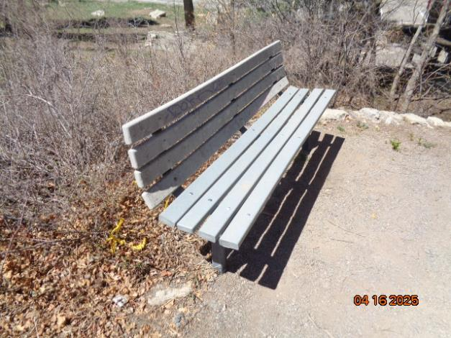

The repaired bench near the upper parking lot with four new slats in the seat.

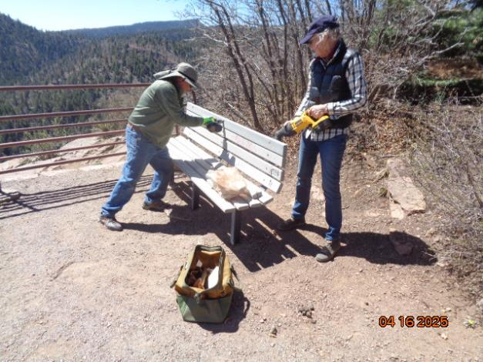

Dan and Joelle repairing the bench at Madera Canyon Overlook

with one new slat on top of the back.