**Report of FOSM Project to Paint Parts of Three Doc Long Picnic Area Restrooms on Tuesday, April 22, 2025**

Sam Beard

On Tuesday, April 22, the lower parts of the three restrooms in Doc Long Picnic Area, where the paint condition was poor, were painted. The decayed part of the narrow bottom board on the lowest restroom was replaced with pieces of a cedar fence picket having a cross section of 5/8-inch by 1-3/4-inch.

The dark brown paint used on the Sandia Ranger District is Federal Standard Color 20059. This color is specified in the USFS publication: Standard Colors for Forest Service Developed Recreation Sites, National Technology & Development Program, 1623-1810-SDTDC Recreation, August 2016.

The photos below show the conditions of the exterior boards on the restrooms before and after being painted.

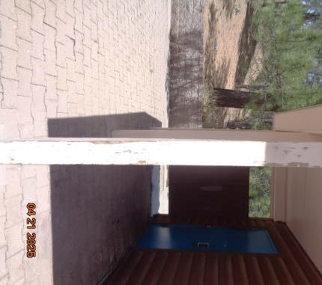

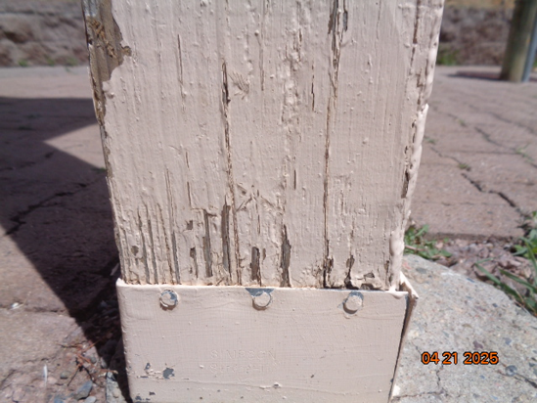

Photos showing condition of paint on one of six posts on lowest restroom.

All photos by Sam Beard

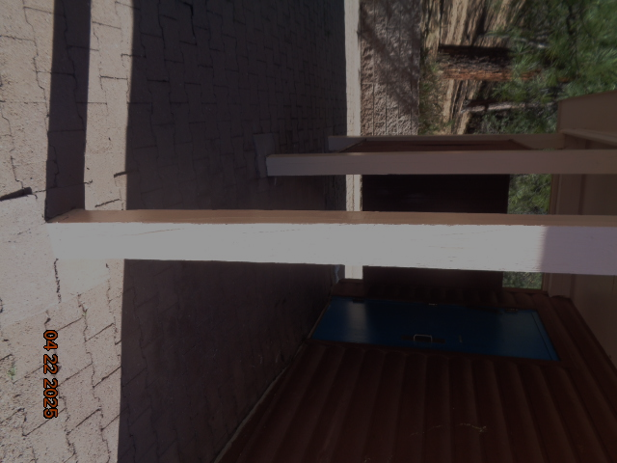

Post has been painted with off-white (slightly pink) Federal Standard Color 21643,

a good match for the original color of the post.

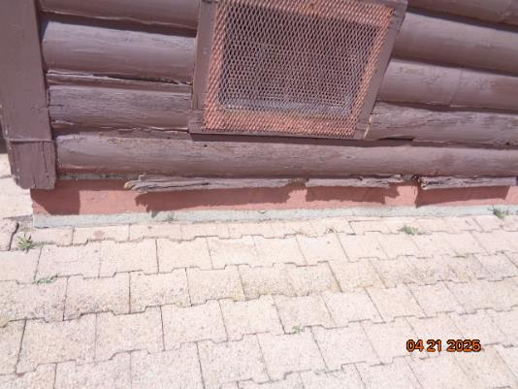

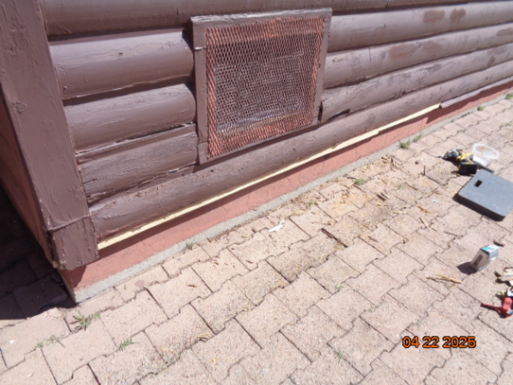

Top – Photo showing damaged narrow bottom board on front of lowest restroom.

Bottom – Narrow piece of cedar fence picket has been installed to replace damaged

board that covers lower edge of oriented strand board (OSB) sheathing.

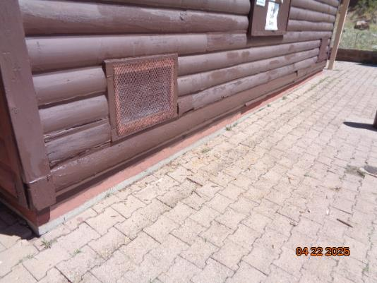

Bottom wide and narrow boards and ventilation frames have been painted.

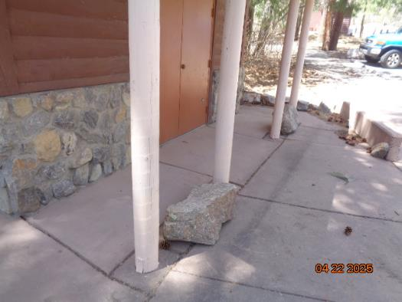

Lower 18-inches of posts on interpretation building have been painted

with the off-white pink color paint.

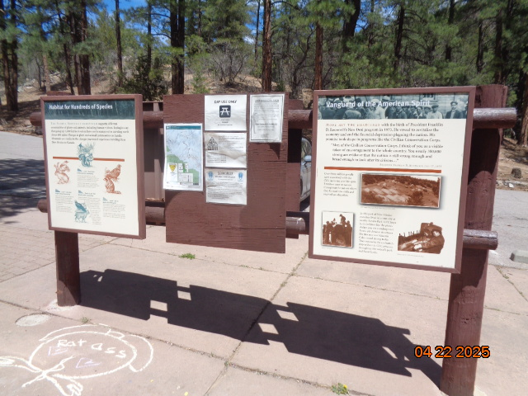

Right side of plywood panel has been painted with official USFS brown paint to cover

remains of glue used to paste an unofficial paper sign on the plywood. The official USFS

brown paint is Federal Standard Color 20059.

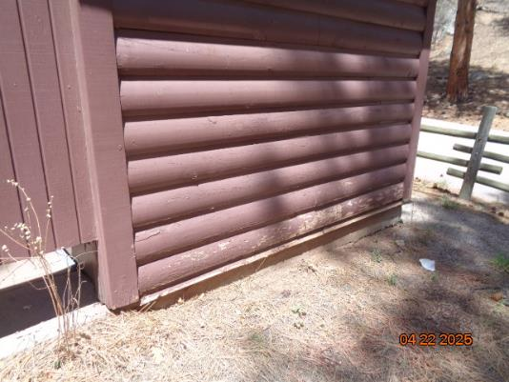

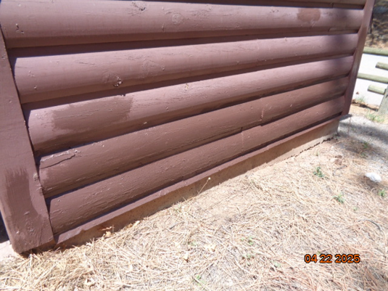

Top – Photo showing damaged paint on two lower wide boards and the narrow bottom

board on one side of the second restroom

Bottom – The bottom three boards have been painted.

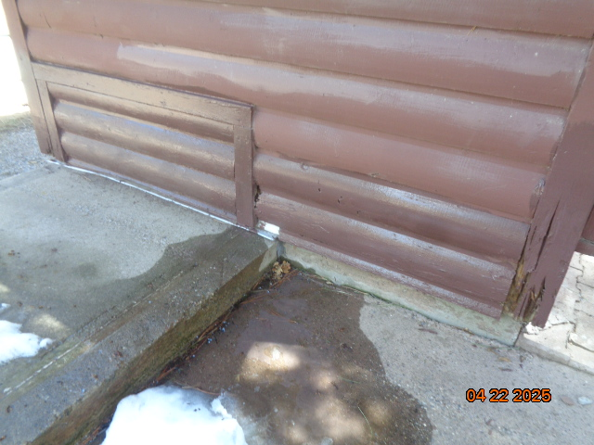

The bottom three boards on the upper side of the second restroom have been painted.

Note the decay in the lower ends of the two vertical corner 2x6 boards due to snow that remains

on this side of the restroom for a long period.

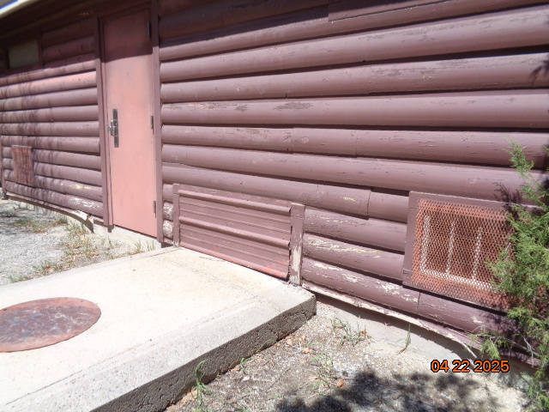

Photo showing the poor condition of the paint on the lower boards on the back of the upper restroom.

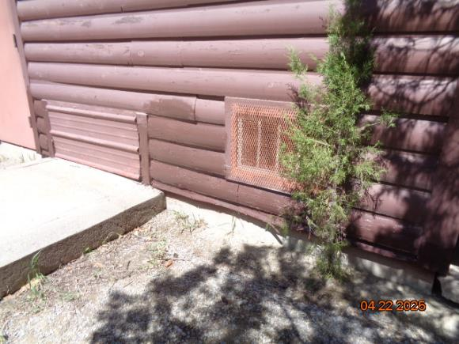

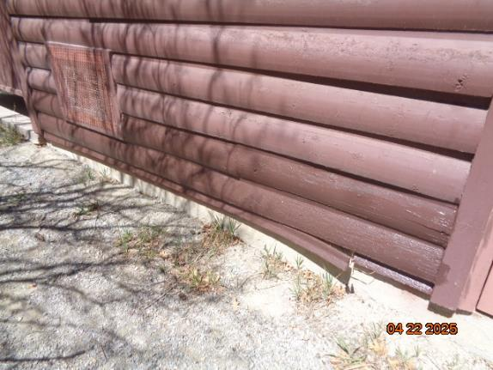

The lower boards on the back of the upper restroom have been painted.