Thursday, 04/24/25- North faulty: Nine volunteers met up with Chris to continue work on reroute #5 this week. We are very close to finishing and hope to get it done next week. We had great weather and lively conversation over lunch about old TV shows. All that’s left are the reroute ends and a little wiggle up the trail and we can move on.

Volunteers: Bruce Hansche, Laura Leon, Rich Fagioli, Claudia Bergsohn,
Byron Garner, John McNett, Jim Houle, Bill Perkins, Eric Russell

Photos: Laura Leon and Bruce Hansche

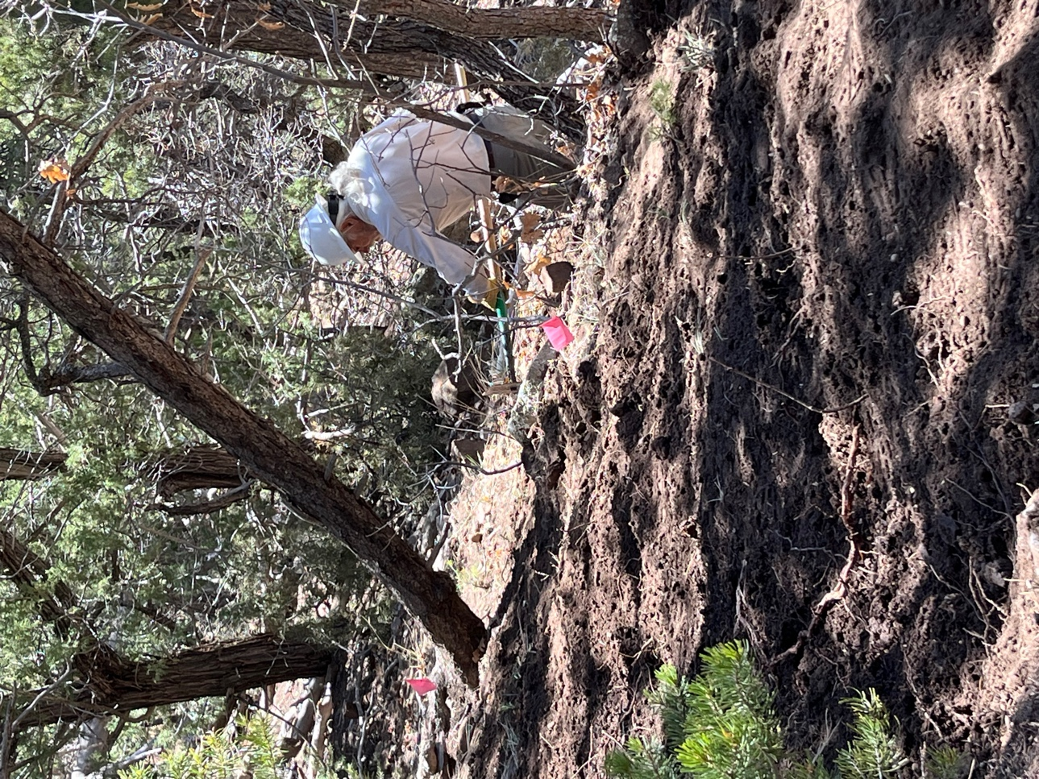

Bill did an excellent job on the downslope. That tree has got to go.
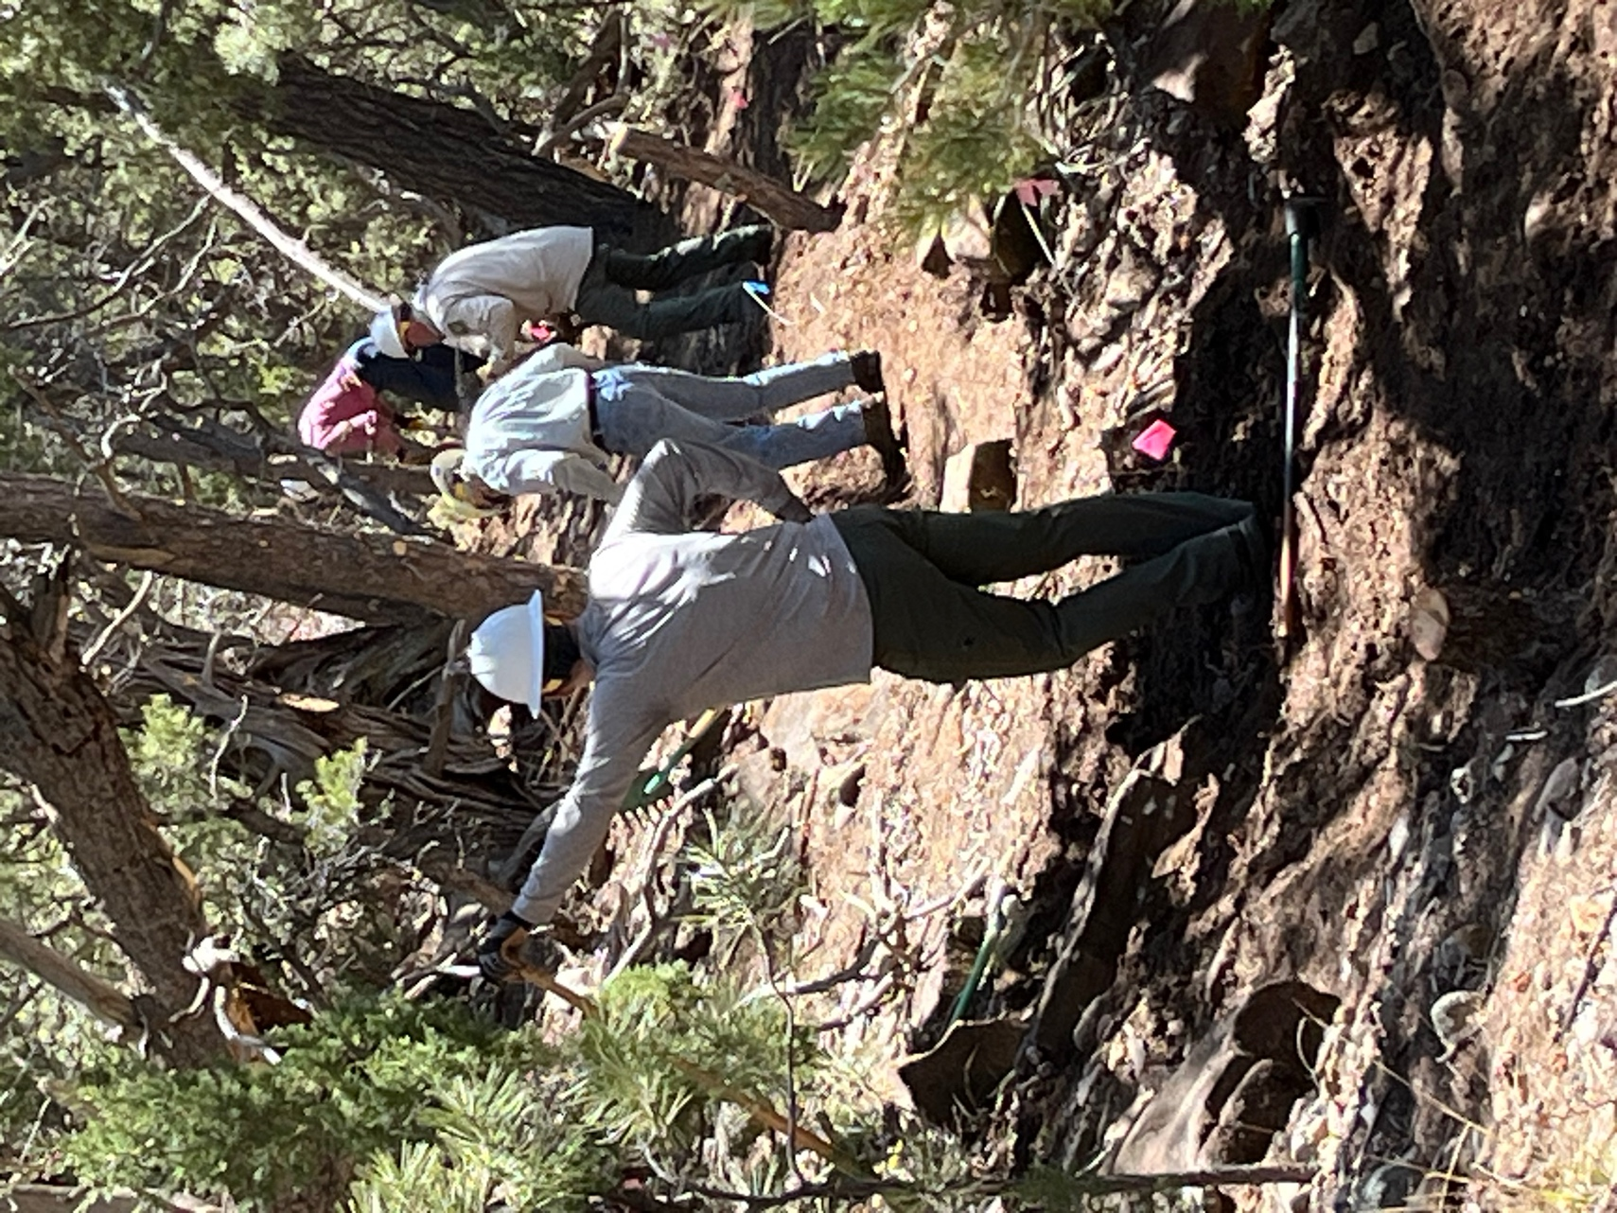

The line worked on - John M., Byron, Chris and Bruce.

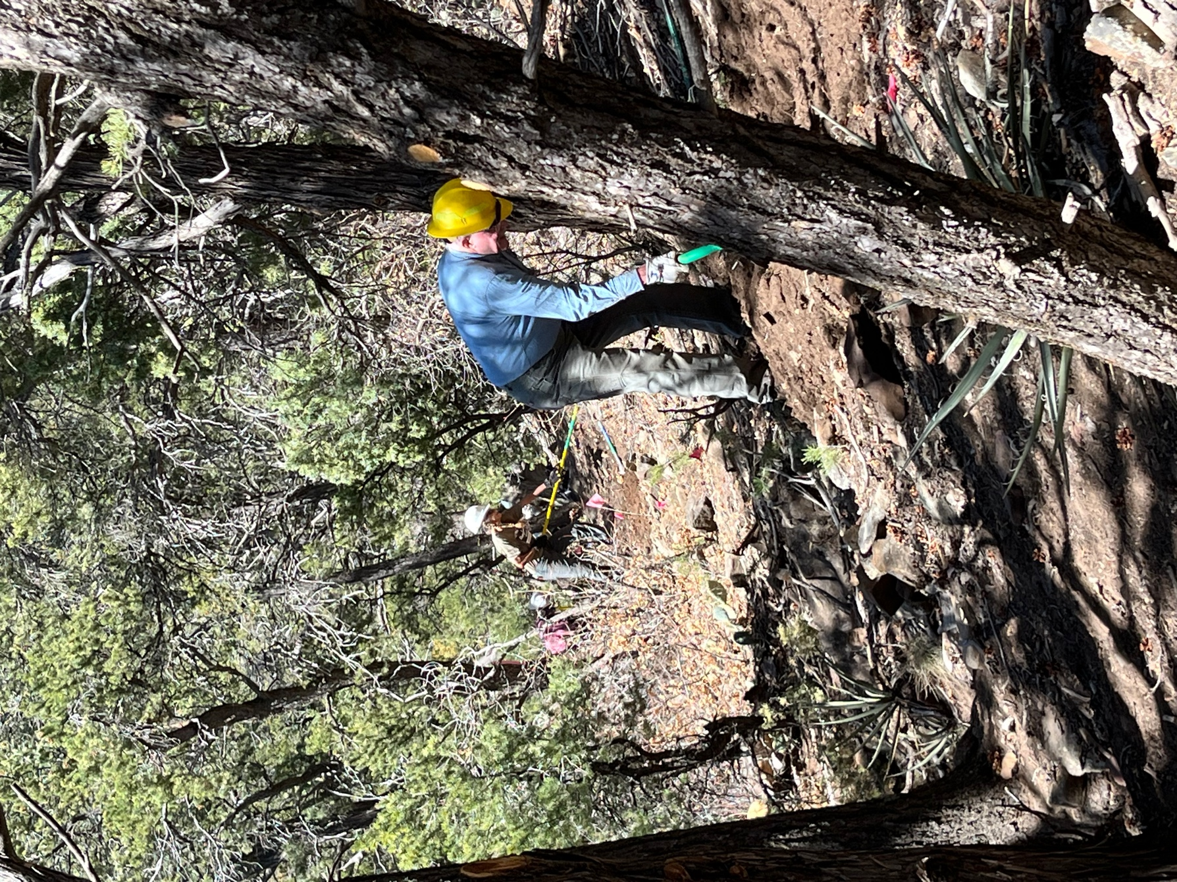

Eric and Claudia were almost to the end of the reroute.

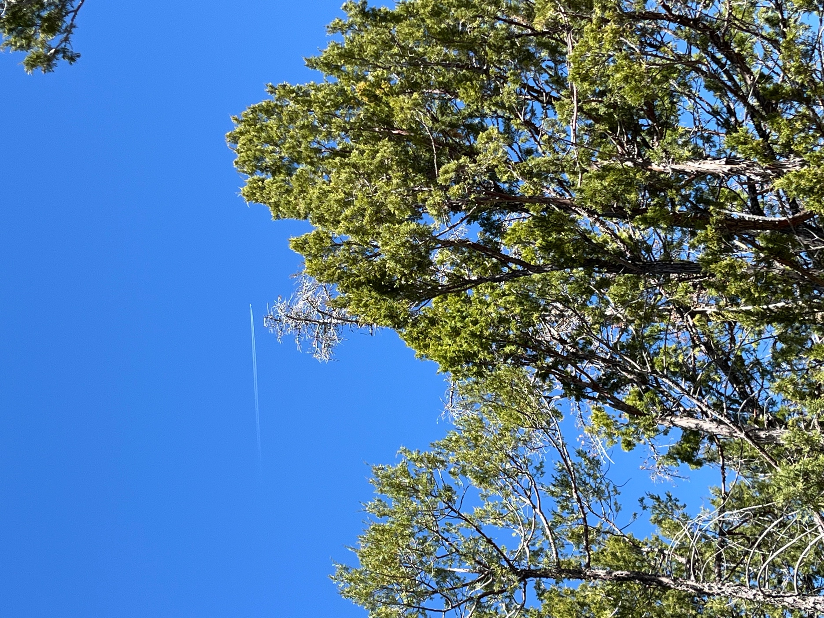

Blue skies abound!
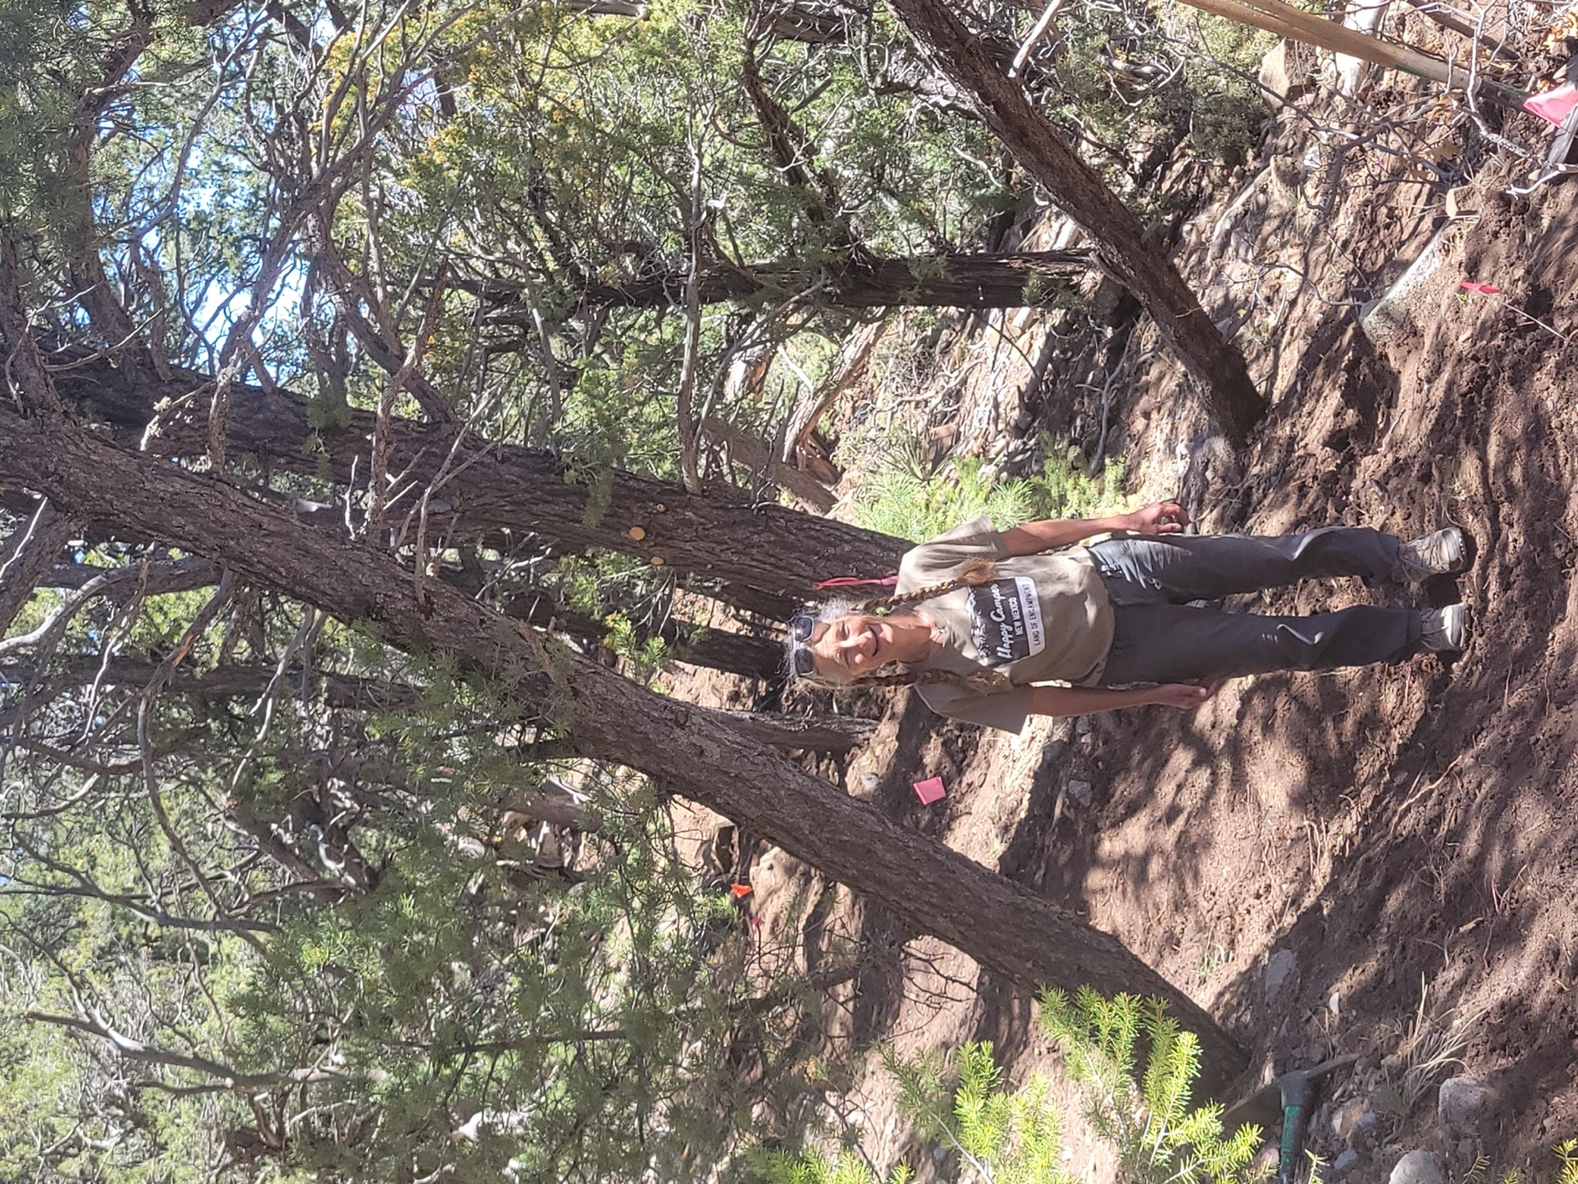

Claudia agreed- the tree needed to go and Chris took it down after lunch.

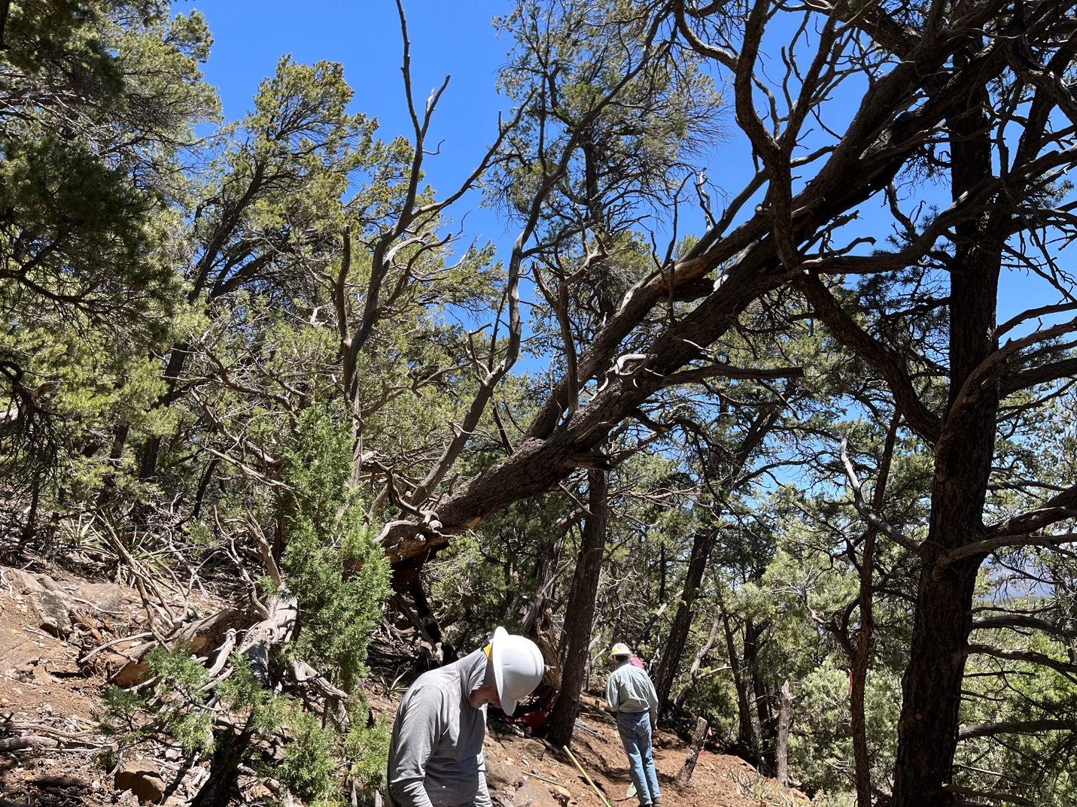

This tree may be a problem. It has cracked just above Byron’s head and it’s probably been like that for a while but it sure looks ominous.

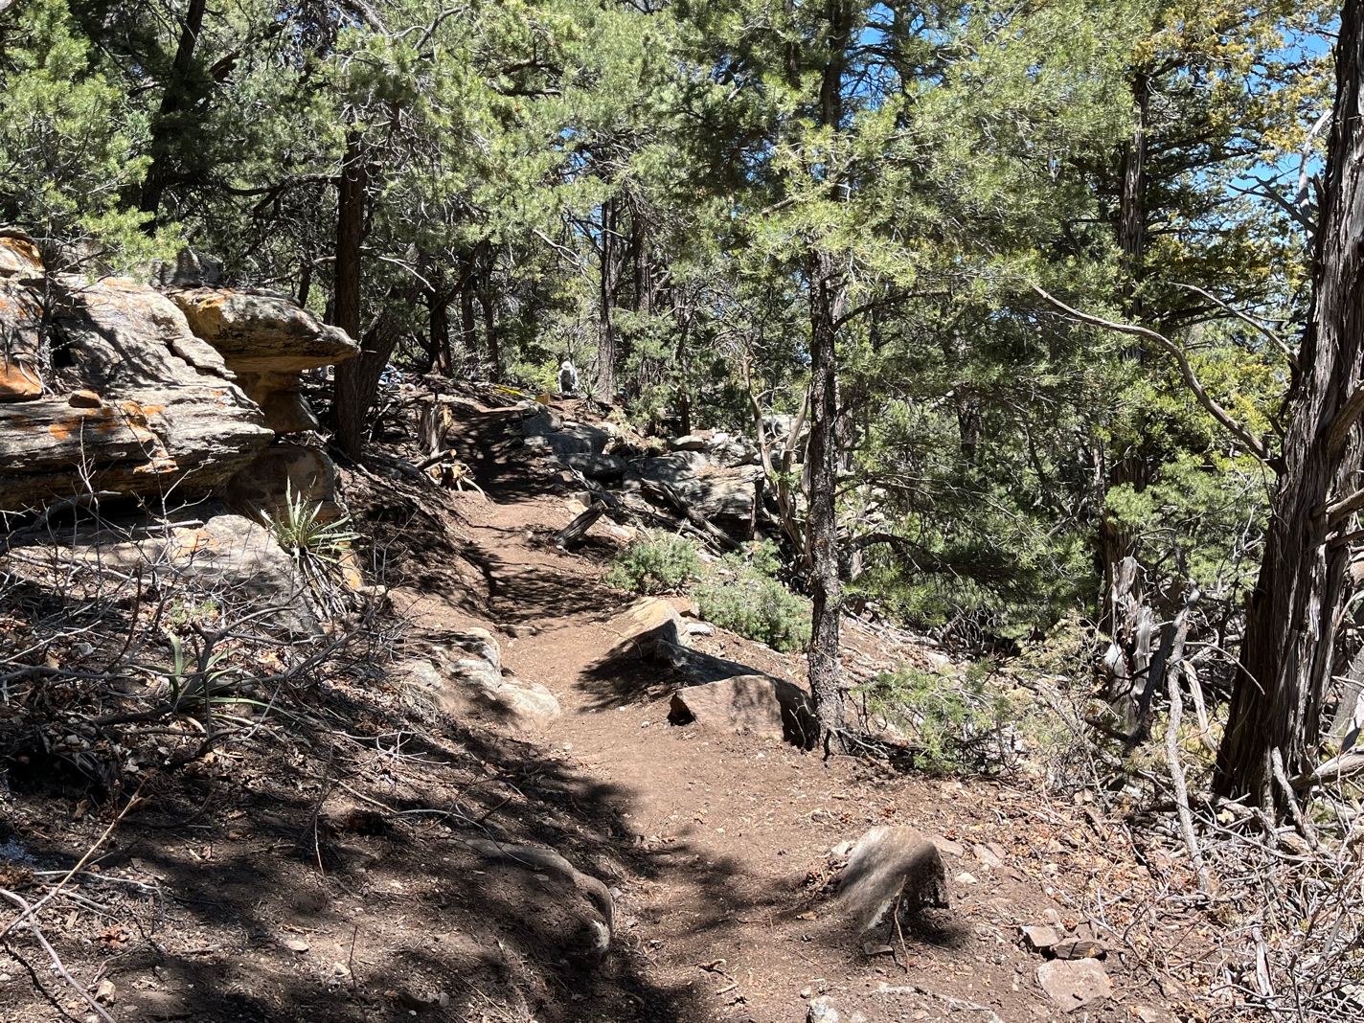

Almost finished new trail.
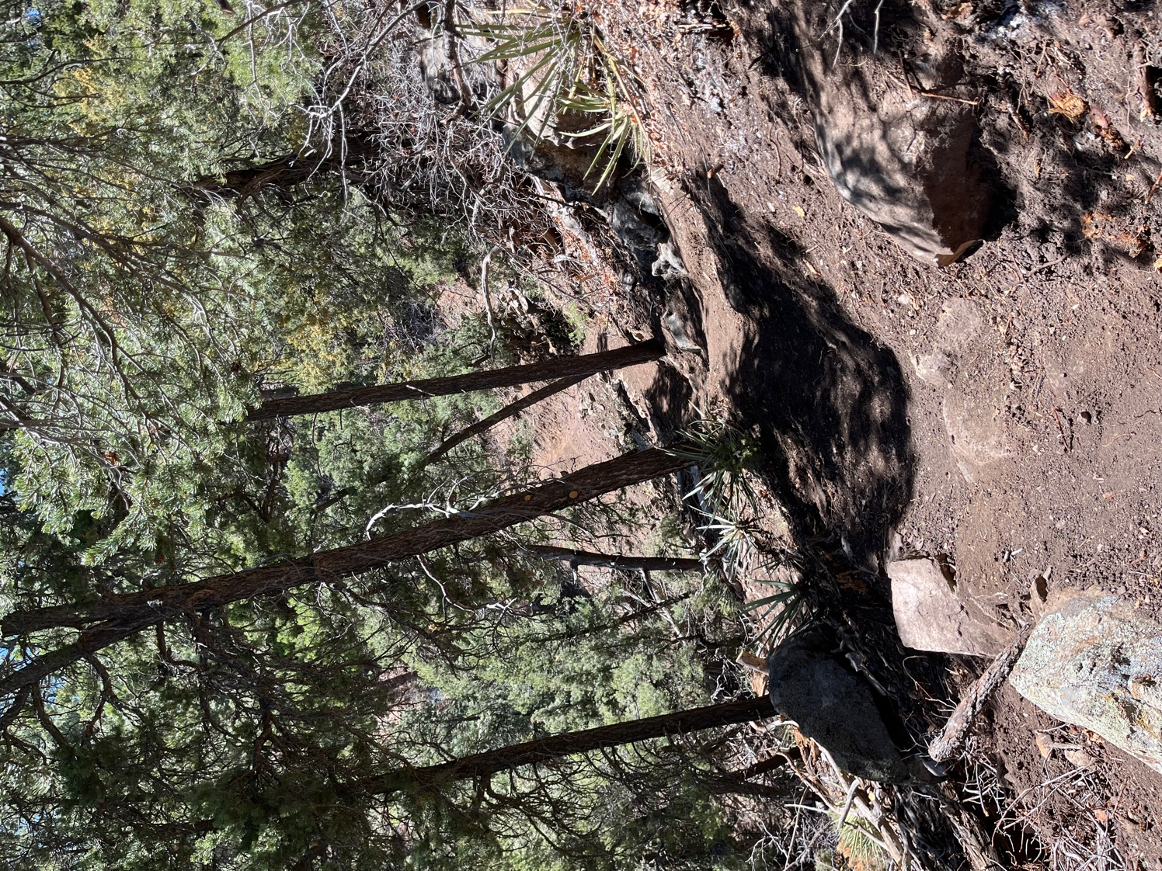

Why does it look so much easier than it really was???

