**Report of FOSM Project to Fell Four Hazard Trees in Capulin Picnic Area and**

**Snow Play Area on Wednesday, April 23, 2025**

Sam Beard

On Wednesday, April 23, seven FOSM volunteers felled and limbed four hazard trees and one adjacent tree in Capulin Picnic Area and Snow Play Area. The hazard trees had been selected by Canyon Young, SRD Trails and Wilderness Program Manager.

The trees will be bucked to a length of 12 inches, split with Lou Romero’s power splitter, and hauled on Mike Oliver’s trailer to the Mountain Christian Church Woodlot. Members of the church Wood Ministry will distribute the wood to families in the East Mountain area who heat their homes with wood. The Sandia Ranger District provides the permit for the processed hazard tree wood to be donated to the church.

The volunteers working on this project were Cliff Giles, Dan Benton, Jerry Carroll, Eric Russell, Sam Beard, Don Carnicom, and Dennis Crowther.

Project photos are presented below.

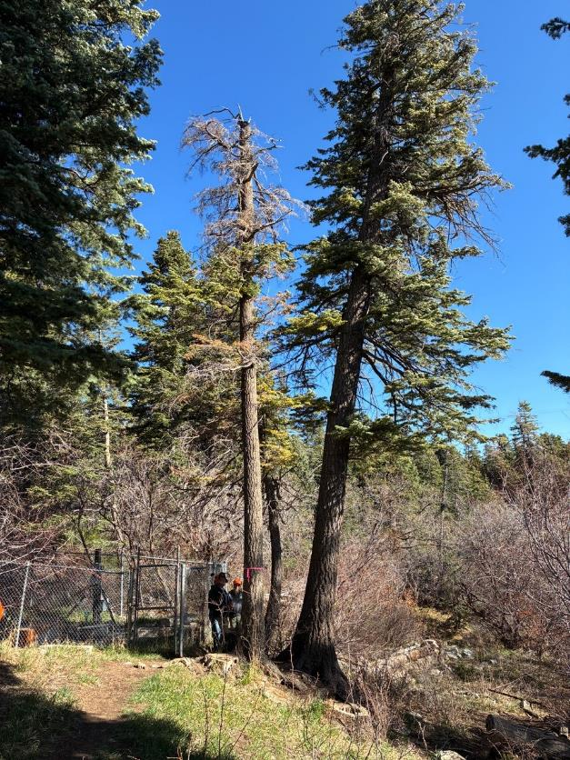

Dead hazard tree at Bird Log in lower Capulin Picnic Area. The fence is around Capulin Spring

and equipment to pump spring water to Sandia Peak Ski Area to make snow in the winter.

All photos by Cliff Giles

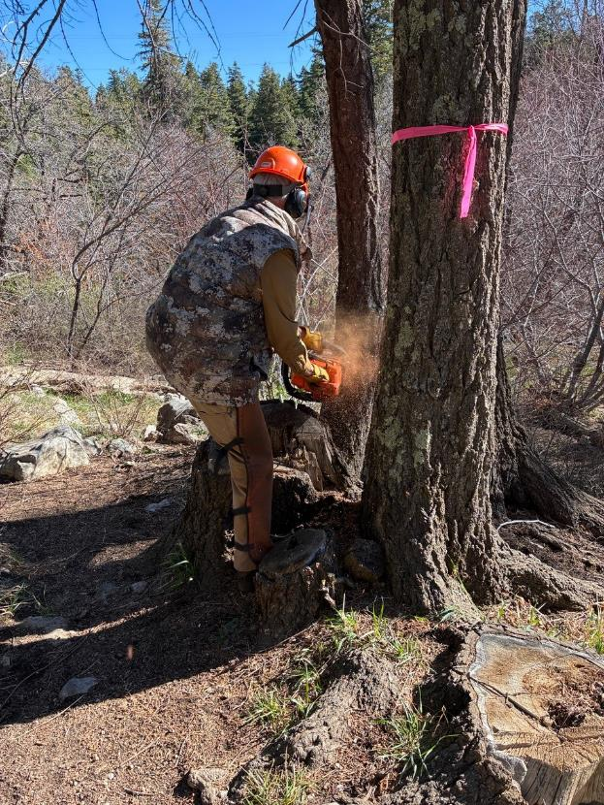

Dan Benton felling a small tree to make room to safely fell the marked hazard tree.

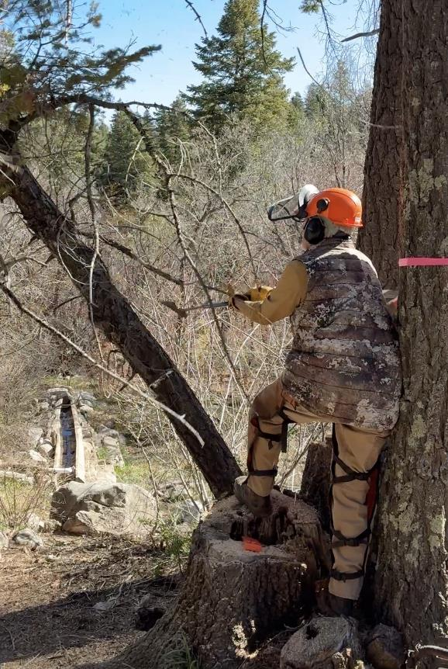

Dan pushing the small tree over. The Bird Log is seen below the falling tree farther down the hill.

A small trickle of water is directed to the Bird Log at the spring inside the fence.

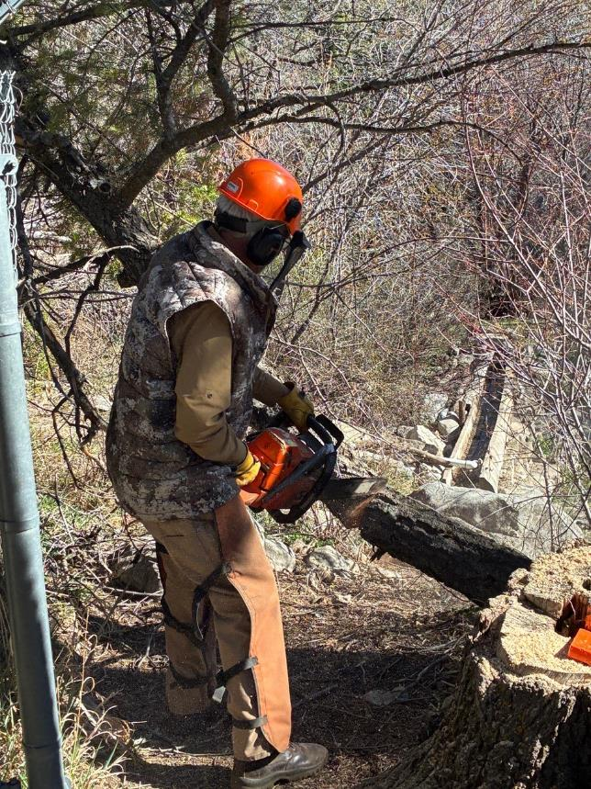

Dan bucking the small tree trunk.

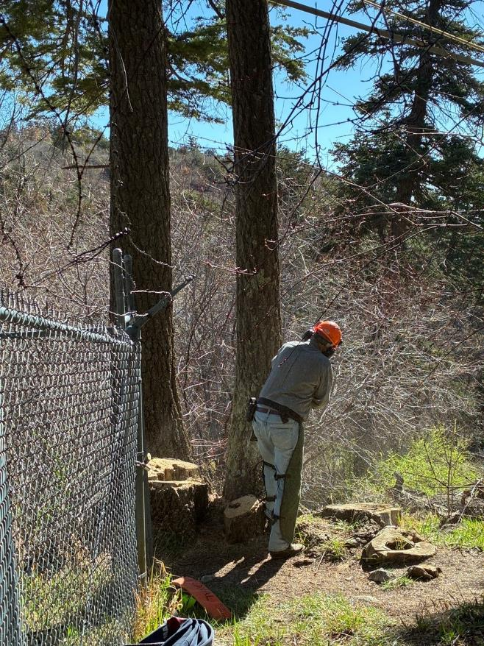

Jerry Carroll felling the hazard tree.

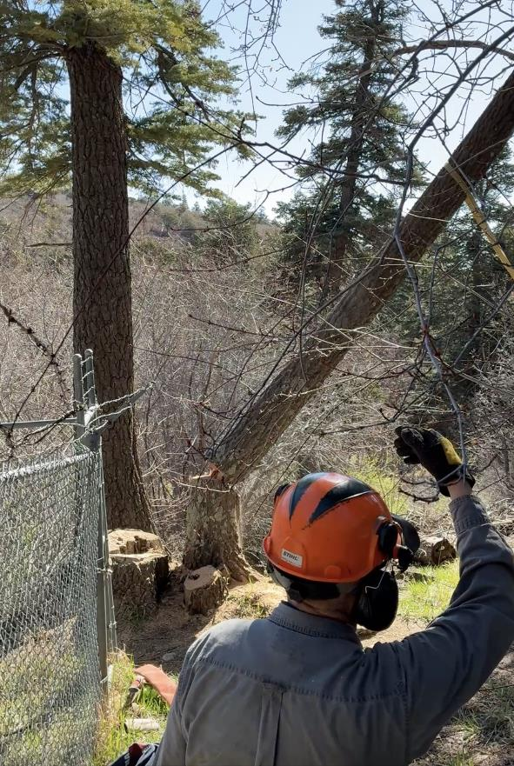

Jerry watching the hazard tree fall.

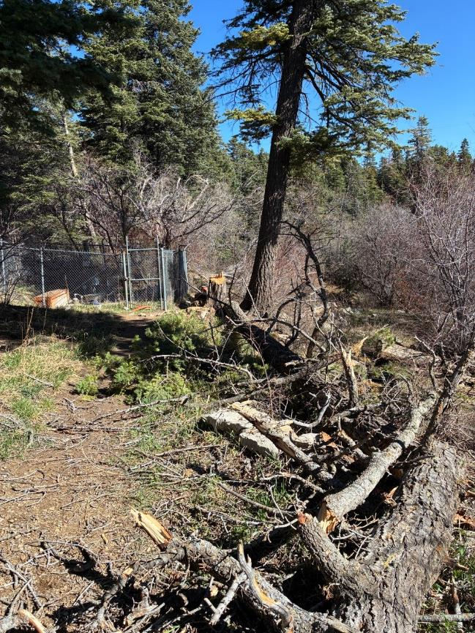

The hazard tree trunk is safely on the ground with the spring and Bird Log in the background.

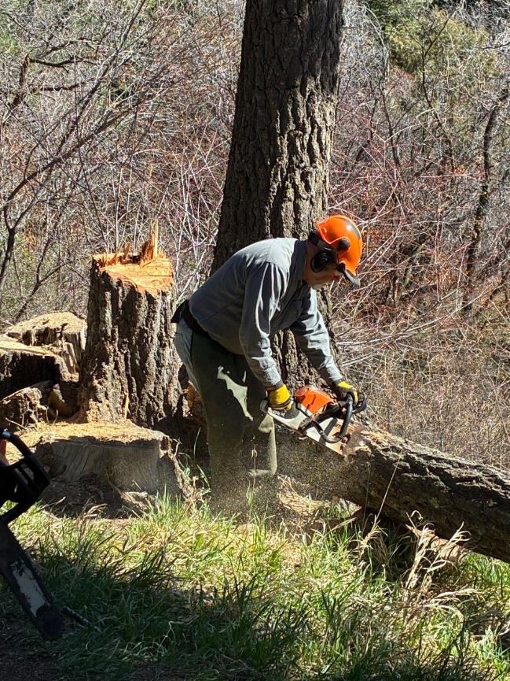

Jerry bucking the felled hazard tree.

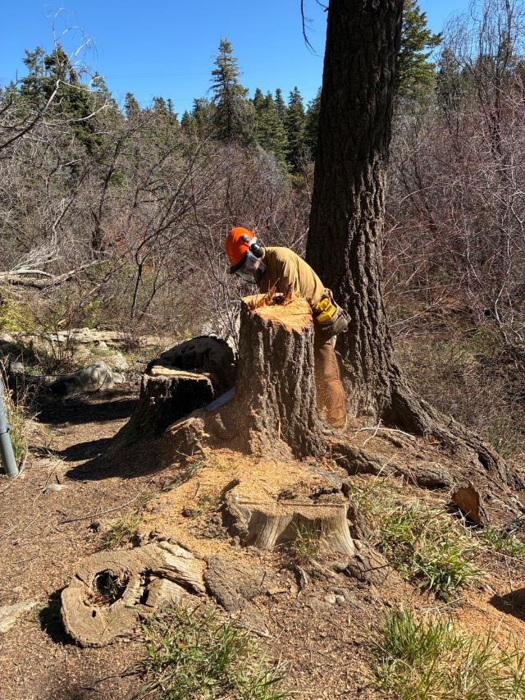

Dan Benton cutting the stump lower so that the area is more attractive.

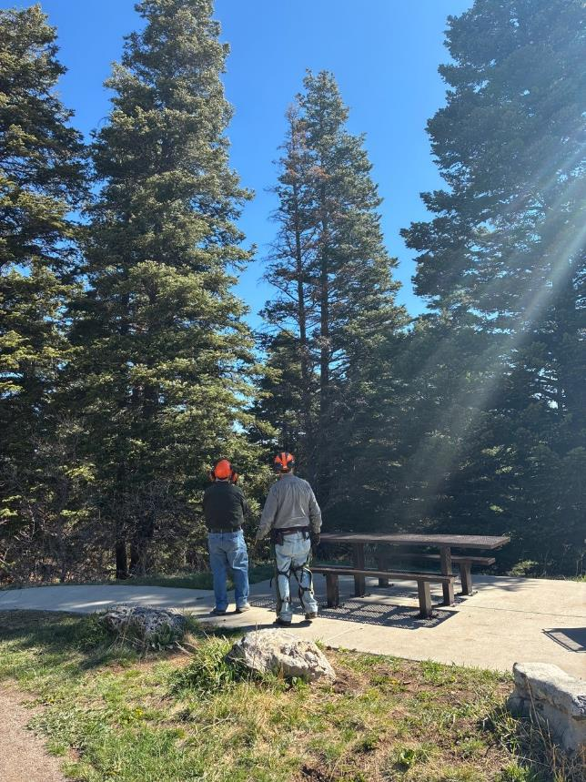

Dennis Crowther and Jerry Carroll looking at the dead hazard tree near the host site

in Capulin Spring Picnic Area.

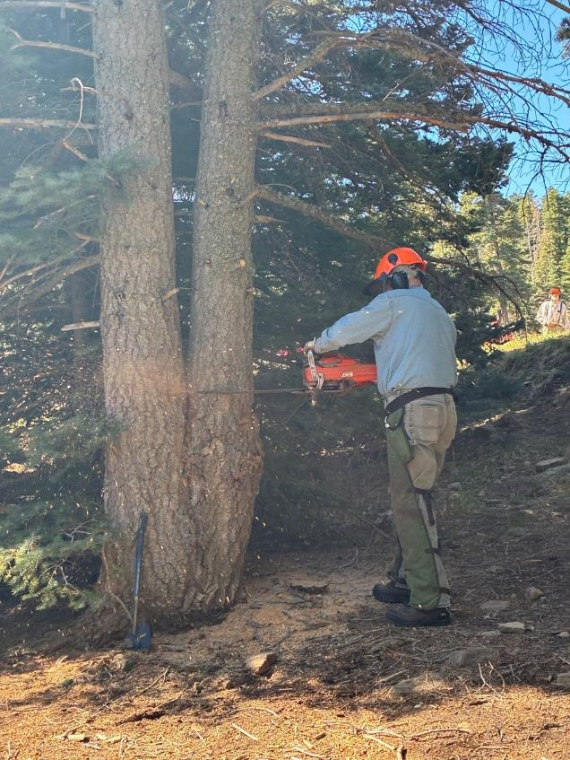

Eric Russell beginning to fell the dead trunk a V-forked white fir tree near the host site.

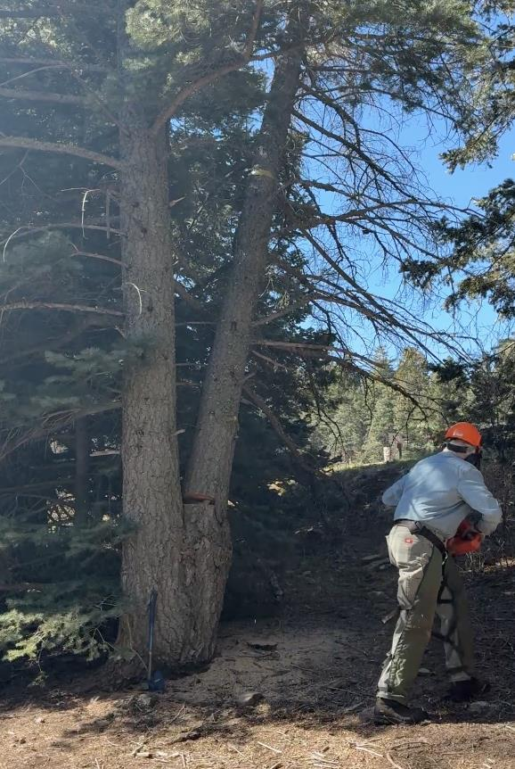

Eric running away from the falling tree.

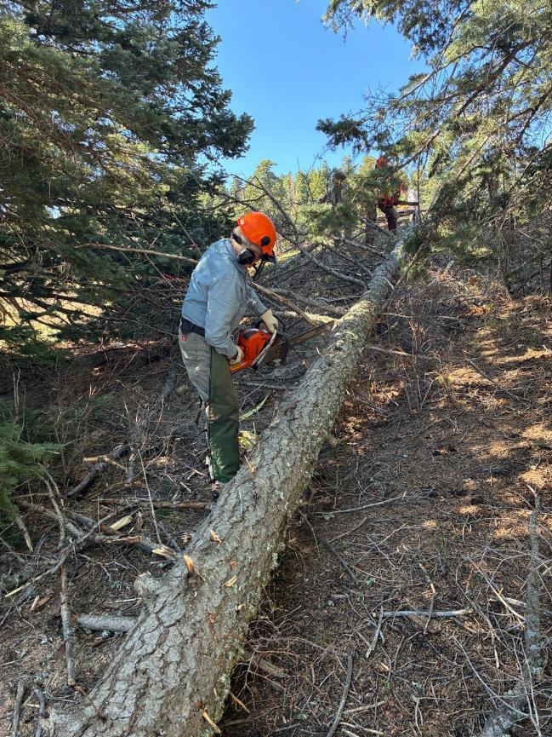

Eric and Dan limbing the felled tree.

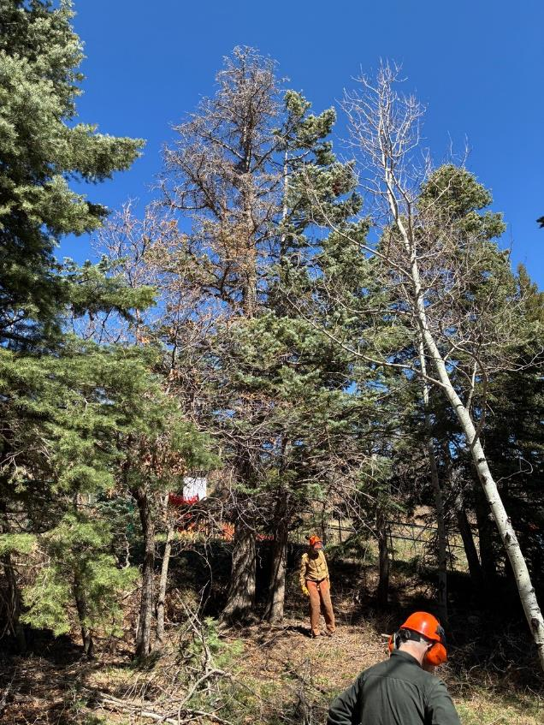

Dan Benton and Dennis Crowther analyzing the hazard tree with a dead top

adjacent to the children’s sledding area in the Capulin Snow Play Area.

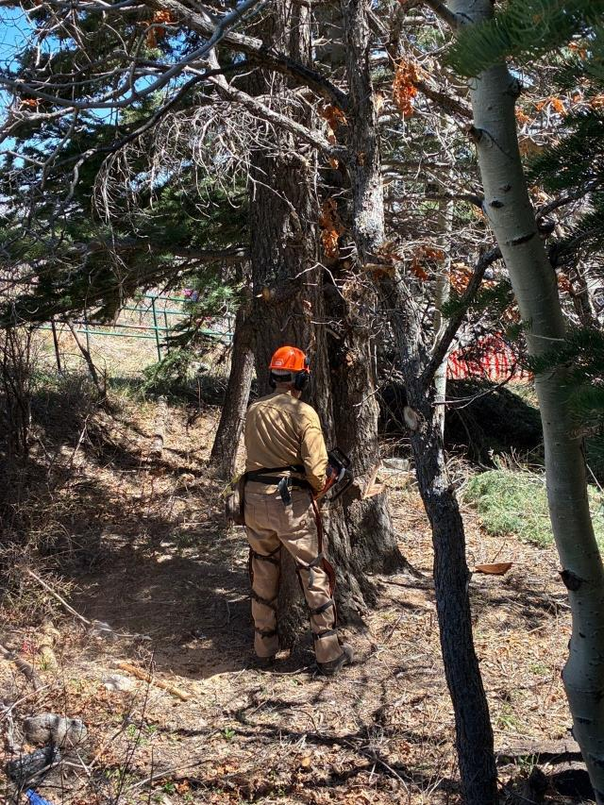

Dan felling the hazard tree near the children’s sledding area. He has already made a face cut

and back cut in a smaller tree adjacent to the hazard tree.

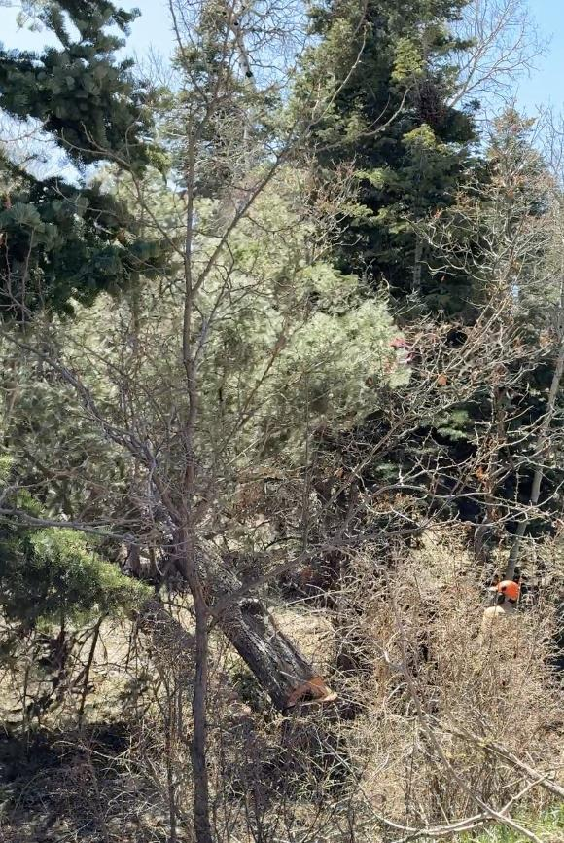

The larger hazard tree and the smaller tree adjacent to it are falling together.

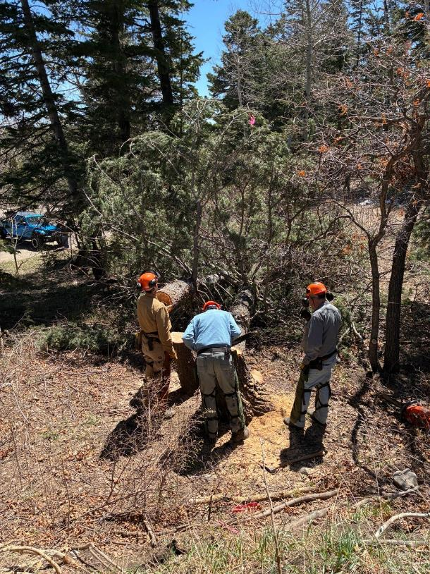

The hazard tree and small tree were felled together, and they will now be limbed. Both trunks

will be bucked and split to make fire wood to be donated to the Mountain Christian

Church Wood Ministry.

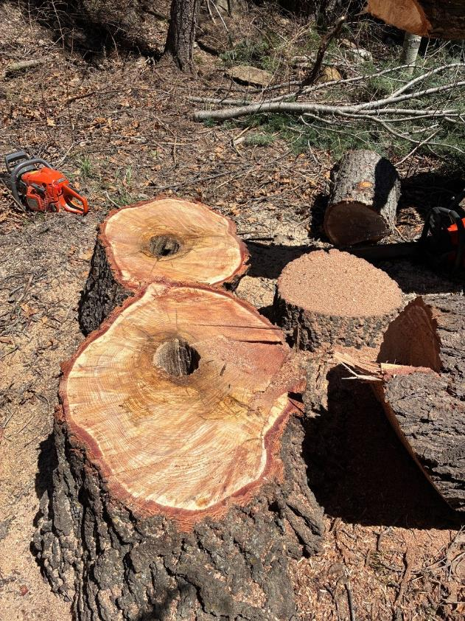

Two low-cut stumps on the right and one cut round behind the larger stump.

Note the small hollow in the center of the stump and round from the larger tree.

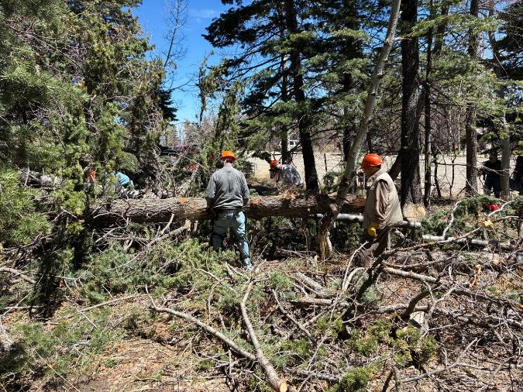

L to R: Eric Russell and Jerry Carroll limbing the trunks with chain saws and Sam Beard and

Don Carnicom swamping (moving the cut branches). The Snow Play Area parking lot is

in the background.

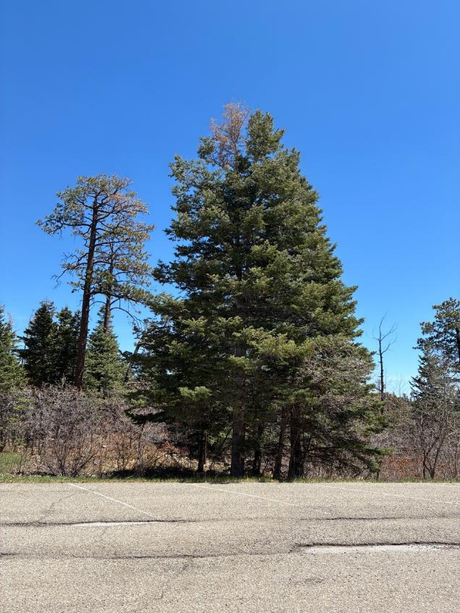

The large (21-inch diameter) white fir hazard tree in the center of the photo beside the

Snow Play Area parking lot. The hazard tree defect was the small dead top.

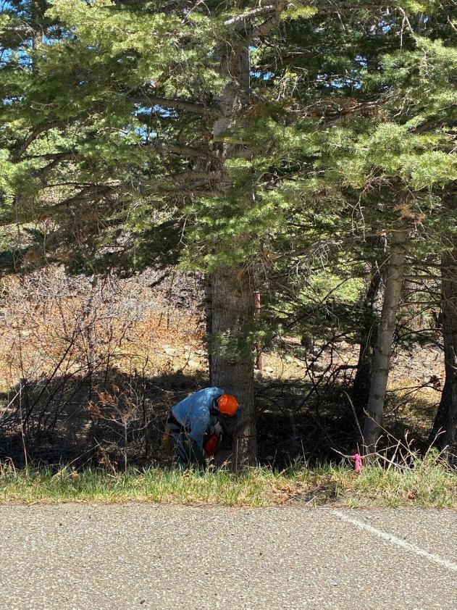

Eric Russell making the triangular face cut to form the notch on the side of the tree

in the direction that it will fall.

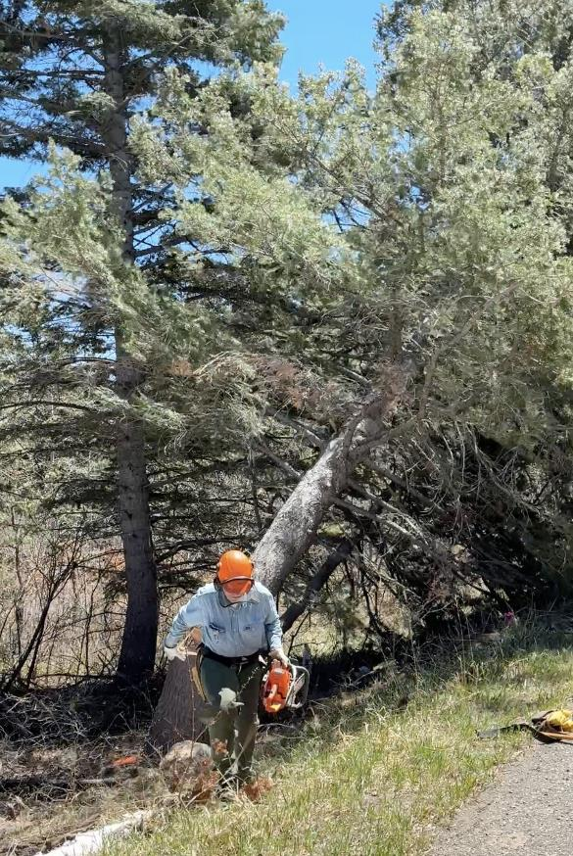

Eric running away from the falling tree.

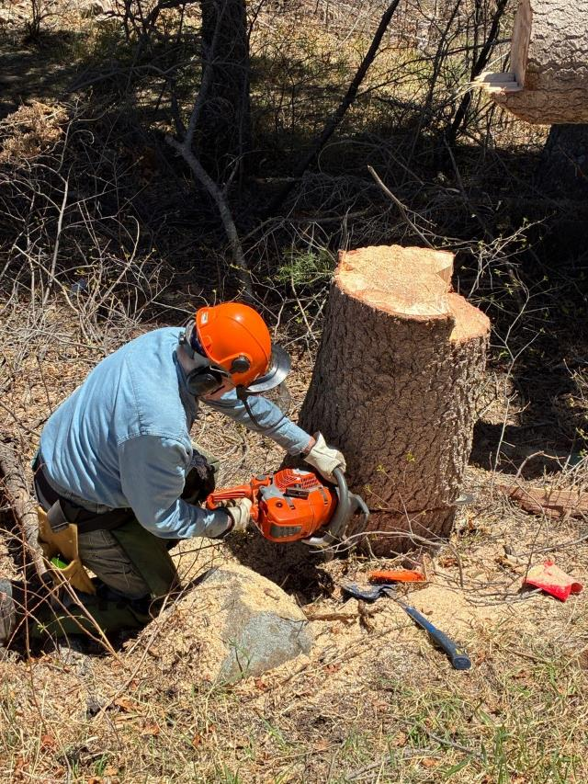

Eric low cutting the stump.

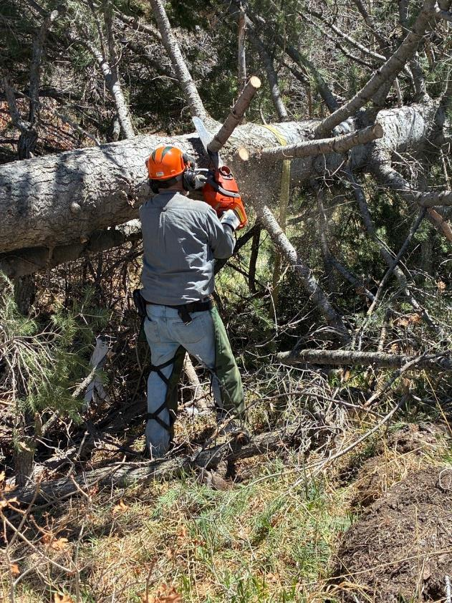

Jerry Carroll removing limbs from the trunk

with the small FOSM Husqvarna Model 440 chain saw.

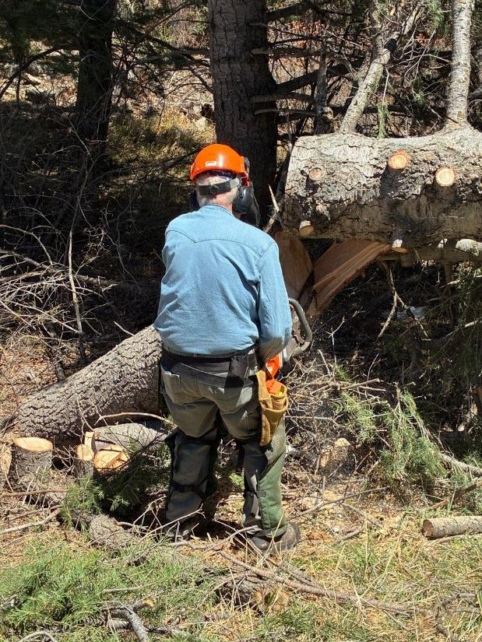

Eric has bucked a large heavy piece of the trunk to reduce the weight of the remaining

trunk. The procedure is to remove all or most of the branches and pieces of the trunk

so that eventually the trunk is small enough to roll and complete the bucking.

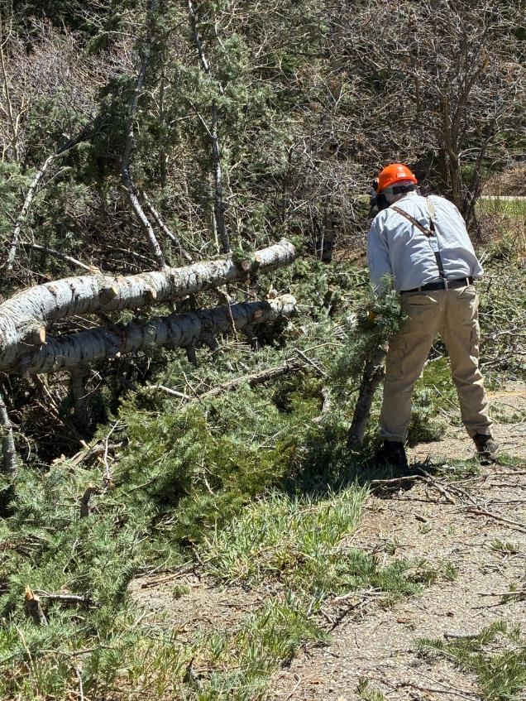

Sam Beard moving cut branches from the trunk and putting them in the parking lot.

Note that the upper half of the tree was forked.

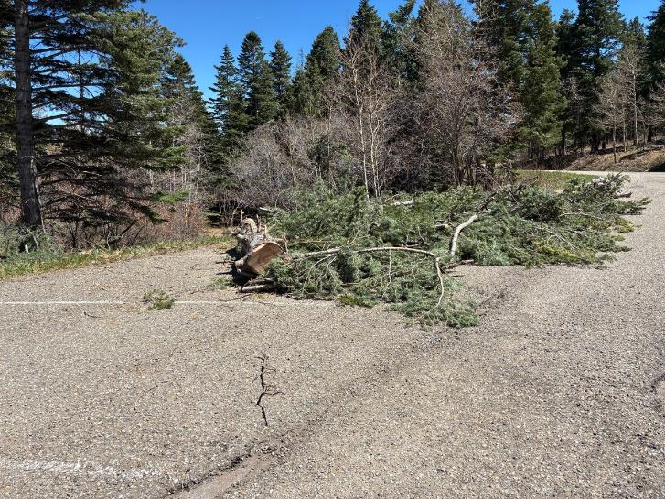

The very large number of branches from the two forks and the lower tree trunk on the Snow Play Area parking lot. The SRD Fire Crew will chip the branches and blow them into the forest.