**Report of FOSM Project to Process Donation Wood in Capulin Spring**

**and Balsam Glade Picnic Areas on Wednesday, April 30, 2025**

Sam Beard

On Wednesday, April 30, eight volunteers bucked, split, and hauled donation wood in Capulin Spring and Balsam Glade Picnic Areas. At the Bird Log in lower Capulin Picnic Area, volunteers bucked and split a 15-inch dead white fir. In the picnic area, near the host site, they bucked and split wood from the dead trunk of a forked white fir. In Balsam Glade Picnic Area, they bucked and split one dead tree beside NM-165 and one tree that had a dead top near the upper parking lot.

Cliff Giles reports that he talked with a family of 10 from France including two men on Harley Davidson motorcycles who stopped at Balsam Glade. They rented the vehicles in Chicago and are driving Route 66 to Los Angeles.

FOSM volunteers were Steve Roholt, Cliff Giles, Lou Romero, Sim Cook, Sam Beard, Dan Benton, Eric Russell, and Michael Oliver.

Project photos by Cliff Giles are presented below.

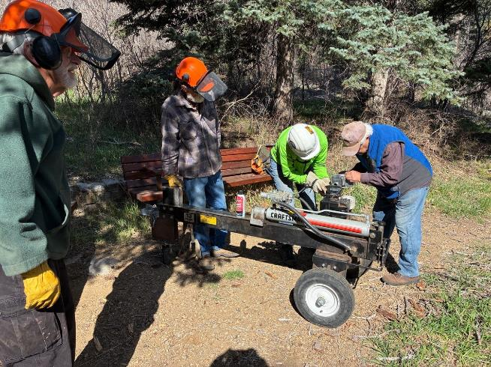

Lou Romero is pouring ethanol-free gasoline into his power splitter at the Bird Log in the lower part of Capulin Picnic Area.

L to R: Sam Beard, Mike Oliver, Steve Roholt, and Lou Romero.

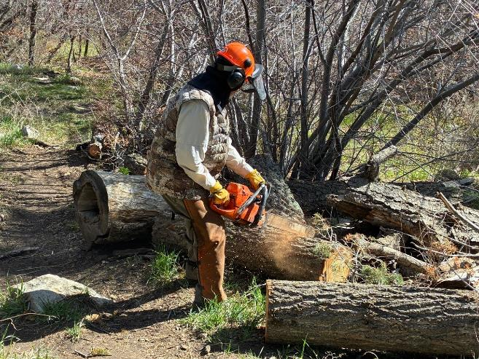

Dan Benton bucking a piece of the dead 14-inch white fir that was felled earlier as a hazard tree.

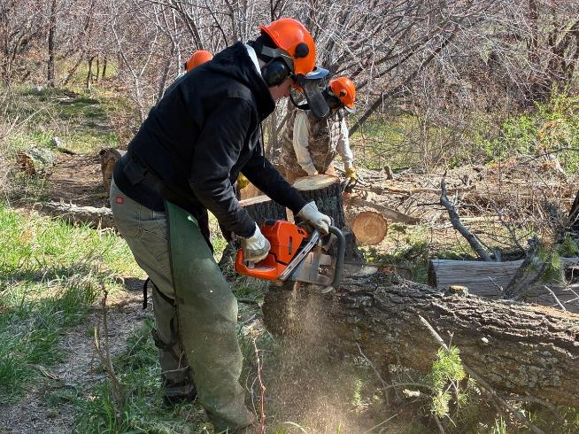

Eric Russell and Dan Benton bucking other pieces of the same tree.

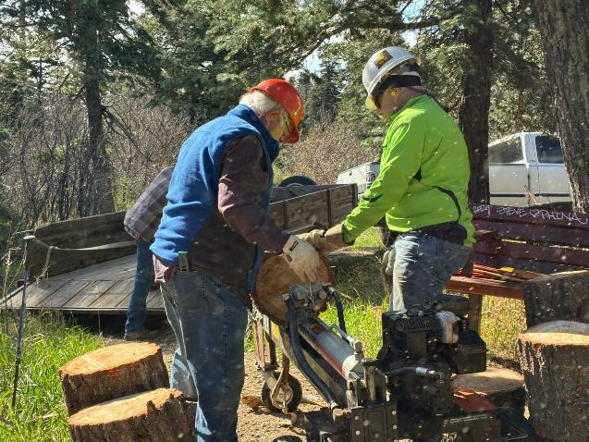

Lou and Steve splitting wood near the Bird Log.

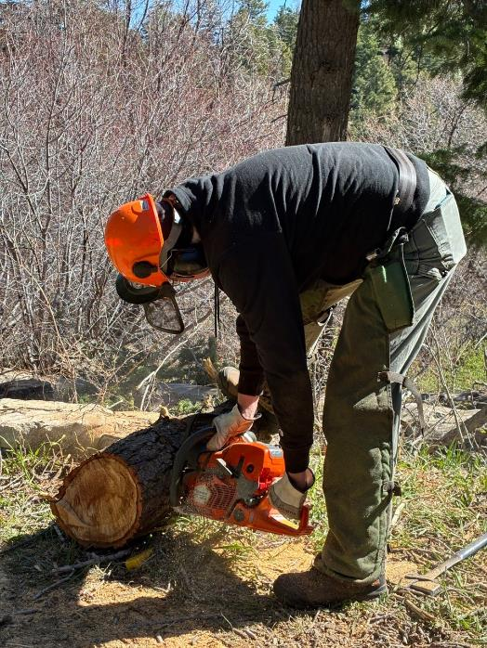

Eric Russell bucking a small log at the Bird Log.

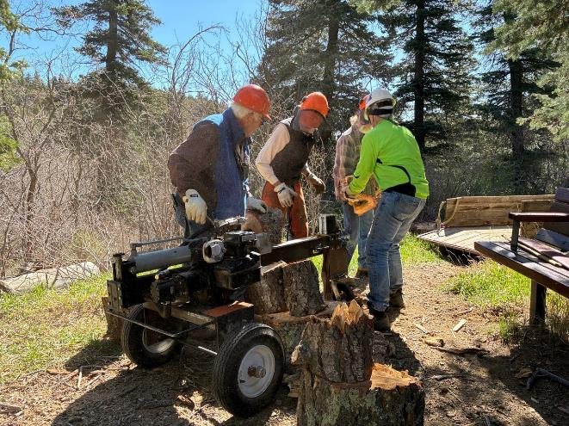

Lou, Sim, and Steve are splitting wood that Mike is loading in his trailer. Mike will store the wood in his woodlot

and next winter the Wood Ministry at his church will donate the wood to families who heat homes with wood.

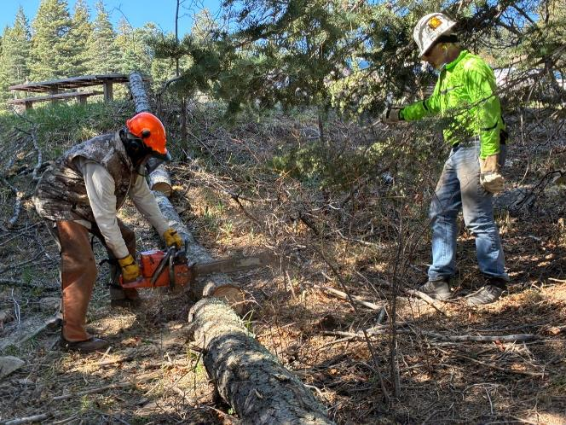

Dan is bucking a small log near a picnic table in Capulin Picnic Area.

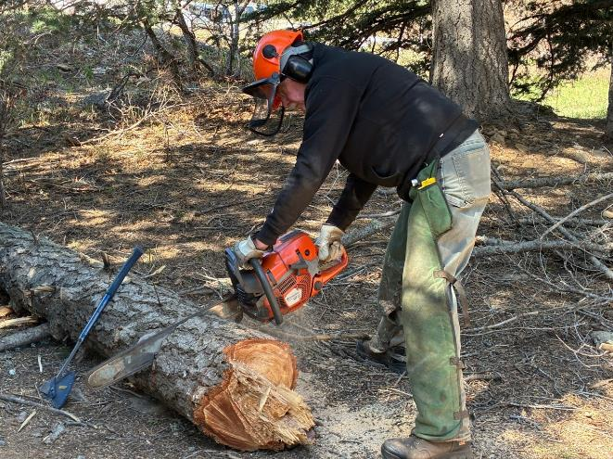

Eric bucking the large end of the dead white fir.

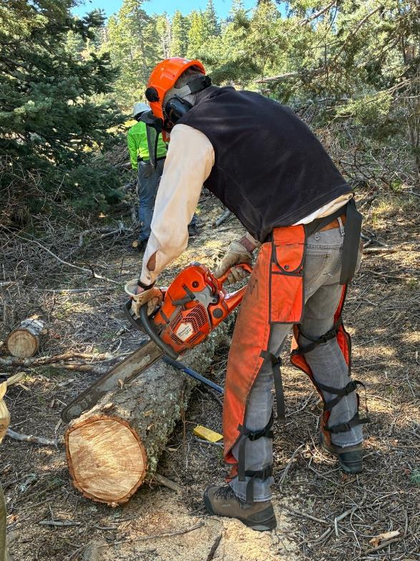

Sim bucking the log in Capulin Picnic Area.

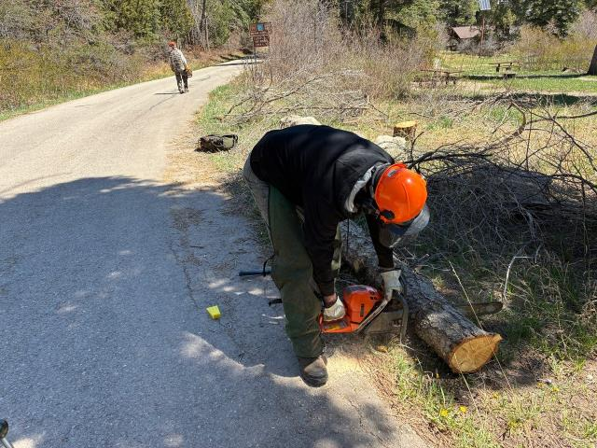

Eric bucking a log in Balsam Glade Picnic Area that Sim Cook felled earlier. On the road in the background,

Dan Benton is hiking to the lower parking lot to buck a 12-inch white fir that fell across a trail.

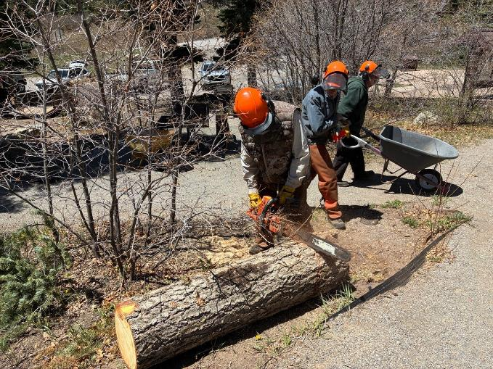

Dan is bucking a log in near the Balsam Glade upper parking lot. In the background, Sam Beard is returning a wheelbarrow

that was used to haul wood from the splitter to Mike Oliver’s trailer.