Thursday, 05/01/25- North Faulty Trail: We finished reroute #5!! Not too many pictures this week because we were spread out and working hard to get section 5 done. Nine volunteers worked with Jen and Chris (SRD) to get the ends of reroute #5 and a short bit just past #5 done this week. The weather was great and everyone worked hard. Eric, Bruce and Jim took one end of the reroute and Chris, Rich, Tony and John worked to finish the other and do some obliteration too. Claudia and Laura worked the short bit just beyond #5 and Jen started work on #4. By the end of the day, we had all the tools and workers on reroute #4 and had started in on some work there. Byron and Tony earned extra credit for staying to help Chris and Jen move some large tree sections. Feels like we are making progress!

Volunteers: Bruce Hansche, Rich Fagioli, Byron Garner, Jim Houle, Tony Pachelli, Eric Russell, John McNett, Claudia Bergsohn, and Laura Leon

Pictures: Laura Leon

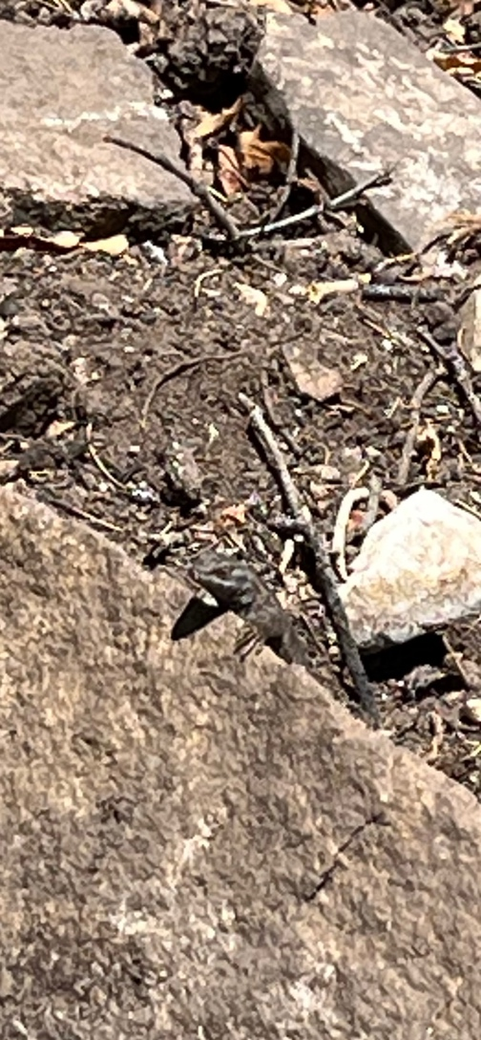 This little guy was peaking over the rock watching us

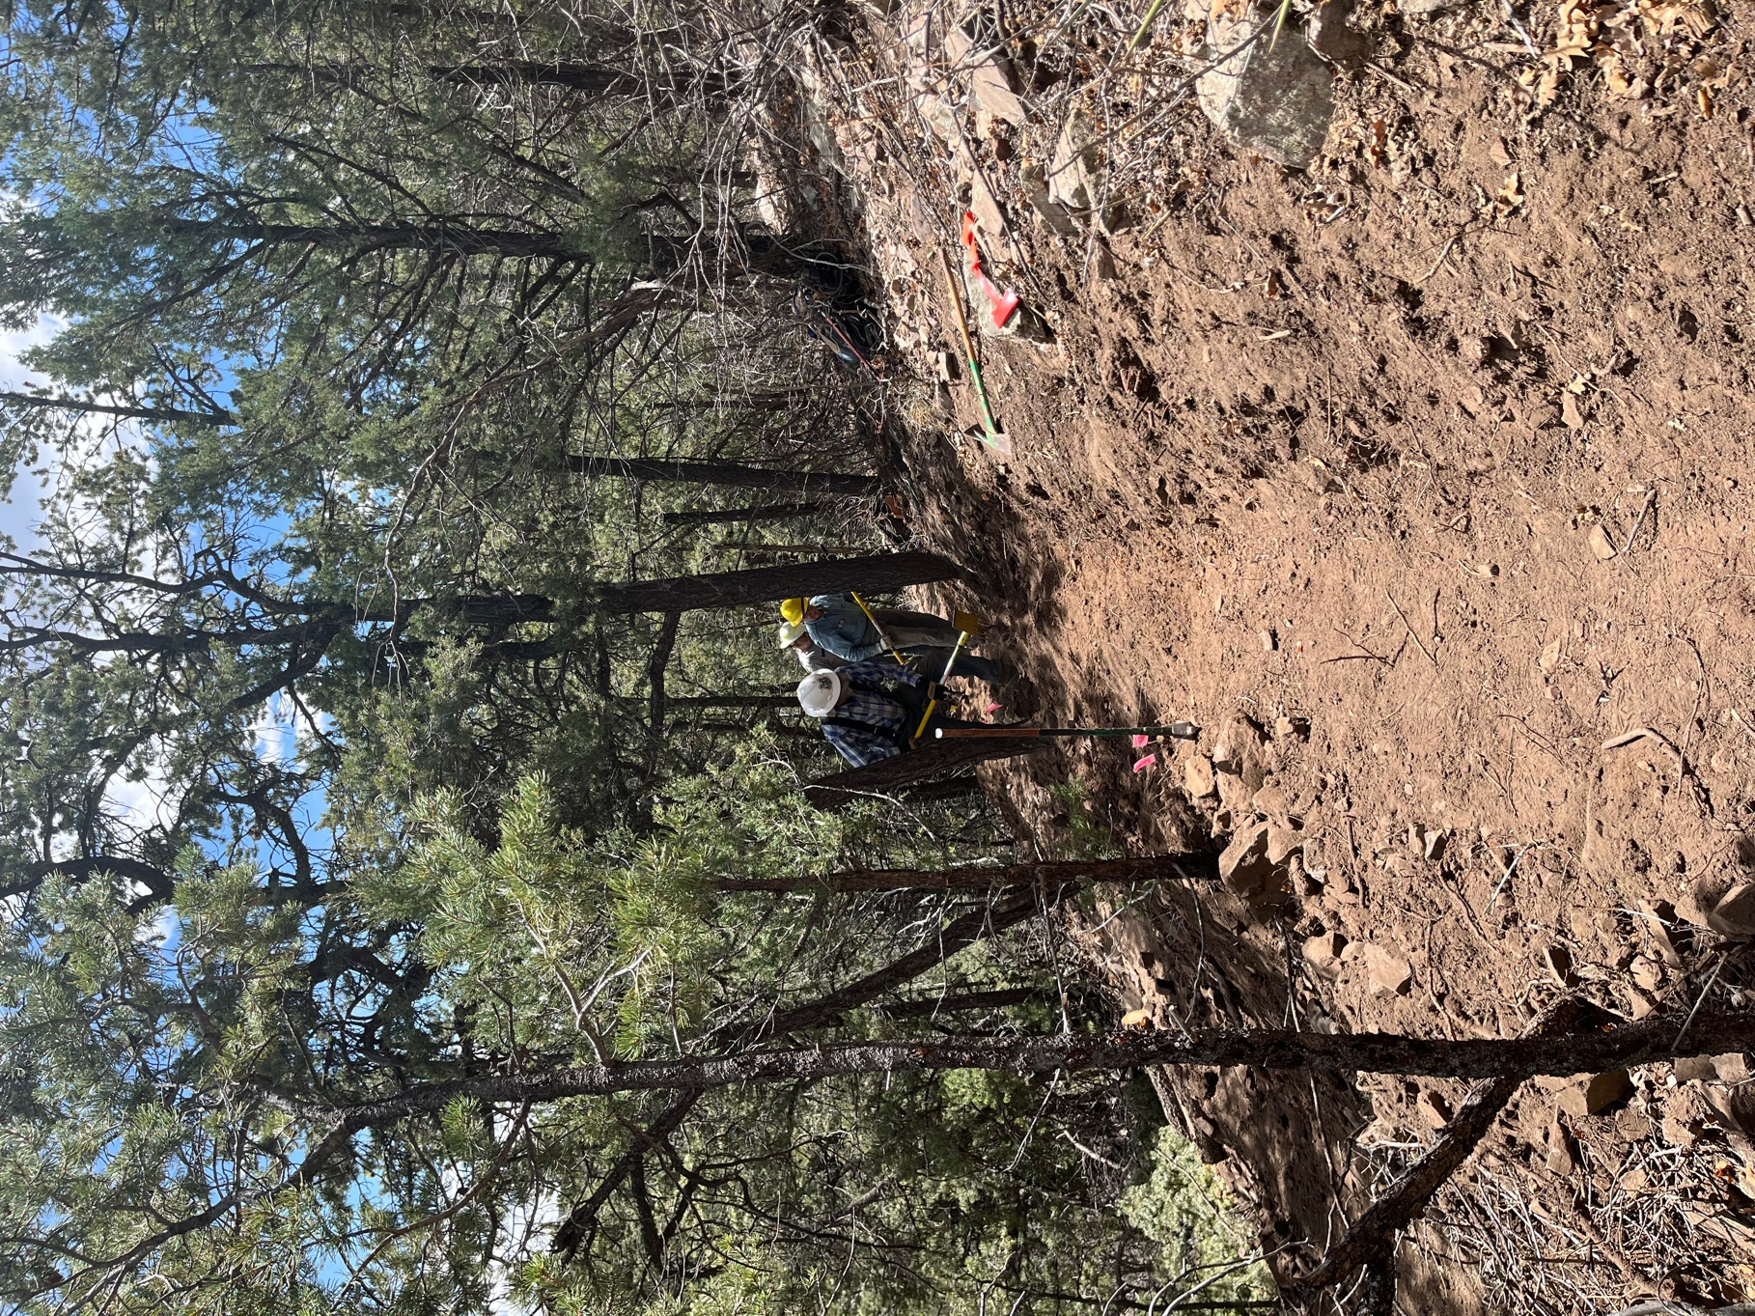

Bruce, Eric and Jim finished off the reroute entrance.

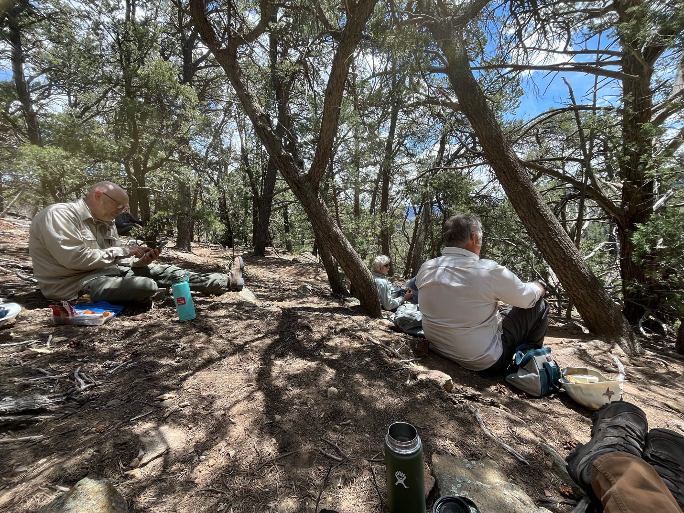

Lunch time for Byron, Chris and Rich.

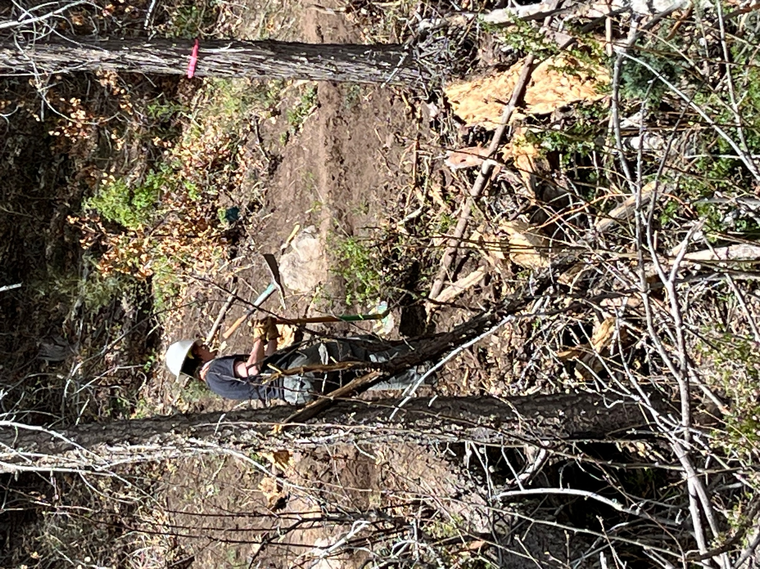

Jen started work on reroute #4.

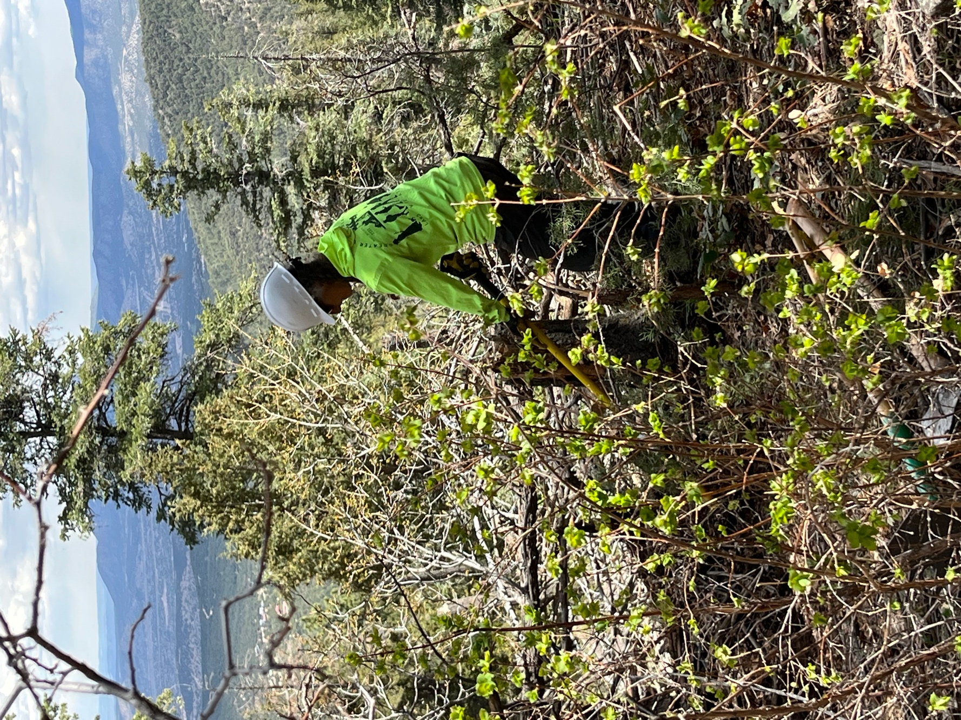

After finishing on reroute #5, Claudia started work on a stump on reroute #4.

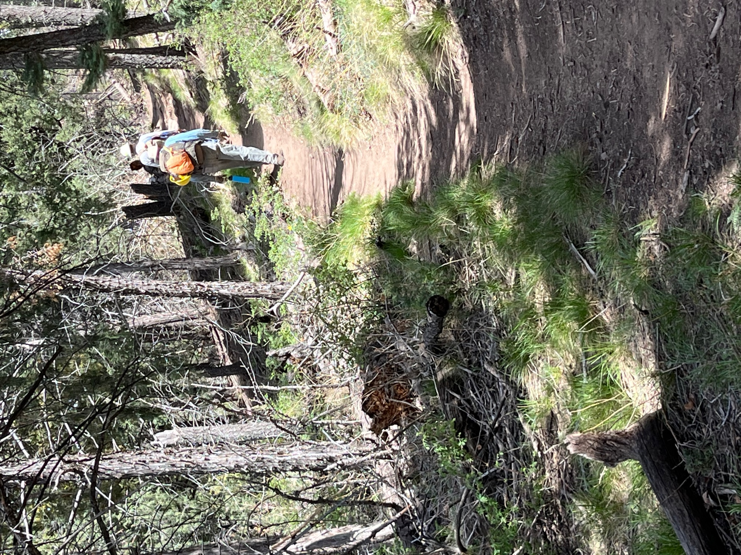

While hiking out you can really see the area is starting to green up!

