**Report of FOSM Project to Fabricate a Short Decorative Post to Replace the Rotten One**

**on Shelter A in Doc Long Picnic Area on Sunday, May 11, 2025**

Sam Beard

On Sunday, May 11, Michael Arndt and Sam Beard began making a replacement for the rotten short decorative post at one of the corners on modern Shelter A in Doc Long Picnic Area. The objective was to find a ponderosa pine or Doulas fir log on the ground at one of the picnic areas along the Crest Highway. The short post is 32 inches long and approximately 14 inches in diameter. Ideally it would be dry and in good condition.

We finally selected a green piece of ponderosa pine on the top that broke off of a large pine along Acequia Trail in Cienega Picnic Area a few weeks ago. The selected piece of green pine is very heavy, and two people are required to handle it. The photos below show the steps taken to cut the log to length, haul it to the FOSM Guard Station, and begin to make it into a short post with a beveled top.

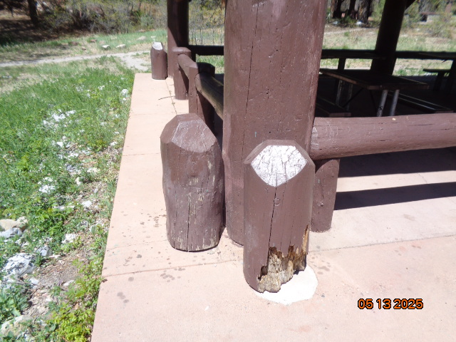

Decayed decorative post on corner of Doc Long Picnic Area Shelter A. Several years ago, FOSM volunteers replaced 24 missing

short decorative posts on the three modern picnic shelters in Doc long and Balsam Glade Picnic Shelters. All photos by Sam Beard

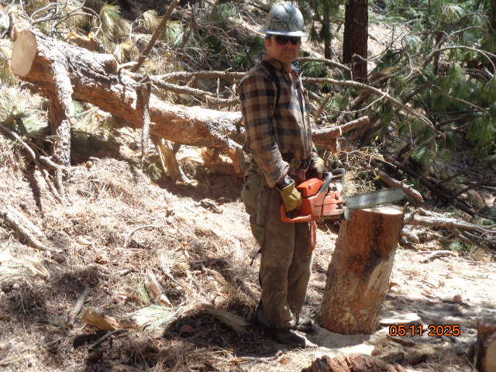

Michael Arndt is standing beside the piece of ponderosa pine that he cut from the green top behind him. This top

fell from a very large (32-inch) pine several weeks ago. The shape of the broken pieces on the ground clearly indicated

that this piece was one of two in the forked top of this tree. The brown bark on one of the pieces on the ground was the included

bark between the two forks where the V-shaped forks grew against each other. The growth of the two forks increases the pressure

exerted on each of the forks, and one of the forks will usually break away from the other fork.

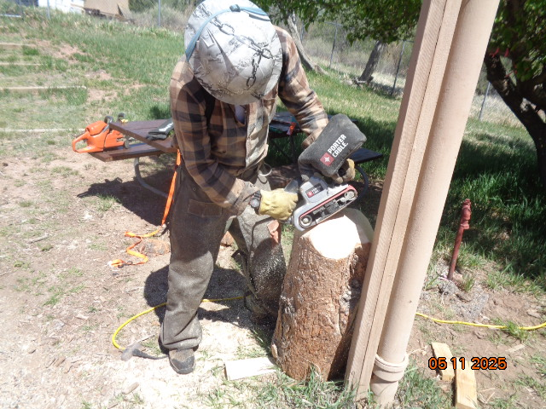

Sam drew a 5.5-inch square on top of the log so that the distance from each square side was 4 inches from the

periphery of the end of the log. In order to cut four bevels at an angle of 45 degrees on the end of the log, he

put a cut line on the side of the log 4 inches down from the top. Michael then set his chain saw bar at an angle

of 45 degrees on top of the log and cut a bevel down to the line cut around the log. In this photo, Michael

is using a belt sander to smooth the four beveled surfaces.

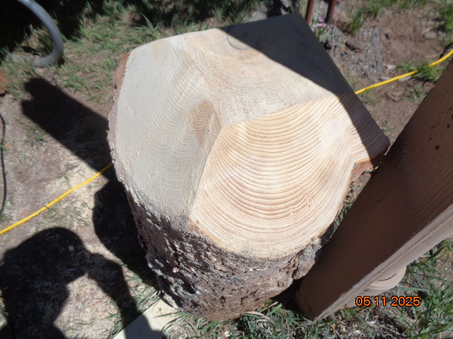

Two of the four sanded beveled surfaces are shown in this photo. The beveled surfaces match those on the original eight decorative

posts on Shelter A in Doc Long Picnic Area. Several years ago, the original eight posts that had been surrounded by the concrete

floor of the shelter for about 30 years were missing, because they had decayed at the floor level and been removed. Volunteers filled the open

holes in the floor with concrete to remove the tripping hazard and installed eight short replacement posts on top of the concrete.

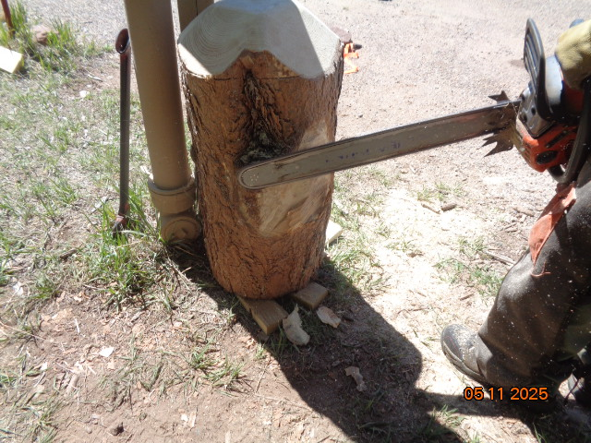

Michael is using his chain saw to smooth the side of the post where a large branch has been removed.

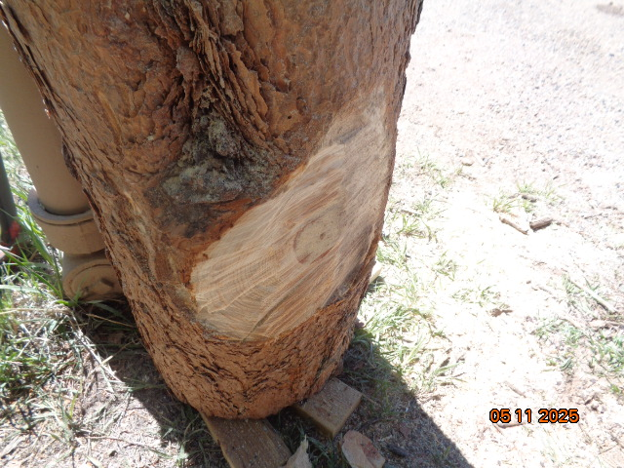

The belt sander with a 36-grit belt will be used to smooth this area and contour it as much as possible

to match the round surface of the side of the log. (Note the dark area of bark in a depression on the side of

the log. The removal of the bark in this depression will be much more difficult than the removal of the bark

on the nominal side of the log.)

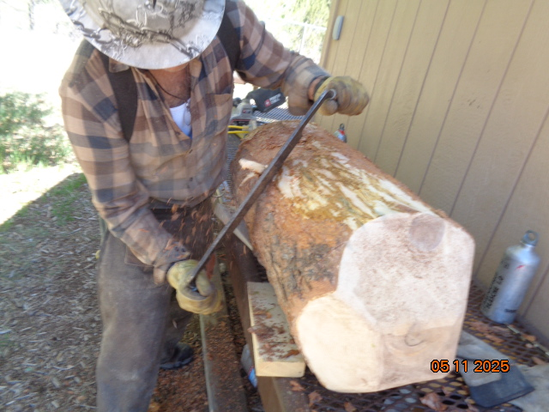

Michael is using a very large USFS draw knife to remove bark from the side of the log. The bark is removed

so that the log will dry faster and reduce the possibility of decay due to trapped moisture.

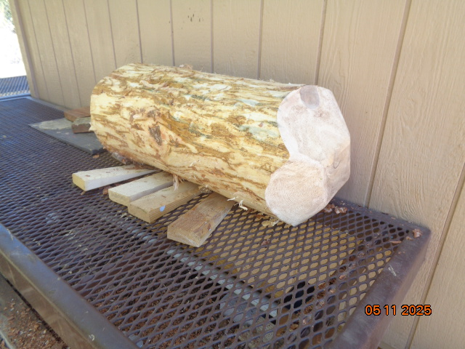

The cut and pealed post will be allowed to dry for a few months, and two coats of green copper naphthenate wood preservative

will be applied to all the surfaces. The post will then be painted with two coats of USFS brown paint and installed

on one corner of Shelter A.