Report of FOSM Project to Replace Decayed Fence Posts and Broken Rails

in Cienega Canyon Picnic Area on Wednesday, May 14, 2025

Sam Beard

On Wednesday, May 14, ten FOSM volunteers and Chris Secor, Sandia Ranger District, replaced five decayed fence posts and one broken rail in Cienega Picnic Area. They also loaded Mike Oliver’s large trailer with donation wood from the hazmat building and the lower parts of Balsam Glade Picnic Area. SRD fire fighters had bucked several trees that were lying on the ground at Balsam Glade.

The volunteers working on this project were Don Carnicom, Mike Oliver, Sam Beard, Sim Cook, Dennis Crowther, Dan Benton, Jerry Carroll, Cliff Giles, Laura Leon, and Eric Russell.

Project photos are presented below.

All photos by Cliff Giles unless noted otherwise.

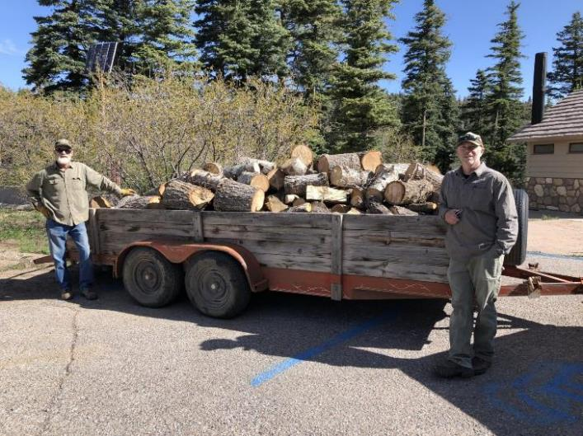

Mike Oliver and Chris Secor standing beside Mike’s trailer that has been loaded with donation wood from the hazmat building and the lower parts of Balsam Glade Picnic Area. Photo by Dan Benton

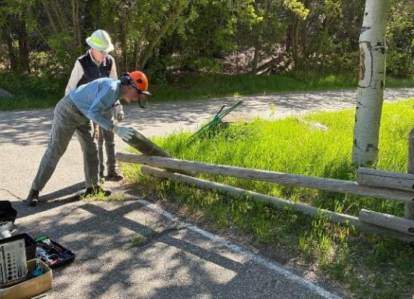

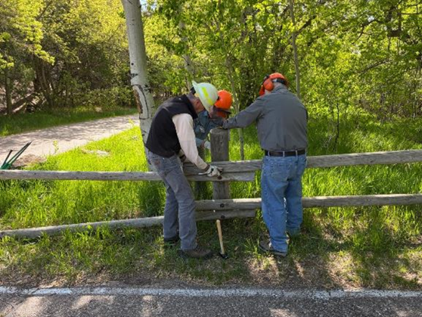

Top – Eric Russell and Sim Cook examining a broken fence post at the upper parking lot in Cienega Canyon Picnic Area. Bottom – Sim Cook, Eric Russell and Dennis Crowther removing threaded rod

from an adjacent broken fence post.

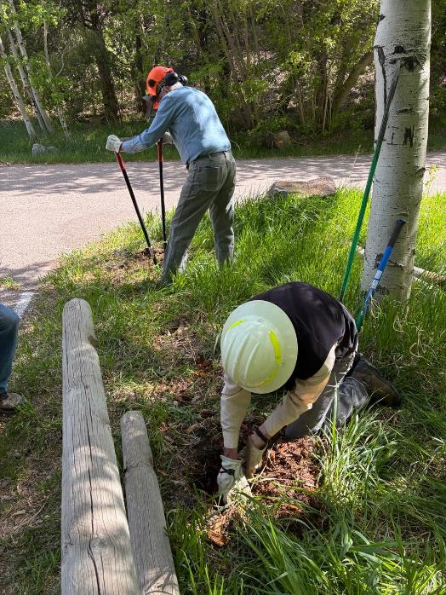

L to R: Eric and Sim are removing parts of the broken posts that had decayed below ground level.

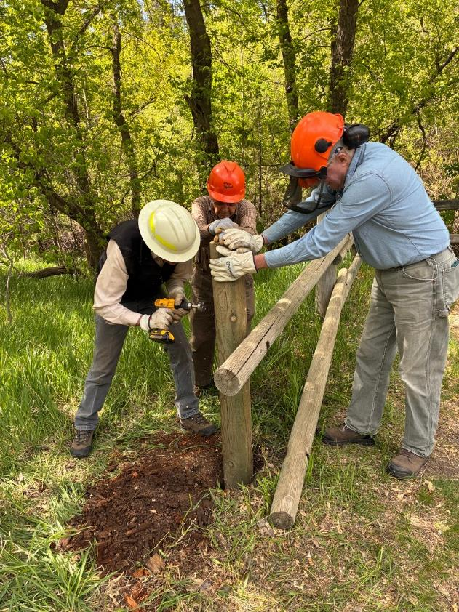

L to R: Don Carnicom and Eric are supporting a new post while Sim drills a counter sink hole so that the threaded rod and nut are not as exposed to make the installation safer.

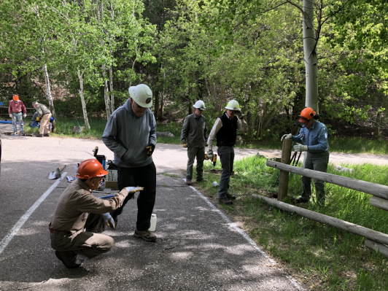

Photo by Dan Benton

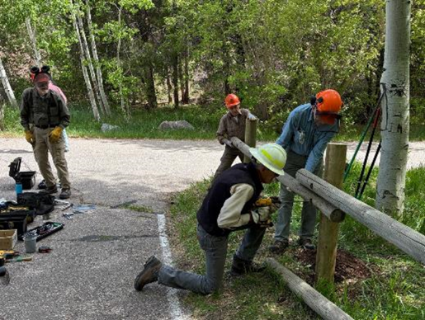

The volunteers are installing the rails on the new posts.

Note the crew across the road in the top photo installing a new rail.

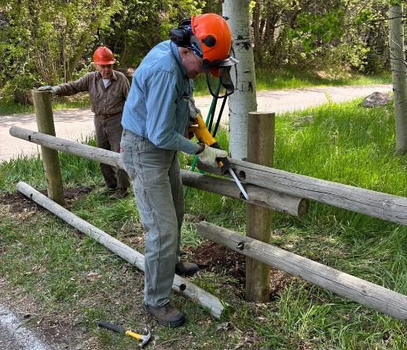

Eric is using the FOSM battery-powered reciprocating saw to cut off a protruding threaded rod.

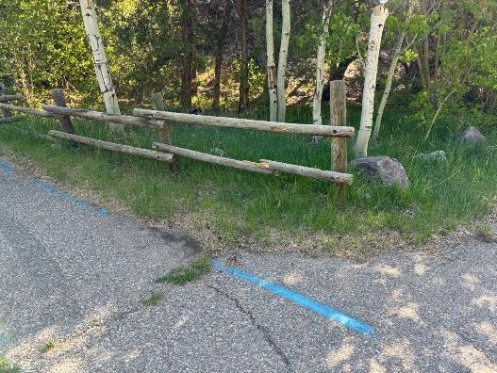

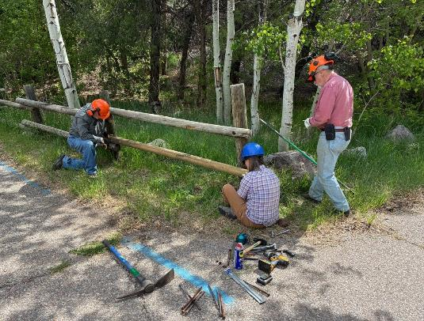

Top – Broken rail at the upper parking lot. Bottom – L to R: Dennis Crowther, Laura Leon,

and Jerry Carroll are installing a new rail.

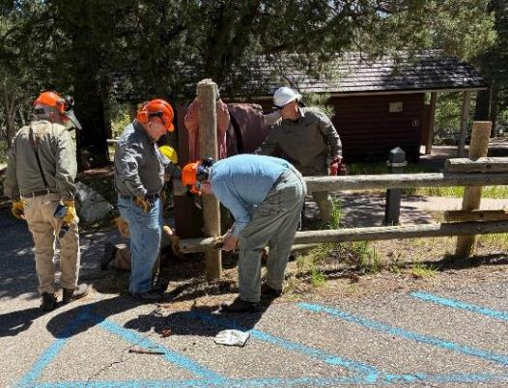

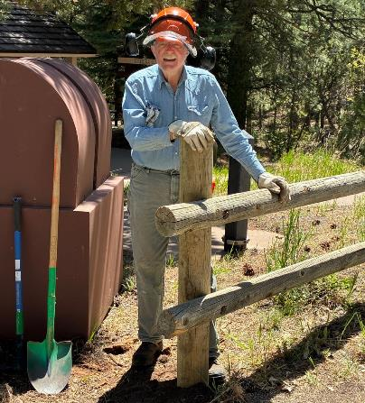

Top – Crew is installing a new post at the lower restroom parking lot.

Bottom – Eric at the completed installation.

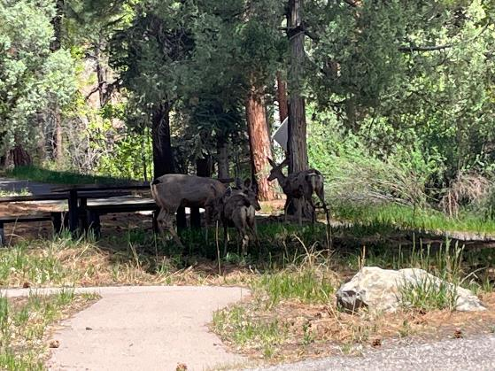

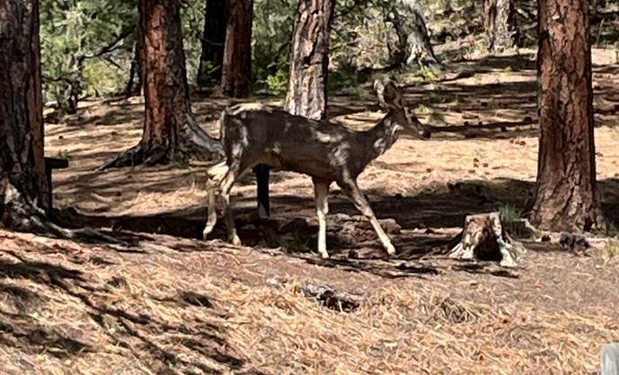

Deer in the picnic area. Photos by Laura Leon

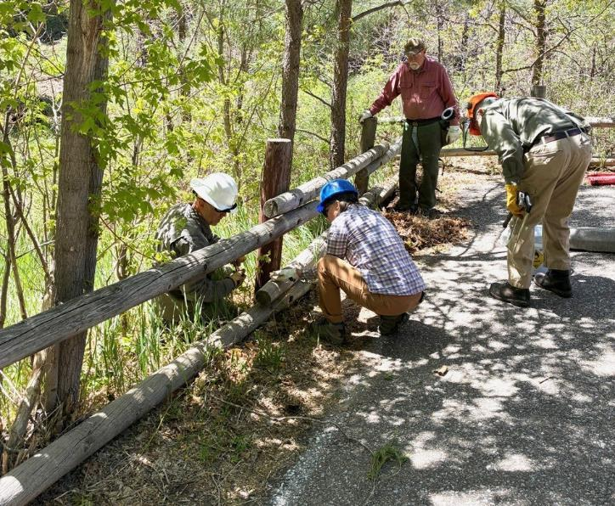

Crew members removing threaded rod and nuts from a broken post at the middle restroom.

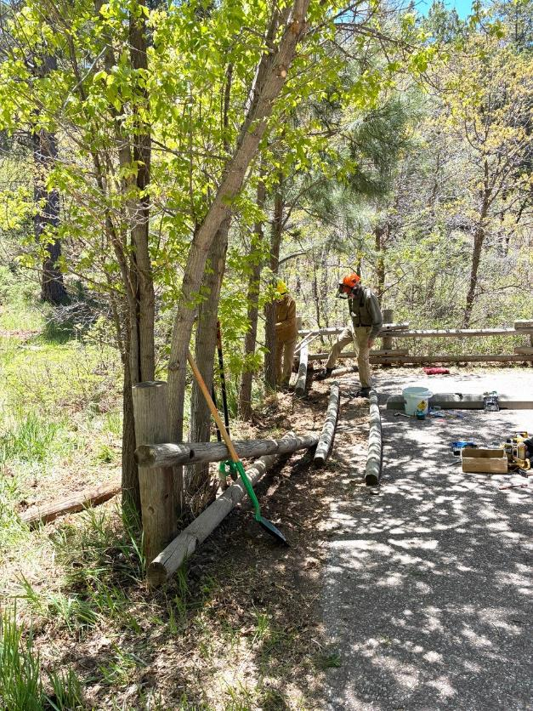

Rails have been removed from two broken posts and debris is being removed from the holes.

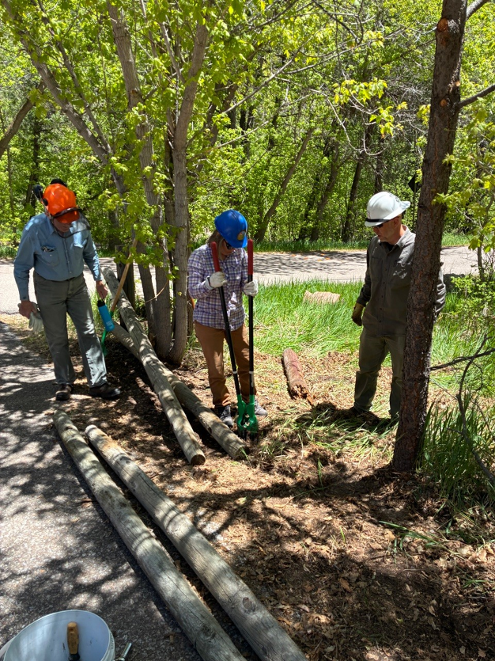

Laura Leon is using a post hole digger to remove decayed post and dirt from the old post hole.

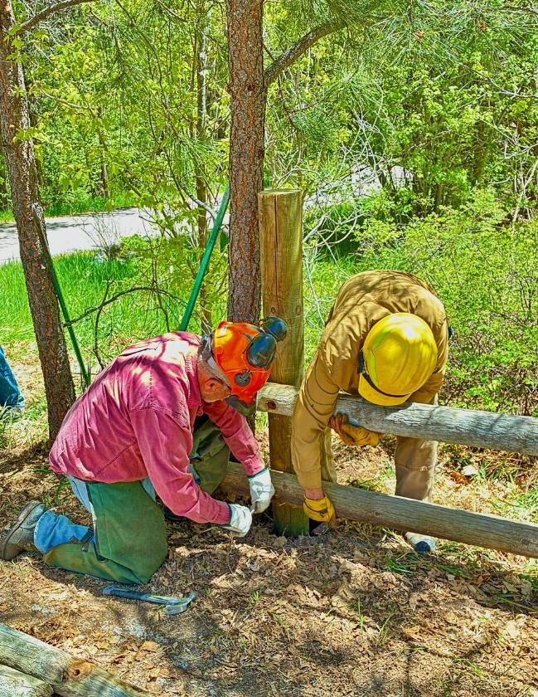

Jerry Carroll and Dan Benton are bolting the rails to the new post.

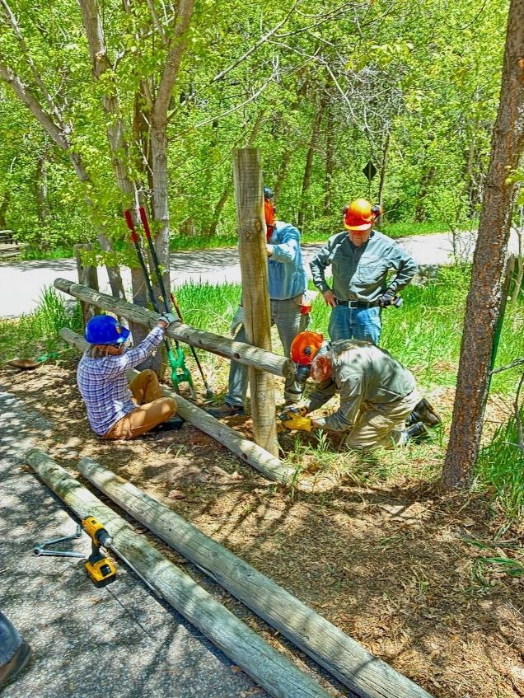

Laura and Eric are supporting the new post while Sam Beard drills a counter sink.

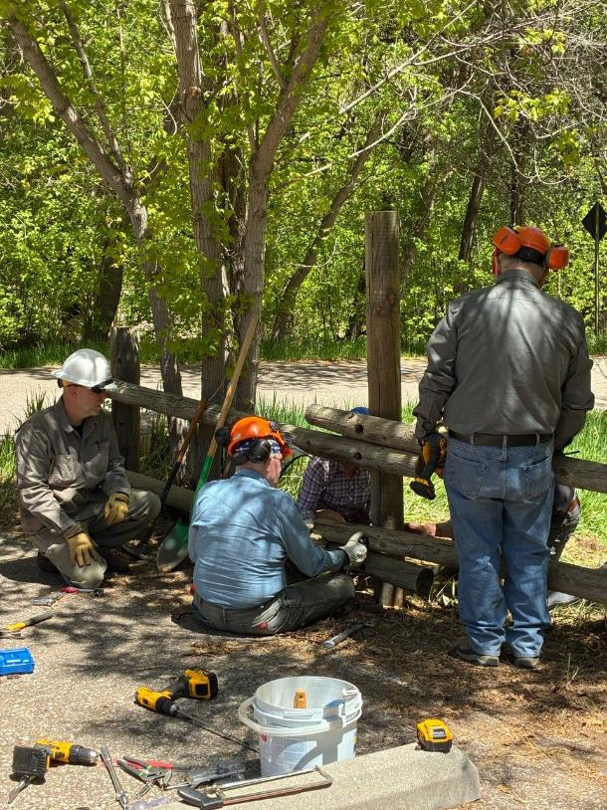

L to R- Chris, Eric, and Dennis bolting the rails to the new post at the middle restroom.

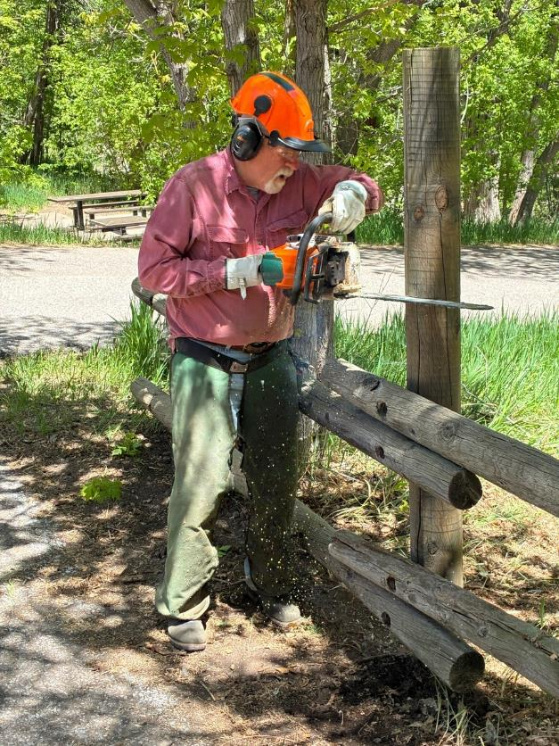

Jerry Carroll cutting off the top of a new post.

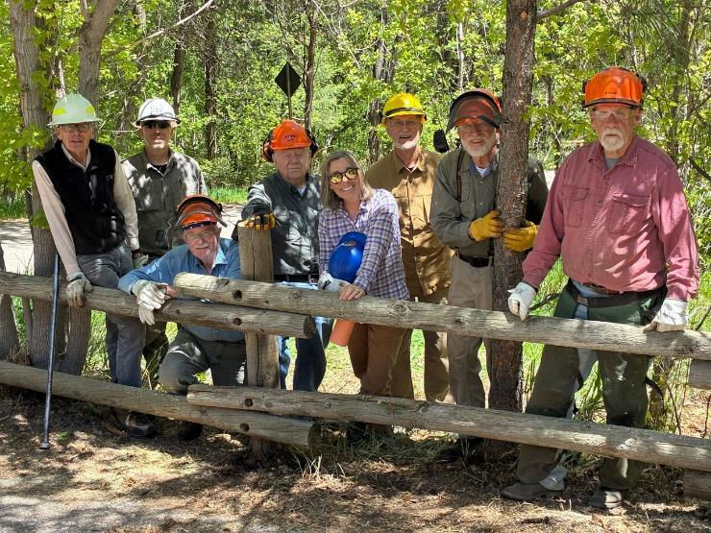

L to R - The crew working in Cienega Canyon Picnic Area on Wednesday:

Sim Cook, Chirs Secor, Eric Russell, Dennis Crowther, Laura Leon, Dan Benton,

Sam Beard, and Jerry Carroll.