Thursday, 05/15/25- North Faulty: After being rained out last week, 9 volunteers met Jen and Chris (SRD) back at the North Faulty trail this week. It was a cool start and a long hike in, and then the group split up and worked on reroute 4A and 4B. We had a great day with plenty of sunshine and breeze. There was even some moisture left in the soil! We hope to have reroute #4 finished and reroute #3 started next week.

Volunteers: Mike Madden, Bruce Hansche, Luis Cuadros, Byron Garner,
Laura Leon, John McNett, Eric Russell, Tony Pachelli and Bill Perkins

Pictures- Laura Leon

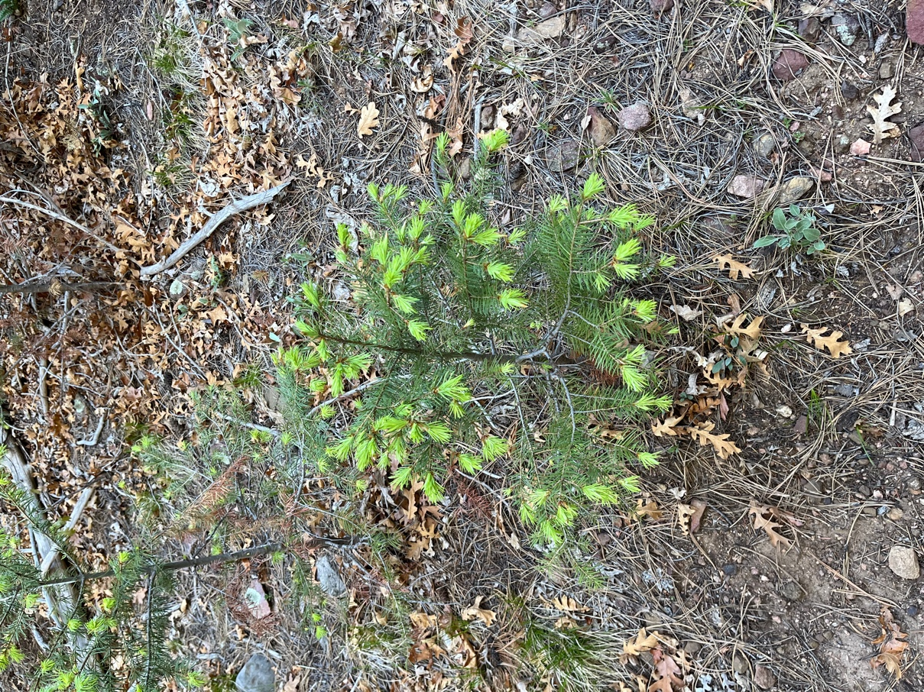

New growth everywhere!
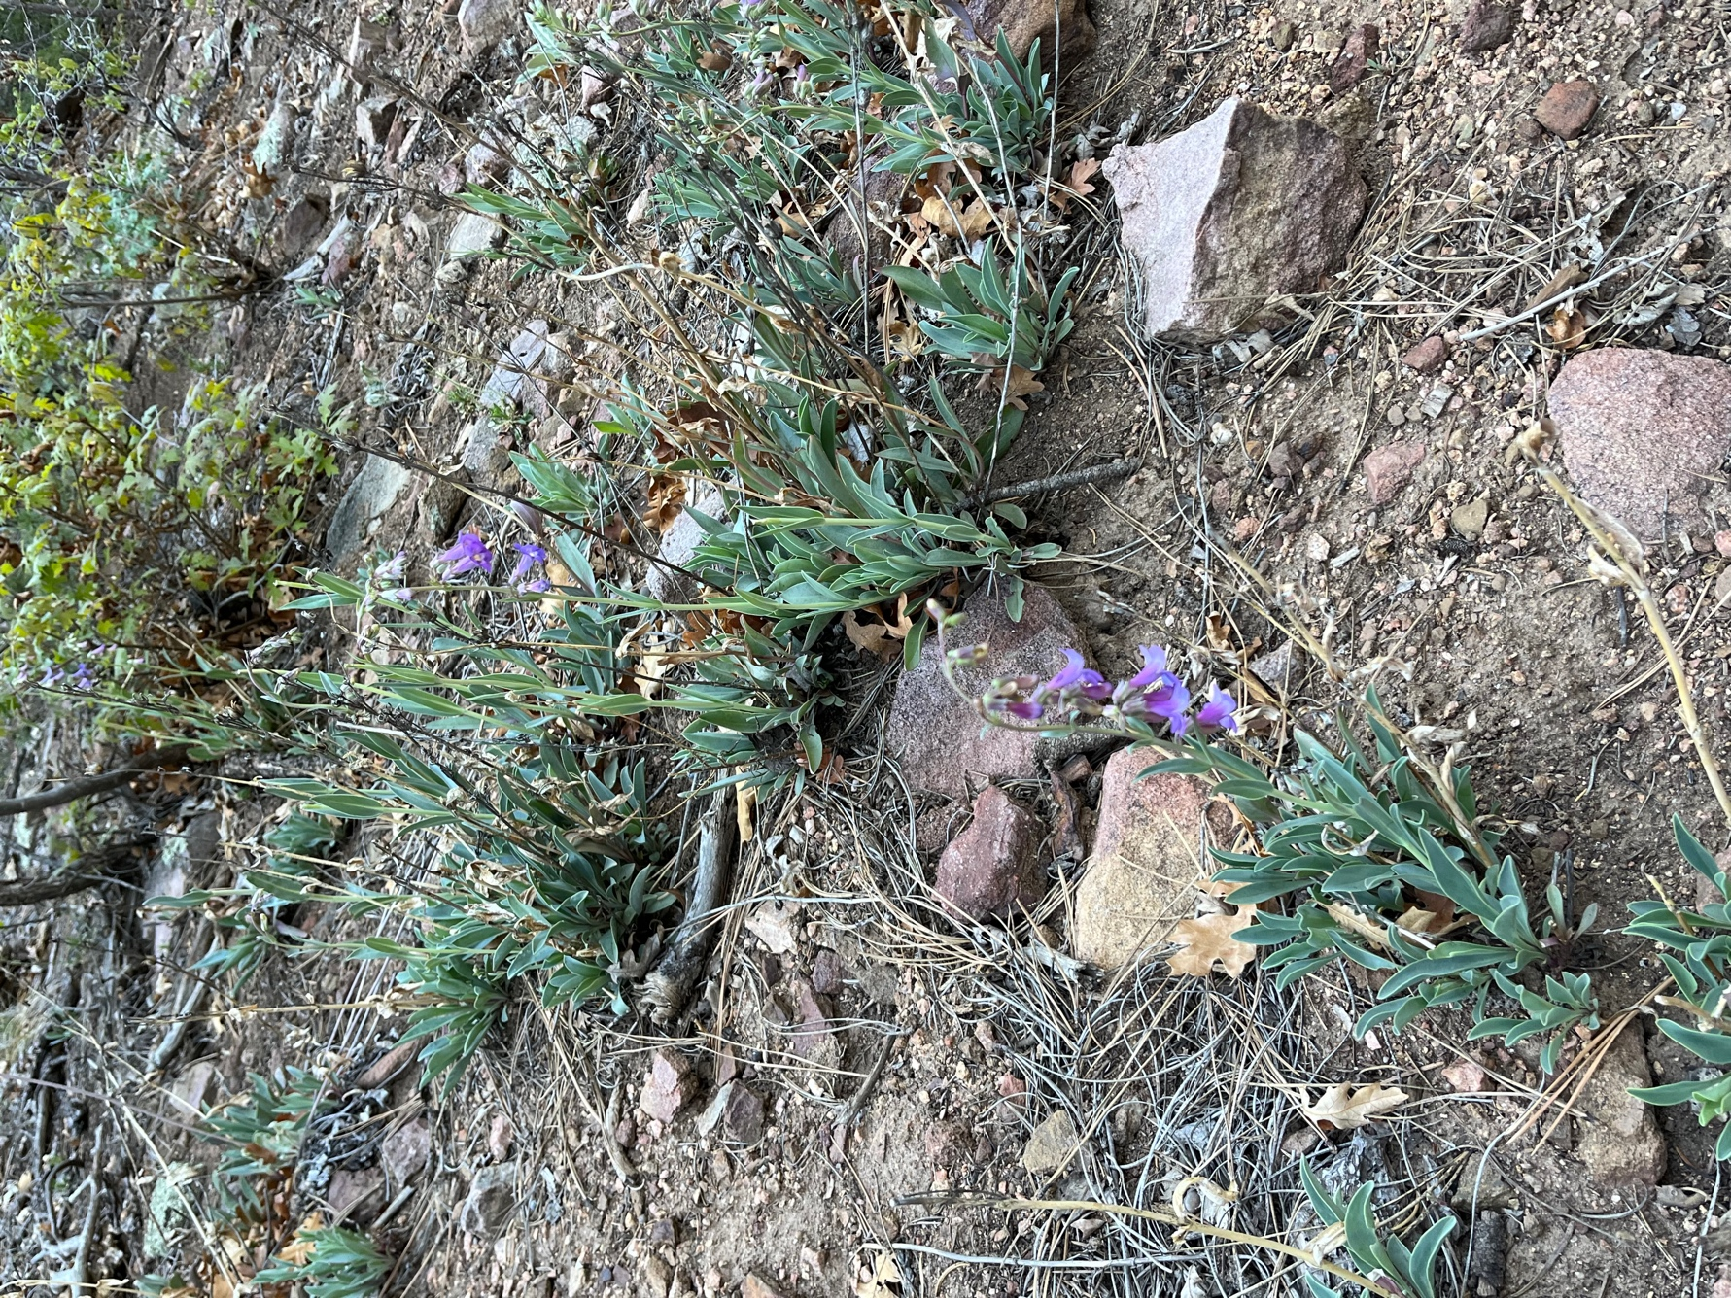

Flowers blooming all around.

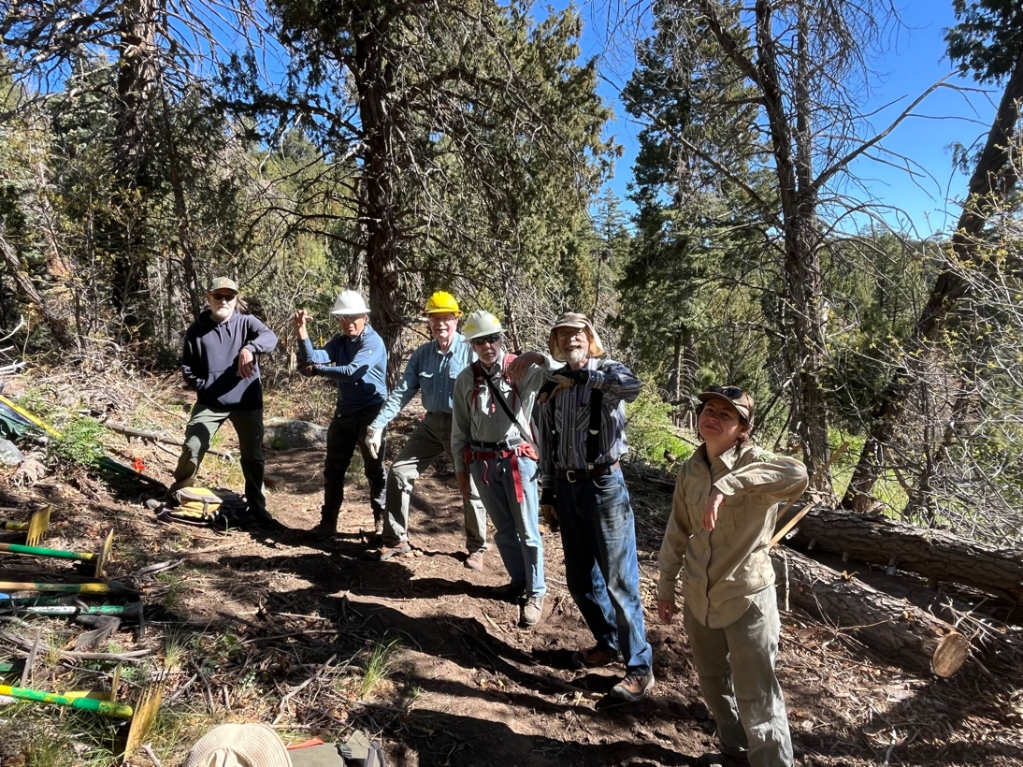

We all gave Claudia a one arm salute- she was having her break fixed instead of working with us.

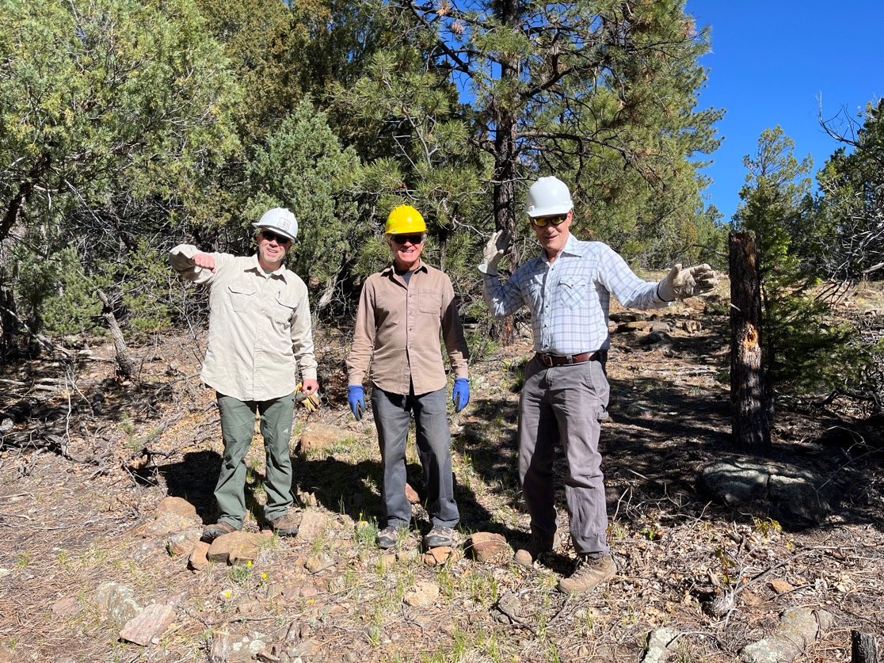
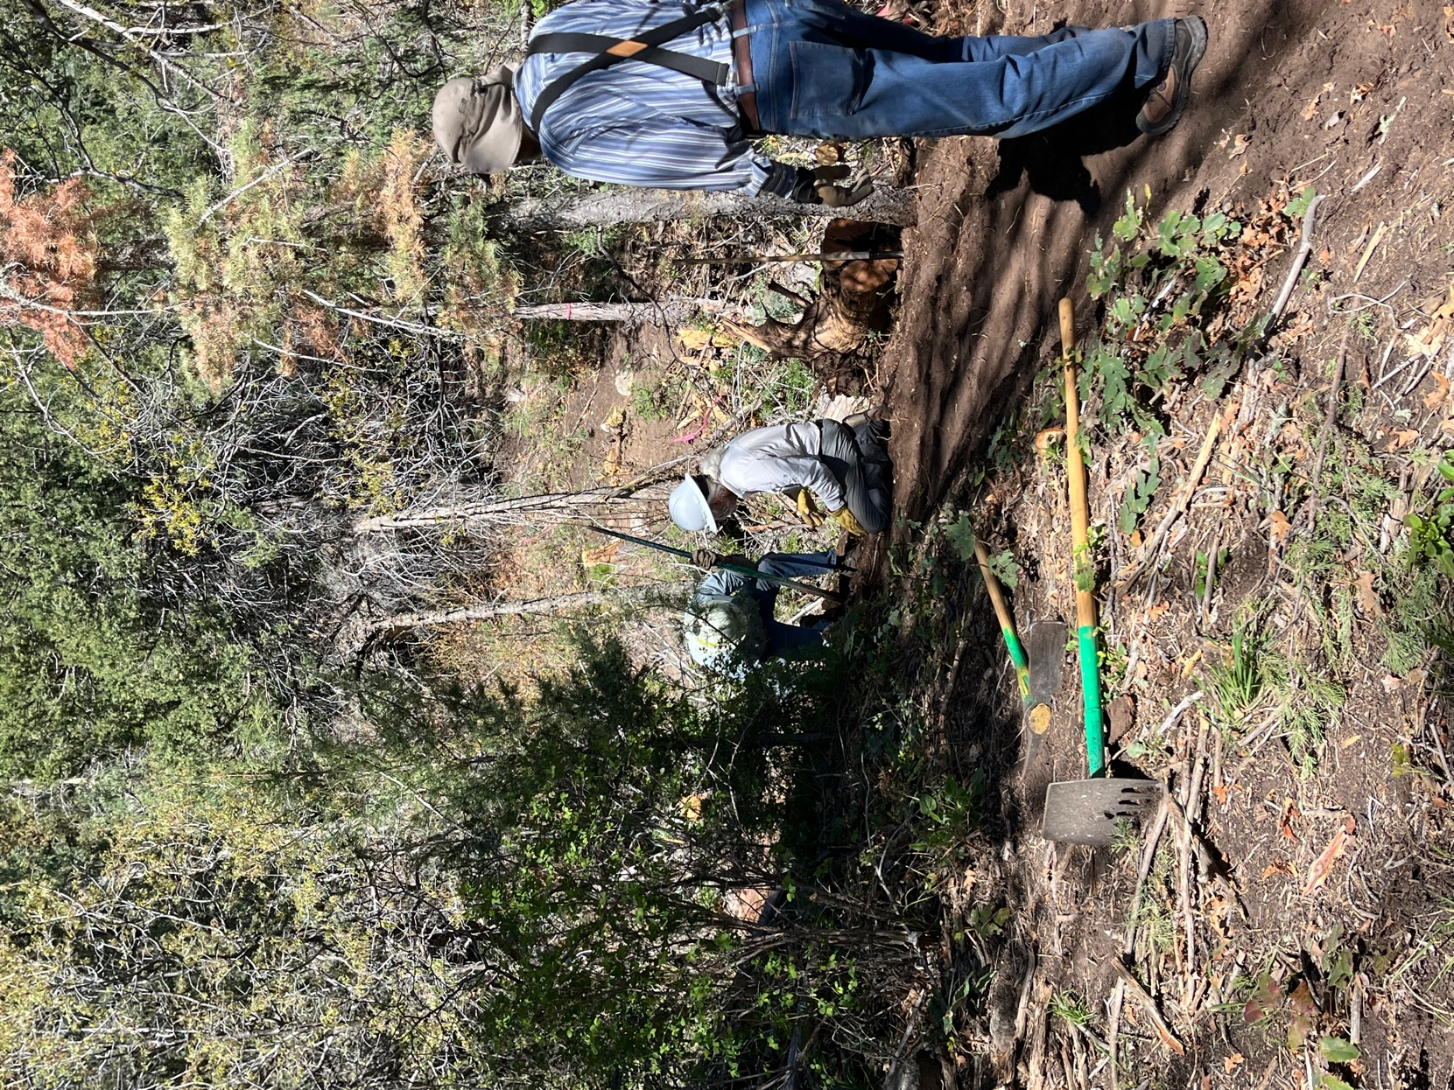

Byron and Bill worked at removing a stump on 4B while Bruce readied to move to reroute 4A.
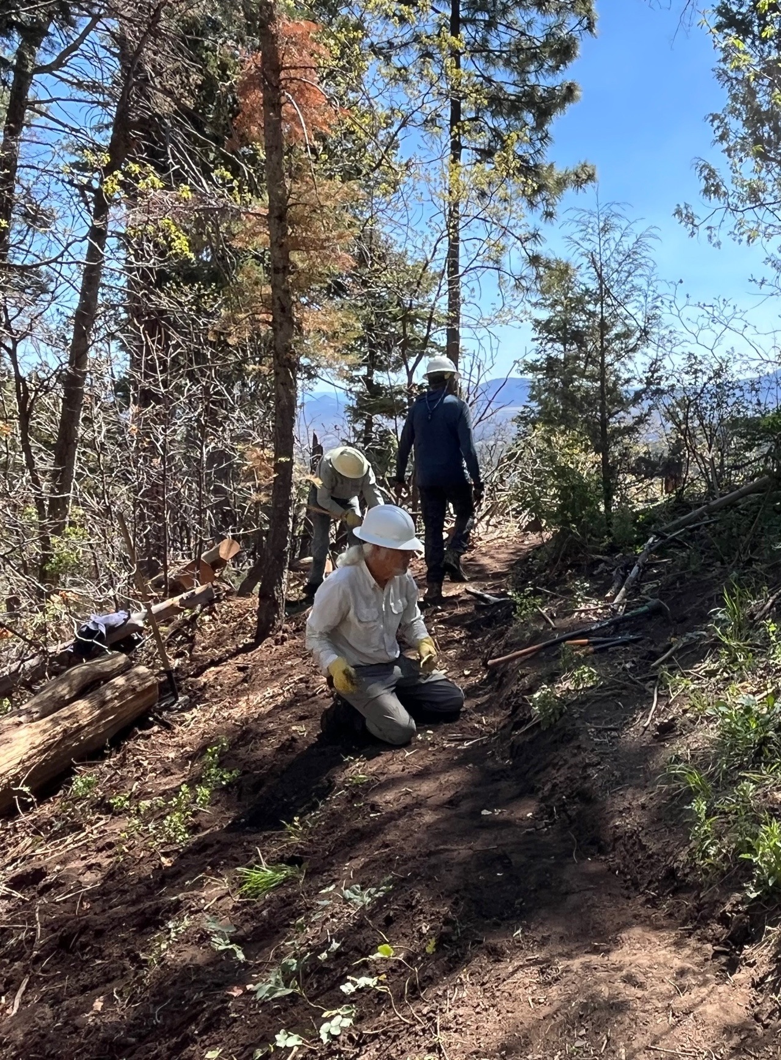

The stump is out and Bill cleaned the area. Byron packed up to move on and Luis was just going to finish one last spot.

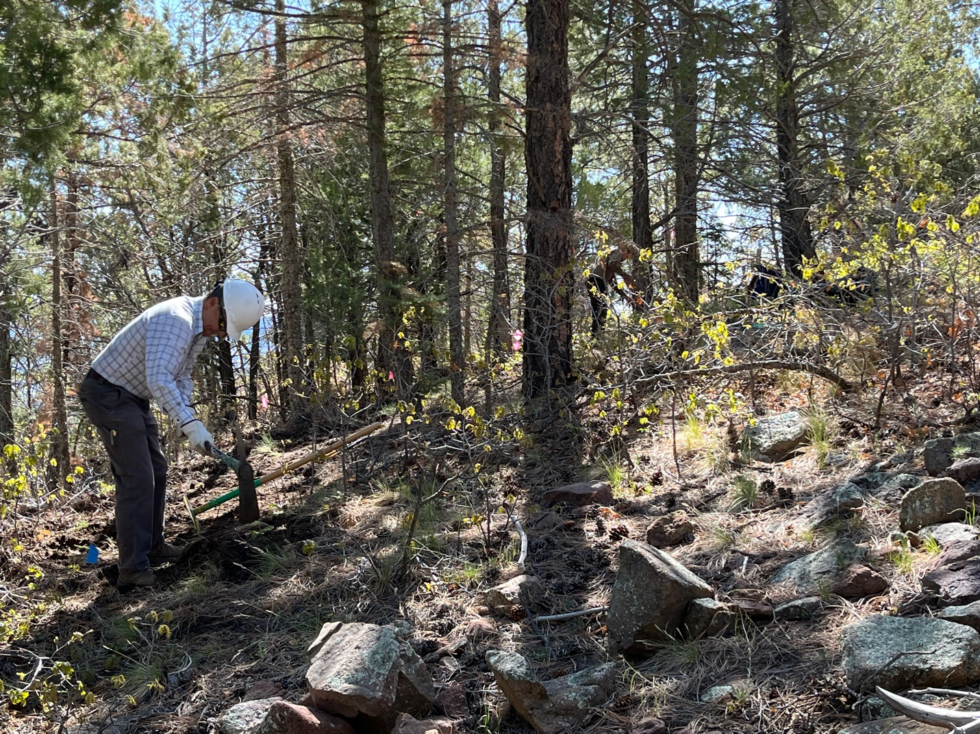

Meanwhile on 4A, Tony and Mike get started benching trail.

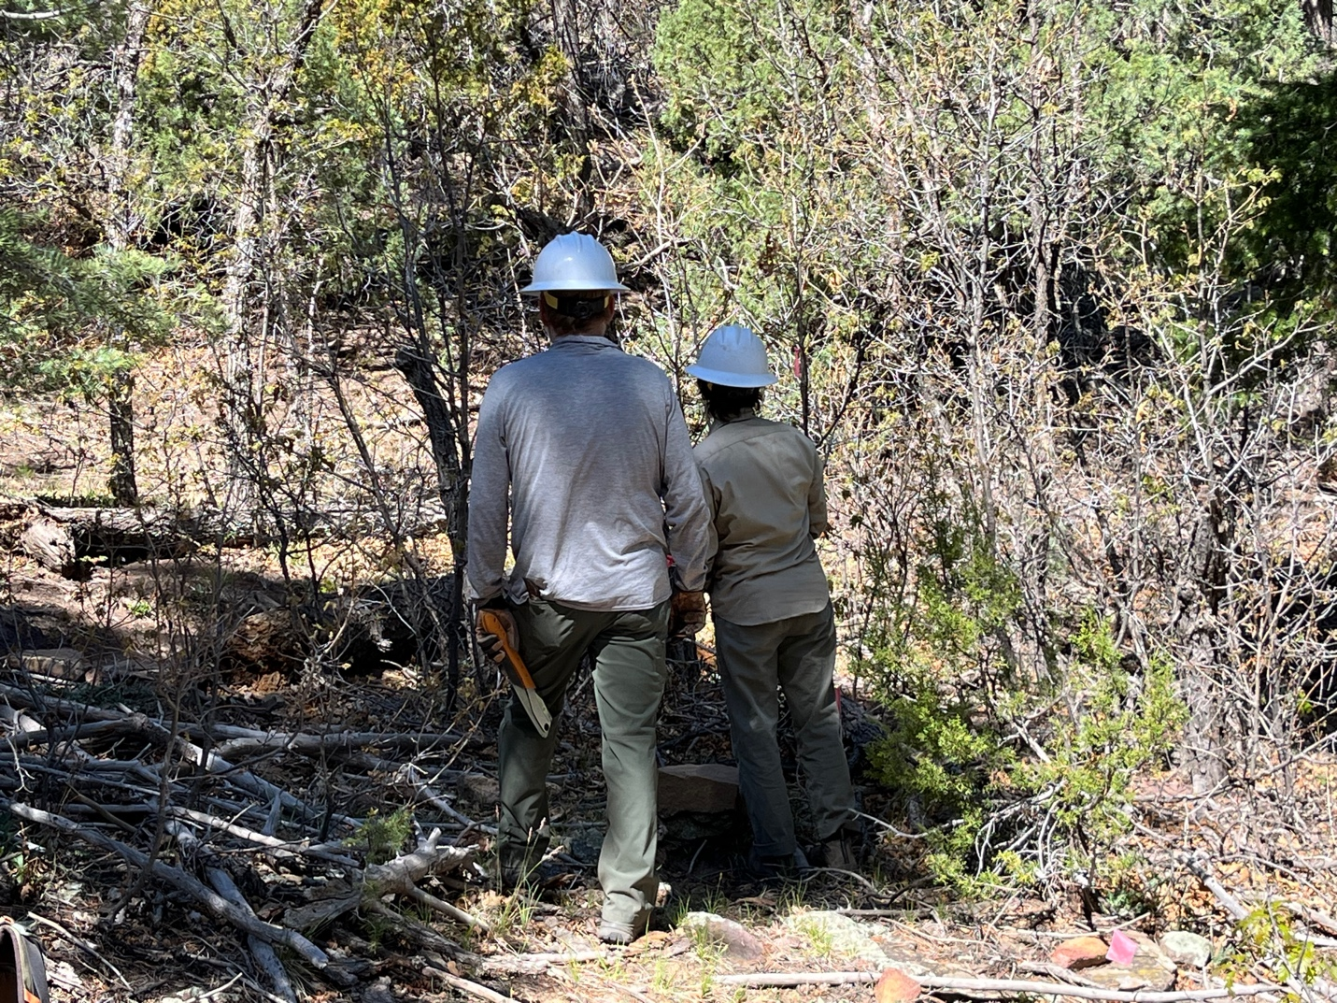

John and Jen discussed what needed to be cut out of the stump garden in this spot.
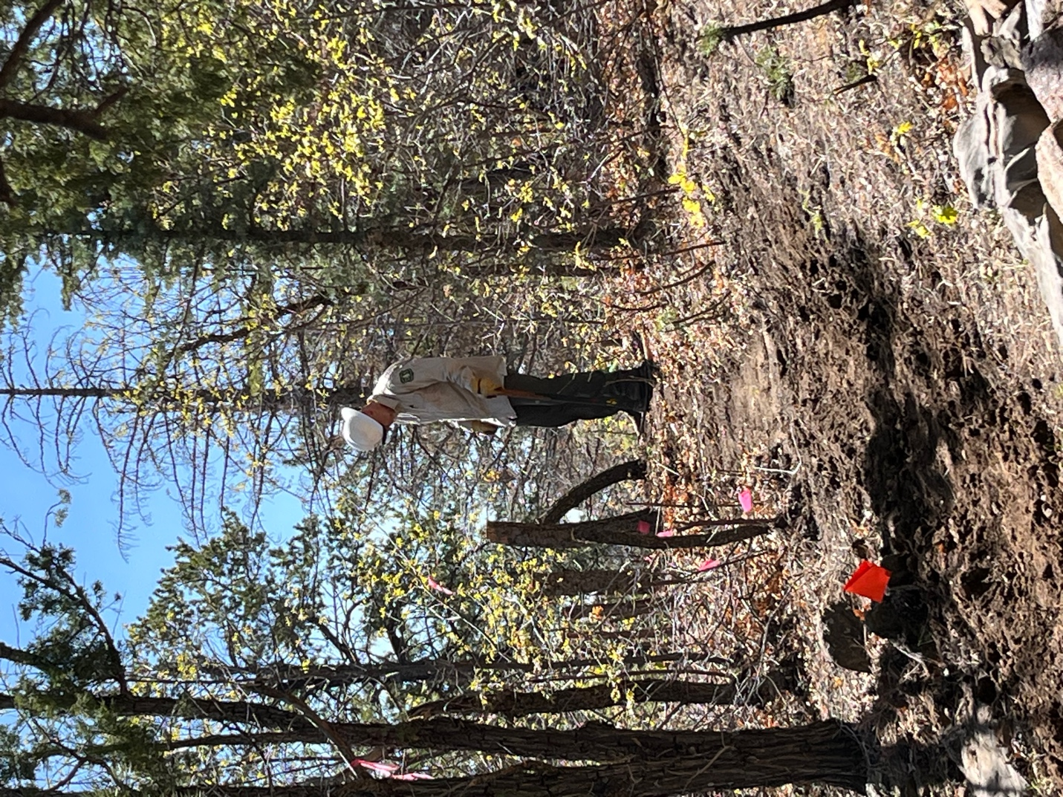

Chris contemplated the stump that just doesn’t want to leave…

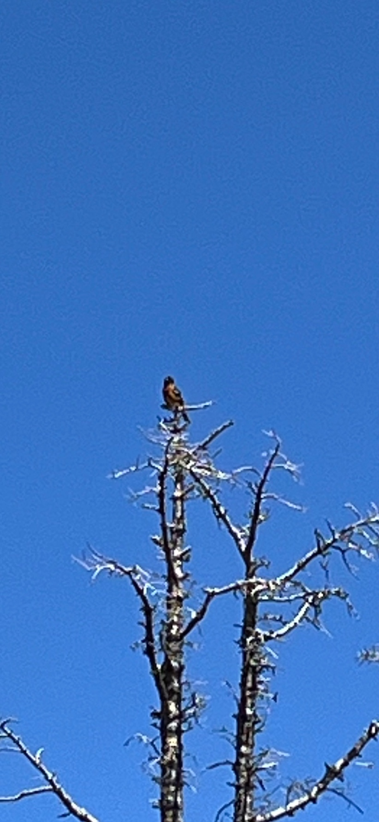

This is a terrible picture but this black-headed grosbeak sang to us for about 20 minutes and worked his way all around the area.
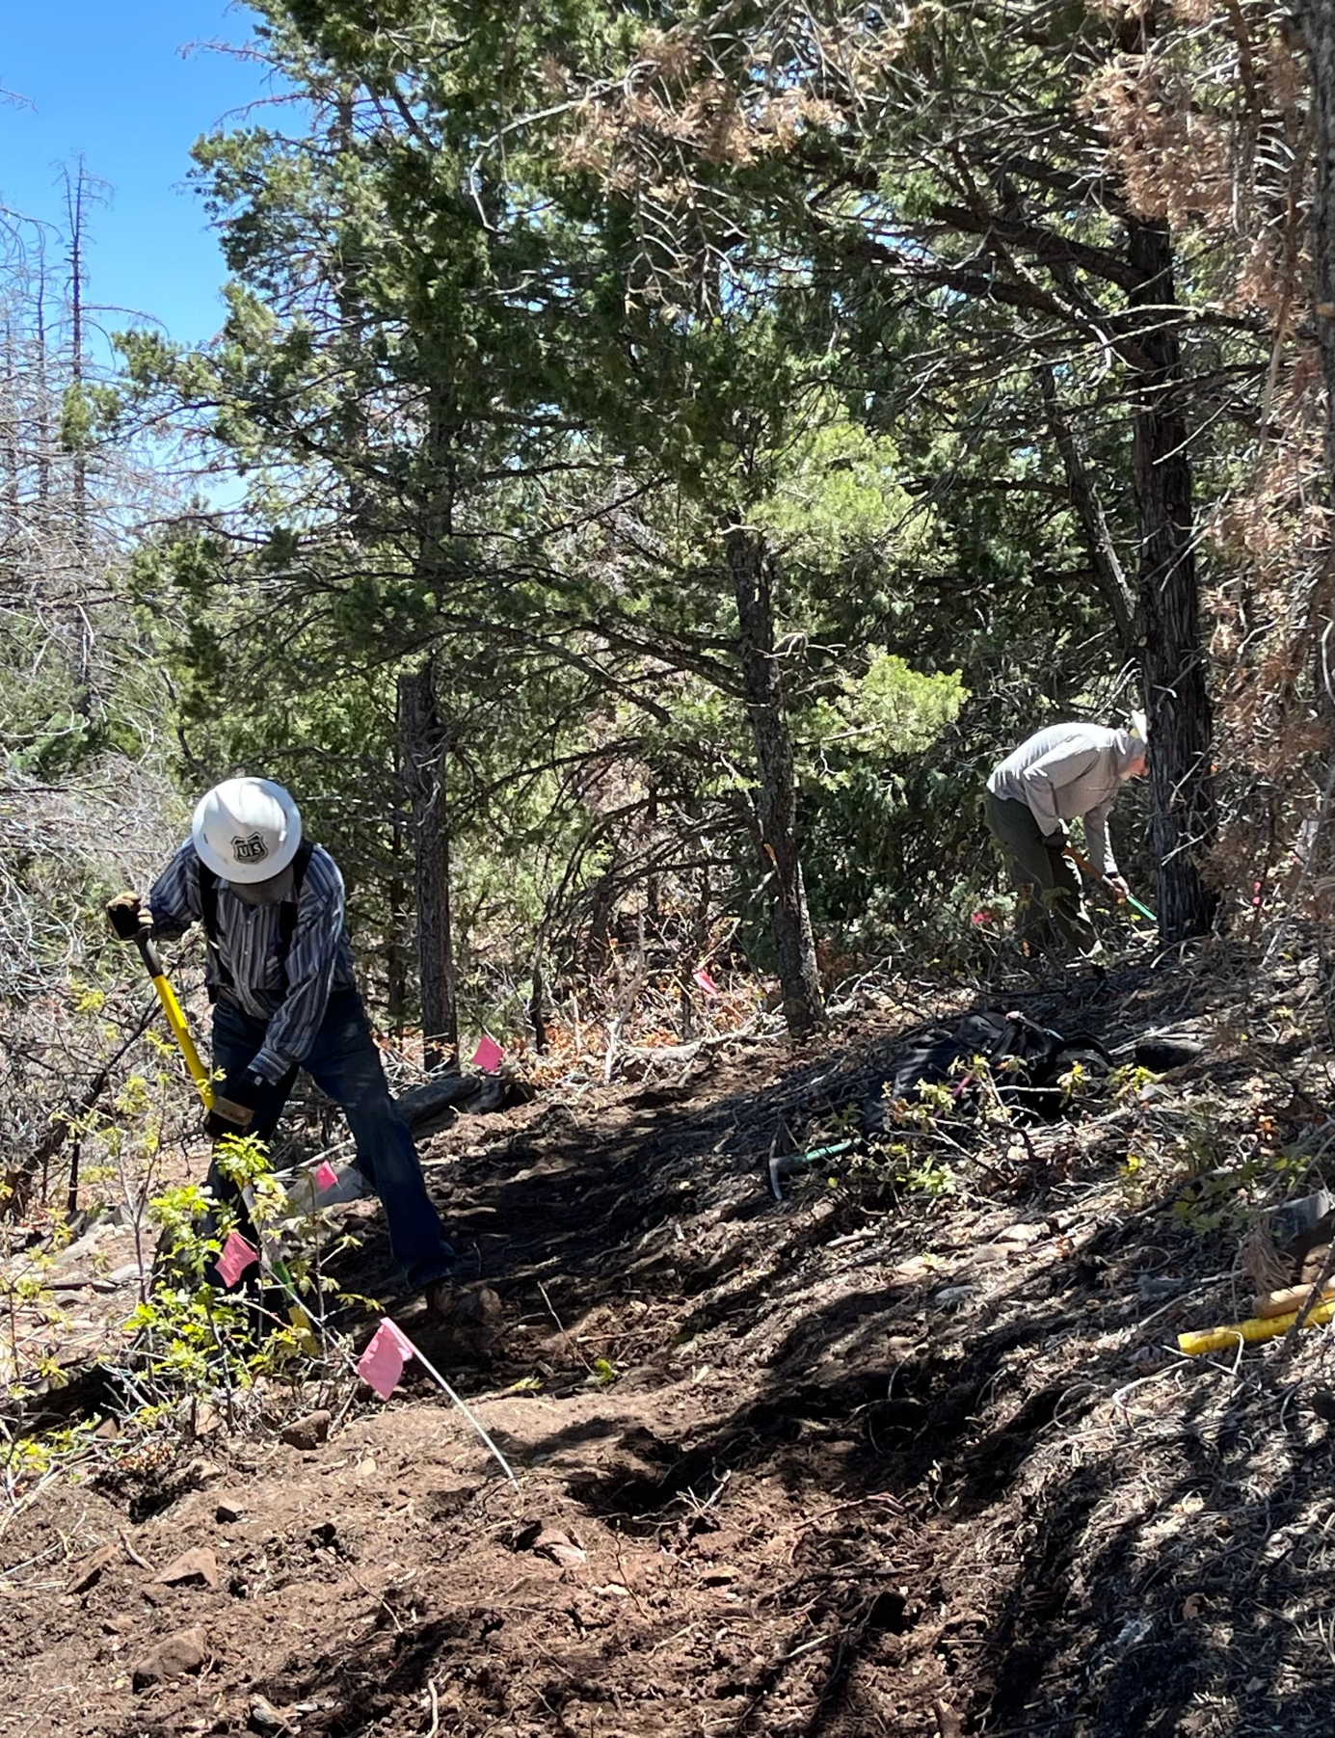

Bruce and John worked this problem area. It’s full of rocks and roots and by
1:30 pm we decided to stop work and come back to it next week.

