Thursday, 05/22/25- North Faulty: It was a hot one! 10 volunteers, Chris (SRD) and Doran who is putting in some trail building hours to satisfy a marathon application requirement headed up the North Faulty trail again. Mike worked on brushing some of the overgrown areas of the old trail. Reroute #4 was finished and obliterated. The crew worked on clearing the corridor for 2 small reroutes between #4 and #3 and for reroute #3. Tread was dug on the 2 short sections but we’ll need to finish that up next week. We were all dragging on the hike out!

Volunteers: Mike Madden, Cleve Sharp, Byron Garner, Jim Houle, Eric Russell,
John McNett, Rich Fagioli, Laura Leon and some new faces- Scott Forman and
Bart Vander Plas. Doran Bostwick was with us this week also.

Photos: Laura Leon

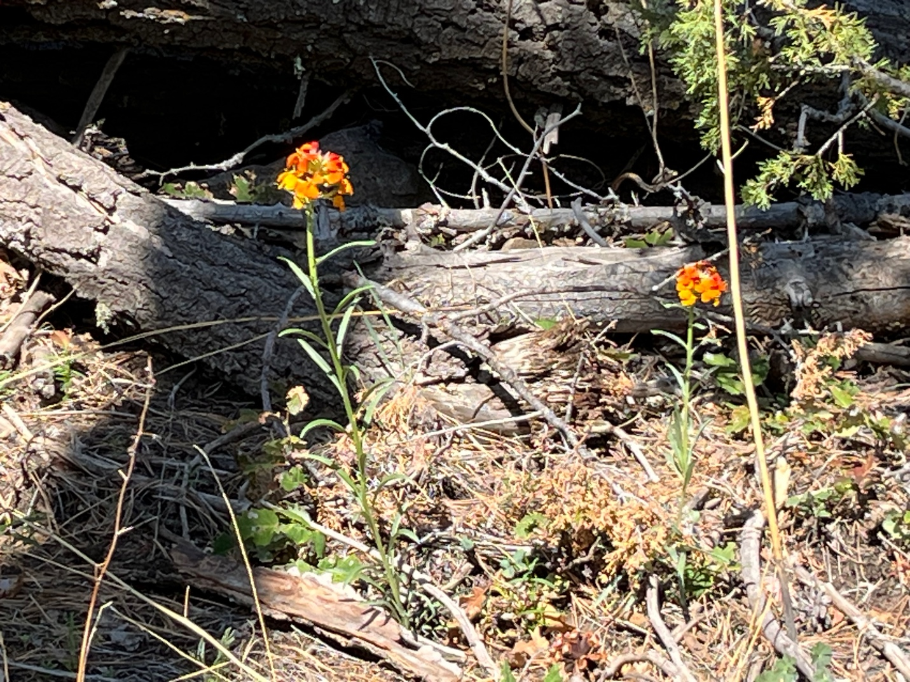

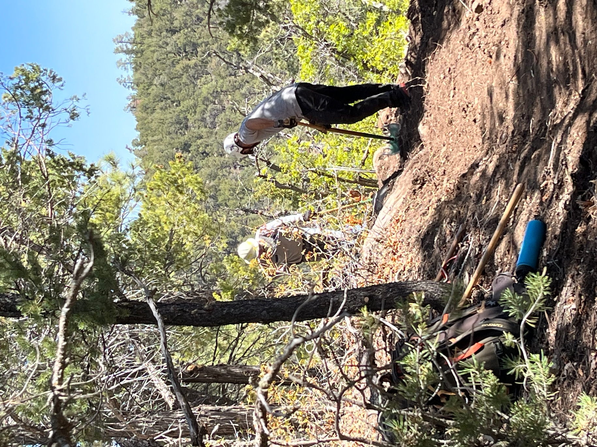

Jim and Scott worked a bend in the trail on reroute #4. Lots of roots and rocks.
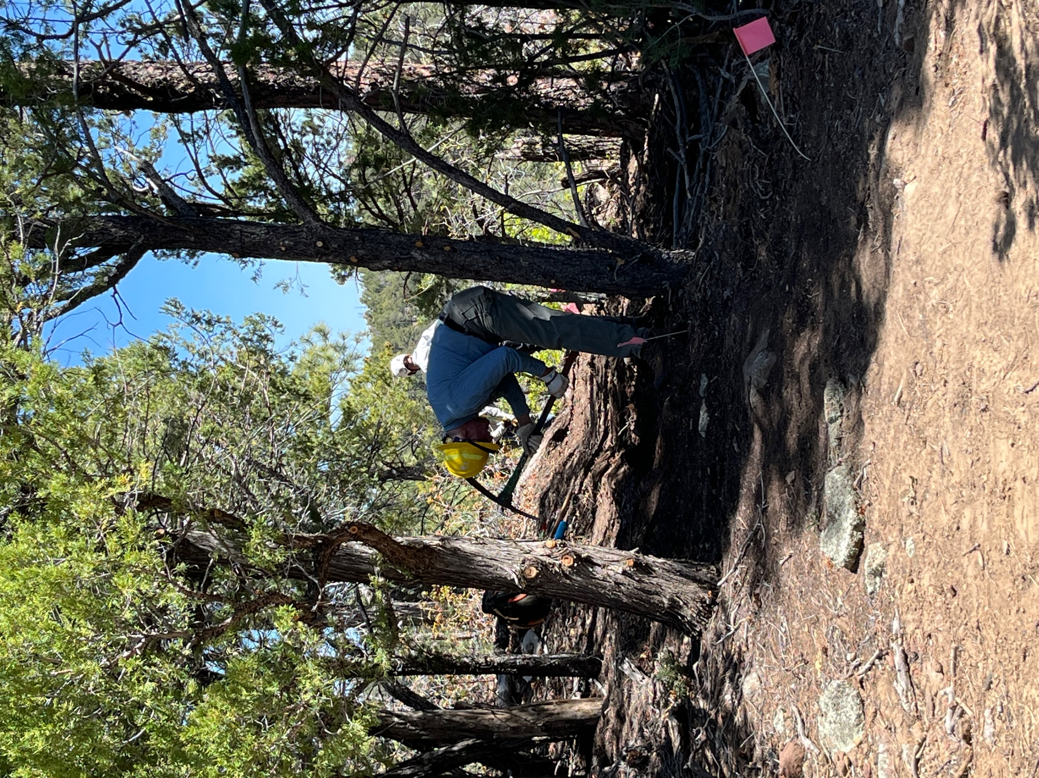

Eric was at it too!
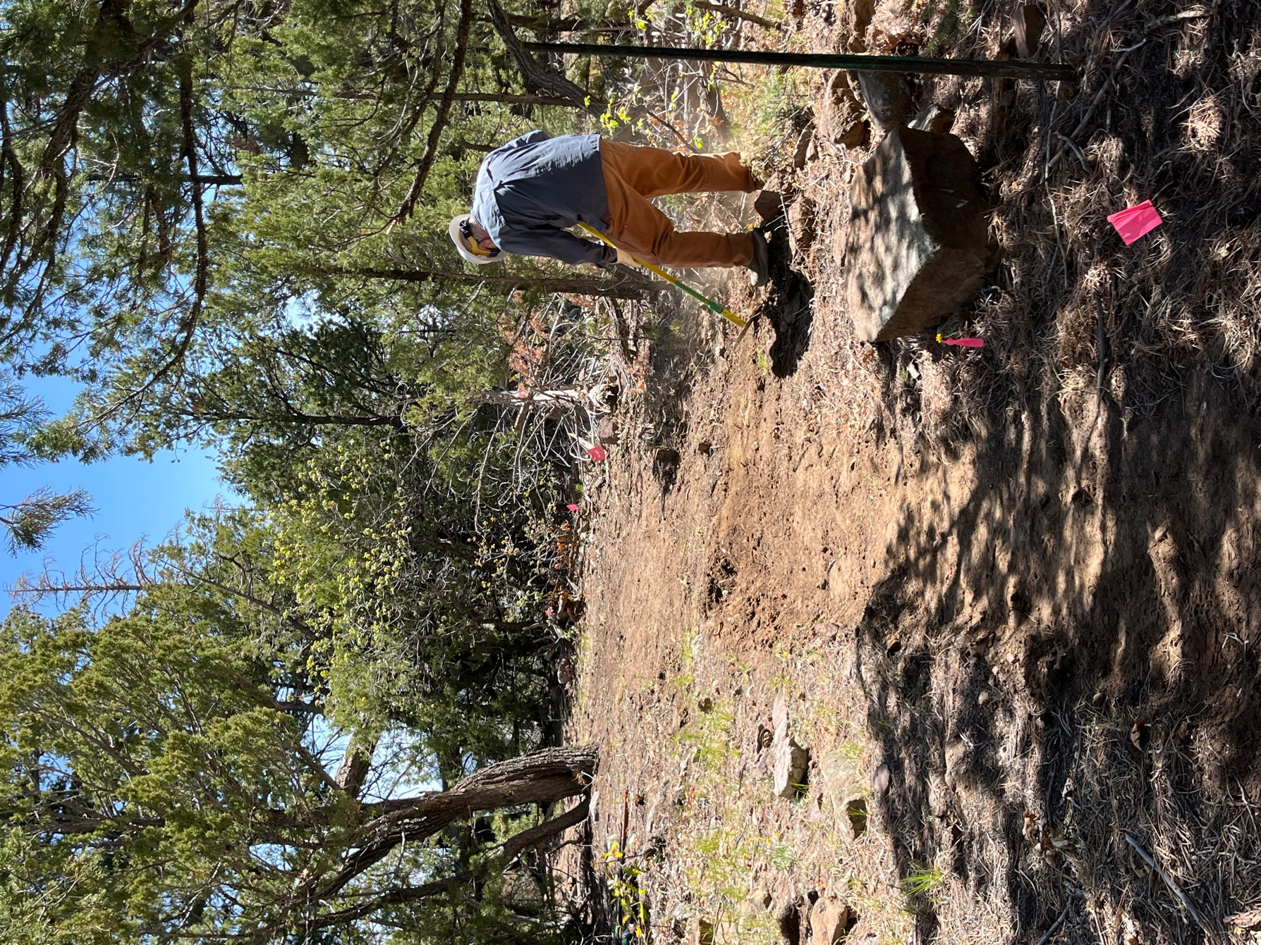

Bart worked the turn on this flat section.
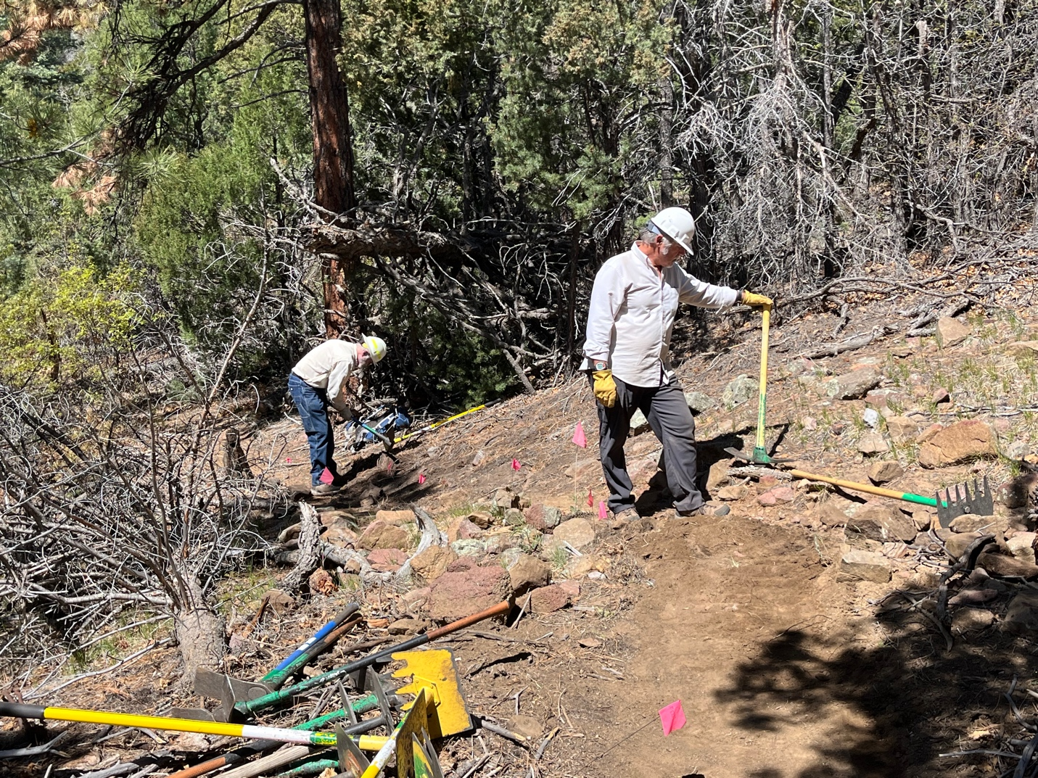

Cleve and Rich worked on connecting the new reroute to the old trail.

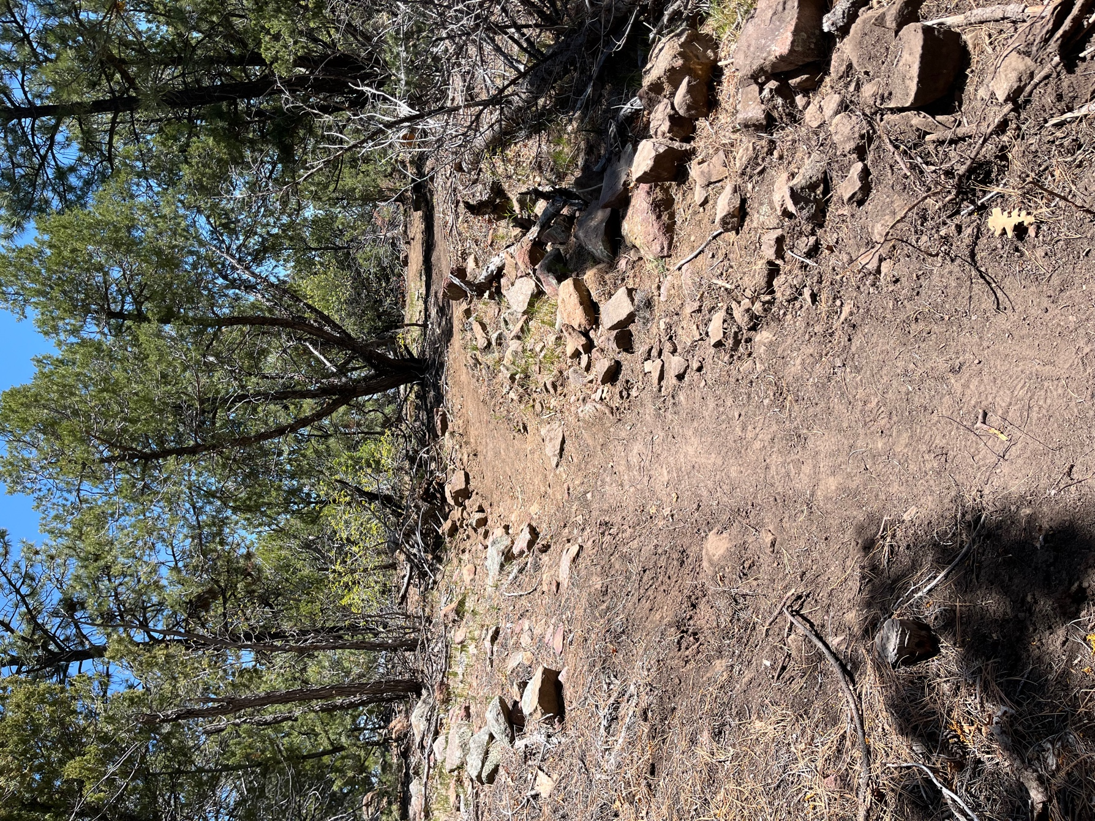

Success! Connection and obliteration completed!
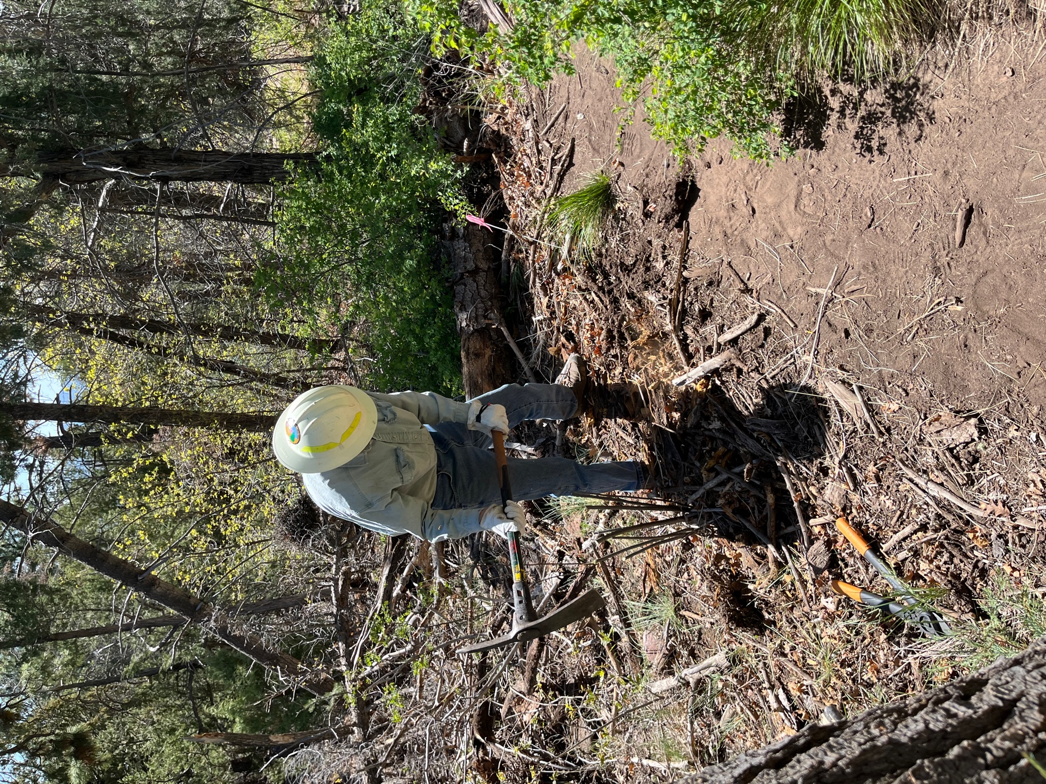

Meanwhile, Byron worked on clearing the tangled mess of branches and logs on the 2 short sections between #4 and #3.

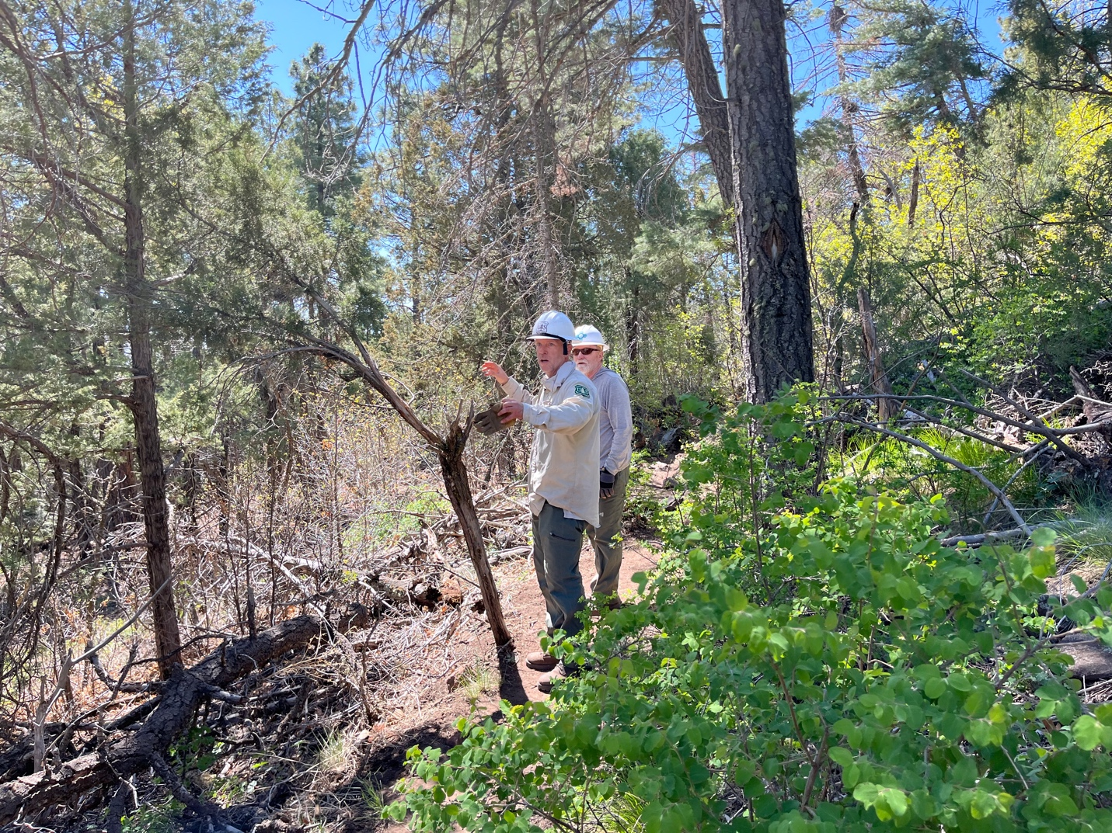

Chris and John sorted out what needs clearing. Lots of sawing!
Not much shade and lots of clear skies. Everyone was glad to be back to the cars by 2:30PM

