**FOSM Project to Paint Shelter and Remove Graffiti Tags**

**in the Sandia Crest Area, Tuesday, May 27, 2025**

**Sam Beard**

On Tuesday, May 27, Pauline Ho, Rick Buss, and Sam Beard repaired a window frame, painted the parking lot shelter, painted over graffiti on a large black pipe, and tried to remove graffiti on the restroom wall and on the large concrete wall below the upper parking lot.

Project photos are presented below.

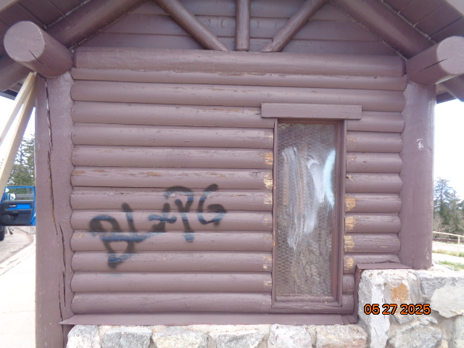

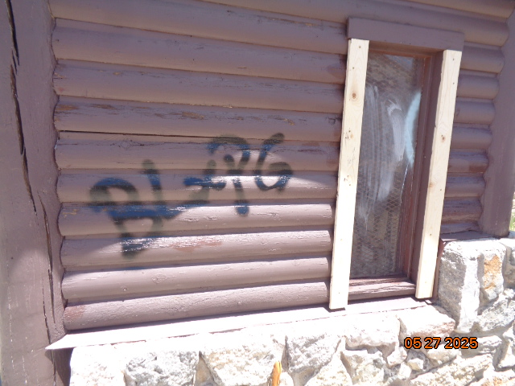

Top: Graffiti on end of parking lot shelter and the missing window frame sides. Bottom:

The 1x4 window frame sides have been replaced. All photos by Sam Beard

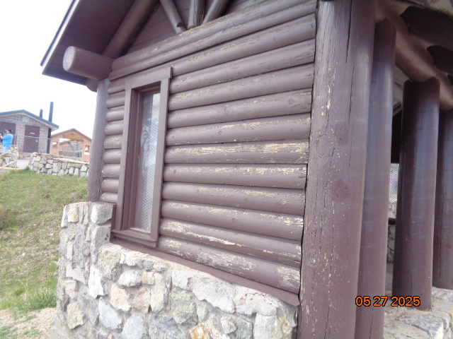

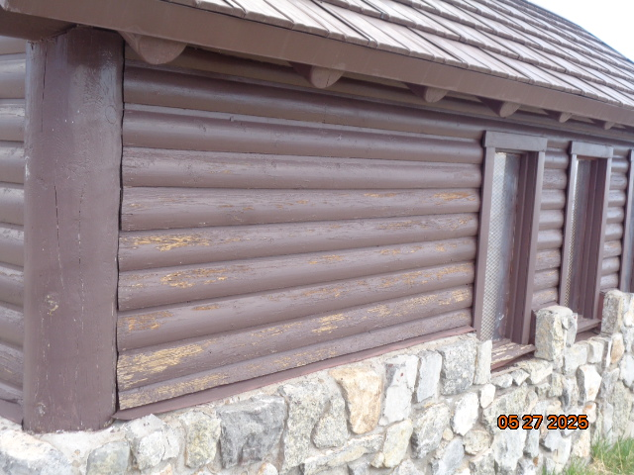

Chipped paint on two sides of the shelter.

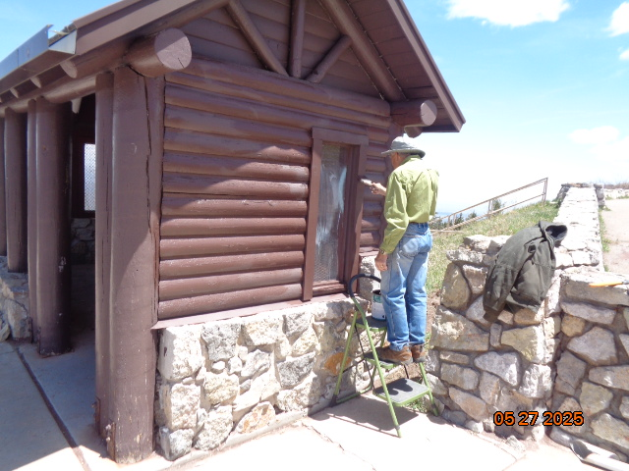

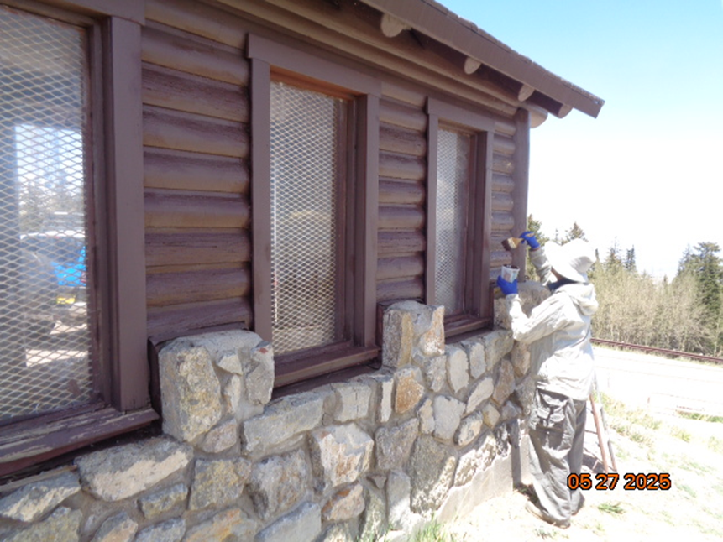

Rick and Pauline painting two sides of the shelter.

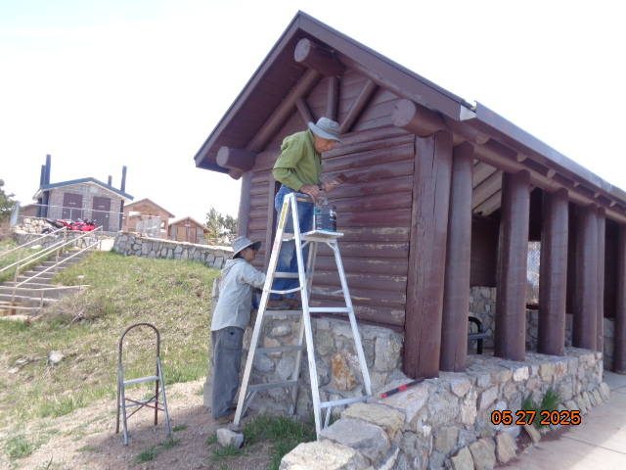

Pauline and Rick painting the north end of the shelter.

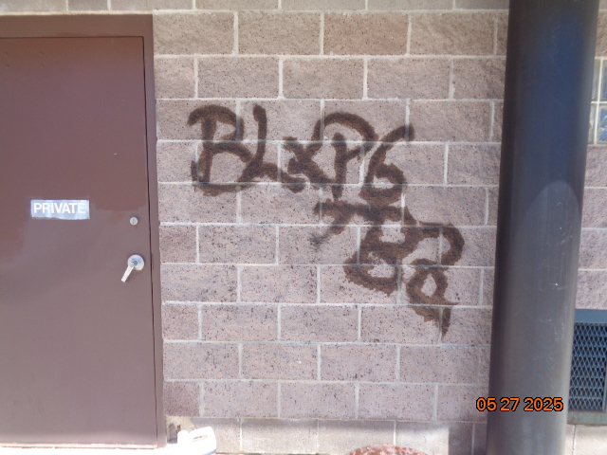

Large black graffiti tag on south side of Crest restroom.

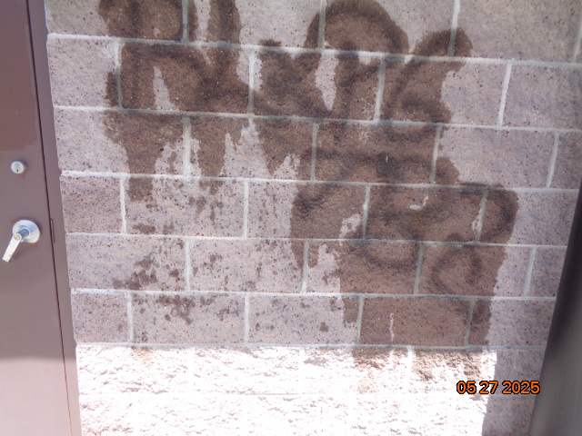

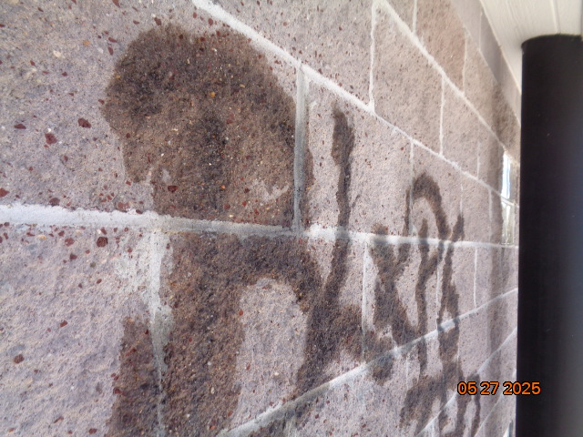

Top: Graffiti removal chemical has been applied to the tag and rinsed with water. The tag

was not removed. Bottom: The rough surface of concrete block wall is seen. The black paint

was absorbed by the rough porous surface and was not removed by the chemical.

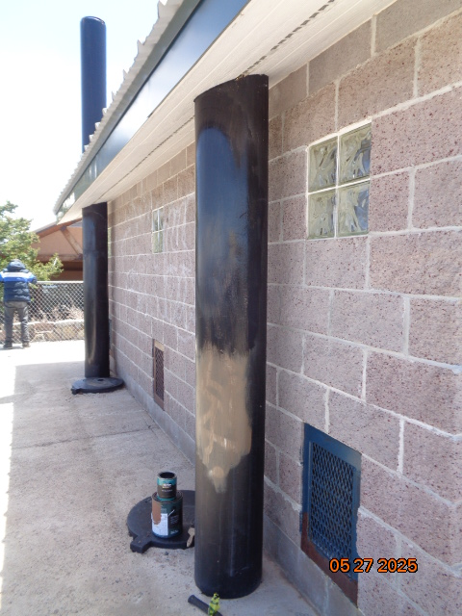

The large white tags on these ventilation pipes at the restroom were painted over with

brown paint earlier. On Tuesday, the brown paint was painted over with black paint.

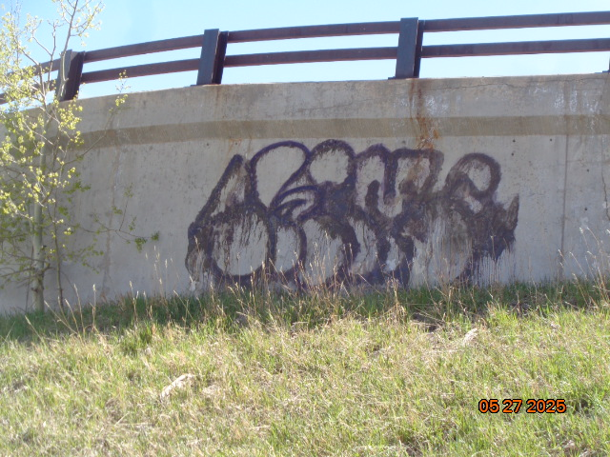

Three coats of graffiti removal chemical were applied to this large purple tag on the surface of the concrete wall below the upper Crest parking lot, but the tag was not removed. The vertical streaks

indicate that some of the paint had been dissolved and was running down the wall. We will try to

remove this tag on a later trip to the Crest.