**FOSM Report of Loading Split Donation Wood on Mike Oliver’s Trailer**

**in Capulin Snow Play Area, Wednesday, May 28, 2025**

Sam Beard

On Wednesday, May 28, FOSM volunteers loaded over a cord of split wood on Mike Oliver’s trailer in the Capulin Snow Play Area. Three hazard trees in the SPA were felled, limbed, bucked, and split by FOSM volunteers recently. Mike will store the wood in his wood lot until the Mountain Christian Wood Ministry

donates it to East Mountain families next winter.

Project photos are presented below.

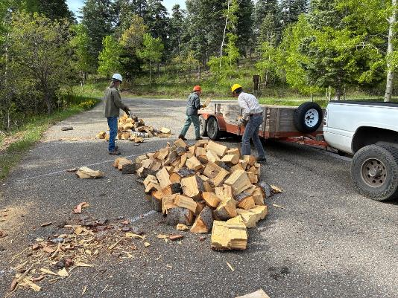

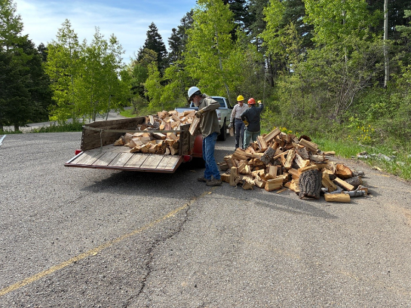

Top: L to R: Mike Oliver, Don Carnicom, and Sim Cook. Loading split donation wood

in Mike Oliver’s trailer at the lower level of the Capulin Snow Play Area.

Bottom: Loading at the upper SPA level. Photos by Cliff Giles unless noted otherwise

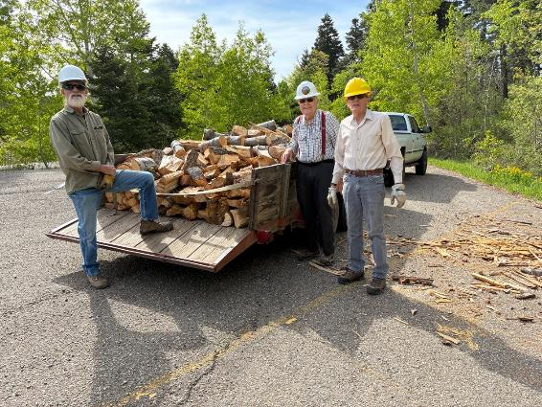

L to R: Mike Oliver, Cliff Giles, and Sim Cook. The trailer is loaded, and Mike will

store the wood in his wood lot until the Mountain Christian Wood Ministry

donates it to East Mountain families next winter. Photo by Don Carnicom