**Report of Unloading Kiwanis Meadow Buck and Rail Fence Materials**

**from United Wood Products in Longmont, Colorado, on Friday, May 30, 2025**

Sam Beard

On Friday, May 30, a trailer truck load of materials for the Kiwanis Meadow buck and rail fence arrived at the Sandia Ranger Station. Joelle Hertel, FOSM Special Projects Lead, had ordered the materials. The cost of these materials was $13,000. The funds for this project were taken from the generous bequest from the estate of Dr. Charles Wood to FOSM.

These pressure-treated materials and associated hardware were purchased from United Wood Products in Longmont, Colorado. In the photos below, Manny Chavez, SRD Maintenance Supervisor, is using the Ditch Witch skid steer to unload bundles of 5-inch by 5-feet posts, 3-inch by 12-feet poles, and 3-inch by 4-feet poles. The notched posts will be used to fabricate the fence bucks, and the 4-foot poles will be the brace on the bucks. Three of the 12-foot poles will be the rails on the fence. A photo of a section of the fence is included in the photos below.

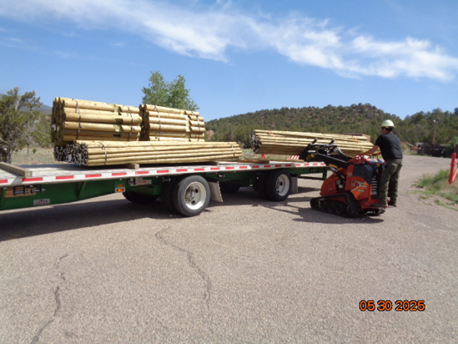

Manny is unloading a bundle of 12-foot poles with the skid steer.

All photos by Sam Beard

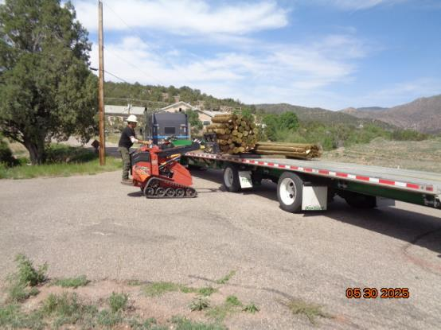

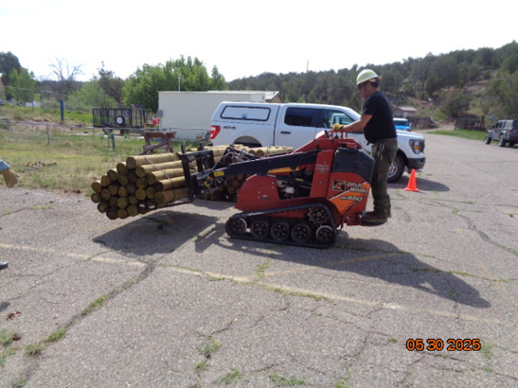

Manny is unloading a bundle of posts and taking them to a location near the hazmat building

behind the Ranger Station.

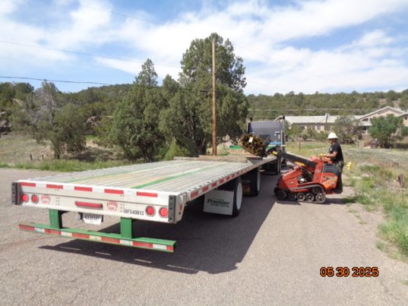

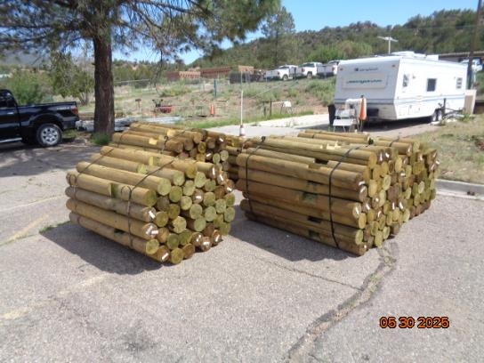

Top -- Manny is unloading the last bundle of posts from the trailer.

Bottom – The posts have been stored in the parking lot near the hazmat building.

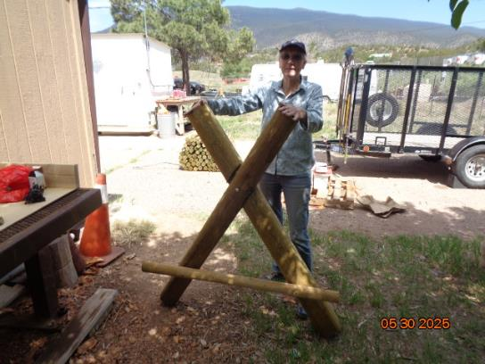

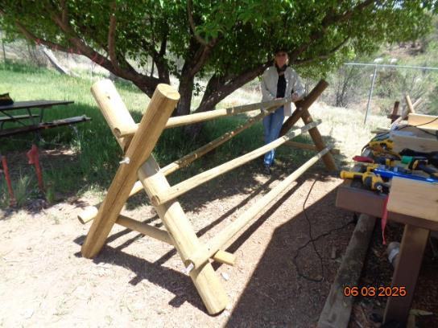

Top – Joelle with the first buck fabricated with the treated materials. Bottom – A section

of the type of fence that will be constructed on the north and south sides of Kiwanis Meadow

to discourage hiking in the meadow and the formation of unofficial user trails.