**FOSM Report of the Removal of Graffiti Tags on Structures and Boulders in Juan Tabo Picnic Area on Tuesday, June 2, 2025.**

Sam Beard

On Tuesday, June 2, Pauline Ho, Rick Buss, and Sam Beard removed approximately a dozen graffiti tags from the Juan Tabo Picnic Area CCC shelter, a restroom, and adjacent boulders.

Project photos are presented below.

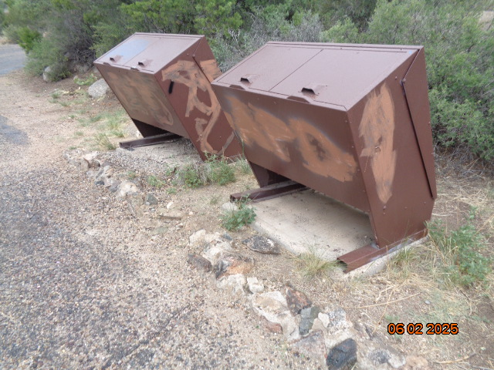

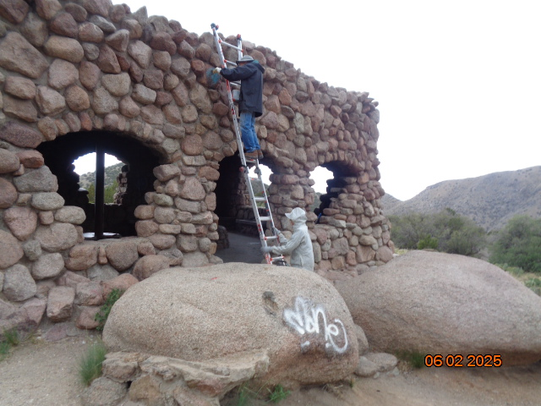

Top – Tags painted over with tan paint that will be covered by USFS brown paint

later. Bottom – Rick Buss removing a tag high on the outside of the shelter. After

Sam left, Rick and Pauline removed another tag high on the shelter.

All photos by Sam Beard.

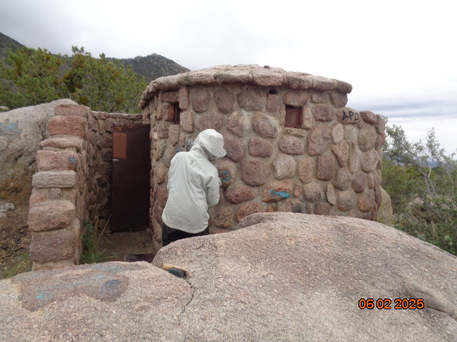

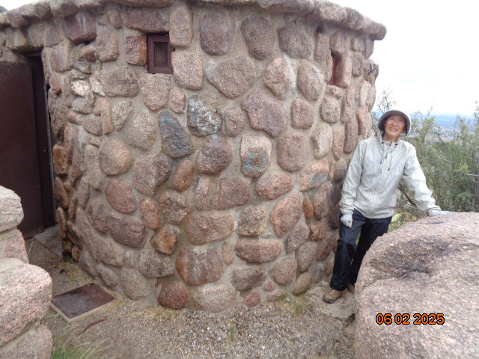

Pauline at the women’s restroom where she removed tags.

Note the small APD tag high on the right side of the restroom wall.

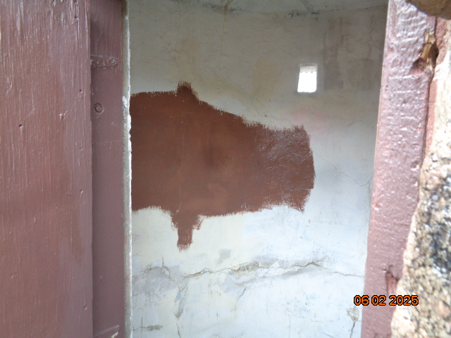

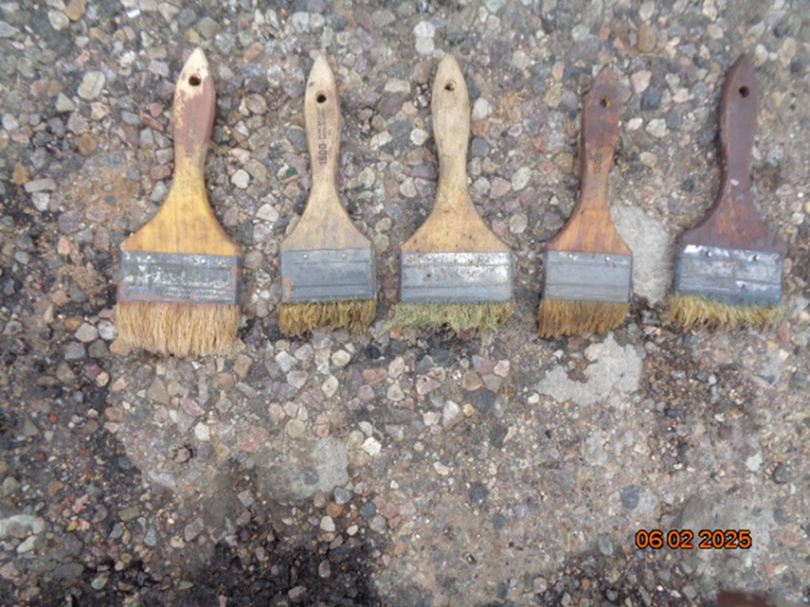

Top – Brown paint covers a tag on interior of the restroom. The brown paint

will be covered with white paint later. Bottom – Inexpensive chip brushes that are

used to apply graffiti removal chemical and chemical/water residue. Using the brushes

on rough granite quickly wears away the bristles.

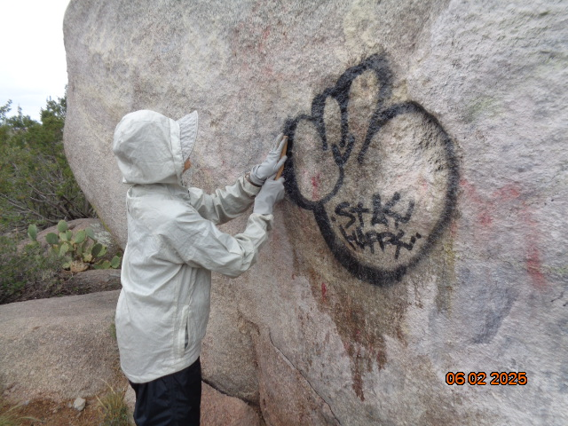

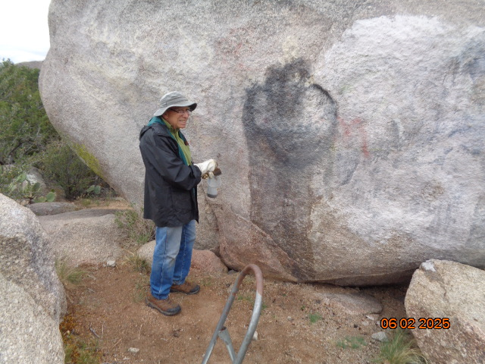

Before and after photos of tag on boulder where chemical was applied.

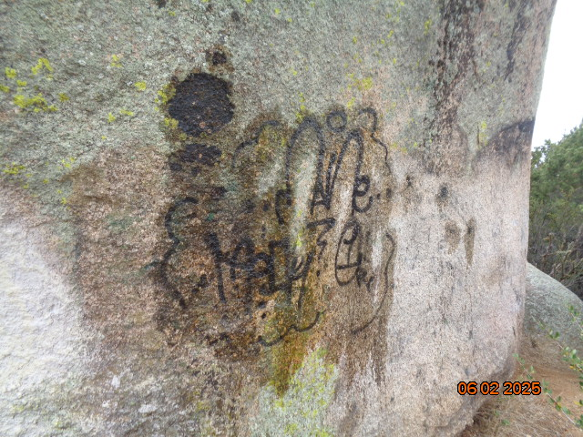

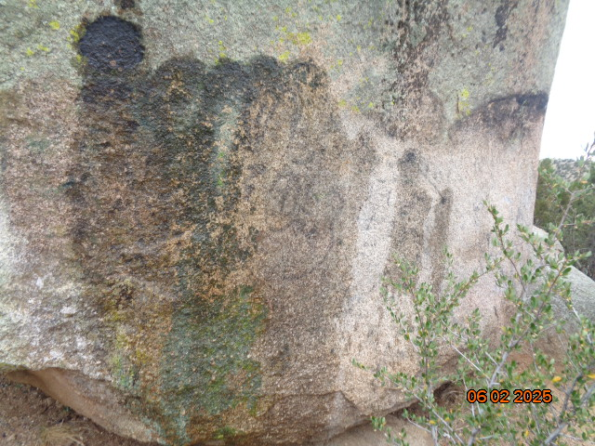

Before and after photos of tag on another side of the same huge boulder.

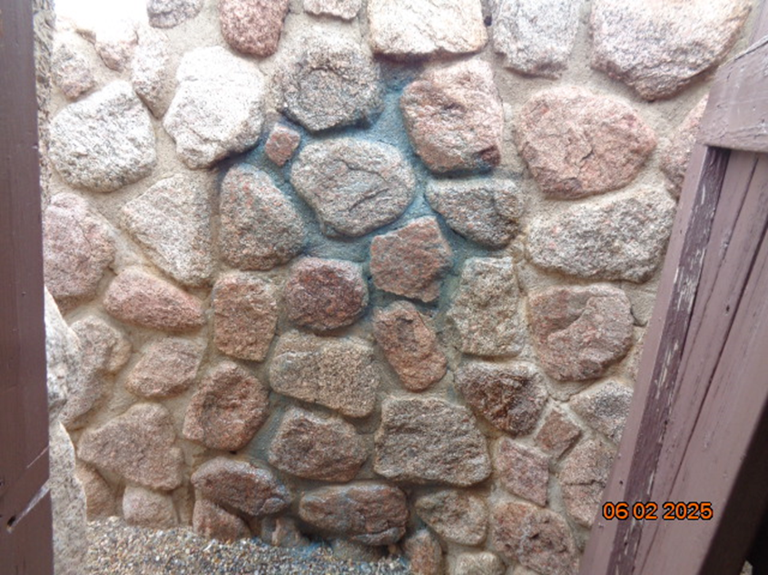

A large blue solid color tag was removed from this stone wall

at the men’s restroom. The mortar between the stones is porous, and

the chemical will not remove all the color.