**FOSM Report of the Fabrication of Bucks for the Kiwanis Meadow Buck and Rail Fence, Saturday, May 31, 2025**

Sam Beard

On Saturday, May 31, FOSM volunteers and SRD fire fighters fabricated most of the bucks for the Kiwanis Meadow buck and rail fence at the FOSM Guard Station. The photos present the fabrication of the bucks with two notched pressure-treated posts, a 4-foot brace on the buck legs, a long carriage bolt, and two timber screws.

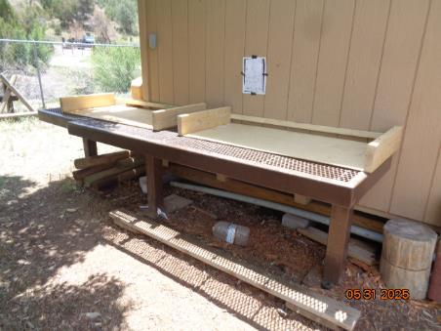

Jigs by Joelle Hertel for making bucks for the buck and rail fence at Kiwanis Meadow.

This work area is located at the east end of the FOSM guard station. All photos by Sam Beard

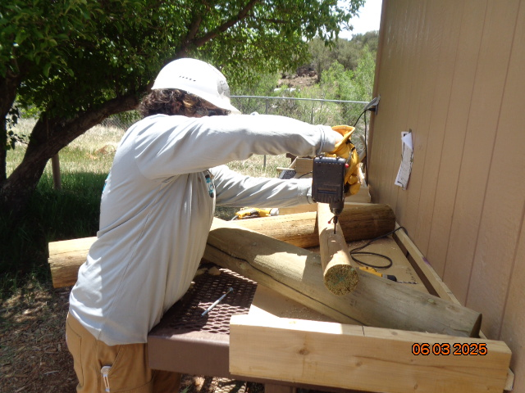

This photo taken on June 3 shows one of the TTYL/YCC crew members making a

buck using the jig shown above. The two notched and crossed posts are placed in the jig

in the correct position, and a 3-inch by 4-foot brace is placed on the buck legs at

a location marked on the jig 2x6 sidewall. An 8-inch or 9-inch 3/8-inch carriage bolt

is inserted through a hole in the crossed legs, and a washer and nut are screwed on the bottom

of the buck. In this photo, the crew member is using a battery-powered driver to

place a 6-inch timber screw through the brace into a leg.

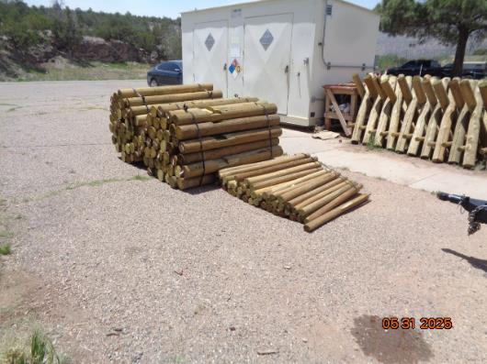

Piles of notched pressure-treated posts, 4-foot braces, and assembled bucks at the

hazmat building.

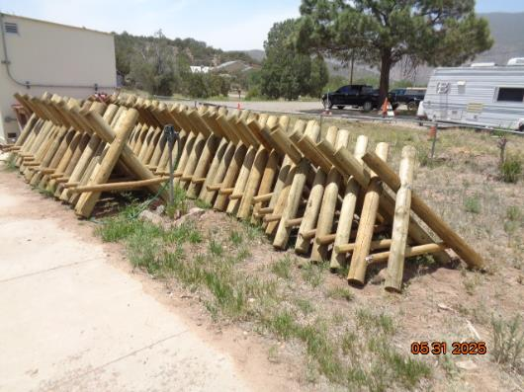

Most of these bucks stored at the hazmat building were made by FOSM volunteers

and SRD fire fighters on Saturday, May 31.