**FOSM Report of Hauling Old** **Buck and Rail Fence Wood from Kiwanis Meadow to the East Mountain Transfer Station, May 28, 2025**

Sam Beard

On Wednesday, May 28, FOSM volunteers hauled several pickup loads of the old Kiwanis Meadow buck and rail fence to the gate on the Kiwanis Cabin Road where it was transferred to an SRD trailer. Manny Chavez, SRD Maintenance Supervisor, will haul the wood to the East Mountain Transfer Station. Two pickup loads of the fence rails were piled beside the pavement near the gate, and it will be collected as donation wood later. The old fence wood was removed, because a new buck and rail fence will be built around parts of the meadow.

Project photos are presented below.

The FOSM volunteers working on this project were Cliff Giles, Don Carnicom, Jerry Carroll, Dennis Crowther, Sim Cook, Laura Leon, and Sam Beard.

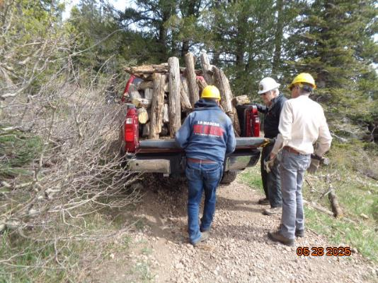

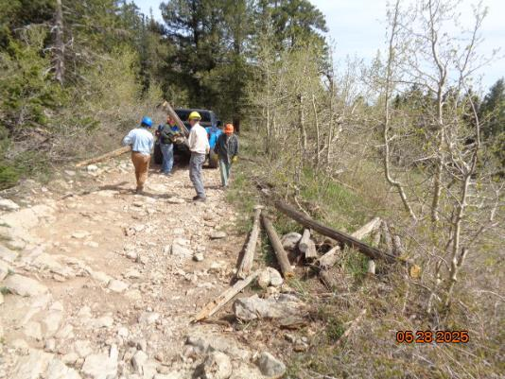

Top – Old fence bucks have been loaded on Jerry Carroll’s pickup on the Kiwanis Cabin Road.

L to R: Jerry Carroll, Cliff Giles, and Sim Cook. Bottom – Volunteers are loading parts

of the old fence on Dennis Crowther’s Jeep.

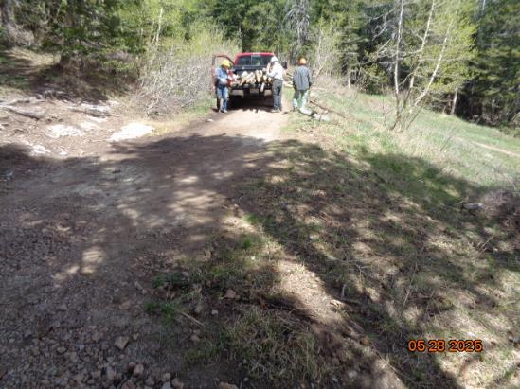

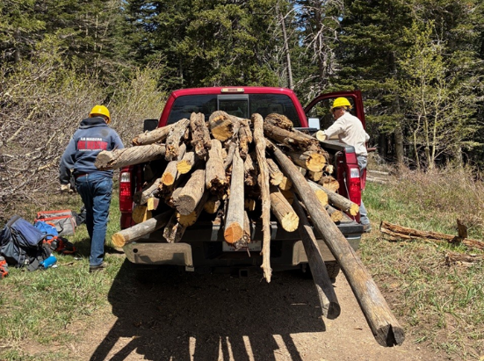

Top – All parts of the old fence have been removed from the firsts curve in the road

adjacent to the meadow. Bottom -- L to R: Jerry Carroll and Sim Cook. Jerry is

hauling out a load of old rails in his pickup.

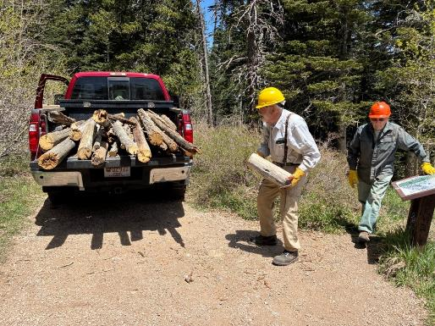

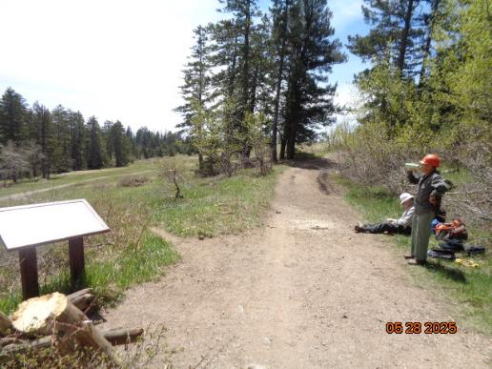

Top – Sam Beard is throwing the last piece of the old fence onto Jerry’s truck. Don Carnicom

is walking around the interpretive sign at the north end of the meadow.

Bottom – Volunteers are resting after several pickup loads of old fence materials

were hauled out. Note how clean the left side of the road is after all the old

wood has been removed.

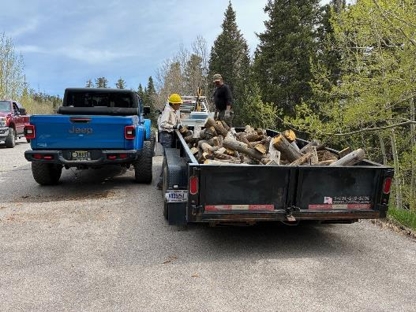

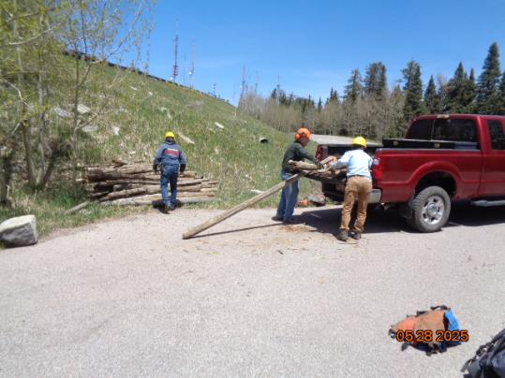

Top – Manny Chavez, SRD Maintenance Supervisor, will haul this load of old fence wood

to the East Mountain Transfer Station. Bottom – Volunteers are unloading some of the

old fence rails and piling them beside the road to the Kiwanis Cabin Road gate. This material

will be collected as donation wood later.