**FOSM Report of Fabrication of Last Buck and Hauling of Bucks and Rails**

**to Kiwanis Meadow near Sandia Crest, Tuesday, June 3, 2025**

Sam Beard and Joelle Hertel

On Tuesday, June 3, TTYL/YCC (Talking Talons Youth Leadership/Youth Conservation Corps) crew members fabricated the last bucks for the Kiwanis Meadow buck and rail fence. Holes were drilled in one end of each rail, 6 inches from the end. This step helped save time and battery power in the field. These fence components (90 bucks and 300 rails) were loaded on SRD pickups and trailers and hauled to Kiwanis Meadow in several loads by Canyon Young, SRD Trails and Wilderness Program Manager, and Manny Chavez, Maintenance Supervisor. TTYL/YCC crew members unloaded the pickups at the meadow.

The TTLY/YCC crew members were Aidan Stewart, Crew Leader, Hans Martin, Lila Eaton, Evan Cooney-Martin,

Jamie Medina-Soto, Rebecca Duggar, and Eli Iwanczyk.

Project photos are presented below.

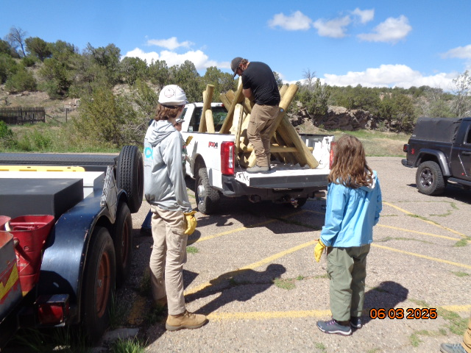

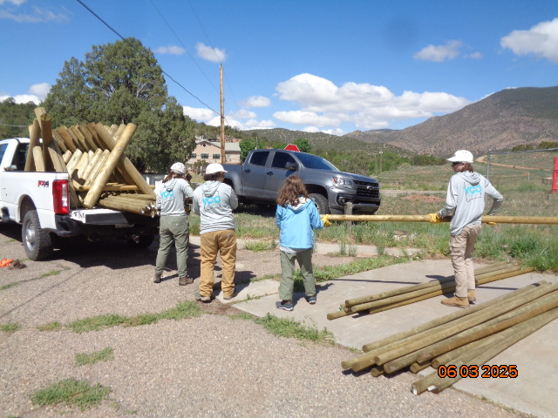

Top – Canyon Young, SRD Trails and Wilderness Program Manager, loading bucks on an

SRD pickup with TTYL/YCC crew members observing. Bottom – TTYL/YCC crew members

loading rails on the pickup. Canyon hauled the bucks and rails to Kiwanis Meadow where

a buck and rail fence will be constructed. Photos by Sam Beard unless stated otherwise

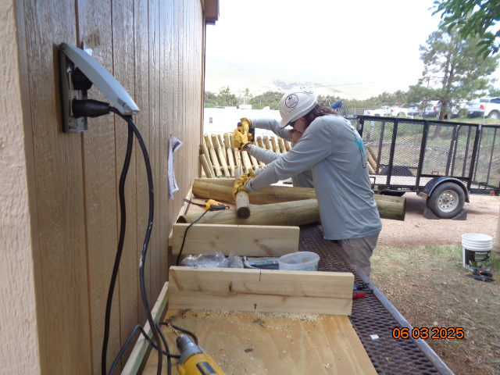

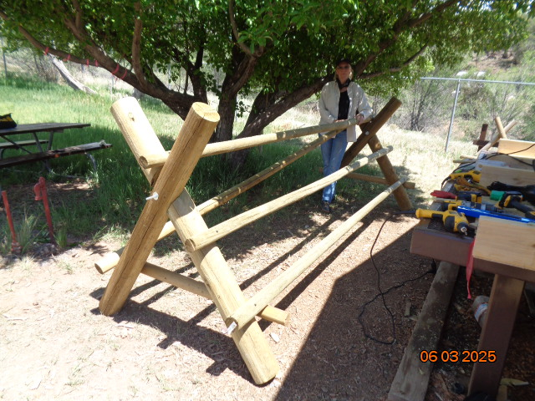

Top – Two TTYL/YCC crew members fabricating the last buck for the new fence using

Joelle’s jig to align the buck legs and the brace. Bottom – Joelle with the fence section that

was assembled at the FOSM Guard Station to learn fabrication procedures for the 1000 feet

of fence that will be constructed at Kiwanis Meadow.

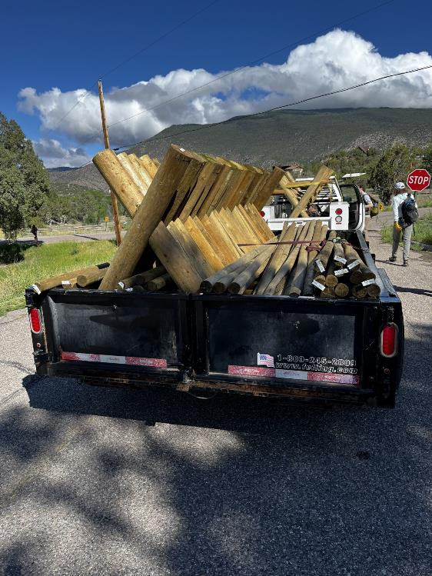

Bucks and rails on a trailer and pickup that Manny Chavez will drive to Sandia Crest. The bucks and rails

on the trailer were transferred to pickups and hauled down the rough Kiwanis Cabin Road to the meadow.

Photo by Joelle Hertel

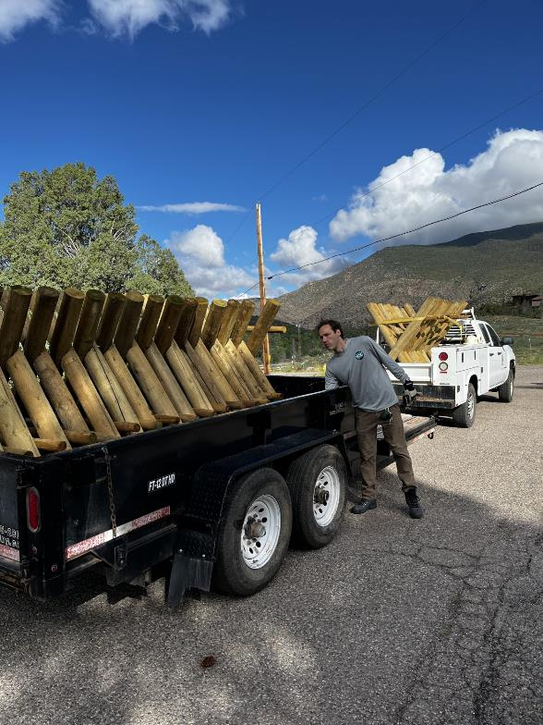

Aidan Stewart, TTYL/YCC Crew Leader, checking a load of bucks that Manny Chavez will

haul to Kiwanis Meadow. Photo by Joelle Hertel