**Report of Work on the FOSM Project to Build a Buck and Rail Fence on Two Sides of Kiwanis Meadow, Monday, June 9, 2025**

Sam Beard and Joelle Hertel

On Monday, June 9, TTYL/YCC (Talking Talons Youth Leadership/Youth Conservation Corps) and FOSM volunteers continued building the Kiwanis Meadow buck and rail fence. Manny Chavez, SRD Maintenance Supervisor) hauled the original assembled fence section from the FOSM Guard Station to Kiwanis Meadow. He also hauled away the debris from the old fence sections from the corner of the meadow adjacent to the South Crest Trail. A TTYL crew with Joelle Hertel trimmed aspen along the edge of Kiwanis Meadow Road and used the slash in the meadow to obliterate user trails. The crew also built a few more sections of the fence farther up the Kiwanis Cabin Road to the tall forest trees.

Sam Beard, Michael Arndt, and Sim Cook, FOSM members, completed the fence in the meadow corner by the South Crest Trail with a TTYL crew.

The TTLY/YCC crew members working today were Aidan Stewart, Crew Leader, Hans Martin, Lila Eaton, Evan Cooney-Martin, Jamie Medina-Soto, Rebecca Duggar, and Eli Iwanczyk.

Project photos are presented below.

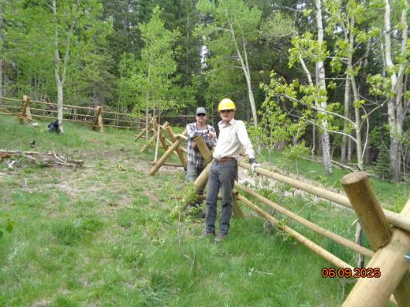

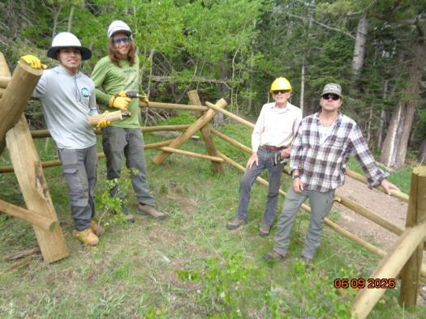

Top – L to R: Michael Arndt and Sim Cook at the sections of the fence in the north

corner of Kiwanis Meadow. Bottom – L to R: TTYL crew members Jamie Medina-Soto and Evin

Cooney-Martin, and FOSM members Sim Cook and Michael Arndt at the last corner in this part of the

fence. South Crest Trail is behind Sim and Michael. All photos by Sam Beard unless stated otherwise.

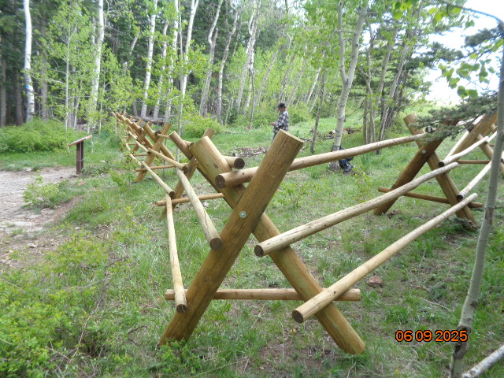

View from the last corner in the section of the fence adjacent to the South Crest Trail toward

the end of the fence in the edge of the forest in the background. The interpretative sign on the

left presents information about the meadow.

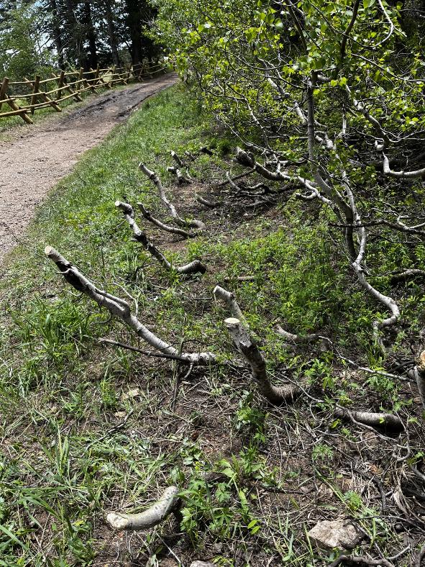

At the request of Canyon Young, SRD Trails and Wilderness Program Manager,

the small aspens encroaching on the road were cut with loppers near the first curve

in the road. The lower parts of these trees will be cut down to the ground with a chain saw later.

Photo by Joelle Hertel

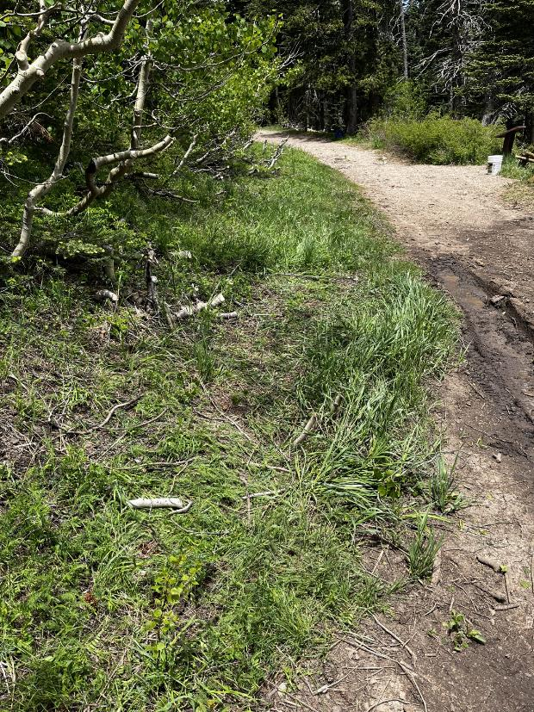

At this location on the road, the aspen brush was cut down to the ground with loppers.

The northern corner of the fence is at the sign on the upper right side of the photo.

Photo by Joelle Hertel

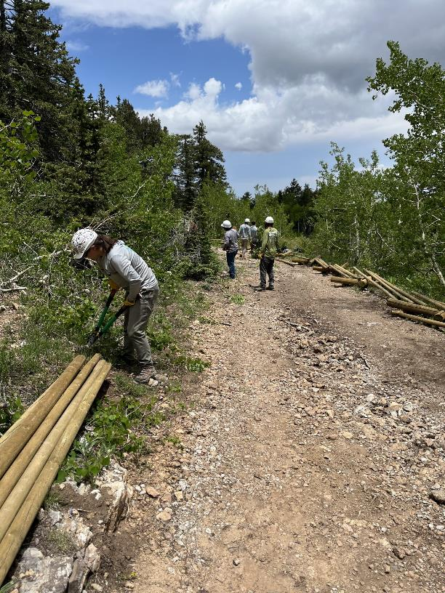

TTYL crew members continued to cut the aspen brush several hundred

feet along the Kiwanis Cabin Road.

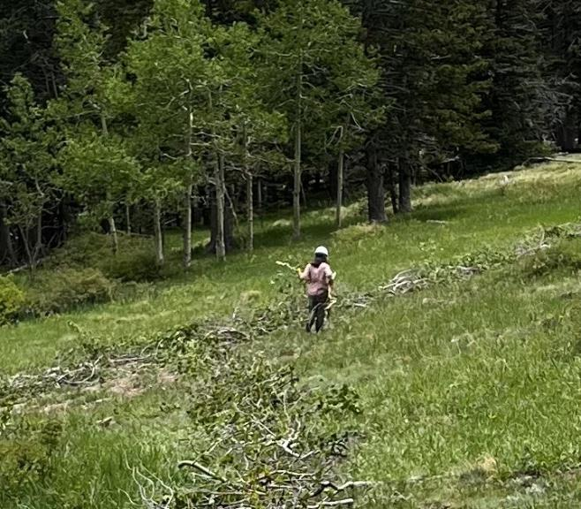

TTYL crew members placed cut aspen brush on user trails to obliterate

Them and discourage hiking here by visitors. Photo by Joelle Hertel

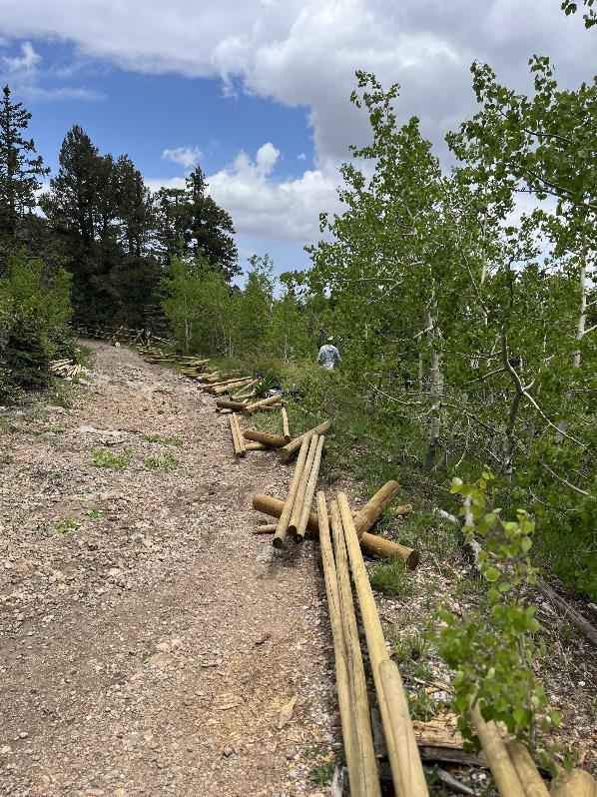

These bucks and rails will be used to extend the fence in the background

long the Kiwanis Cabin Road. Photo by Joelle Hertel

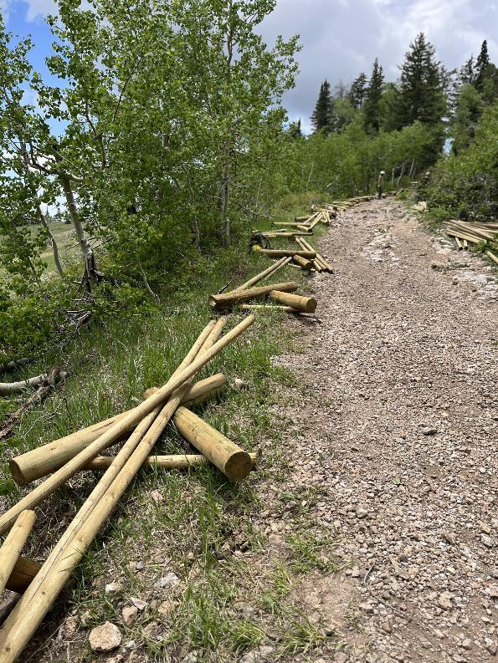

Bucks and rails along Kiwanis Meadow Road that will be used to

extend the fence up the road toward Kiwanis Cabin.