**Report of Movement of Old Kiwanis Meadow Buck and Rail Fence**

**to Service Road, Tuesday, June 10, 2025**

Sam Beard and Joelle Hertel

On Tuesday, June 10, FOSM volunteers and TTYL/YCC crew members removed pieces of the old collapsed buck and rail fence from the south side of Kiwanis Meadow to improve the appearance of the area. FOSM member Michael Arndt used a battery-powered chain saw until 10 am to cut old rails off bucks so that TTYL/YCC crew members could move the debris to the top of the gravel pit. The rails and bucks were then moved down the steep slope to the Service Road. They will be hauled to the East Mountain Transfer Station later.

In the afternoon the crew worked distributing bucks and rails down the hillside at the south end of the meadow.  Materials were staged approximately where fence sections would be constructed when FOSM volunteers joined the crew on Wednesday.

The TTLY/YCC crew members working today were Aidan Stewart, Crew Leader, Hans Martin, Lila Eaton, Evan Cooney-Martin, Rebecca Duggar, and Eli Iwanczyk.

Project photos are presented below.

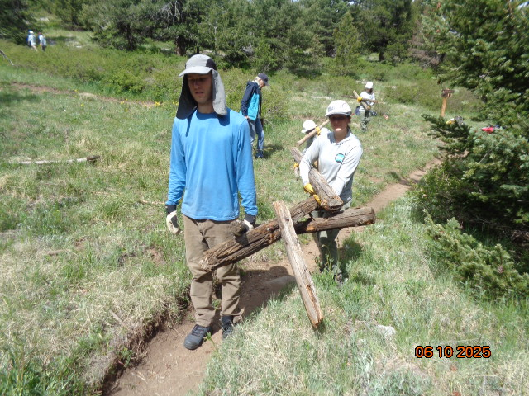

TTYL/YCC crew members Aidan Stewart and Lila Eaton carrying old buck and rail fence debris from Kiwanis Meadow

south side to the top of the gravel pit. All photos by Sam Beard

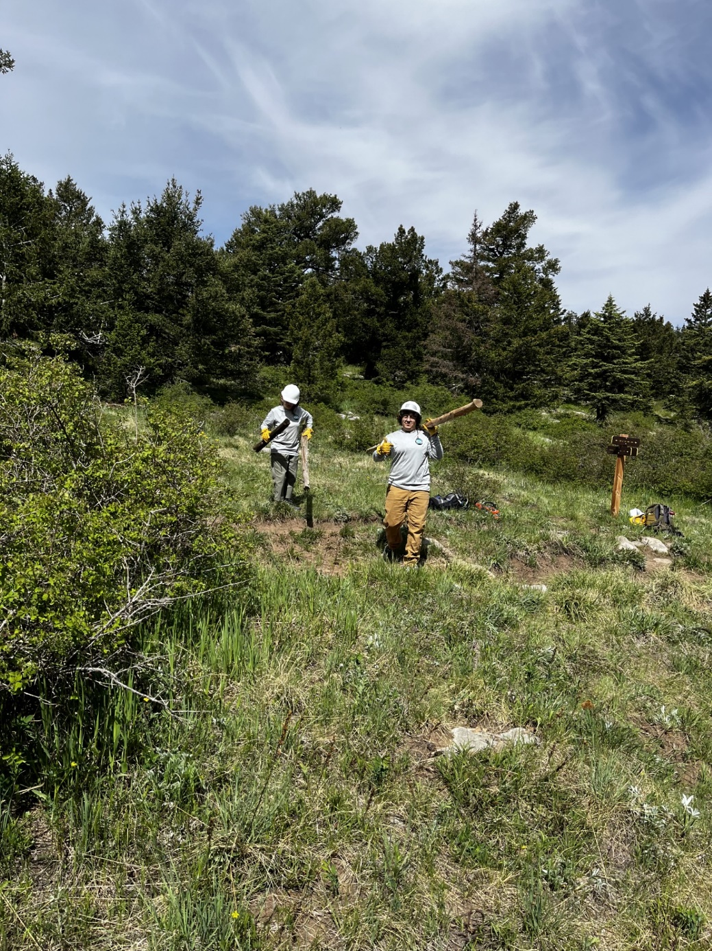

TTYL crew members carry old rails to the top of the gravel pit. Photo by Joelle Hertel.

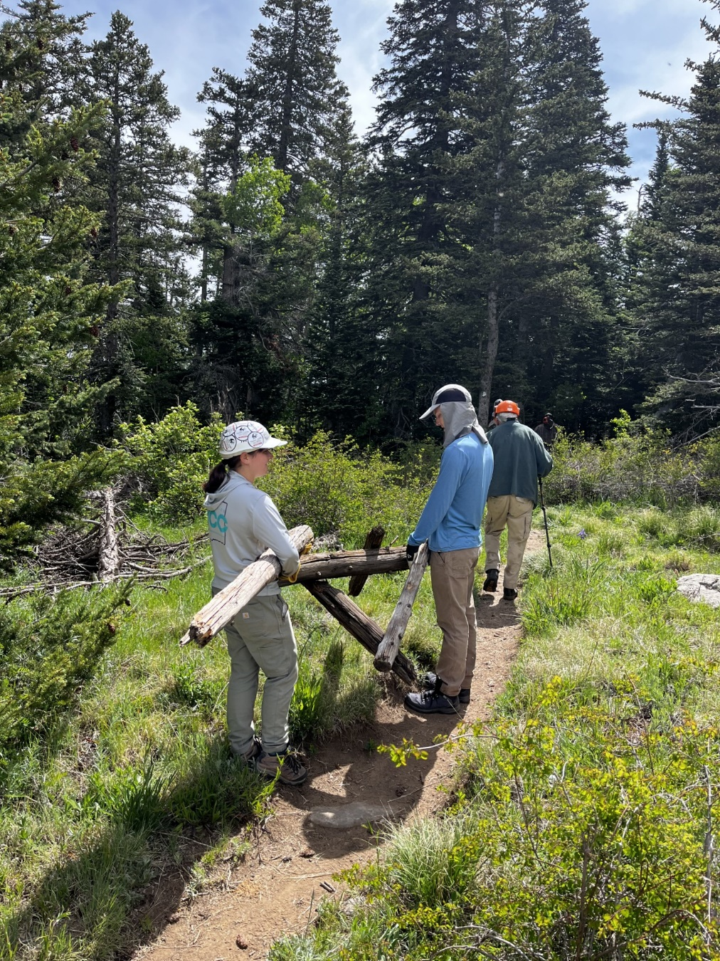

Lila Eaton and Aidan Stewart carrying on old buck along the Gravel Pit Trail.

Photo by Joelle Hertel

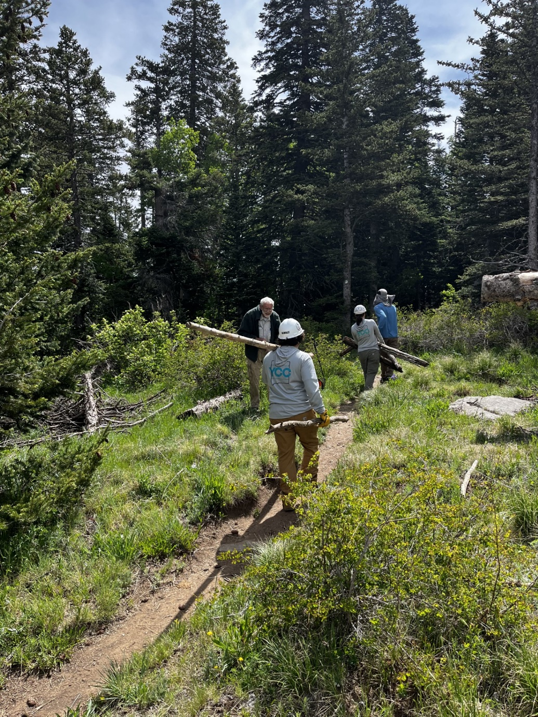

TTYL crew members carrying old rails on Gravel Pit Trail. Photo by Joelle Hertel

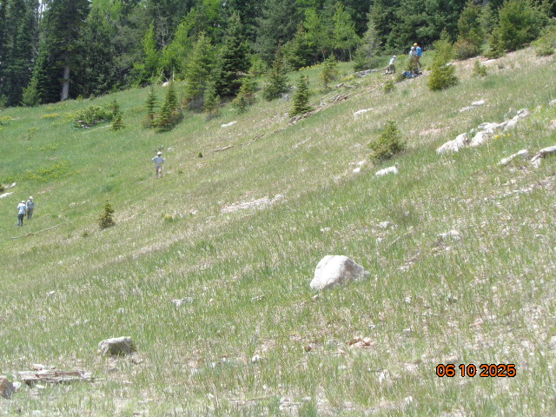

Crew members moving pieces of the old buck and rail fence from the top of the gravel

pit to the Service Road.

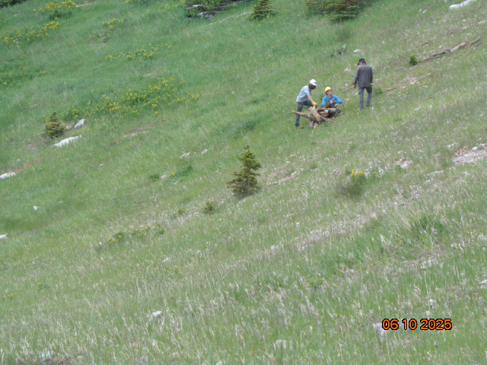

Michael Arndt wrapped a strap around some pieces of debris so that it could be rolled down the slope.