Trail Maintenance Report: Monday, June 9, 2025
Byron Garner

With the recent brake in the weather, the Monday crew headed out from Ellis on a beautiful clear and cool morning, starting our third attempt to clear the remaining four reported trees on Survey. We arrived at our first 16 inch fir at mile 1.2 which required clearing debris, limbing and a couple of crosscuts with everyone getting in on the action. Moving on, four more trees were cleared ranging in size from 3 inches to another 16 incher. An eight inch fir was found at the Survey/ 10k junction but was only limbed as at that time, storm clouds were moving in and we had a 2.3 mile hike back to Ellis and luckily arrived forty minutes before the rain. With a great crew effort, we all enjoyed a productive day on the mountain with work for everyone. The crew included Rene Archer, John Cooper, Susan Gregory, Ken Wilson, Chuck Logan, Rich Feddersen and Jamey Browning. Photo credits: Rene Archer, Jamey Browning and Byron garner

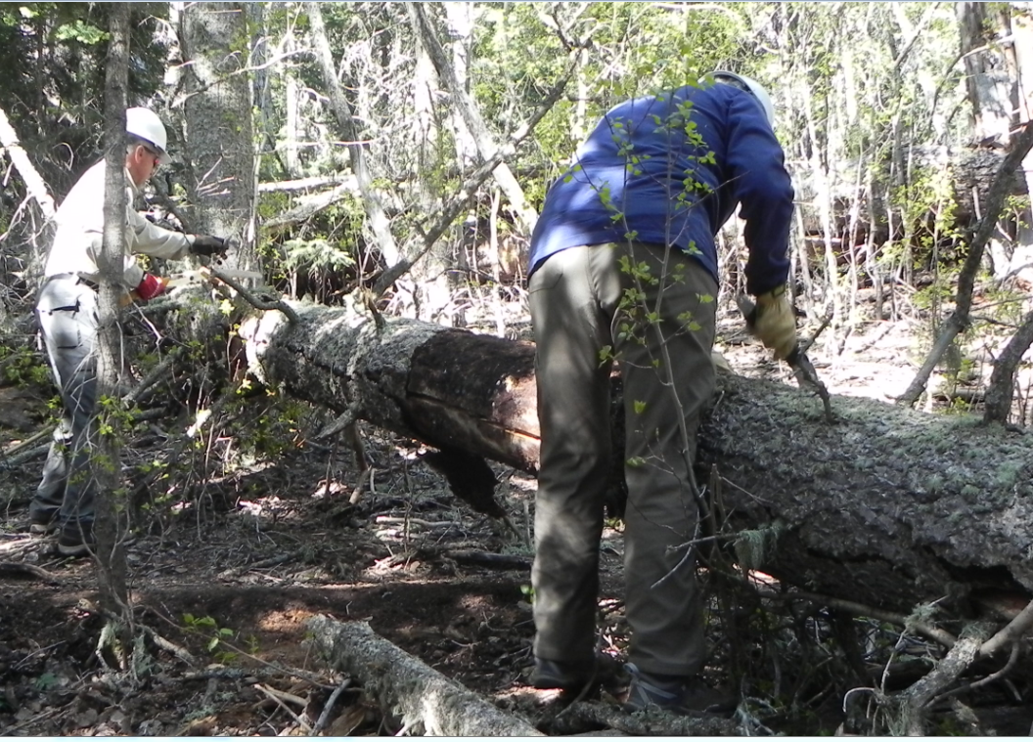

Ken and Susan start the limbing on the first 16 incher

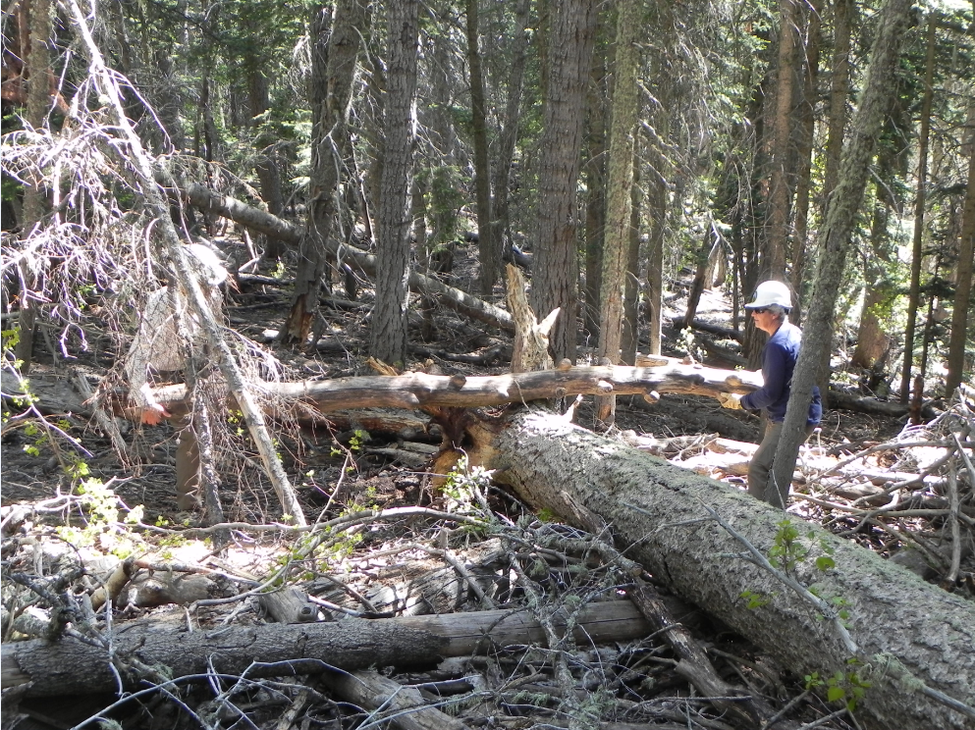

John and Susan clearing debris

Archer
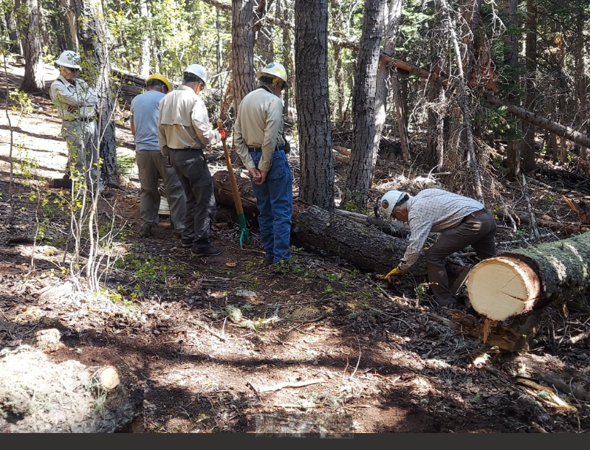 John's got this one fellas

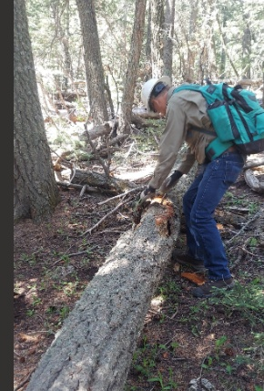Archer

Chuck "debarks" for the cut on this 10 incher

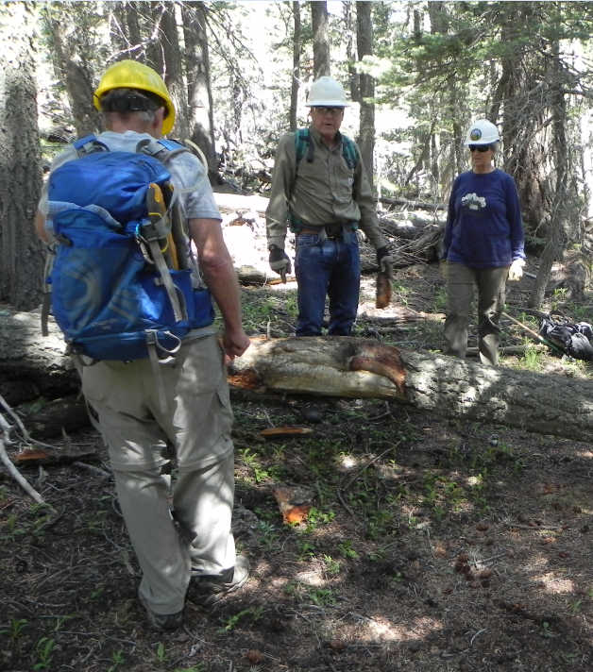
Rich, Chuck and Susan strategize on this second 10 incher

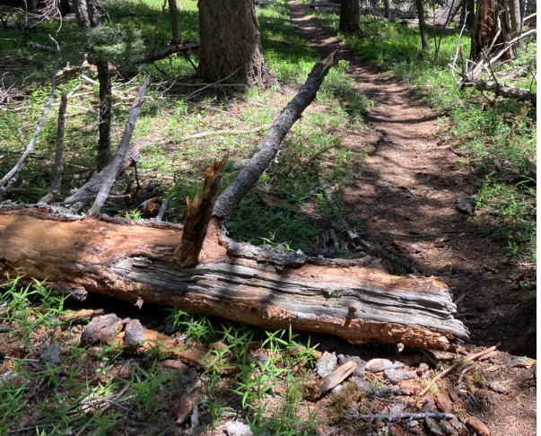Browning

The 13 inch intrusion cleared by Jamey and Susan

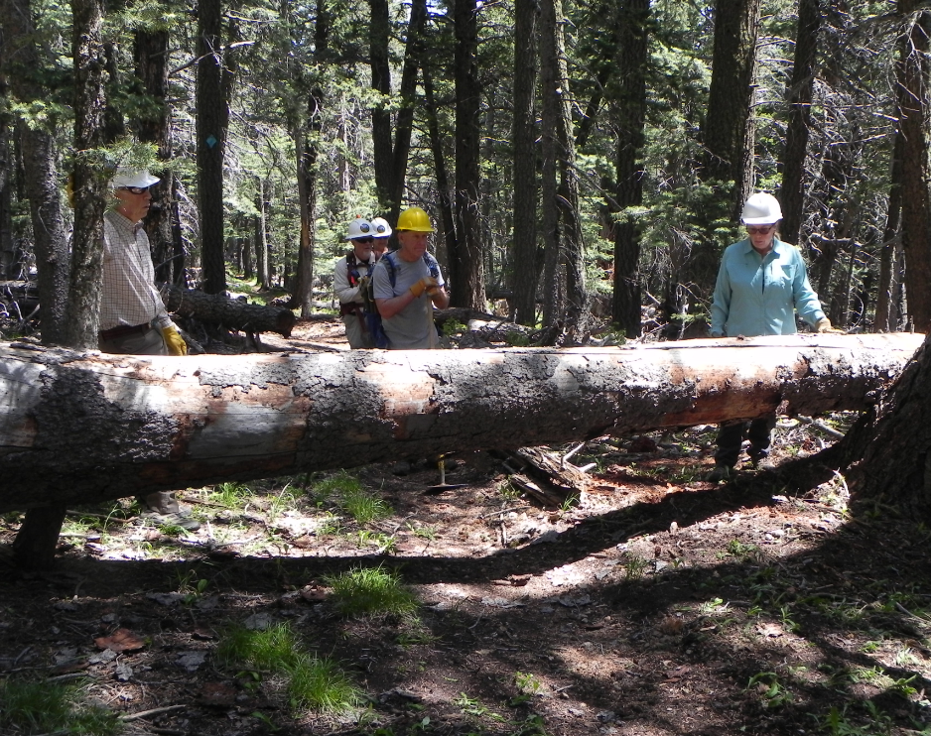

The second 16 incher
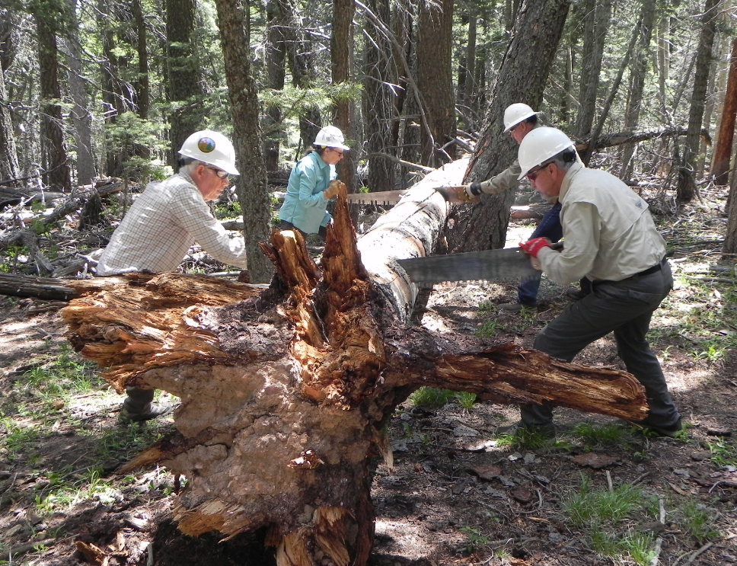
John, Ken, Rene and Chuck double teaming to beat the clouds
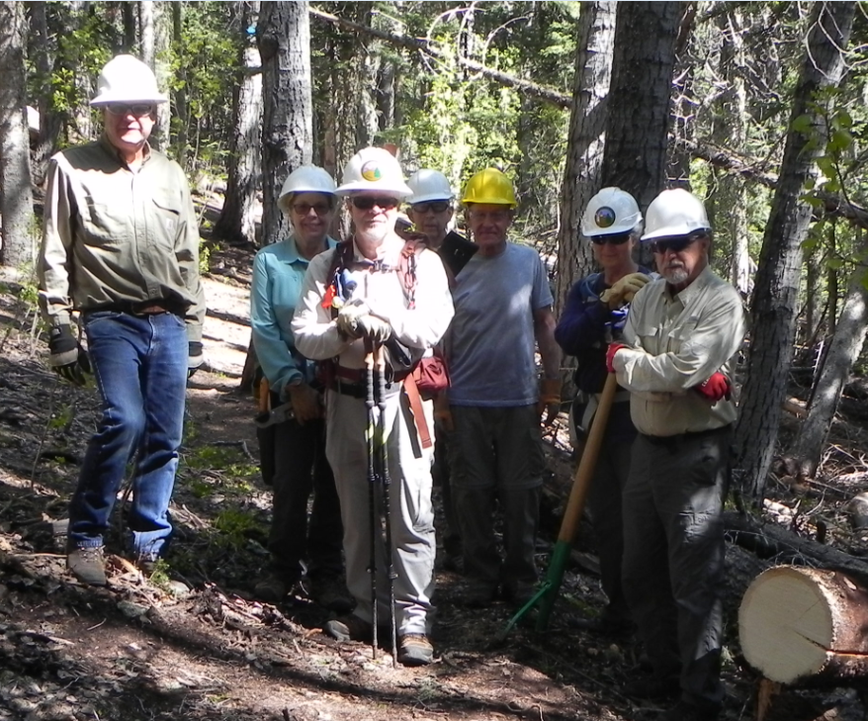
Chuck, Rene, Jamey, John, Rich, Susan and Ken

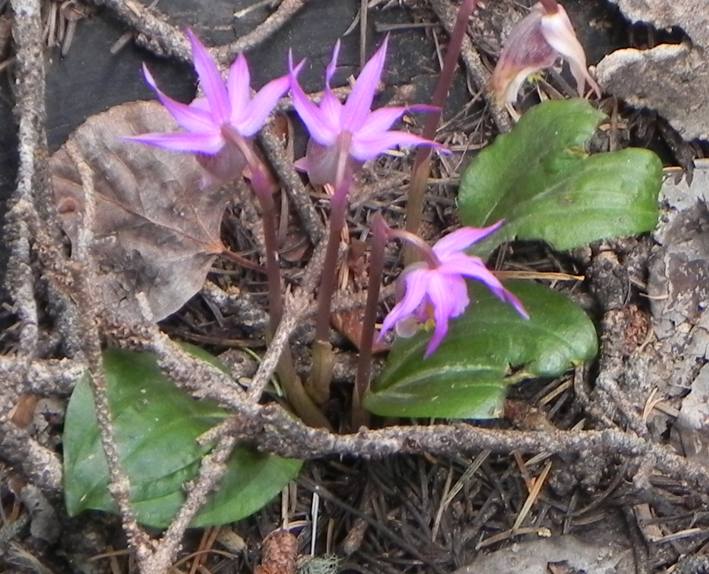
A good day for orchids

