**Report of Completion of Construction of the Kiwanis Meadow Buck**

**and Rail Fence, Wednesday, June 11, 2025**

Sam Beard and Joelle Hertel

On Wednesday, June 11, FOSM volunteers, the TTYL/YCC (Talking Talons Youth Leadership/Youth Conservation Corps) crew, and a USFS intern completed the installation of the buck and rail fence at two locations on Kiwanis Meadow. Sam Beard’s crew worked on the north end of the meadow along the road to Kiwanis Cabin, Dan Benton’s crew worked on the high side of the south end of the meadow, and Aidan Stewart’s crew worked on the low side of the fence on the south end of the meadow. Each crew constructed approximately a dozen 11-foot-long sections of the fence. Fence materials had been purchased by FOSM from a company in Longmont, Colorado.

Project photos are presented below. They include the names of the workers who participated in the project on Wednesday.

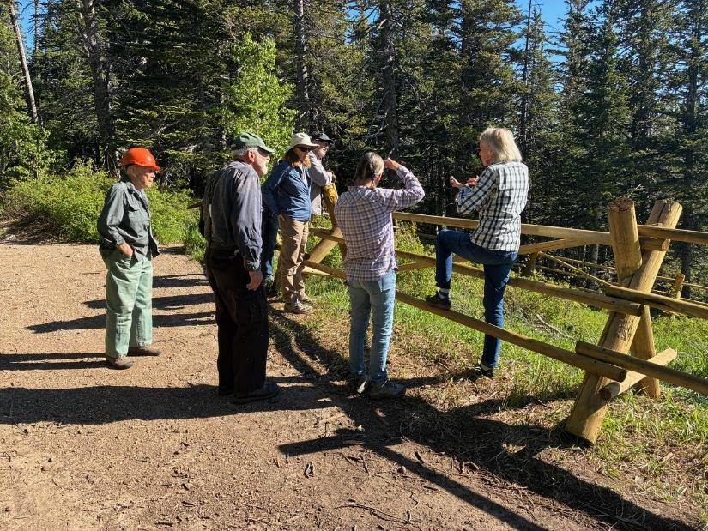

Joelle Hertel explaining the building of the fence to FOSM members. L to R: Don Carnicom, Sam Beard, Betsy Galloway,

Dan Benton, Laura Leon, and Joelle Hertel. All photos by Cliff Giles unless noted otherwise

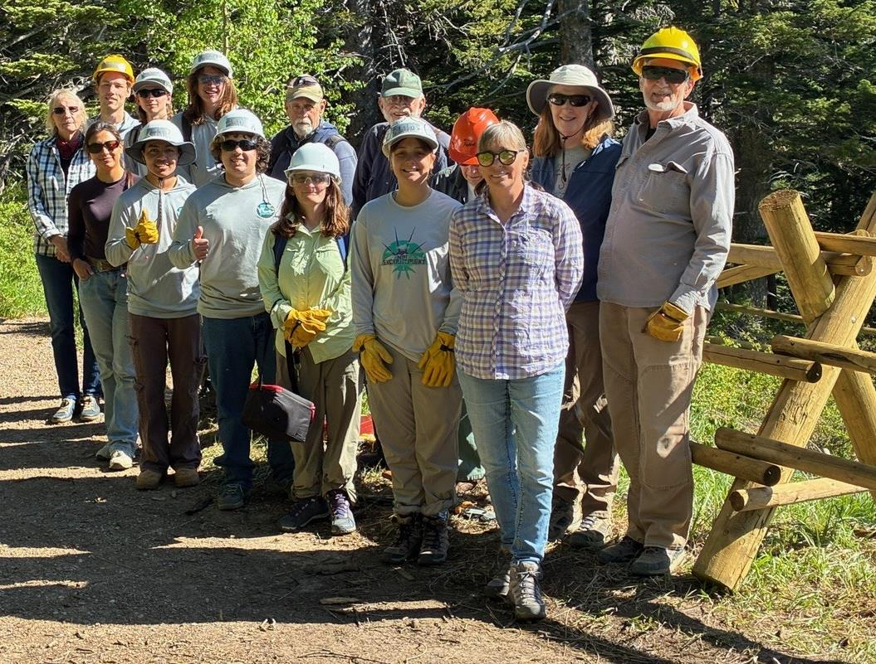

The TTYL/YCC crew and FOSM members who completed the fence on Wednesday. Front Row – Joelle Hertel, Kaitlan Velarde (USFS

Intern), Jamie Medina-Soto, Eli Iwanczyk, Rebecca Duggar, Lila Eaton and Laura Leon. Back Row – Aidan Stewart (crew leader), Hans Martin,

Evan Cooney-Martin, Jerry Carroll, Sam Beard, Don Carnicom, Betsy Galloway, Dan Benton.

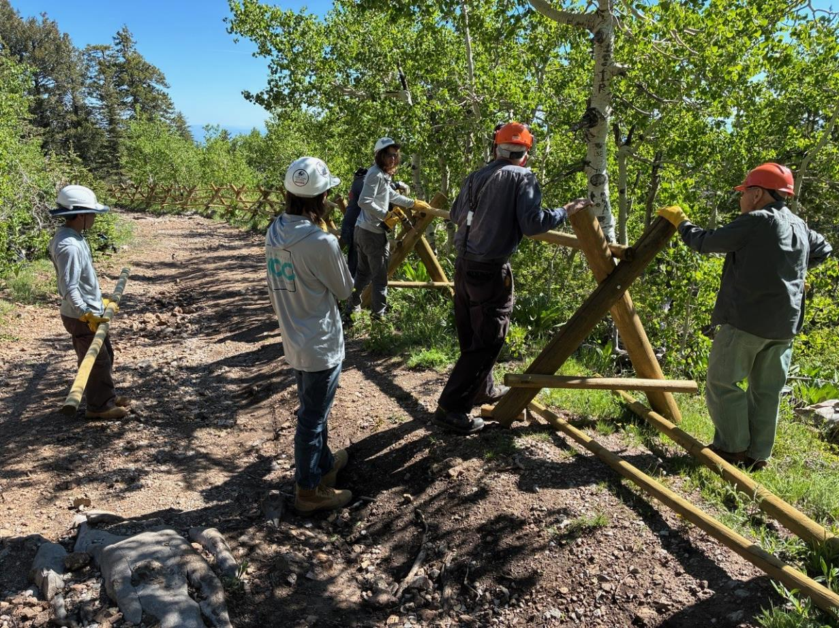

Sam’s crew extending the fence along the Kiwanis Meadow Road toward Kiwanis Cabin.

L to R: Jamie Medina-Soto, Hans Martin, Evin Cooney-Martin, Sam Beard, and Don Carnicom

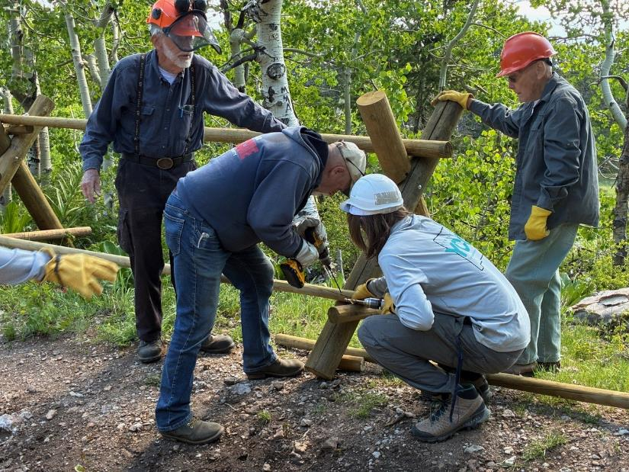

Jerry Carroll driving an 8-inch timber screw into a lower rail. L to R: Sam Beard, Jerry Carroll, Evan Cooney-Martin, and Don Carnicom.

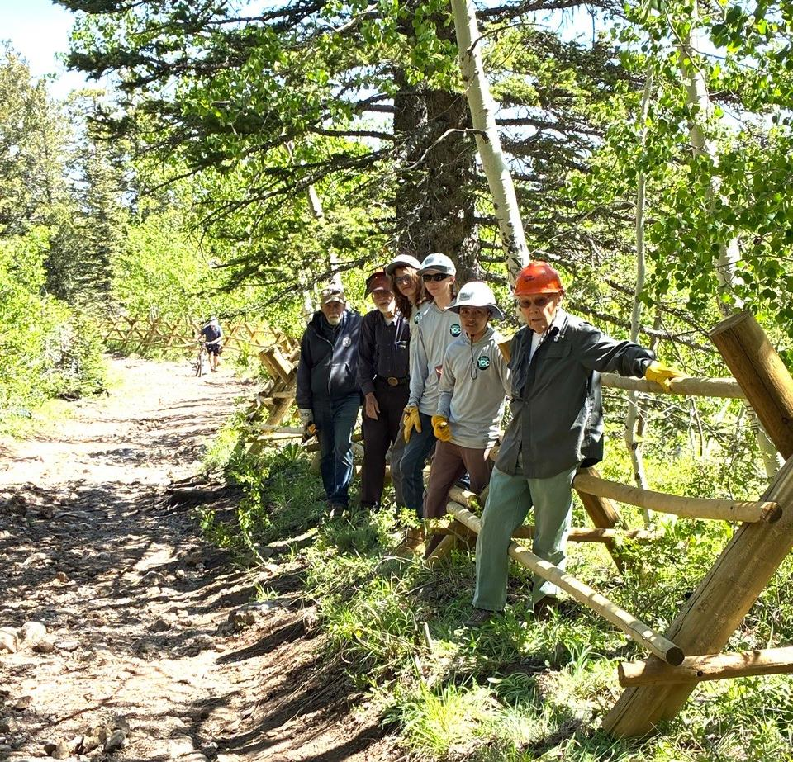

Sam’s crew on the road to the cabin. L to R: Jerry Carroll, Sam Beard, Evan Cooney-Martin,

Hans Martin, Jamie Medina-Soto, and Don Carnicom.

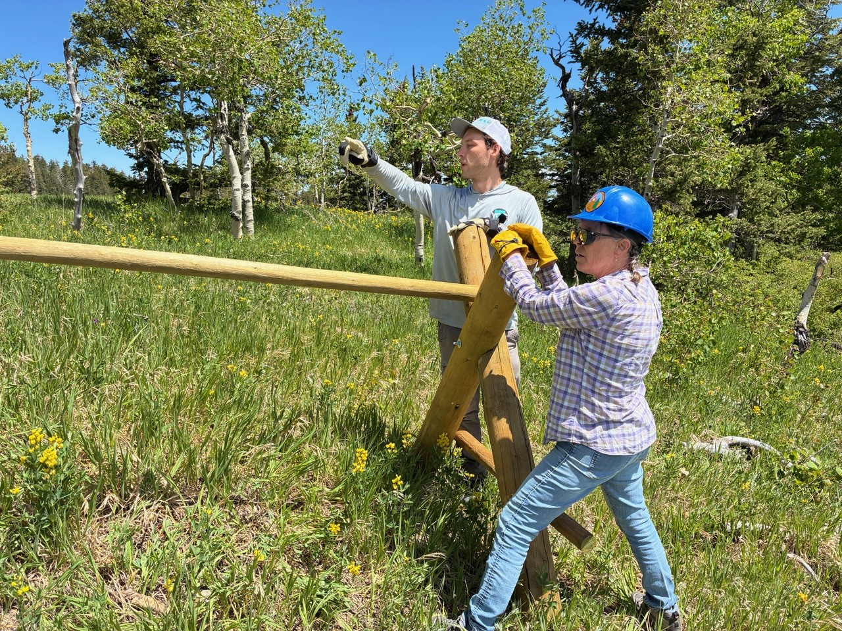

Aidan Stewart and Laura Leon hold a buck for a new section of the fence.

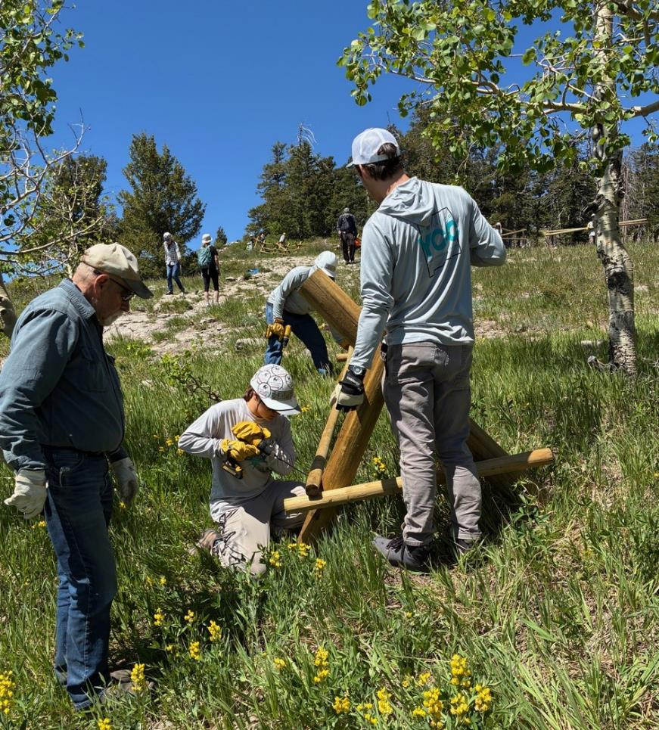

Jerry Carroll observing Lila Eaton driving a screw on a rail at the lower end of the south part of the fence.

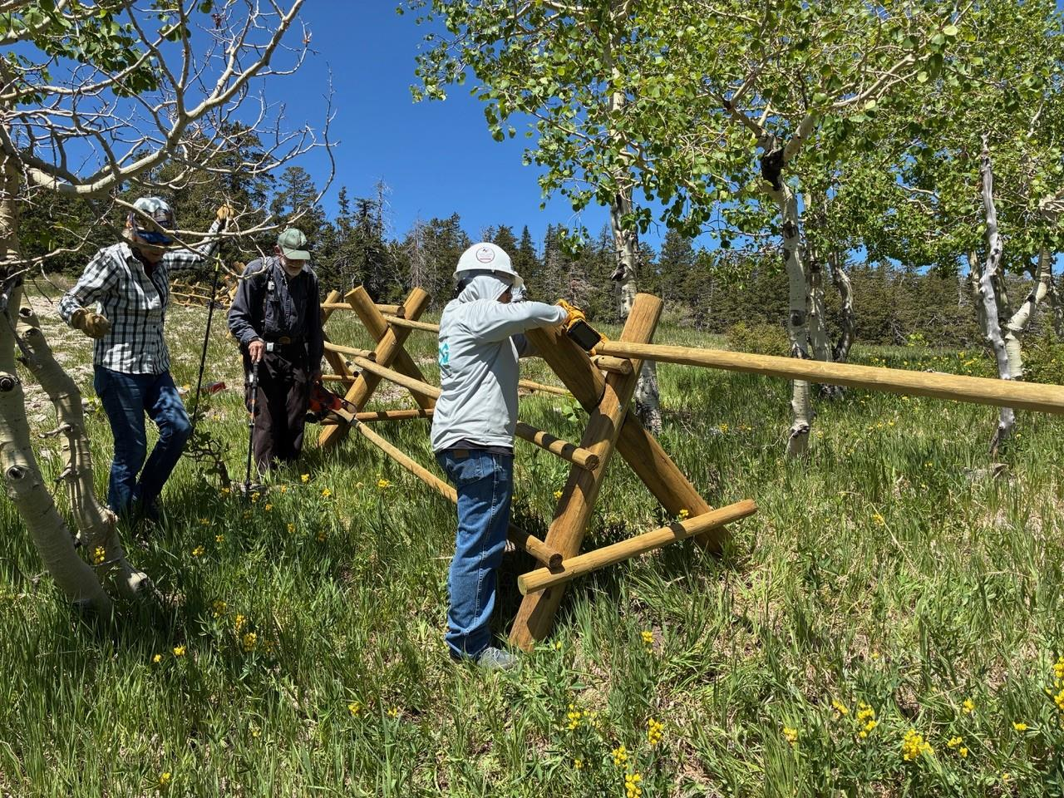

L to R: Joelle Hertel and Sam Beard observing Eli Iwanczyk driving a screw in the top rail.

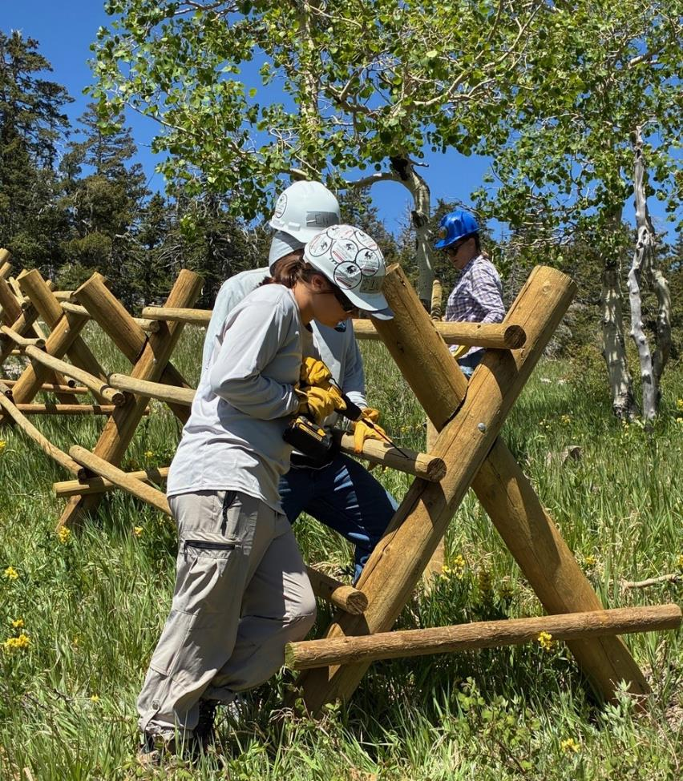

Eli Iwanczyk holds rail while Lila Eaton driving a screw on Aidan Stewart’s section of the fence.

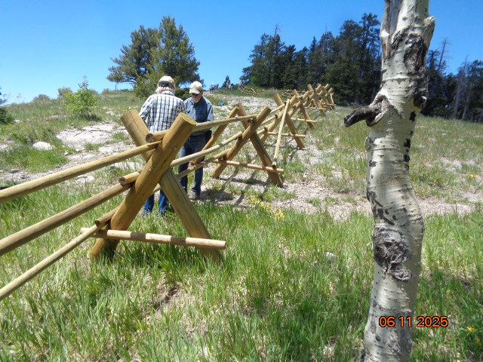

Joelle and Jerry working on a sign to go on the fence. Photo by Sam Beard

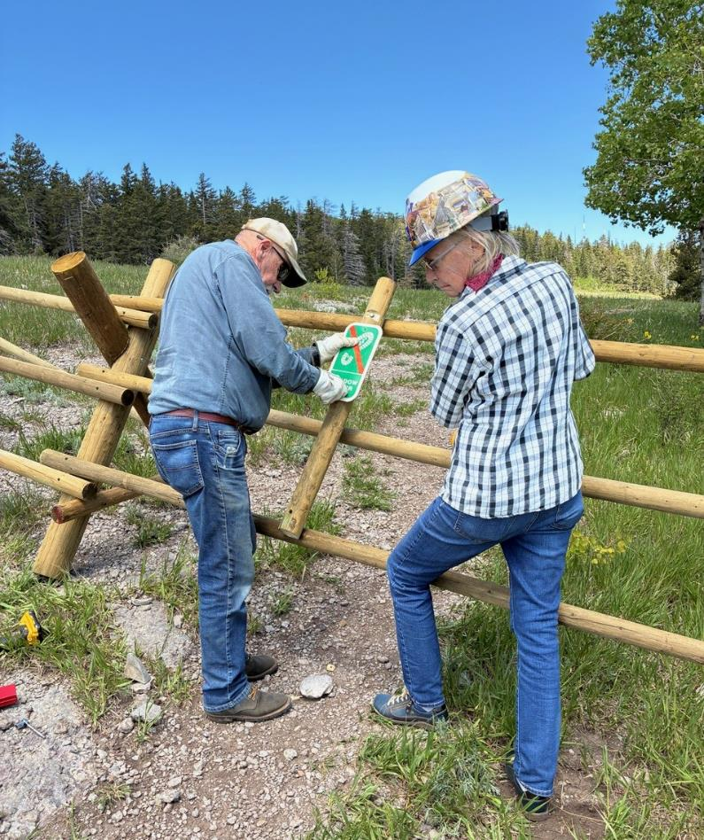

Jerry attaching Keep-Out sign.

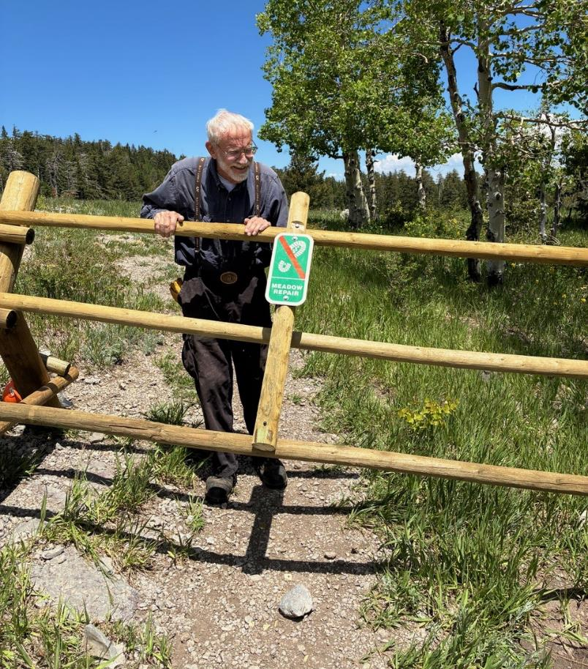

Sam violating the Keep-Out sign.

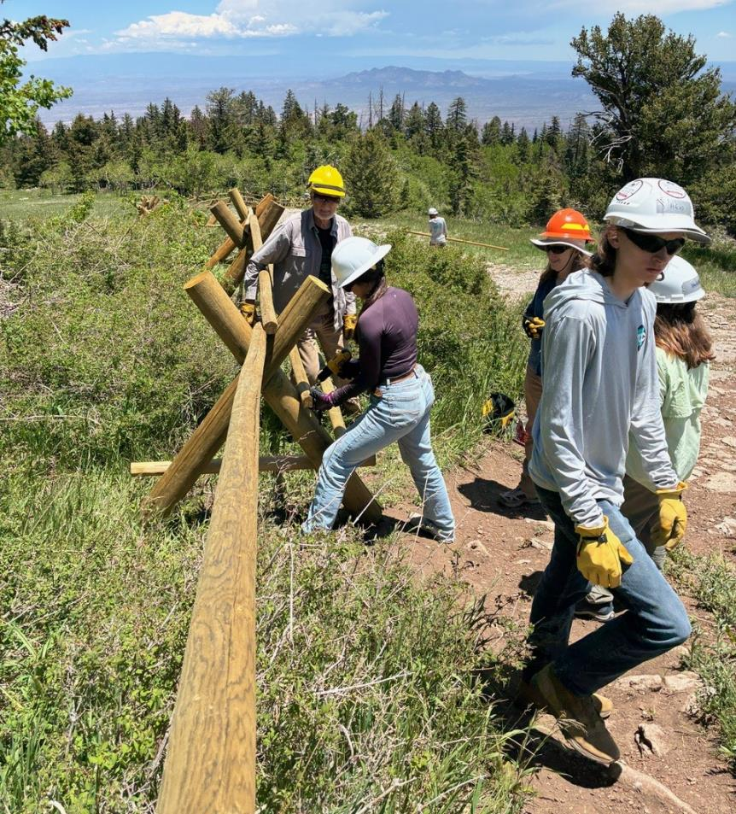

Dan and Betsy observe Kaitlan Velarde driving a screw in a middle rail on the upper end of the south part of the fence.

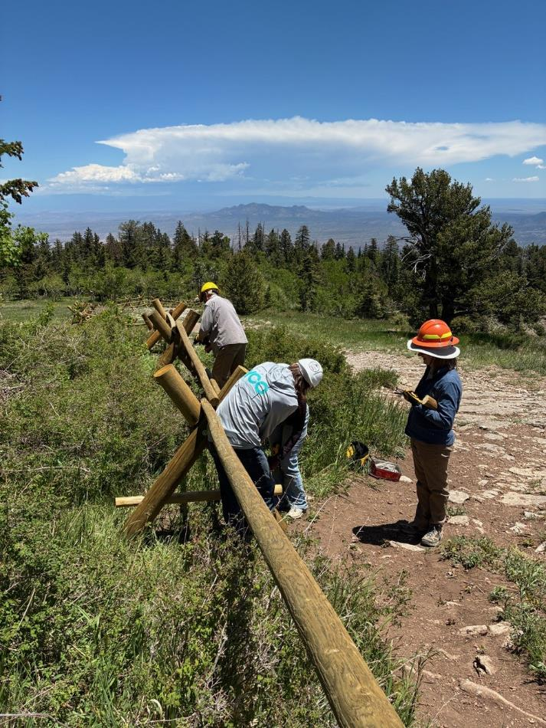

Betsy watching as two TTYL/YCC crew members install a rail with Dan in the background.

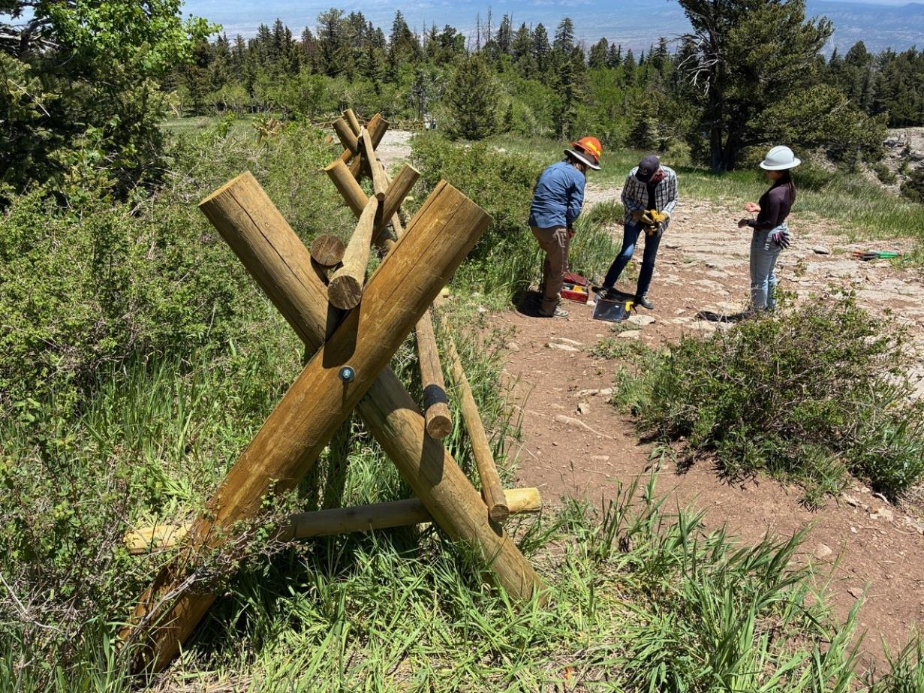

Crew putting away tools at the upper end of Dan’s section of the south fence.

L to R: Betsy Galloway, Joelle Hertel, and Kaitlin Velarde, a USFS intern.