**Report of FOSM Work with TTYL/YCC Crew to Complete Several Small Tasks Related to the Buck and Rail Fence at Two Sites on Kiwanis Meadow on Monday, June 16, 2025**

Sam Beard and Joelle Hertel

On Monday, June 16, Sam Beard and Joelle Hertel worked with the TTY/YCC crew to complete the following tasks related to the construction of the buck and rail fence at two sites on Kiwanis Meadow:

1. Cutting aspens stumps to ground level where they had been trimmed for slash where the road enters the meadow.
2. Construction of one final fence section in order to use the last buck we had made.
3. Obliterating a few more user trail segments in the meadow behind the new fence on the south side of the meadow.
4. Removing excess rails that will be used for future repairs. Manny Chavez, SRD Maintenance Supervisor, hauled 42 rails from Kiwanis Meadow to the FOSM Guard Station.
5. Manny also hauled a pile of old fence material from the south side of the meadow to the transfer station. This material had been moved from the meadow to the gravel pit last week.

Ninety-four fence sections, 11 feet each, were completed making 1034 feet of barrier around the meadow.

The layout of the fence was done by Canyon Young, SRD Trails and Wilderness Program Manager. The fence includes 330 feet on the south side of the meadow near the cliff, and 704 feet on the north end of the meadow.

The TTLY/YCC crew members were Aidan Stewart, Crew Leader, Hans Martin, Lila Eaton, Evan Cooney-Martin, Jamie Medina-Soto, Rebecca Duggar, and Eli Iwanczy.

Project photos are presented below.

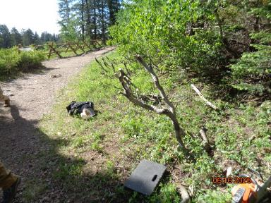

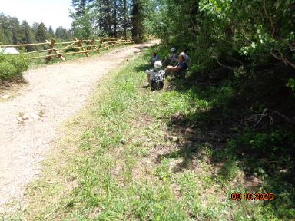

Top – Small aspen trunks at entrance to Kiwanis Meadow where they were cut to provide slash to cover old user trails.

Bottom – Small trunks were cut to ground level to clear shoulder of road where TTYL/YCC crew members are resting.

All photos by Sam Beard unless noted otherwise.

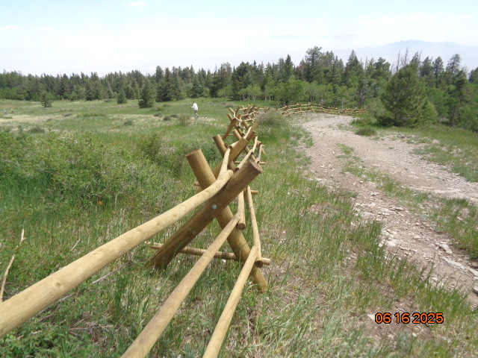

Buck and rail fence across south side of Kiwanis Meadow to discourage hiking in the meadow and creating user trails.

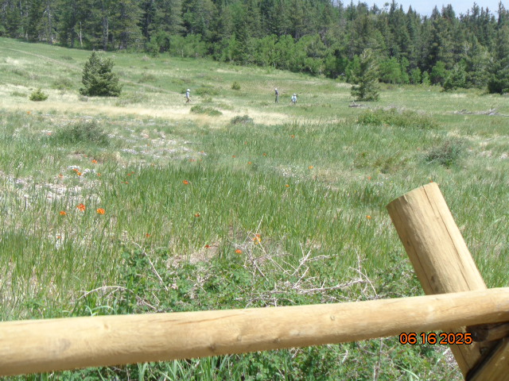

TTYL/YCC crew covering user trail with slash and old tree trunks near the south side of Kiwanis Meadow.

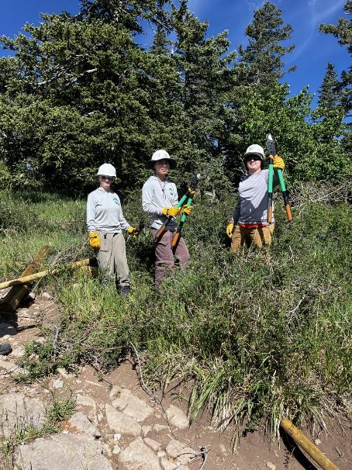

TTYL/YCC crew cutting brush where last fence section will be assembled.

Photo by Joelle Hertel

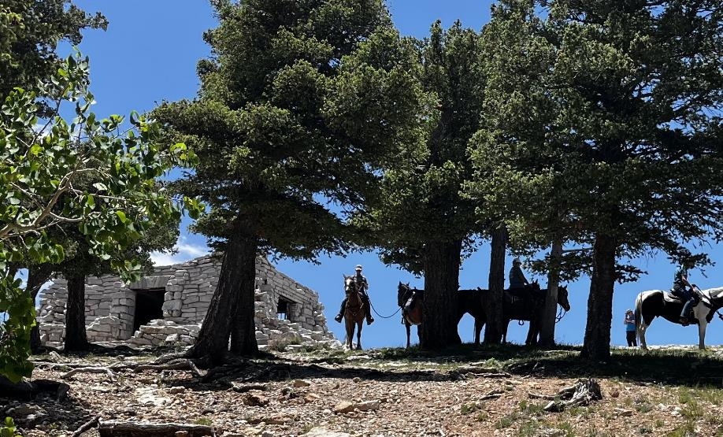

Horse back riders at Kiwanis Cabin after coming down the road from the meadow.

Photo by Joelle Hertel

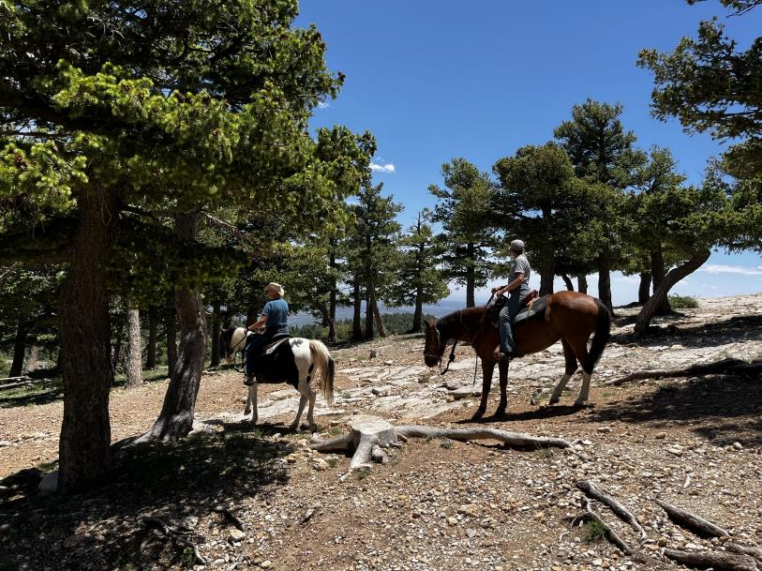

Riders leaving the Kiwanis Cabin area. Photo by Joelle Hertel

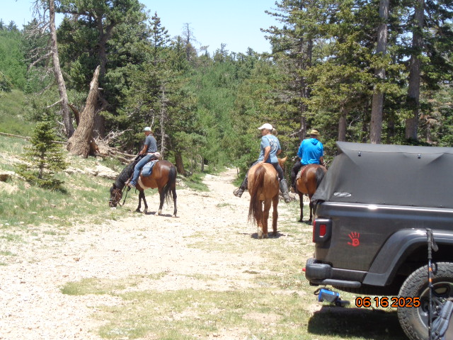

Riders leaving the parking lot at Kiwanis Cabin.

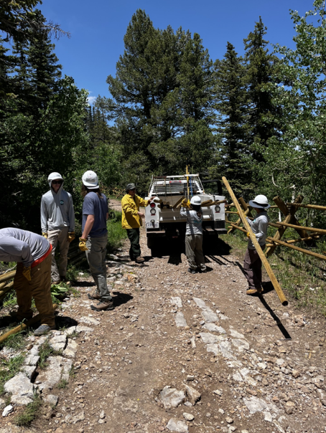

TTYL/YCC crew loading excess rails in Manny Chavez’s truck. He hauled them to the

FOSM Guard Station where they will be stored until needed to replace broken rails. Photo by Joelle Hertel

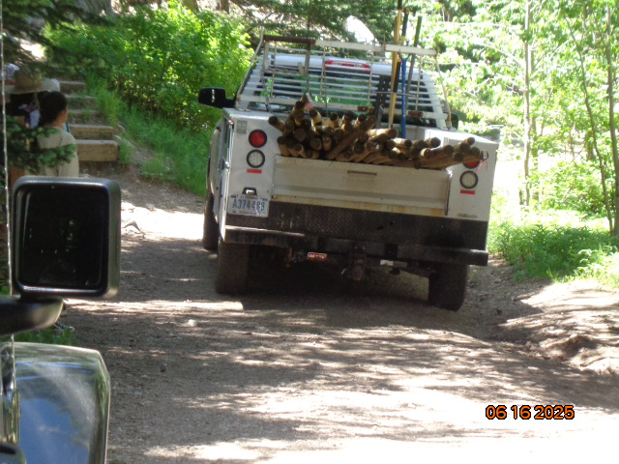

Manny’s pickup crossing the South Crest Trail on its way to the Crest area and the Gravel Pit where old fence debris

was loaded and taken to the transfer station. The rails were moved to a trailer before the debris was loaded on the pickup.