**Report of FOSM Crew Felling Hazard Tree in Pine Flat Picnic Area,**

**Wednesday, June 25, 2025**

Sam Beard

On Wednesday, June 25, a crew of five FOSM members felled a hazard tree in Pine Flat Picnic Area that had been selected recently by Canyon Young, SRD Trails and Wilderness Program Manager.

The tree was located at the north end of the picnic area between the group area and a powerline. Fortunately, the tree was leaning away from the powerline, and Dan Benton felled it directly away from the lines between two smaller pine trees. The felled tree was limbed and bucked into 8-foot lengths so that it would not be stolen until a FOSM crew can process it. Later the logs will be bucked it into 12-inch lengths, split with Lou Romero’s power splitter, and hauled to the Mountain Christian Church woodlot as donation wood for East Mountain families next winter.

The FOSM members working today were Dan Benton, Sim Cook, Cliff Giles, Steve Roholt, and Sam Beard.

Project photos by Cliff Giles are presented below.

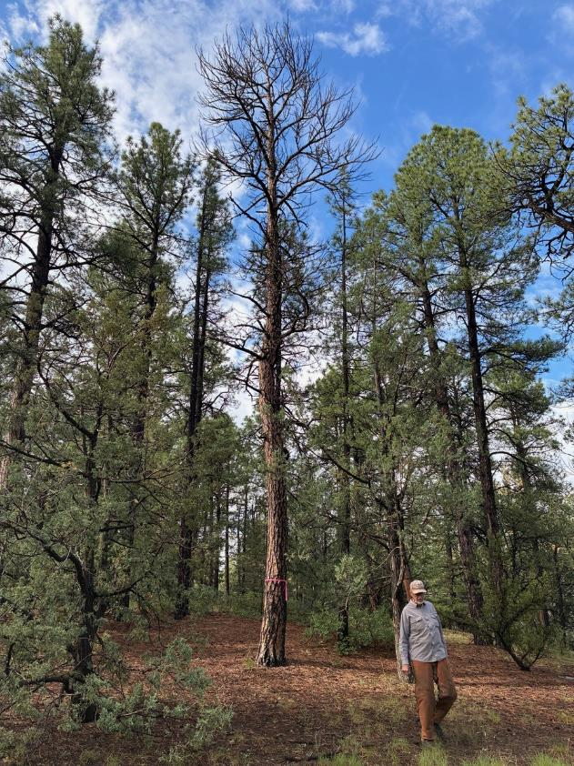

Dan Benton walking away from the dead ponderosa pine tree so that he can get a better

view of the trunk to determine the lean. Note that there a curve in the center of the trunk.

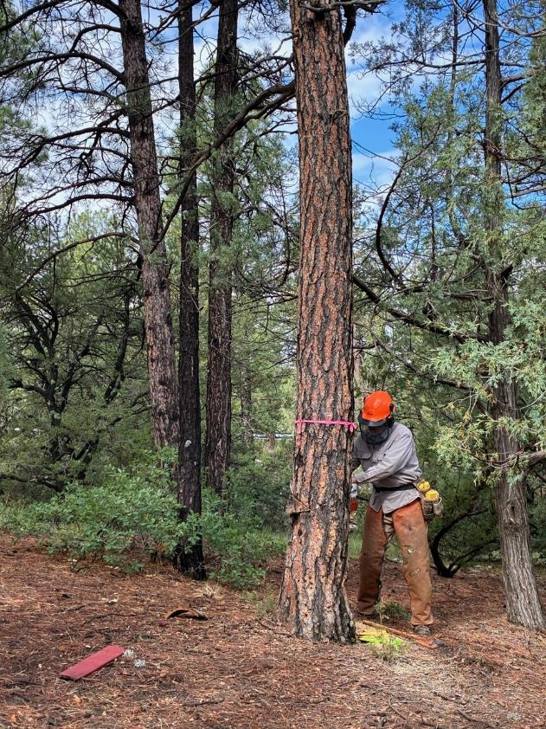

Dan making the face cut on the left side of the tree

which is the direction in which he will fell the tree.

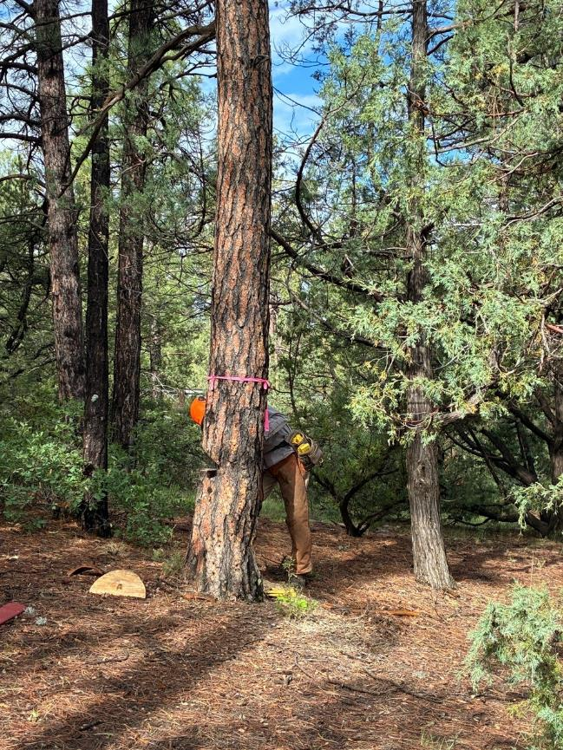

Dan completing the face cut

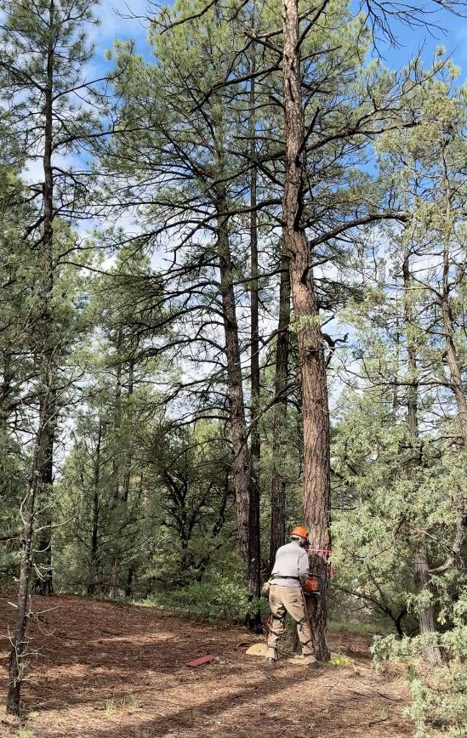

Dan making the back cut just before it fell to the left.

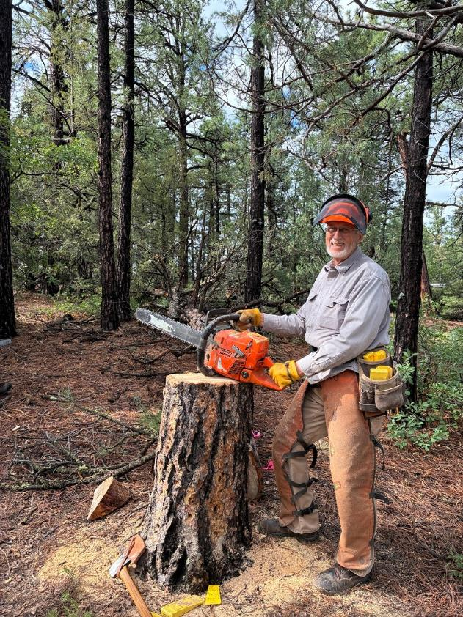

Dan at the stump with the Husqvarna Model 372 XP chain saw that he used to fell the tree.

The bar length of 24 inches was more than enough to fell the 17-inch tree.

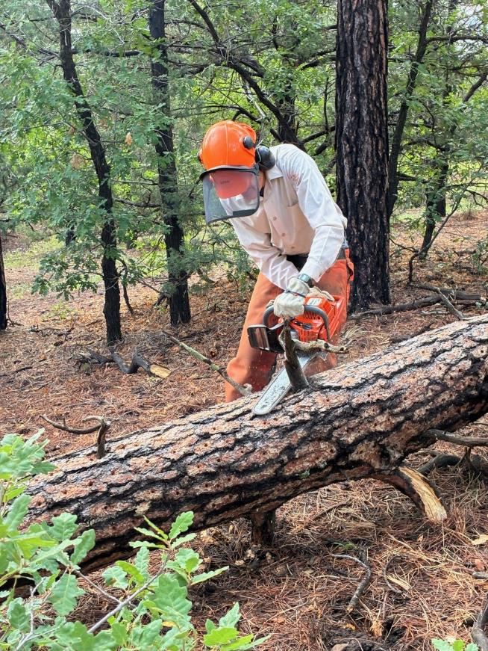

Sim Cook limbing the log.

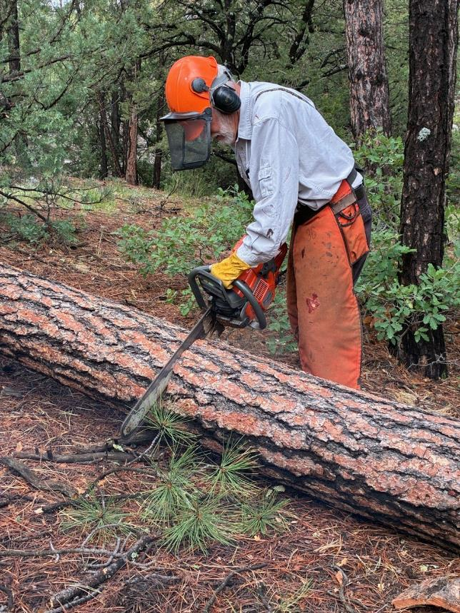

Sam Beard bucking the trunk.

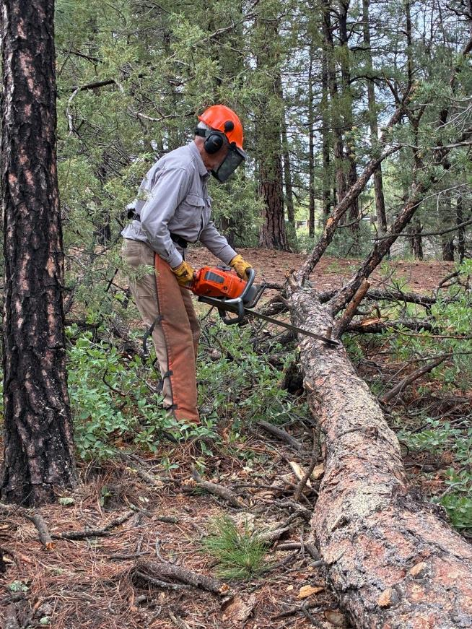

Dan limbing the log.

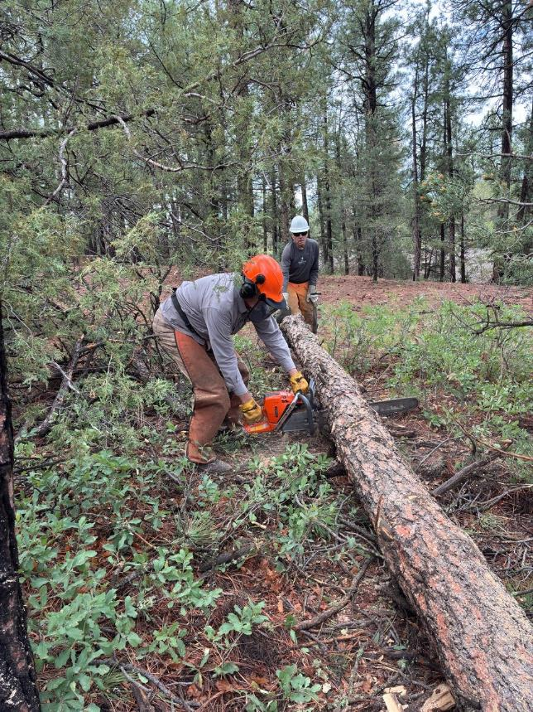

Dan bucking the log with Steve Roholt observing.

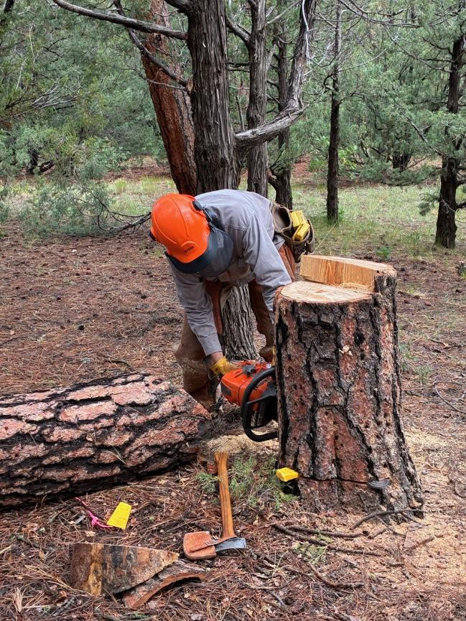

Dan cutting the stump lower to improve the appearance of the forest around the picnic area.