Thursday, 06/26/25- Wagon extension: Thursday had 10 volunteers and Jen and Chris (SRD) back working on the Wagon extension. One group went back to the farthest point and worked their way back doing some finishing work. Chris and Laura worked on flagging and Claudia and John started work around the point mid-way through the extension. The soil was moist which was very exciting and the temps stayed reasonable. Also, no flies or mosquitos! We finished up the day working a bit past the mid-way point where the trail will be on a slope, near the lower car parking area.

Volunteers: Jim Houle, Rich Fagioli, Claudia Bergsohn, Mike Madden,
Courtnee Bennett, Cleve Sharp, John McNett, Byron Garner, Laura Leon
and Luis Cuadros

Photos: Laura Leon

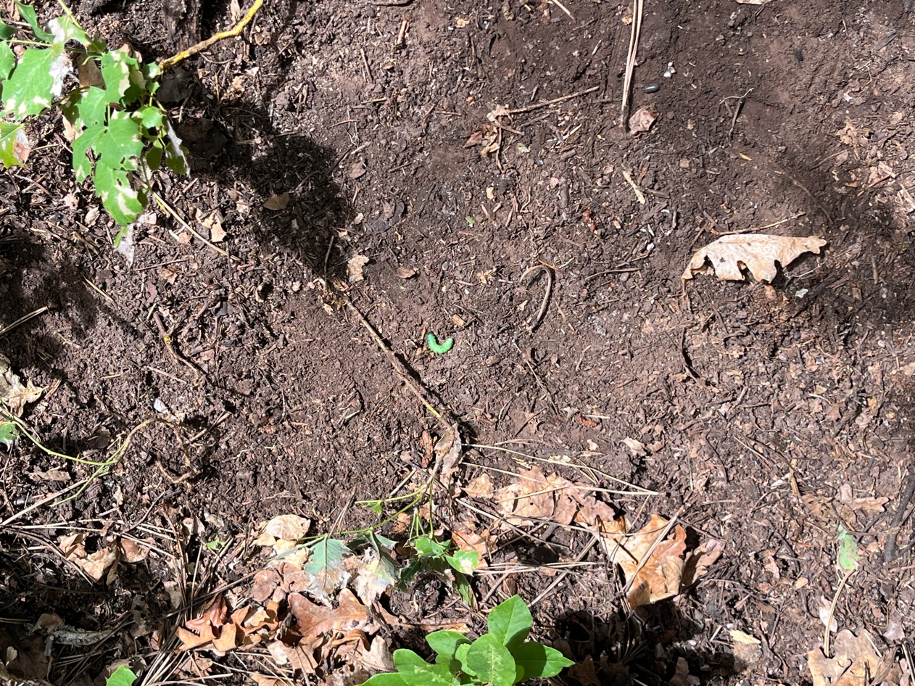

A neon green grub/larva laying in the pathway.

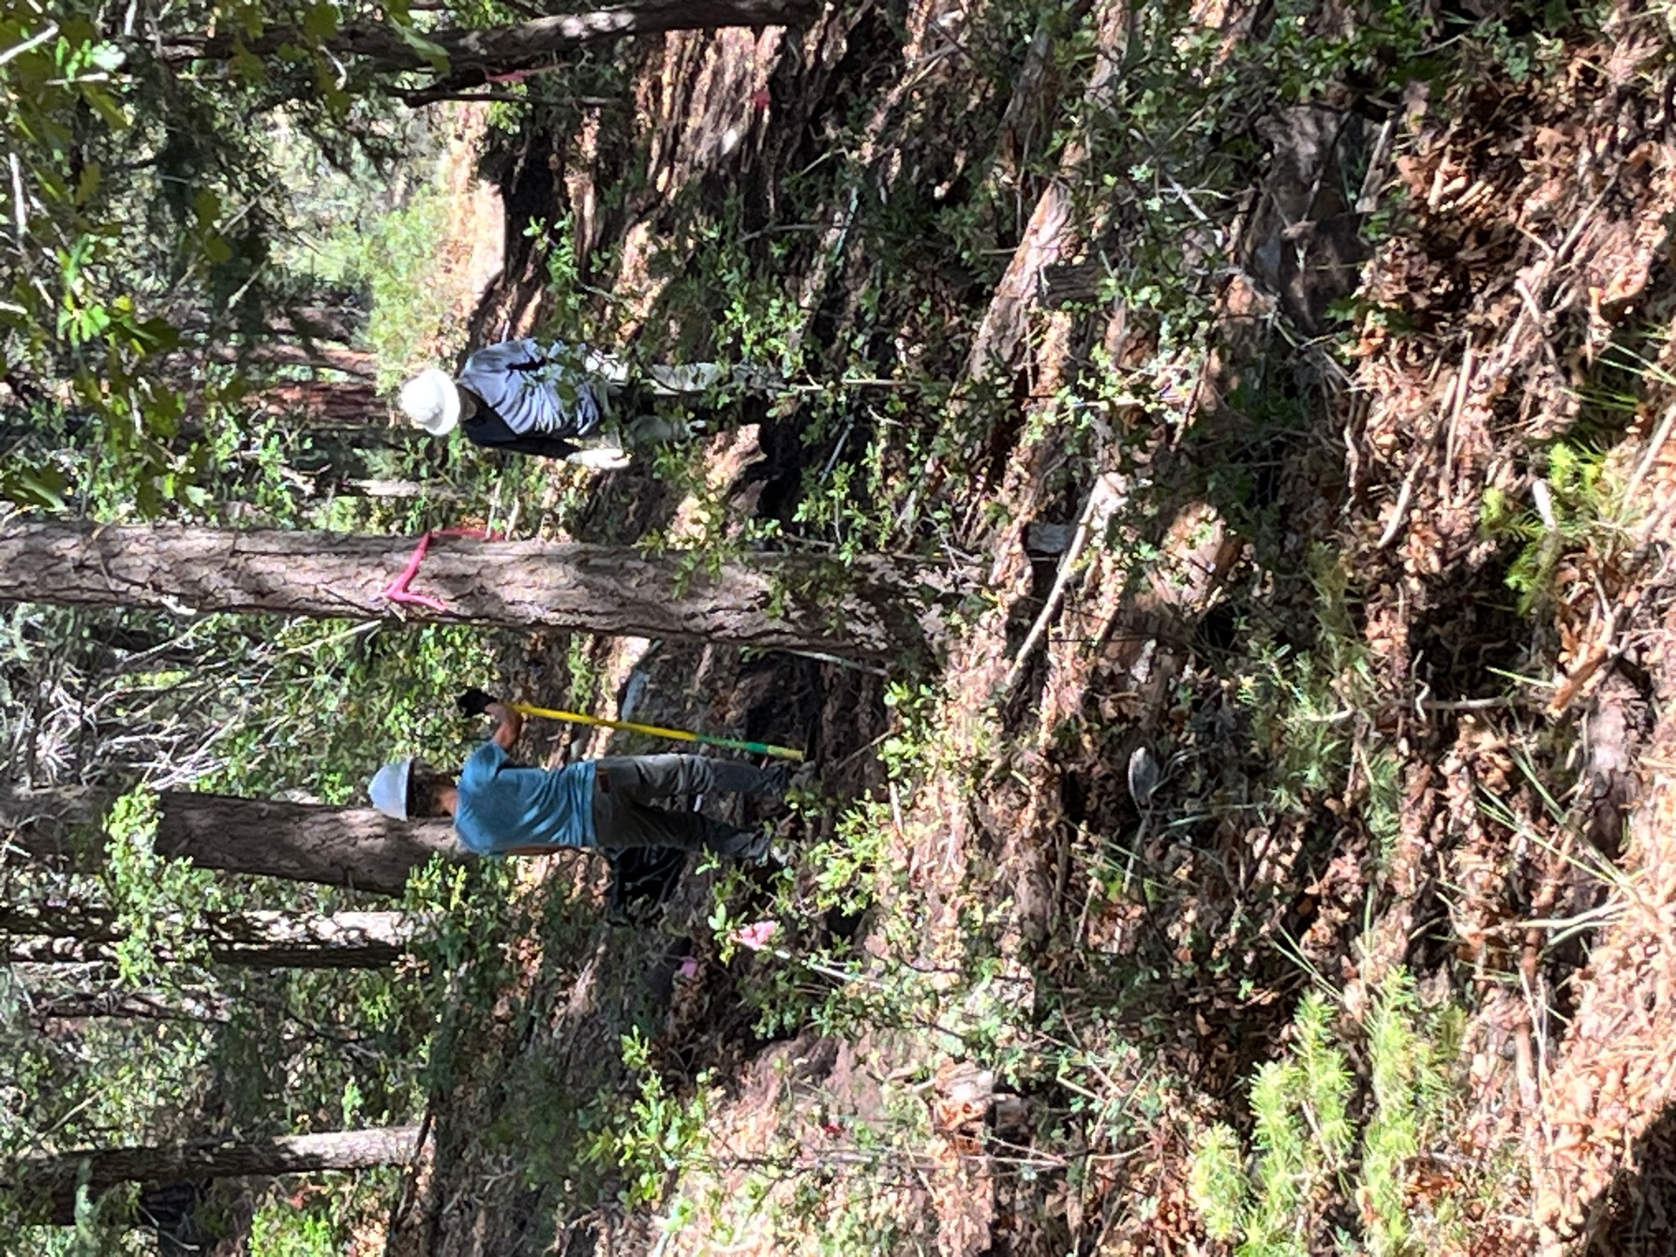

Claudia and John contemplate stumps.

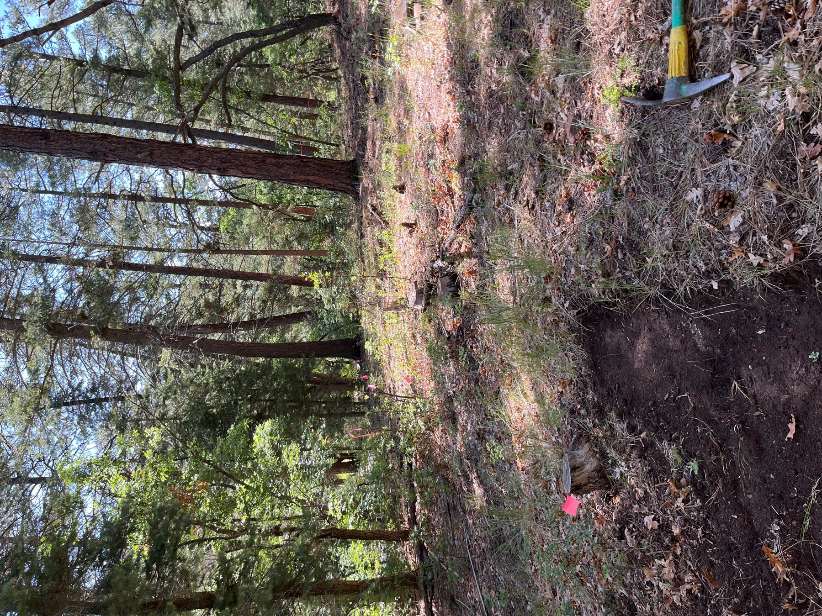

Before…

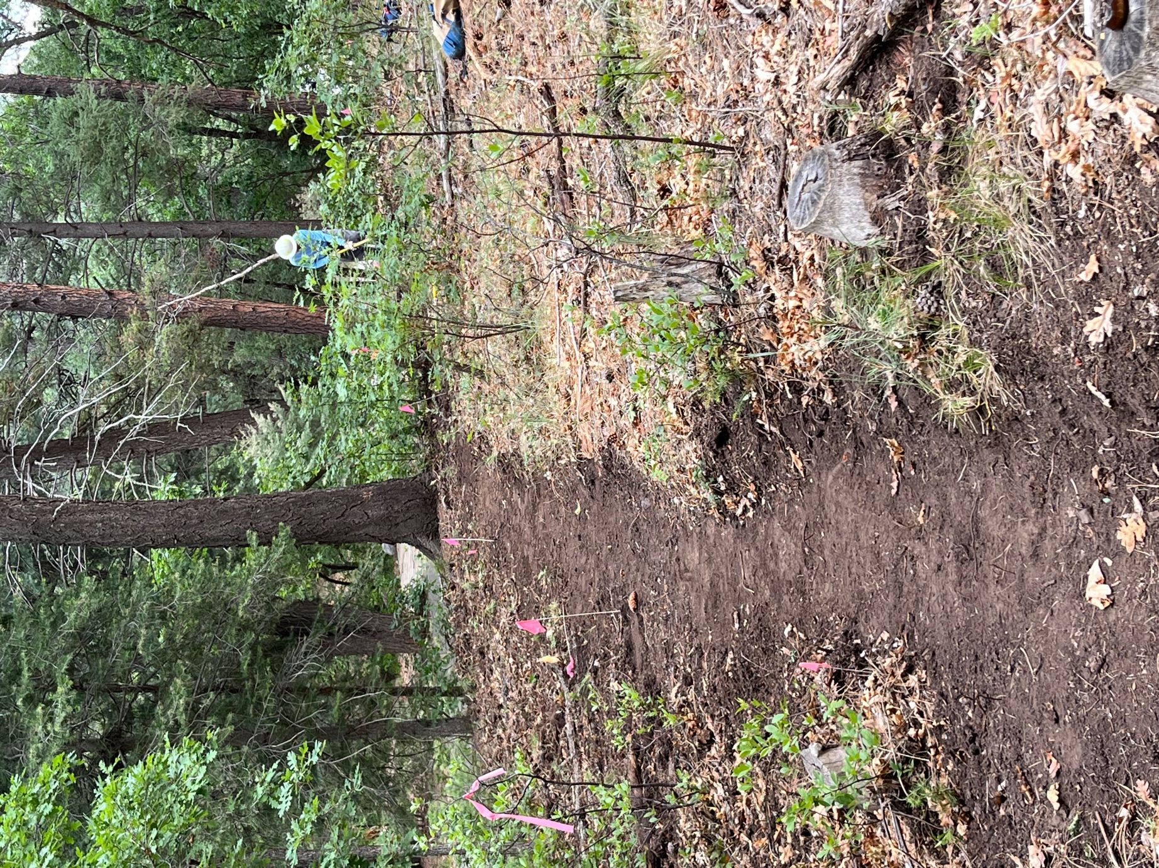

and after.
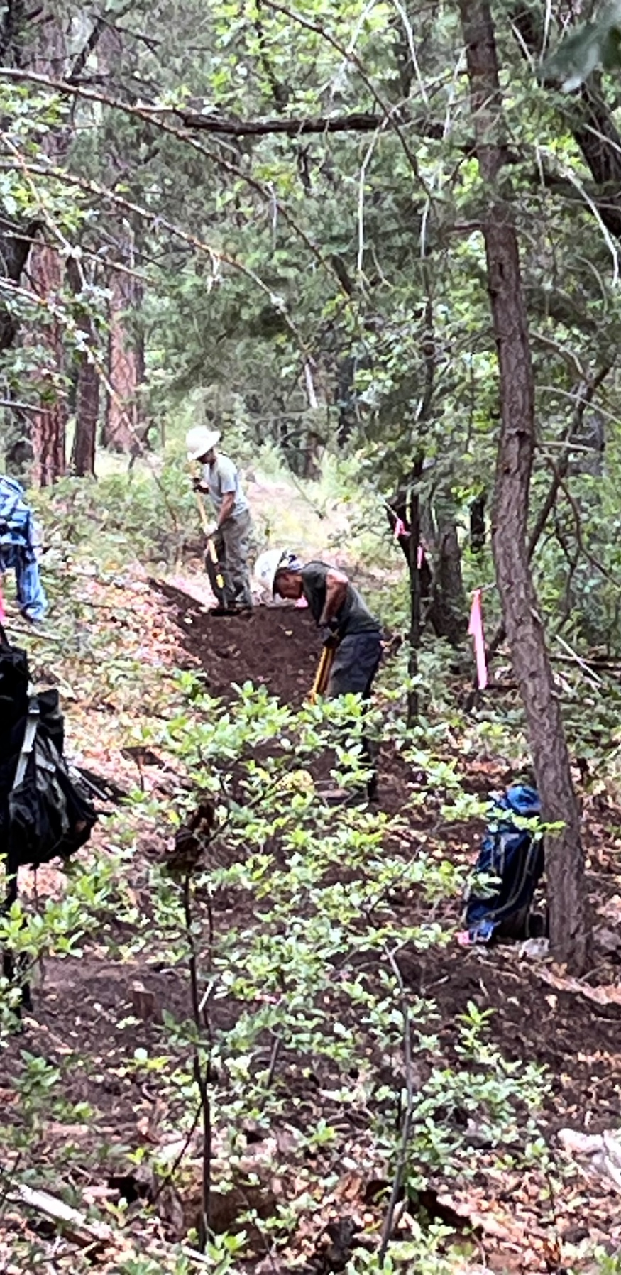

Jen and Luis do some finishing work.

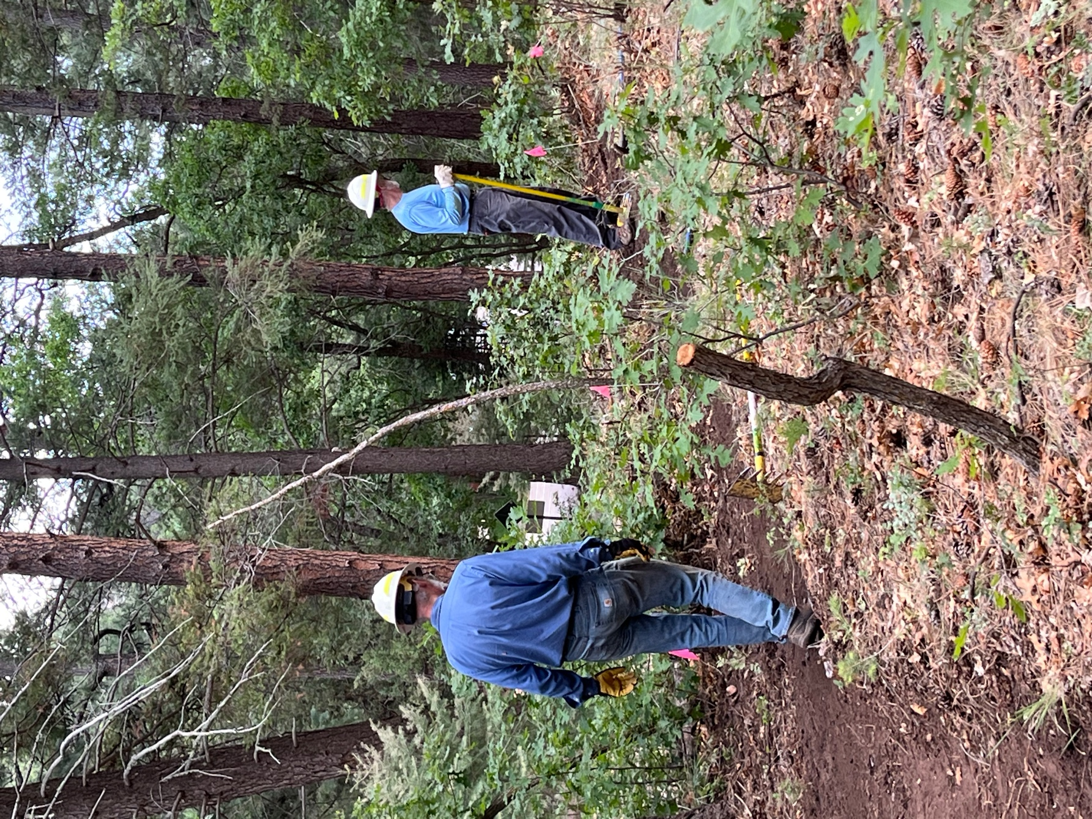

Jim and Cleve finishing a section.

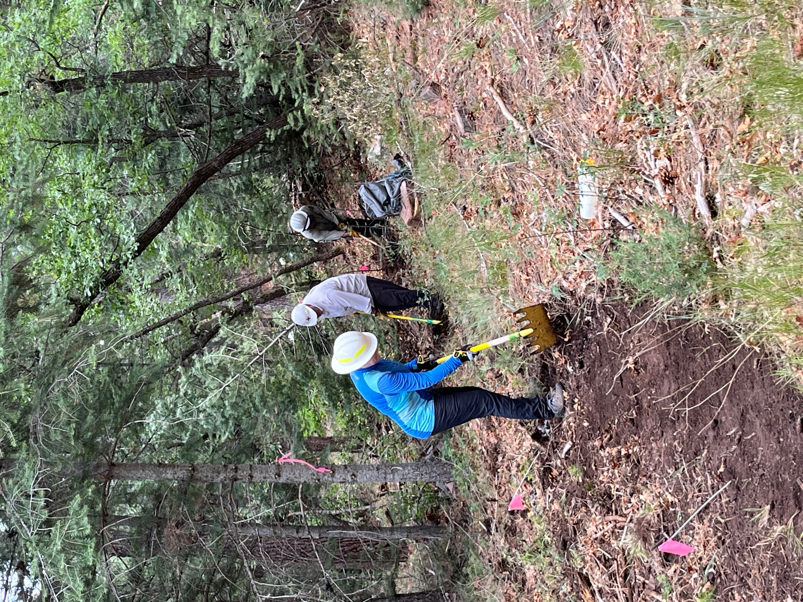

Courtnee, Rich and Chris head into a rocky, stumpy area.
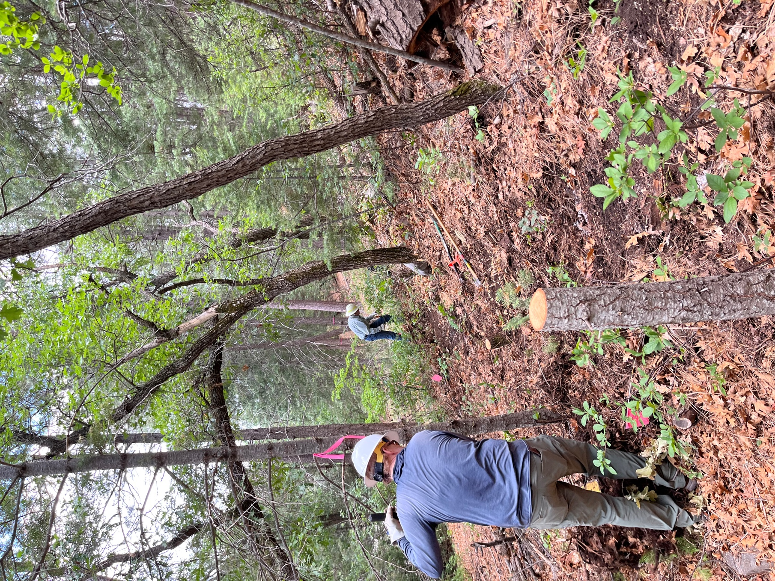

Starting in on the last section for the day- John digs stumps and Byron clears oak.
The slope is definitely increasing.

