**Report of FOSM Paint Crew Removing Graffiti Tags**

**in Juan Tabo Picnic Area on Tuesday, July 1**

Sam Beard

On Tuesday, July 1, Pauline Ho, Rick Buss, and Sam Beard removed or painted over numerous graffiti tags in the Juan Tabo Picnic Area.

Project photos are presented below.

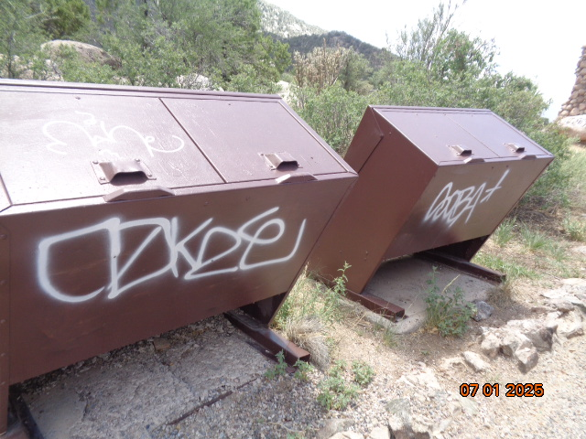

These tags at the parking lot were painted over with USFS brown paint. (Do not have an after photo.)

All photos by Sam Beard unless noted otherwise.

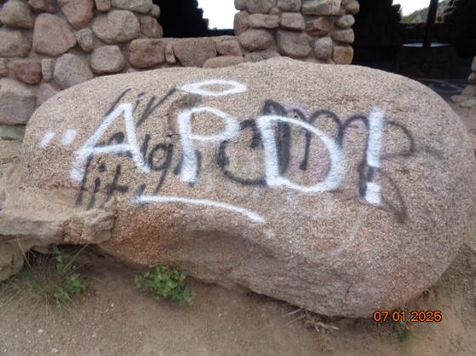

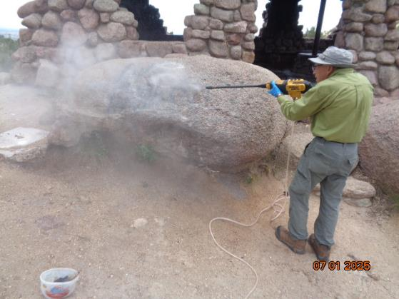

Before and after photos of boulder in front of CCC picnic shelter. Rick Buss is using the FOSM

battery-powered low-pressure washer to remove the paint and chemical residue.

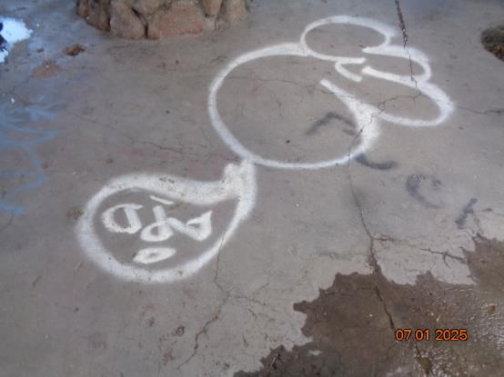

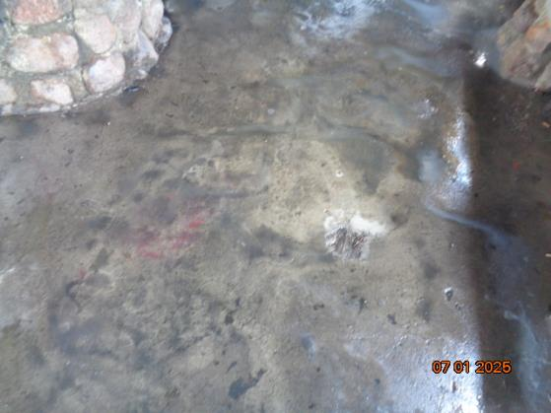

Before and after photos of tag on floor at the door of picnic shelter.

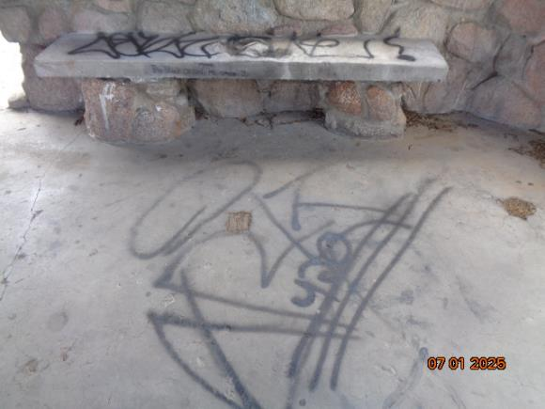

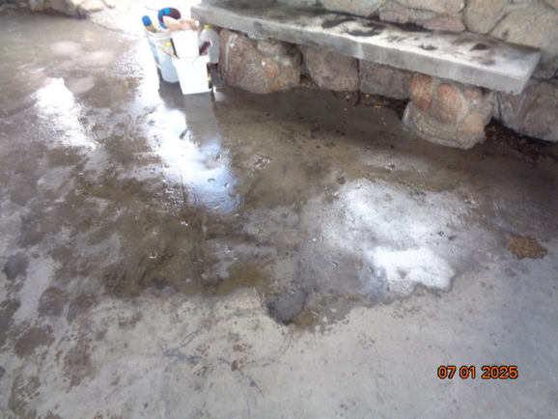

Before and after photos of tags on floor of shelter.

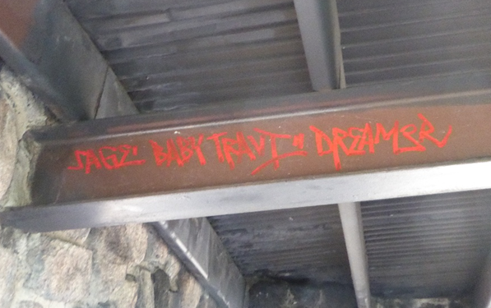

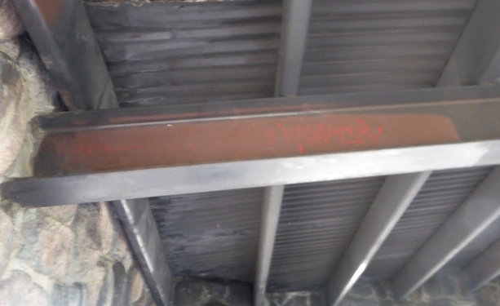

Before and after photos of overhead tag. Photos by Pauline Ho

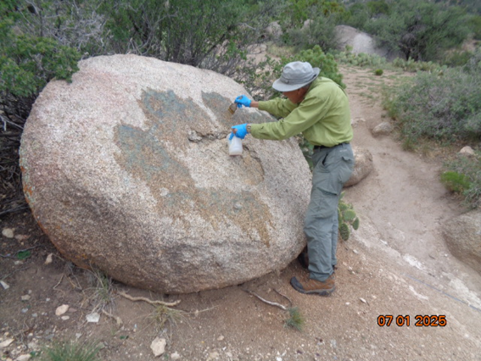

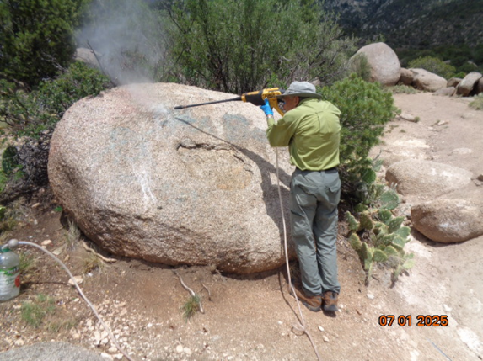

Before and after photos of boulder in front of picnic shelter.

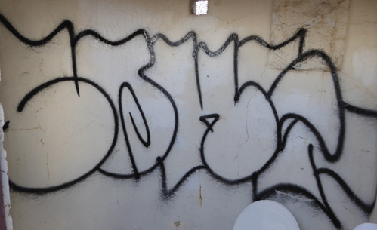

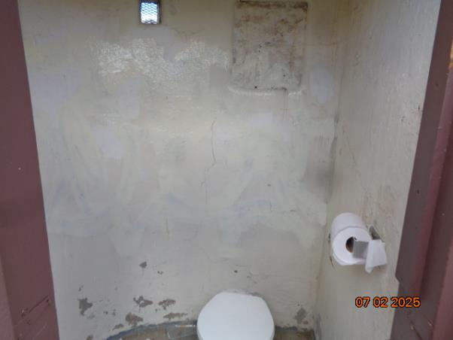

Before and after photos of tag in men’s restroom. The tag was painted over with linen white paint.

Top photo by Pauline Ho.

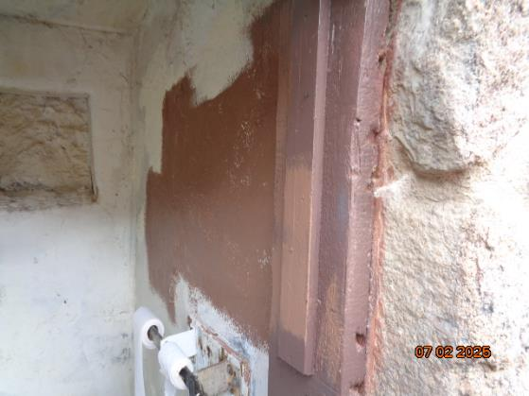

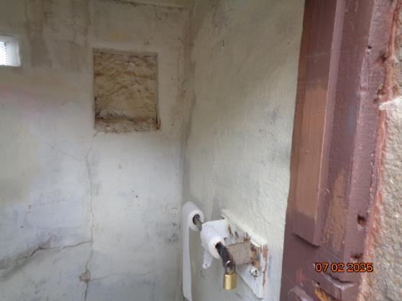

Top – Tag in women’s restroom was painted over with brown paint on a day when we

did not have white paint with us. Bottom – Brown paint was painted over with white paint.