**Report of FOSM Projects to Buck, Split, and Haul One Log at Pine Flat Picnic Area**

**and to Fell Five Trees and Buck and Haul Them at Tree Spring Trailhead**

**on Wednesday, July 2, 2025**

Sam Beard

On Wednesday, July 2, seven FOSM volunteers processed donation logs at Pine Flat Picnic Area and at Tree Spring Trailhead.

At Pine Flat PA, the crew bucked, split, and loaded a 17-inch log on Mike Oliver’s trailer. They had felled this log last Wednesday. The crew then moved to Tree Spring Trailhead where they felled five hazard trees that Canyon Young, SRD Trails and Wilderness Program Manager, had identified. These trees were limbed, bucked, and loaded on Mike’s trailer. He will store this wood in his woodlot until next winter when the Mountain Christian Church Wood Ministry volunteers will donate the wood to families in the East Mountains who heat their homes with wood.

The volunteers working on this project were Cliff Giles, Lou Romero, Sim Cook, Dan Benton, Sam Beard, Jerry Carroll, and Eric Russell.

Project photos are presented below.

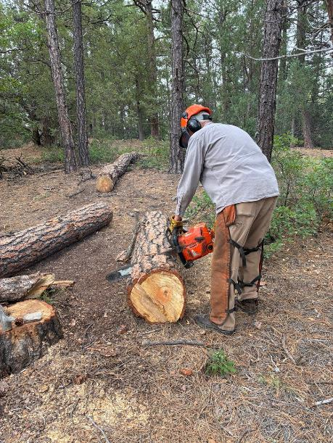

Dan Benton bucking the log at Pine Flat Picnic Area.

All photos by Cliff Giles unless noted otherwise

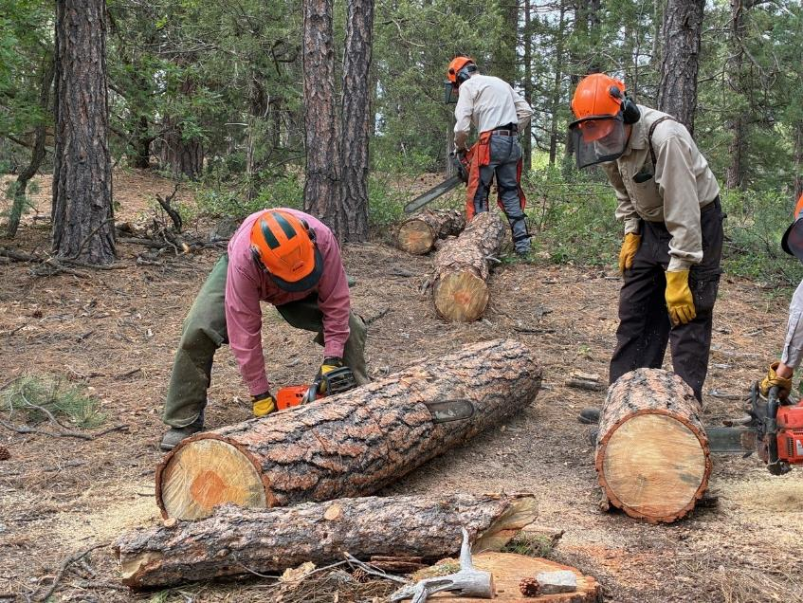

L to R: Jerry Carroll and Sim Cook bucking logs with Sam Beard observing.

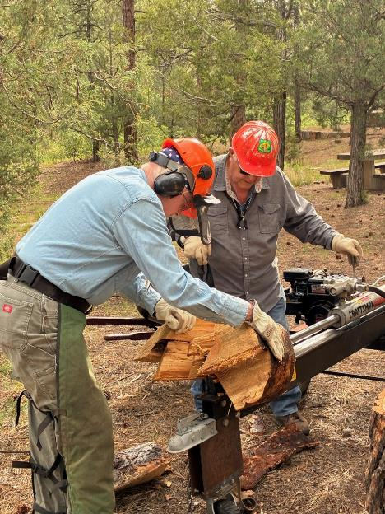

Eric Russell and Lou Romero splitting wood on Lou’s power splitter.

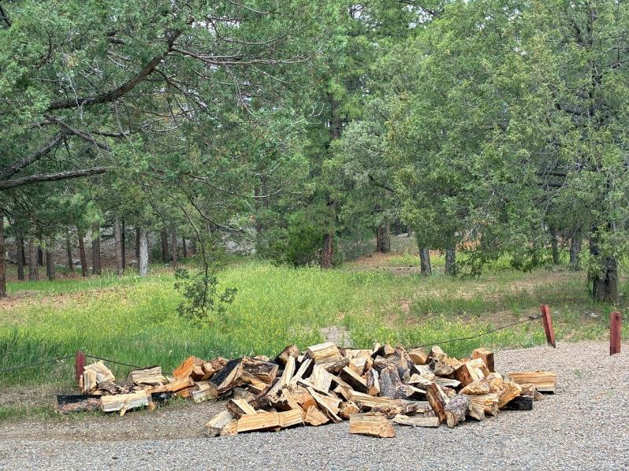

The split wood was hauled in wheelbarrows up the hill from the splitting site to the parking lot

where it was loaded on Mike Oliver’s trailer.

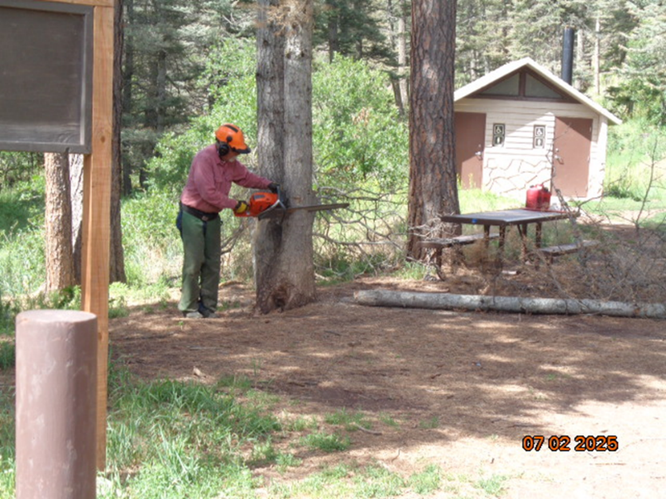

Jerry Carroll felling the second of three small dead trees in this group at Tree Spring Trailhead.

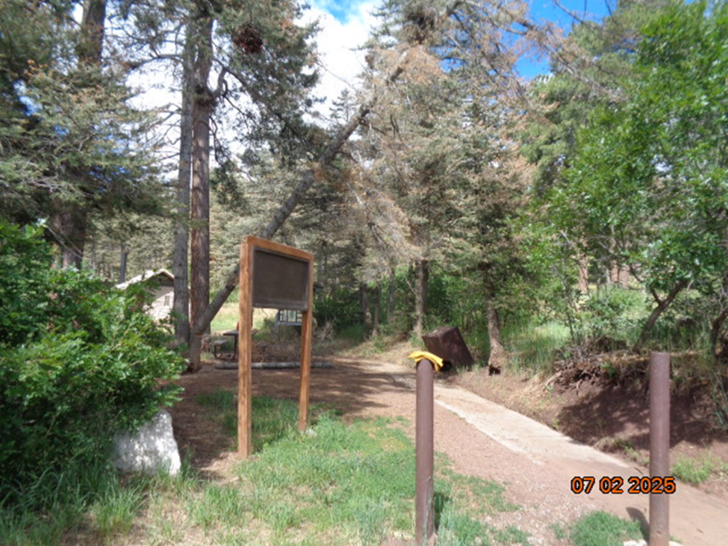

One of the trees felled by Jerry is falling across the sidewalk toward the parking lot.

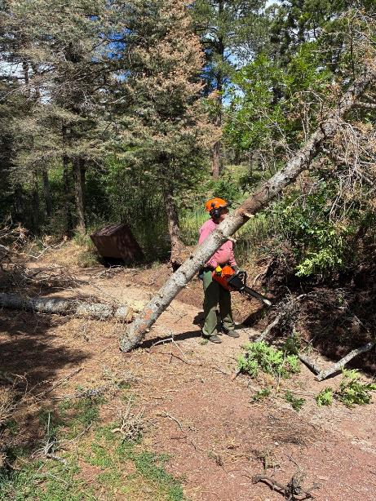

Jerry limbing and bucking this tree.

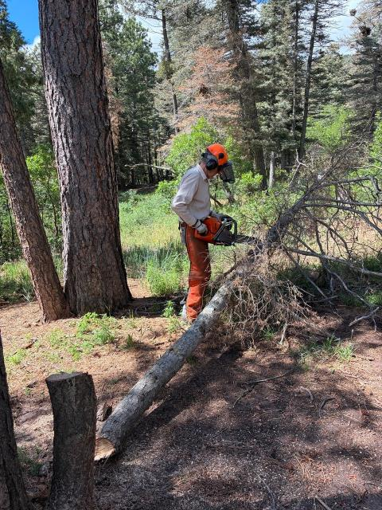

Sim Cook limbing and bucking this small tree.

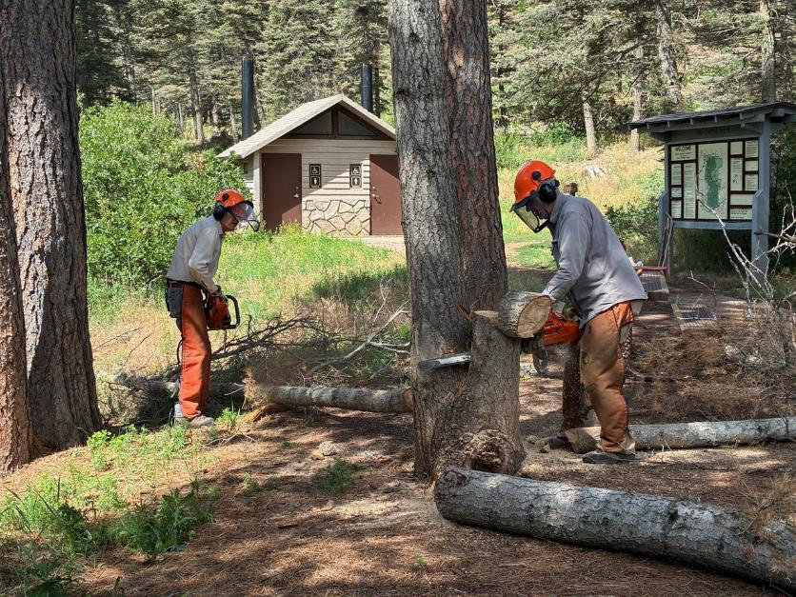

Dan Benton cutting a stump lower after the three smallest trees have been felled.

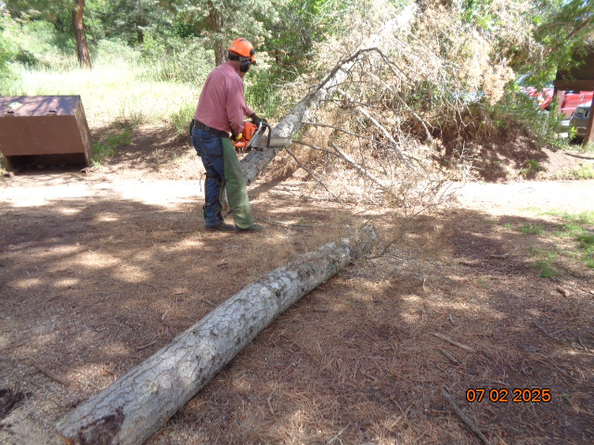

Jerry limbing one of the trees.

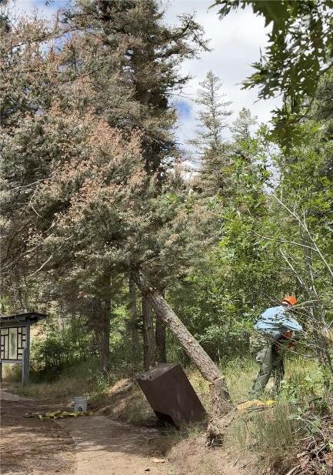

Eric Russell running away from the tree he felled so that the largest tree

in the group of four can be safely felled.

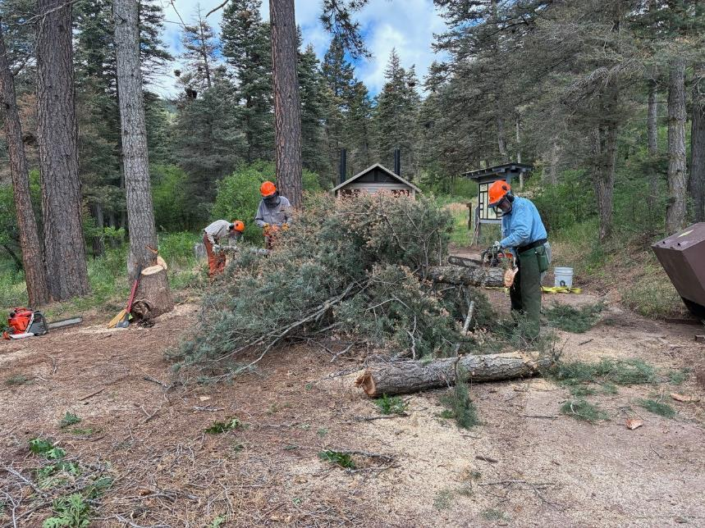

Eric is limbing the tree he just felled.

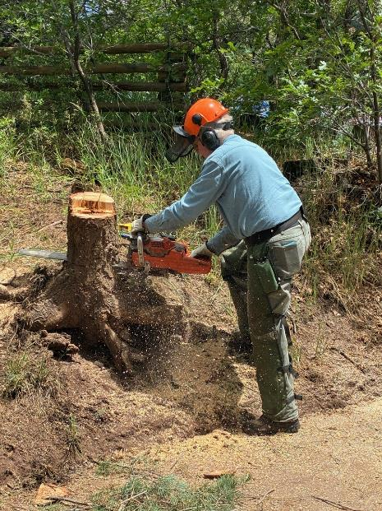

Eric low stumping his tree.

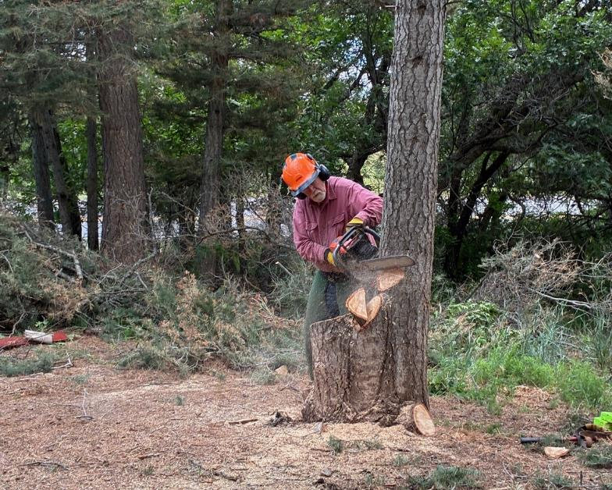

Jerry felling the largest dead tree.

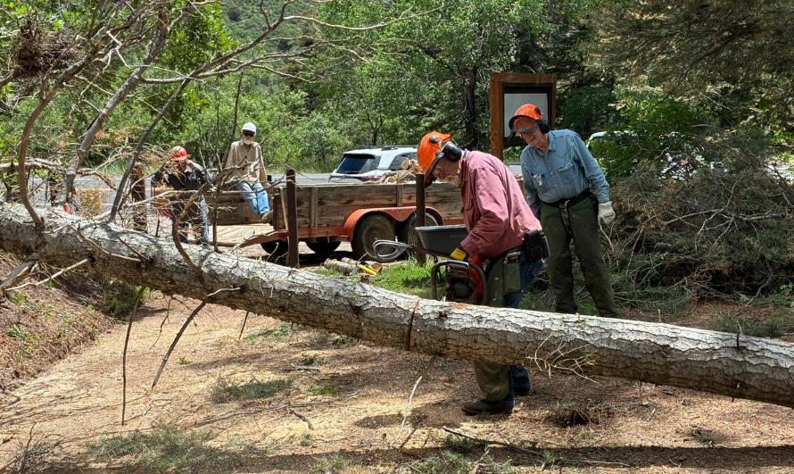

Jerry limbing and bucking the tree that he just felled. Other volunteers are waiting for the tree to be bucked so that they

can load it on Mike’s trailer.

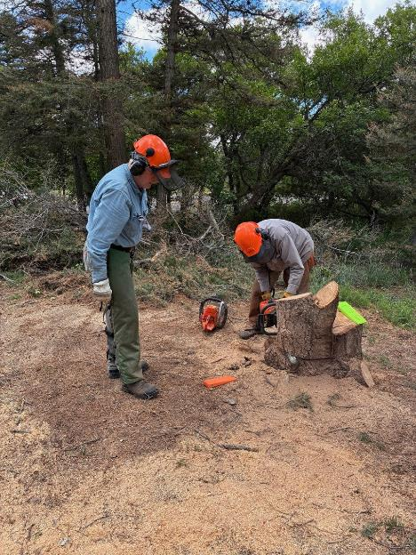

Dan is cutting the stump lower where the four trees were felled.

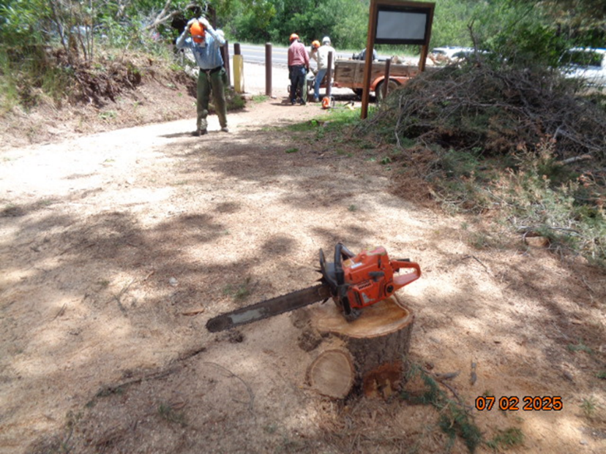

All of the trees were felled near the trailhead where the trailer is parked.

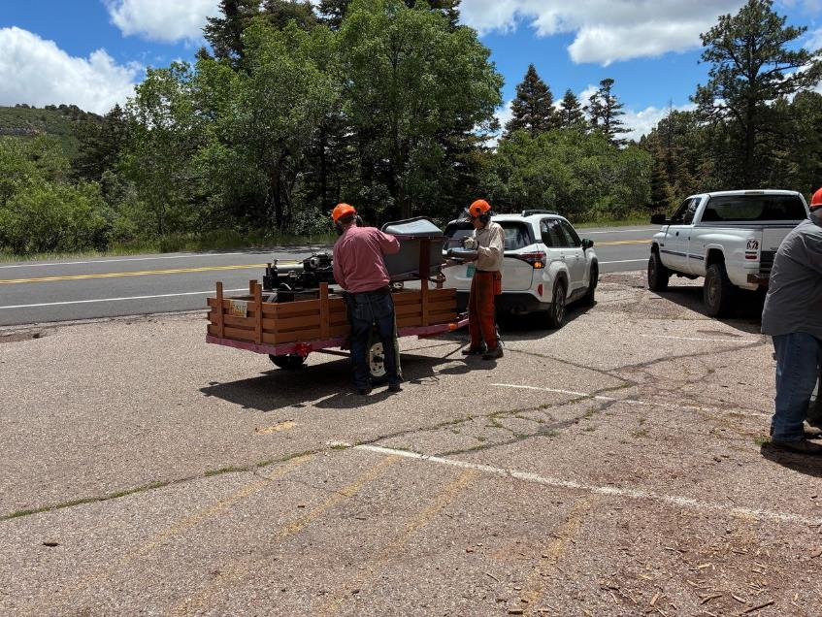

Jerry and Sim are loading a wheelbarrow on Lou’s trailer with the power splitter.

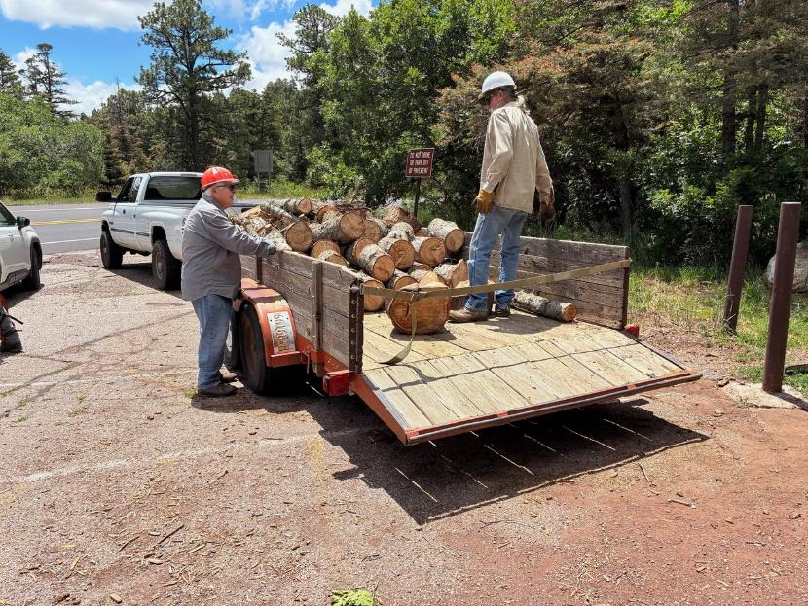

L to R: Lou Romero and Mike Oliver. All the wood processed on Wednesday is more than half a trailer load.