**Report of FOSM Task to Install New Sign Announcing That the Distance to the Oak Flat Recreation Site is ¼-mile, Friday, July 4, 2025**

Sam Beard

On Friday, July 4, Don Carnicom and Sam Beard installed a new sign stating that the distance to a National Forest Recreation Site (Oak Flat Picnic Area) is ¼-mile. The sign was secured to the post with a tamper-proof bolt and nut.

Fortunately, the old 6x6 post was still sound, and we did not have to dig a hole for a new post.

Photos are presented below.

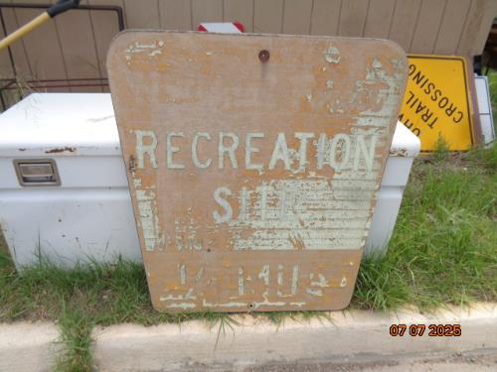

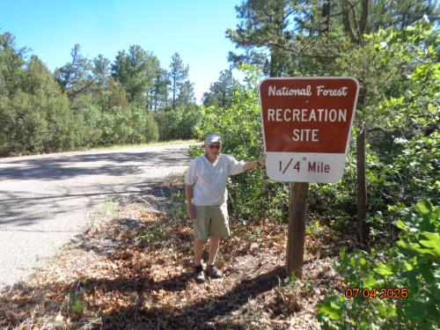

Top – Old damaged sign on Oak Flat Road stating that the recreation site was ¼-mile ahead.

Bottom – New sign on Oak Flat Road stating that the distance to the next recreation site

is ¼-mile. All photos by Sam Beard