**Report of FOSM Repairs of Letter Holders on SRD Front Kiosk, Monday, July 7, 2025**

Sam Beard and Joelle Hertel

During June and early July, Joelle Hertel and Sam Beard completed a FOSM project to improve the support of the letters on the kiosk in front of the Sandia Ranger Station. The kiosk was built when the ranger station was rebuilt several years ago. Each row of letters is held in place by plastic strips on the top and bottom of each row. Some sections of these plastic strips were broken and had fallen off the kiosk. The letters are placed in a row by inserting the letter top in the upper slot, moving the letter to the back surface of the kiosk, and then the bottom of the letter is inserted a slot at the bottom.

Instead of attempting to repair or replace the five plastic strips that hold the four rows of letters, we decided to attach a strip of aluminum over each plastic strip to hold it securely on the white backing plastic sheet. We used a 1/8-inch X ¾-inch aluminum strip on the lowest location and a 1/8-inch by 1-inch aluminum strip over each of the plastic strips in the center of the panel. Each strip of plastic was secured with 12 small machine bolts about 2 inches long with a nut on the other side. In order to secure the aluminum strip over each plastic strip, it was necessary to remove all the old small machine bolts, drill a hole in each of the aluminum strips on both sides of the white sheet of plastic and put a 2.5-inch long #10-24 small bolt through all the layers of the sign – aluminum on the south side, the south plastic strip, two layers of the white sheet, the north plastic strip, and the north aluminum strip. Drilling each of the 48 holes straight through so that all the layers were in line was difficult and tedious. After several work sessions, we finally completed four of the strips. Due to the work involved and the fact that the top plastic strip was mostly in good condition, we did not install an aluminum strip over the top two plastic strips. We tested the installed system by placing letters in all the rows successfully. The present improved kiosk should be useable for many years.

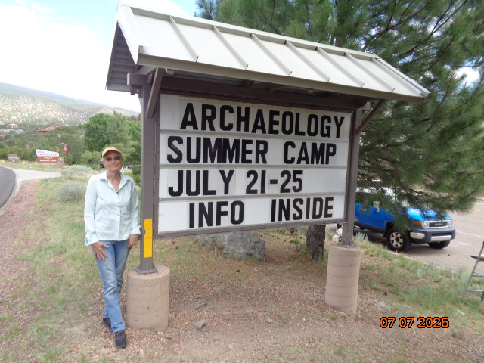

Joelle Hertel standing beside the kiosk with eight strips of aluminum bolted over a total of eight plastic

strips on the two sides of the panel. Photo by Sam Beard

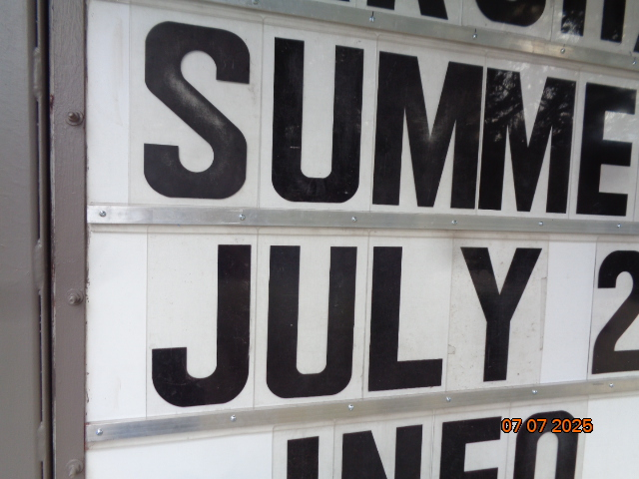

Another view of the kiosk showing the aluminum strips and the small bolts separated by 7.5 inches.