Thursday, 07/10/25- Wagon extension: Man, was it hot! Eleven volunteers joined Chris and Jen (SRD) to continue work on the Wagon extension. We thought we might finish but the weather was really hot and there was a change of route between the kiosk and trail connection that delayed our finishing. We continued work on the extension and are close to finishing the end near the kiosk. Jen and Chris will head out next week to clear the short corridor that connects the kiosk are and the established trails. We completed, or almost completed three connections between the new extension trail and the Sulphur Spring parking lots. John did a bunch of stump and debris removal that helped move the connections along. Mike did some brushing along the fences in the parking areas.
Hopefully the weather will be a bit more reasonable next week and we will finish with a flourish!

Volunteers: Rich Fagioli, Eric Russell, Cleve Sharp, Bill Perkins, Claudia Bergsohn,
Mike Madden, Luis Quadros, Jim Houle, Bruce Hansche, John McNett and
Laura Leon

Pictures: Laura Leon

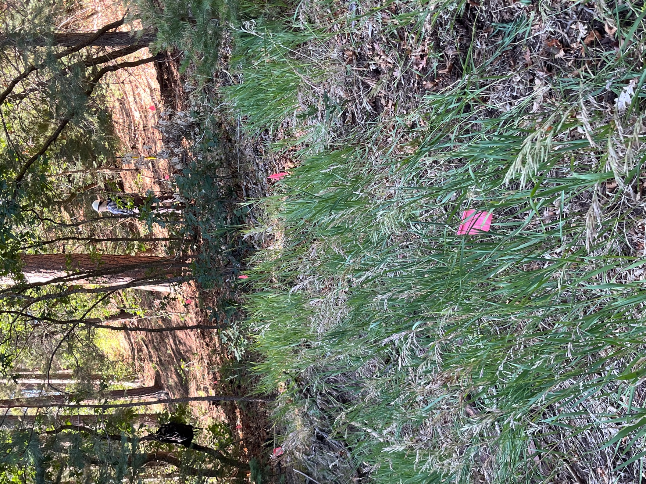

This is one of the parking lot connections. Bruce started at the trail and Laura started at the road. They both moved with the shade when possible. The ditch by the road required some rock work.
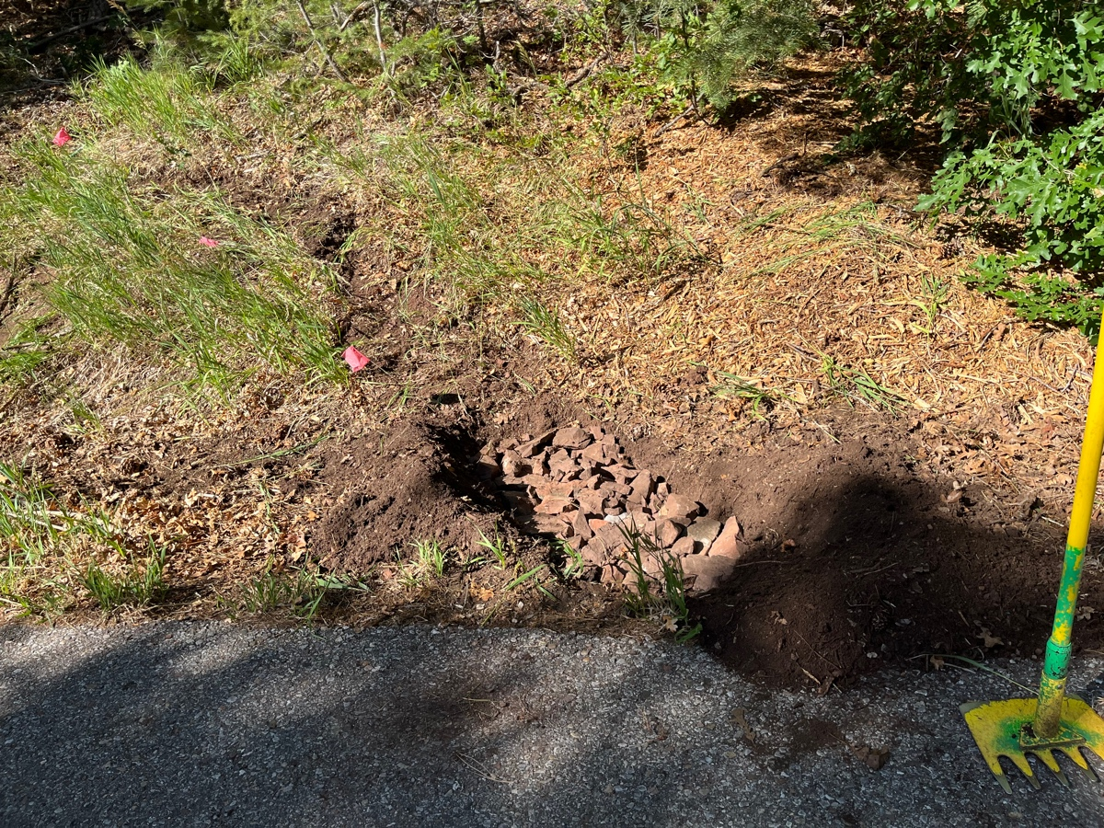

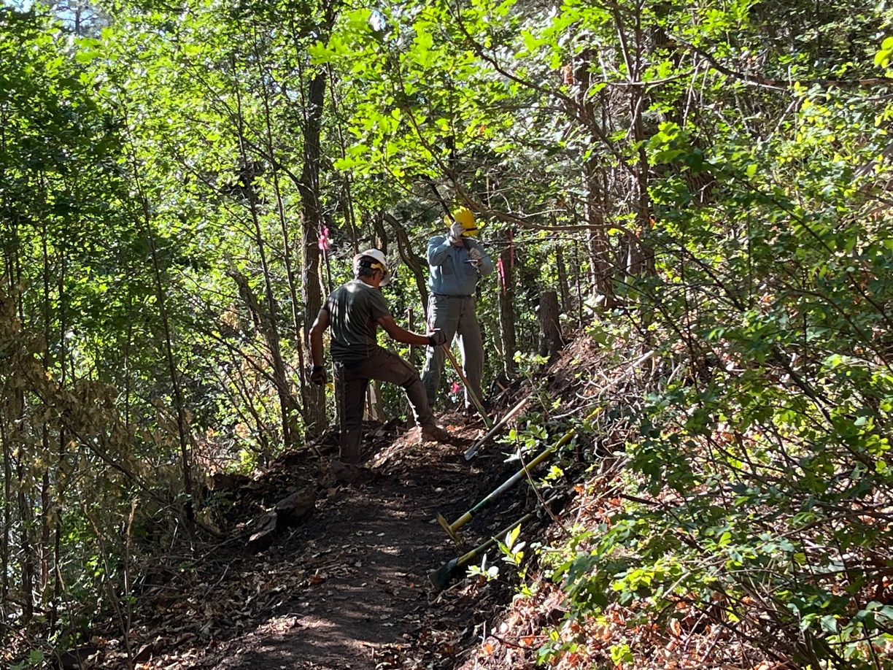

Luis and Eric worked on stumps along the slope.

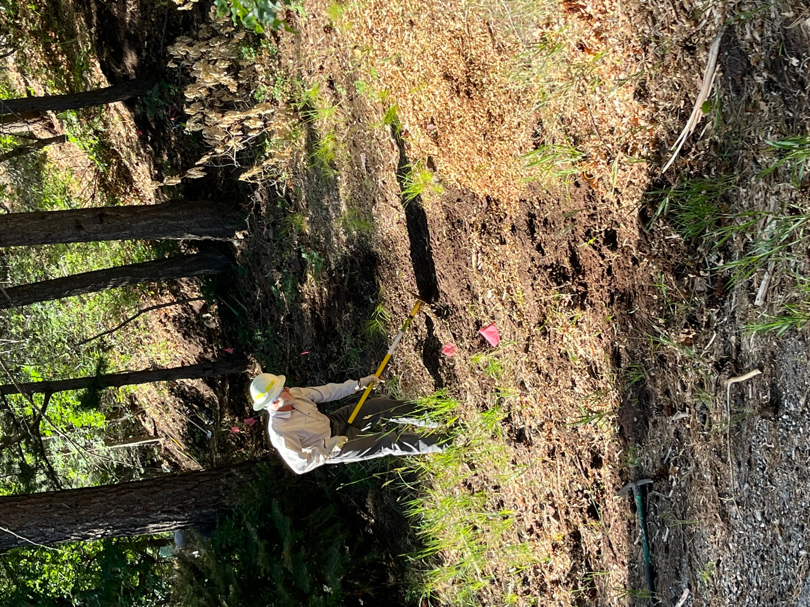

Cleve and Mike worked on another one of the parking lot connections.

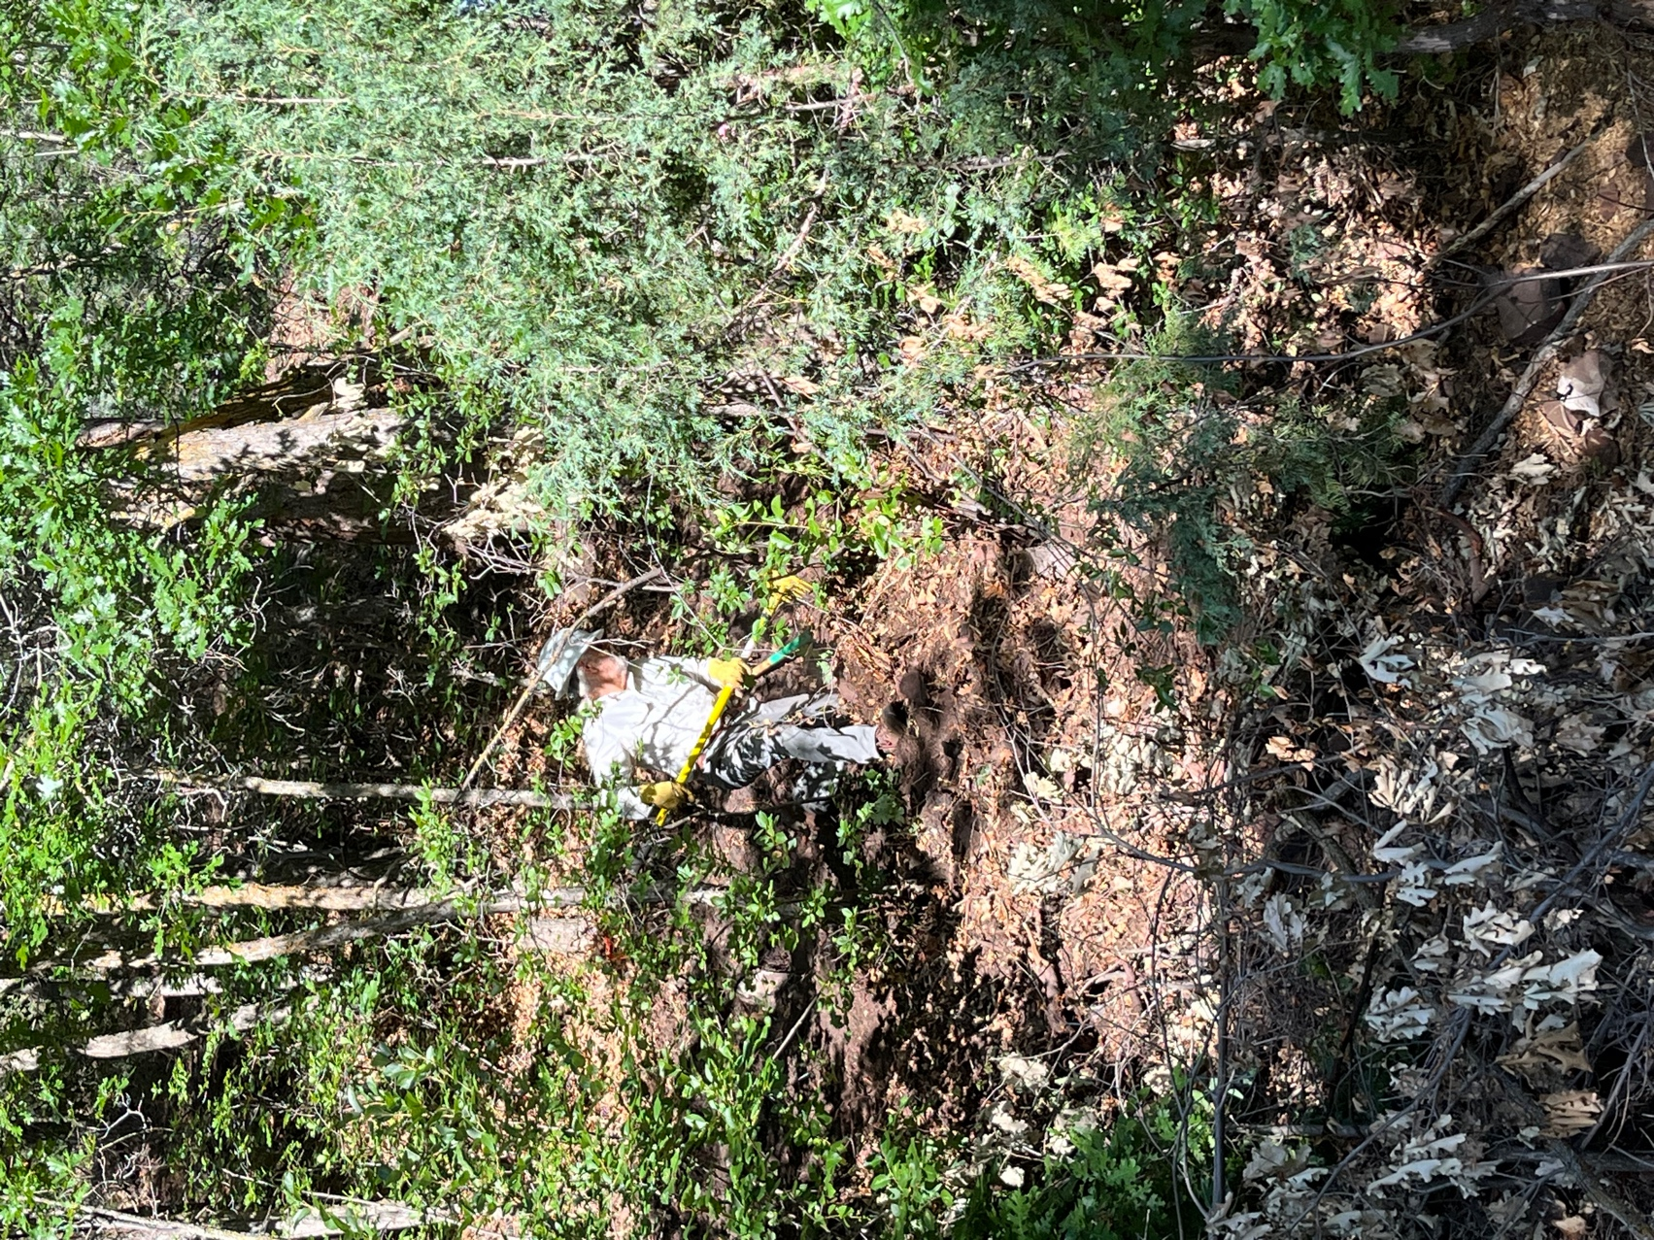

Bill pulled debris down the slope.

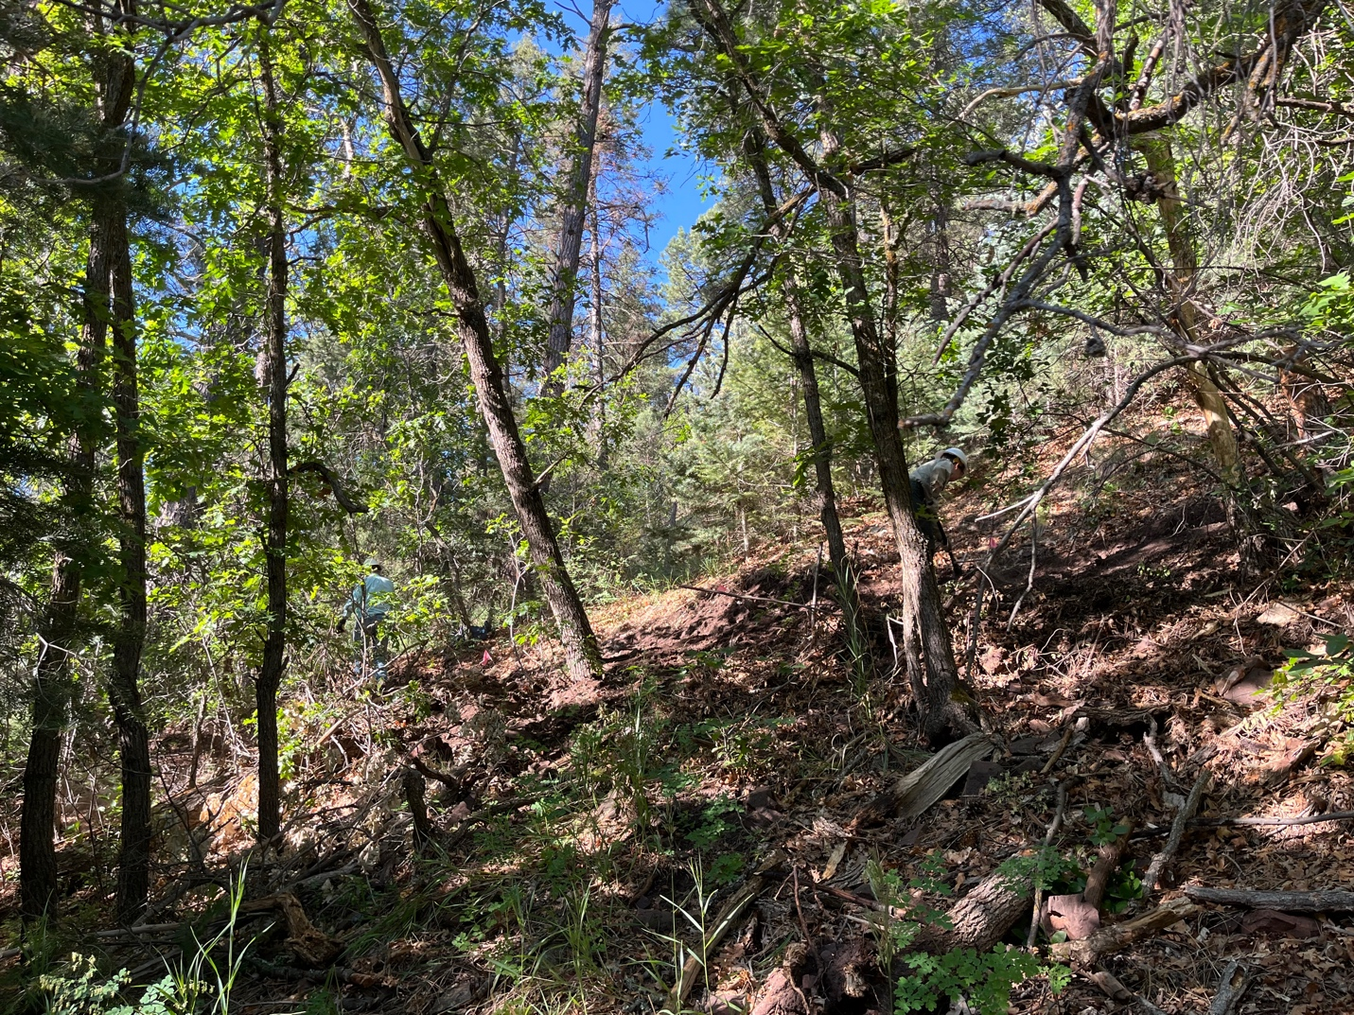

Jen and Jim worked towards the kiosk- almost there!
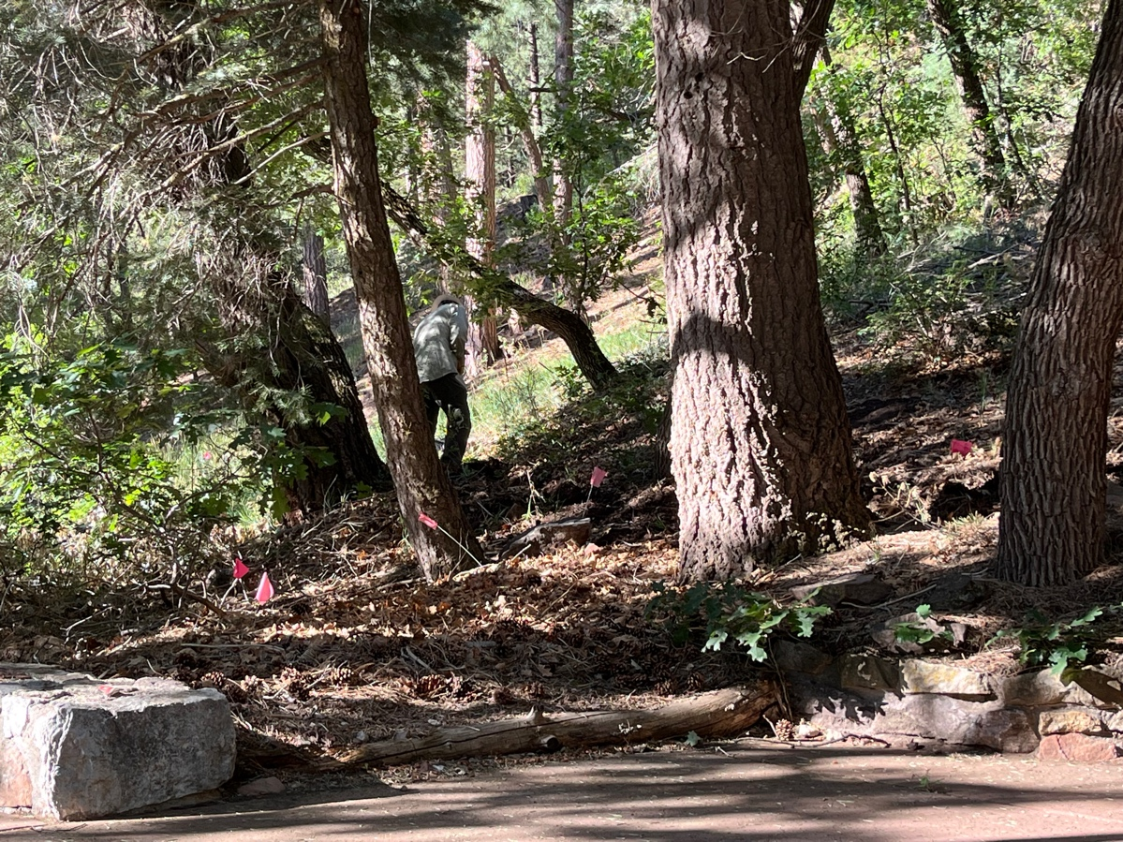

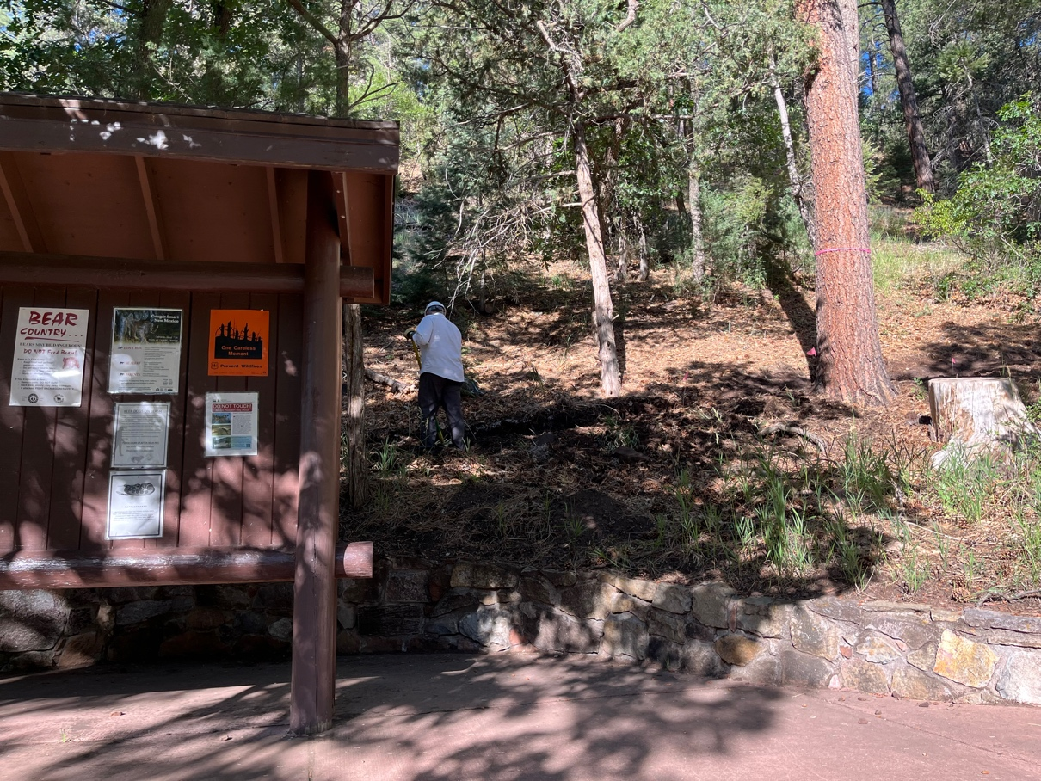

Chris and Rich worked the area around the kiosk.

