**Report of FOSM Processing Wood at Ellis Trailhead, Wed., July 9, 2025**

Sam Beard

On Wednesday, July 9, seven FOSM volunteers bucked logs along Switchback Trail that had been felled when this trail was rerouted near the red gate on the Service Road near Ellis Trailhead. The rounds were split and loaded on Mike Oliver’s trailer. He hauled this donation wood to his woodlot to be distributed to East Mountain families next winter.

The volunteers were Mike Oliver, Lou Romero, Dan Benton, Jerry Carroll, Eric Russell, Sam Beard, and Cliff Giles.

Project photos are presented below.

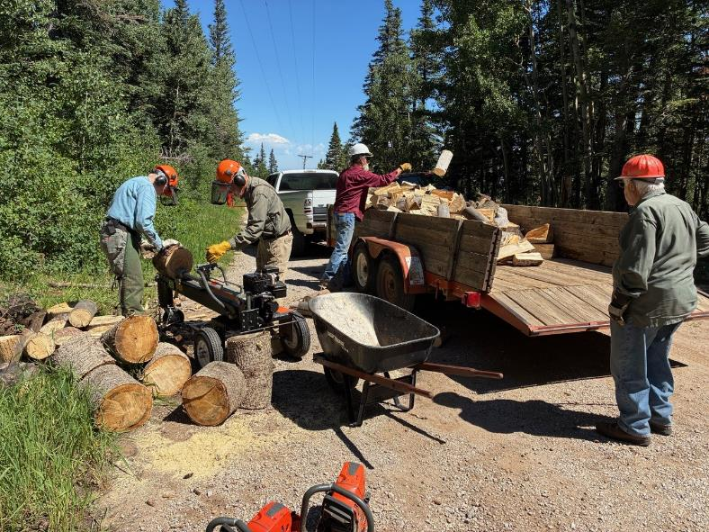

L to R: Eric Russell, Sam Beard, Mike Oliver, and Lou Romero. Eric and Sam are using Lou’s power splitter to spit rounds.

Mike is loading his trailer with wood that he will haul to his woodlot. Next winter, Mountain Christian Church Wood Ministry

Volunteers will donate the wood to East Mountain families who heat their homes with wood. All photos by Cliff Giles unless noted otherwise

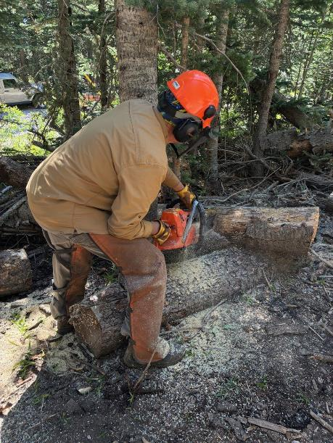

Dan Benton bucking a down tree that was felled when Switchback Trail was rerouted

so that the trailhead was near the Service Road gate at Ellis Trailhead.

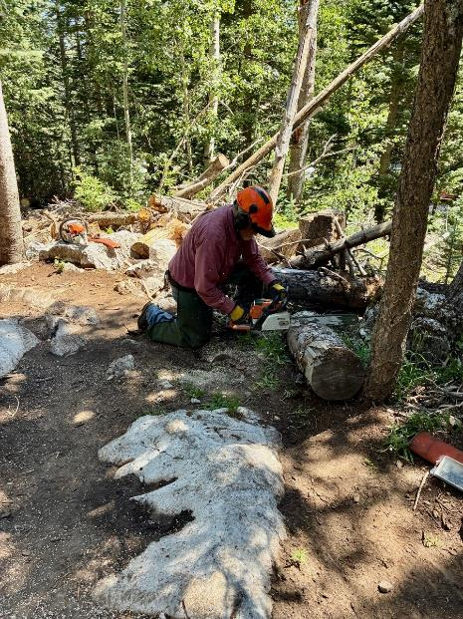

Jerry Carroll bucking a log to make donation wood.

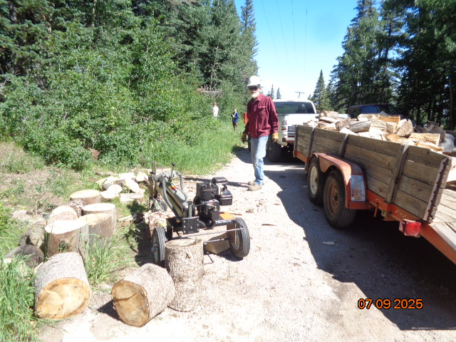

Mike Oliver at his partially loaded trailer. Volunteers will shortly return and continue splitting rounds that have been

rolled down to the splitter. Photo by Sam Beard

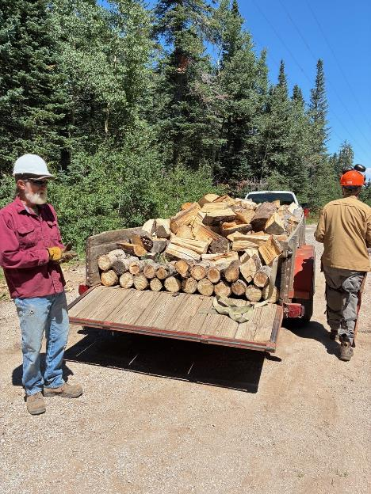

Mike Oliver preparing to haul this load of firewood to his woodlot.